
FPT-aptech computer education
eProject Document
Leave Management System
Group 1
Group Member | Nguyen Manh Hung – A04211 – 691  Nguyen Duc Phuong –A04210 – 694  Le Quang Hung – A04209 – 708
Instructor | TuNN
Batch | C0810L
Semester | <2|4>

- Hanoi, 6/2010-

Content

1. Problem Definition 4
1.1. Problem Abstraction 4
1.2. The Current System 4
1.3. The Proposed System 4
1.4. Boundaries of the System 5
1.5. Development Environment 5
2. Requirements and Business Flow 7
2.1. Customer Requirement Specification 7
2.2. Activity Diagram 7
2.3. Use Case Diagram 8
2.4. Use Case Specification 8
3. Design 21
3.1. System Architecture 21
3.2. Class Diagram 23
3.3. Class Diagram Explanation 24
3.4. Data Flow Diagram 24
3.5. Entity Relationship Diagram 26
3.6. Database Design 27
4. System Prototype 29
5. Management and Project Planning 31
5.1. Management Approach 31
5.2. Project Plan 32
5.3. Task Sheet 33
6. Checklists 33
6.1. Check List of Validation 33
6.2. Submission Checklist 34
7. Screenshots 34
8. Coding Convention 38

Introduction

This project is aimed at developing a leave management system that is of importance to any organization. The Leave Management System (LMS) is an application that can be accessed by all the employees of the organization. This system can be used to automate the workflow of leave applications and their approvals. The periodic crediting of leave is also automated. There are features like cancellation of leave, report generators, etc… in this system.

Problem Definition

Problem Abstraction
In most of the organizations, each employee has been provided with the leave card at the time of appointment. Leave card shows the leaves credited to the employee’s account. Each time employee wants to go on leave, he will have to mention the details on the card, get it approved from the superior and submit it to the human resources staff person for updating in the company records. At the end of the year the leave balance is updated. However this paper based process is very time consuming and also causes discrepancies in the records.

The Current System
Currently, system only uses paper to apply and decide a leave. So, this is very inconvenient and takes so much time for a staff to get a leave because of complex administrative procedures.

The Proposed System
Due to the inconvenience in managing the data using leave cards, it is required to have a computer based system where an employee can login and apply for the leave. He can even see the records of the previous leaves taken as well check the balance leaves.
Each person should have the functions below:
- Login to the system through the first page of the application
- Change the password after logging into the system
- See his/her leave details (how many days of leave
he/she is eligible for, leave balance, leave history , etc…)
- Apply for leave, specifying the dates, reason for taking leave, address for communication while on leave.
- See his/her current leave applications and the leave applications that are submitted to him/her for approval or cancellation
- Approve/reject the leave applications that are submitted to him/her (if he/she is a superior)
- Withdraw his/her leave application (which has not been approved)
- Cancel his/her leave (which has been already approved). This will need to be approved by his/her Superior.
- Get help about the leave system on how to use the different features of the system.

After each staff activity, system will create a log to save the details of the action for the superior giving detail.
The report of leave details will be sent to their manager periodically.
Also, managing director creates a policy of the number of days that a staff can leave in a period time and mark the public holidays in calendar.

Boundaries of the System
As the content above, system can be applied to everyone in the company

Development Environment
Hardware:
- A minimum computer system that will help you access all the tools in the courses is a Pentium 166 or better.
- 128 Megabytes of RAM or better
Software:
- Visual Studio .Net / ASP / Visual Studio 6.0
- IIS server
- .Net Framework
- Java Virtual Machine/ J2EE server
- Notepad/Java editor
- j2sdk1.4.1_02 (or later).
- EJB Dev Kit
- Java enabled web server
- JSP / Servlets Dev. Kit

Requirements and Business Flow

Customer Requirement Specification
Customer requires an IT system that can control and operate every activity about leave management by computer to replace the current manual system.

Activity Diagram
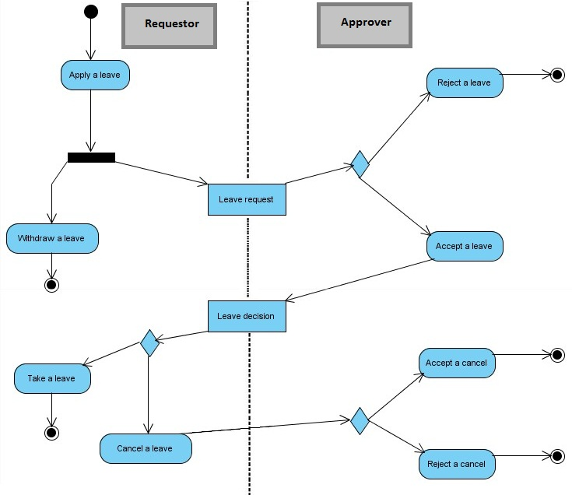

Use Case Diagram
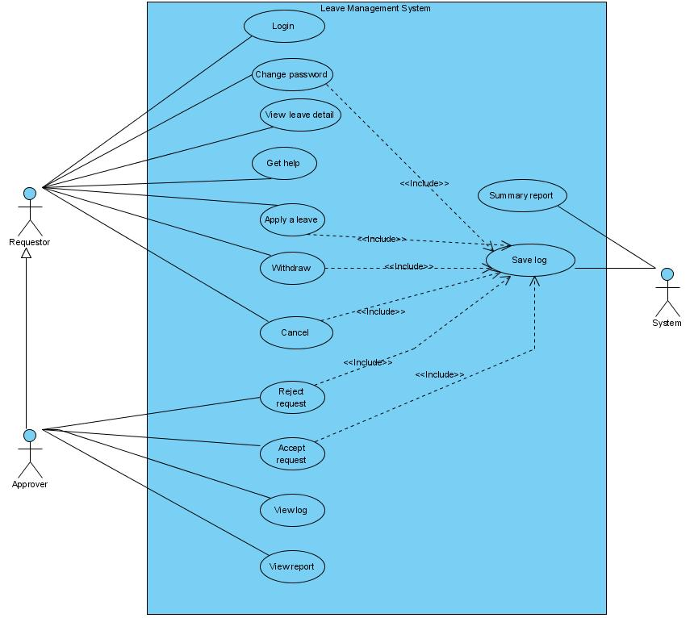

Use Case Specification

Use-case No. | UC01 | Use-case Version |  | 1.0
Use-case Name | Login
Author | Hungnm
Date | 15/06/2010 | Priority | High
Actor:
Requestor/Approver

Summary:
Requestor login to the leave management system
Goal:
Login to the system to use it’s function
Triggers
N/A
Preconditions:
N/A
Post Conditions:
N/A
Main Success Scenario:
Step | Actor | System
1 | User enter username and password then click into button Login
2 |  | If proper the conditions BR01 ,will take users to the system on the main interface else will be forwarded to AS01
3 | End use case

Alternative Scenario:
Step | Actor | System
1 |  | Display message “Wrong username or password. Please try again”
2 |  | Back to step 1 of main scenario
3 | End use case

Exceptions:
N/A
Relationships:
N/A
Business Rules:
- BR1 : Username and password are correctly

Use-case No. | UC02 | Use-case Version |  | 1.0
Use-case Name | Change password
Author | Hungnm
Date | 15/06/2010 | Priority | Normal
Actor:
Requestor/Approver

Summary:
Users want to change their password
Goal:
Change password

Triggers
N/A
Preconditions:
After login
Post Conditions:
N/A
Main Success Scenario:
Step | Actor | System
1 | User click button Change your password
2 |  | System displays the password change interface
3 | User enter old password , new password and confirm password then click button OK
4 |  | If proper the conditions BR01 , system will show the message “password successfully changed ” else will be forwarded to AS01
5 | End use case

Alternative Scenario:

Step | Actor | System
1 |  | Display message “Wrong old password or newpass and confirm pass must be identical”
2 |  | Back to step 3 of main scenario
3 | End use case

Exceptions:
N/A
Relationships:
N/A
Business Rules:
- BR1 : Old password correctly, new password and confirm password must be identical

Use-case No. | UC03 | Use-case Version |  | 1.0
Use-case Name | View leave detail
Author | Hungnm
Date | 15/06/2010 | Priority | Normal
Actor:
Requestor/Approver

Summary:
Users want to view their own history, day of leave and balance
Goal:
Know their own history leave
Triggers
N/A
Preconditions:
After login
Post Conditions:
N/A
Main Success Scenario:
Step | Actor | System
1 |  | System displays the detail leave interface
2 | User double click into row
3 |  | Show dialog display more infomation
4 | End use case

Alternative Scenario:
N/A

Exceptions:
N/A
Relationships:
N/A
Business Rules:
- N/A

Use-case No. | UC04 | Use-case Version |  | 1.0
Use-case Name | Get help
Author | Hungnm
Date | 15/06/2010 | Priority | Normal
Actor:
Requestor/Approver

Summary:
Users want to know more information about system and how to use
Goal:
Know how to use system well

Triggers
N/A
Preconditions:
After login
Post Conditions:
N/A
Main Success Scenario:
Step | Actor | System
1 | User click button Get help
2 |  | System displays the help interface
3 | End use case

Alternative Scenario:
N/A

Exceptions:
N/A
Relationships:
N/A
Business Rules:
- N/A

Use-case No. | UC05 | Use-case Version |  | 1.0
Use-case Name | Apply a leave
Author | Hungnm
Date | 15/06/2010 | Priority | Normal
Actor:
Requestor/Approver

Summary:
Users want to apply a leave
Goal:
Take a leave

Triggers
N/A
Preconditions:
After login
Post Conditions:
N/A
Main Success Scenario:
Step | Actor | System
1 | User click button Apply a leave
2 |  | If proper the conditions BR01, system’ll show form Add new leave else go to EX01
3 | User fill required information in the form
4 |  | If proper the conditions BR02, system’ll show success message else go to AS01
5 | End use case

Alternative Scenario:
AS01
Step | Actor | System
1 |  | Display message “Not enough day leave remaining”
2 |  | Back to step 3 of main scenario
3 | End use case

Exceptions:
EX01: end use case
Relationships:
N/A
Business Rules:
- BR01: User still have leave days
- BR02: smaller number of leave days than remaining leave days

Use-case No. | UC06 | Use-case Version |  | 1.0
Use-case Name | Withdraw a leave
Author | Hungnm
Date | 15/06/2010 | Priority | Normal
Actor:
Requestor/Approver

Summary:
Users want to withdraw a leave
Goal:
Successfully cancel
Triggers
N/A
Preconditions:
After login
A leave is not accepted
Post Conditions:
N/A
Main Success Scenario:
Step | Actor | System
1 | User select row and click button withdraw
2 |  | system’ll show success message and change status of leave
3 | End use case

Alternative Scenario:
N/A
Exceptions:
N/A
Relationships:
N/A
Business Rules:
N/A

Use-case No. | UC07 | Use-case Version |  | 1.0
Use-case Name | Cancel a leave
Author | Hungnm
Date | 15/06/2010 | Priority | Normal
Actor:
Requestor/Approver

Summary:
Users want to cancel a leave
Goal:
Successfully cancel
Triggers
N/A
Preconditions:
After login
A leave is accepted
Post Conditions:
N/A
Main Success Scenario:
Step | Actor | System
1 | User select row and click button cancel
2 |  | system’ll show message “waiting on the manager to accept” and change status of leave
3 | End use case

Alternative Scenario:
N/A
Exceptions:
N/A
Relationships:
N/A
Business Rules:
N/A

Use-case No. | UC08 | Use-case Version |  | 1.0
Use-case Name | Reject request
Author | Hungnm
Date | 15/06/2010 | Priority | Normal
Actor:
Approver

Summary:
Users want to reject a request
Goal:
Successfully cancel
Triggers
N/A
Preconditions:
After login
Role is approver
Post Conditions:
N/A
Main Success Scenario:
Step | Actor | System
1 | User click to button Manage leave
2 |  | system’ll display manage leave interface
3 | User select a row and click button Reject
4 |  | Change status of the leave
5 | End of use case

Alternative Scenario:
N/A
Exceptions:
N/A
Relationships:
N/A
Business Rules:
N/A

Use-case No. | UC09 | Use-case Version |  | 1.0
Use-case Name | Approve request
Author | Hungnm
Date | 15/06/2010 | Priority | Normal
Actor:
Approver

Summary:
Users want to approve a request
Goal:
Successfully accept
Triggers
N/A
Preconditions:
After login
Role is approver
Post Conditions:
N/A
Main Success Scenario:
Step | Actor | System
1 | User click to button Manage leave
2 |  | system’ll display manage leave interface
3 | User select a row and click button Approve
4 |  | Change status of the leave
5 | End of use case

Alternative Scenario:
N/A
Exceptions:
N/A
Relationships:
N/A
Business Rules:
N/A

Use-case No. | UC10 | Use-case Version |  | 1.0
Use-case Name | View log
Author | Hungnm
Date | 15/06/2010 | Priority | Normal
Actor:
Approver

Summary:
Approver want to view log of employee
Goal:
View log
Triggers
N/A
Preconditions:
After login
Role is approver
Post Conditions:
N/A
Main Success Scenario:
Step | Actor | System
1 | User click to button View list employee
2 |  | system’ll display list employee
3 | User double click on a row
4 |  | Show log of employee
5 | End of use case

Alternative Scenario:
N/A
Exceptions:
N/A
Relationships:
N/A
Business Rules:
N/A

Use-case No. | UC11 | Use-case Version |  | 1.0
Use-case Name | View report
Author | Hungnm
Date | 15/06/2010 | Priority | Normal
Actor:
Approver

Summary:
Approver want to view log of employee
Goal:
View log
Triggers
N/A
Preconditions:
After login
Role is approver
Post Conditions:
N/A
Main Success Scenario:
Step | Actor | System
1 | User click to button View report
2 |  | system’ll display report
3 | End of use case

Alternative Scenario:
N/A
Exceptions:
N/A
Relationships:
N/A
Business Rules:
N/A

Use-case No. | UC12 | Use-case Version |  | 1.0
Use-case Name | Save log
Author | Hungnm
Date | 15/06/2010 | Priority | Normal
Actor:
System

Summary:
System automatically save log
Goal:
Save log of action
Triggers
N/A
Preconditions:
One of these actions appear: change password,apply a leave, withdraw, cancel, reject, approve
Post Conditions:
N/A
Main Success Scenario:
Step | Actor | System
1 | Record information and save to database
2 | End of use case

Alternative Scenario:
N/A
Exceptions:
N/A
Relationships:
N/A
Business Rules:
N/A

Use-case No. | UC13 | Use-case Version |  | 1.0
Use-case Name | Summary report
Author | Hungnm
Date | 15/06/2010 | Priority | Normal
Actor:
System

Summary:
System automatically summary report send to approver periodically
Goal:
Summary report.
Triggers
N/A
Preconditions:
One of these actions appear: change password,apply a leave, withdraw, cancel, reject, approve
Post Conditions:
N/A
Main Success Scenario:
Step | Actor | System
1 | Record information and save to database then send to approver periodically
2 | End of use case

Alternative Scenario:
N/A
Exceptions:
N/A
Relationships:
N/A
Business Rules:
N/A

Design

System Architecture
System architecture of our project is: 2-tiers and 3-layers
2-tiers Architecture
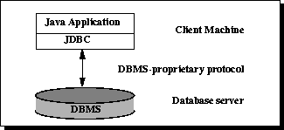

In the two-tier model, a Java application talks directly to the data source. This requires a JDBC driver that can communicate with the particular data source being accessed. A user's commands are delivered to the database or other data source, and the results of those statements are sent back to the user. The data source may be located on another machine to which the user is connected via a network. This is referred to as a client/server configuration, with the user's machine as the client, and the machine housing the data source as the server. The network can be an intranet, which, for example, connects employees within a corporation, or it can be the Internet.

3-layers Architecture
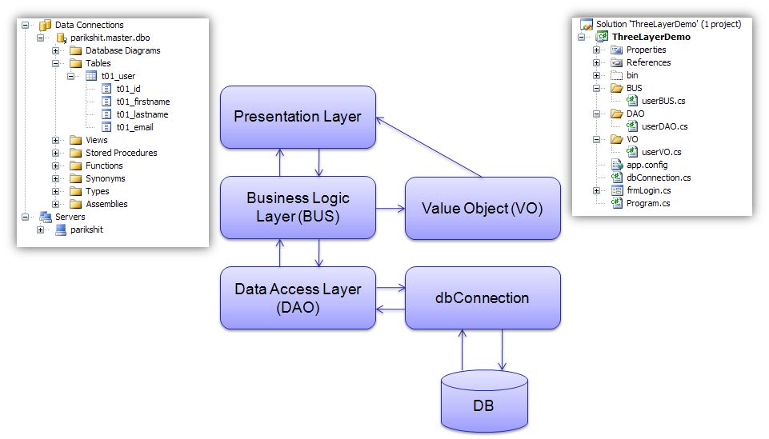
3 main layers are: Presentation, Business and Data. For example in figure:
dbConnection
This class is mainly used to do the database activity like Select, Update and Delete query to database. It also checks if the database connection is open or not. If database connection is not open, then it opens the connection and performs the database query. The database results are to be received and being passing in Data Table in this class.
This class takes the database setting from the app.config file so it’s really flexible to manage the database settings.
Database Access Layer
Database Access Layer (DAO) builds the query based on received parameters from the Business Logic Layer and passes it the dbConnection class for execution. And simple return results from the dbConnection class to Business Logic Layer.
Business Logic Layer
Business Logic Layer (BUS) works as a bridge between Presentation Layer and DAO. All the user values received from the presentation layer are being passed to BUS. The results received from the DAO are in row data in Data Table format but in BUS it’s converting into Value Objects (VO). Business Logic Layer (BUS) is the most important class in the whole architecture because it mainly contains all the business logic of the program. Whenever a user wants to update the business logic of the program only need to update this class.
Presentation Layer
Presentation Layer is the only layer which is directly connected with the user. So in this matter, it’s also a really important layer for marketing purposes. Presentation Layer is mainly used for getting user data and then passing it to Business Logic Layer for further procedure, and when data is received in Value Object then it’s responsible to represent value object in the appropriate form which user can understand.

Class Diagram
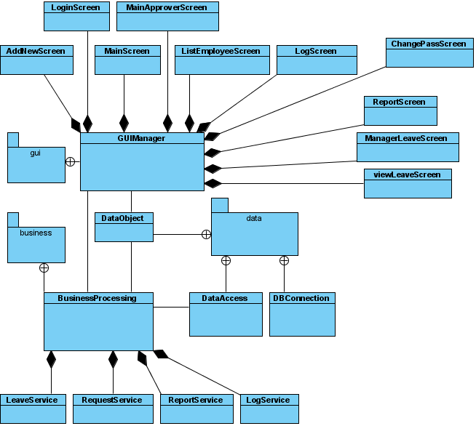

Class Diagram Explanation
- 3 main Layers are:
+ GUIManager (Presentation)
+ BusinessProcessing (Business logic)
+ DataAccess (Data access)
- The GUIManager will manage 4 frame using to provide to user with 4 feature: mange leave, manage request, view log and view report.
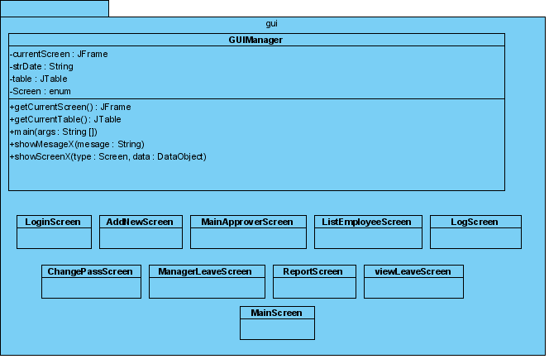
- Data display in presentation layer is DataObject, get from BusinessProcessing by 4 servicesmatched with 4 features. BusinessProcessing and GUIManager can talk directly with each other for more operations.
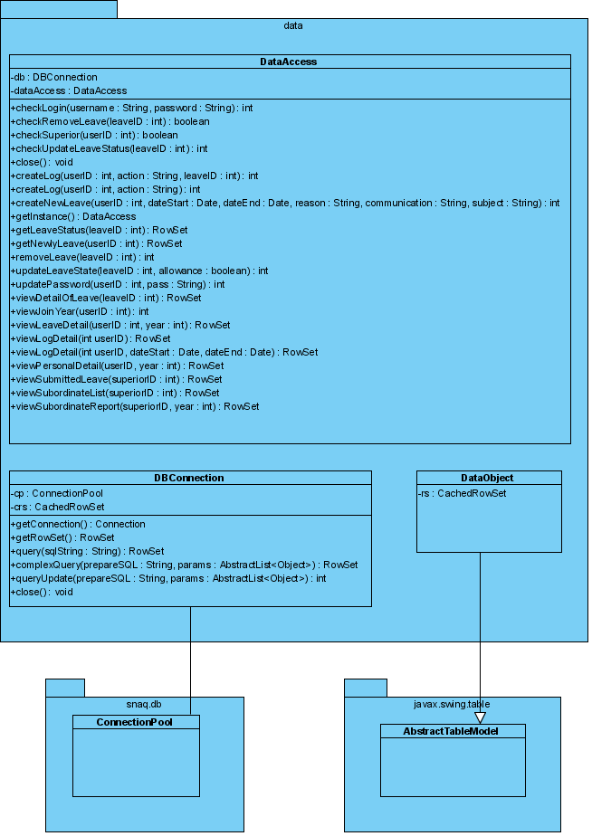
- And about operations related to database, they are executed by DataAccess class. It recieves orders from BusinessProcessing class and retrieve/modify database. DBConnection is a bridge between DataAccess and specific database server.
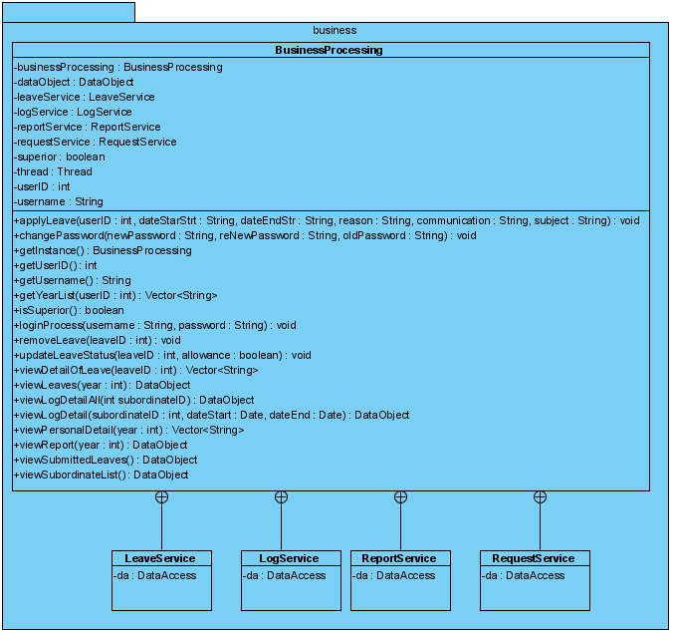

Data Flow Diagram
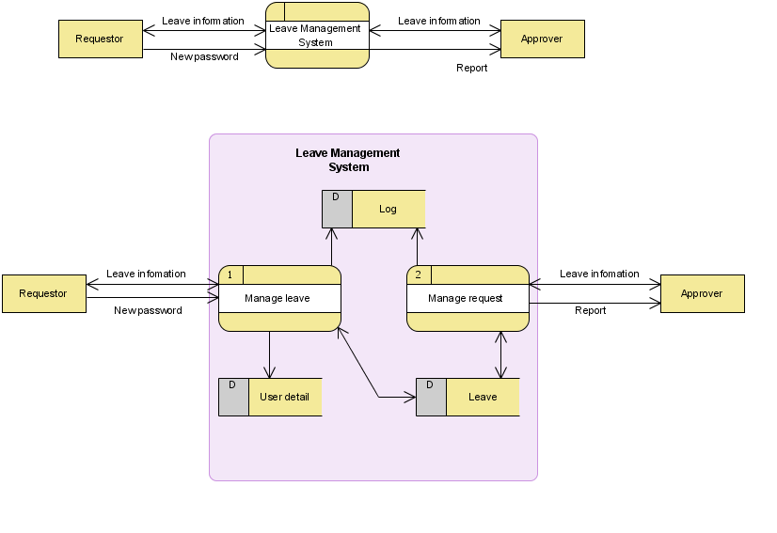

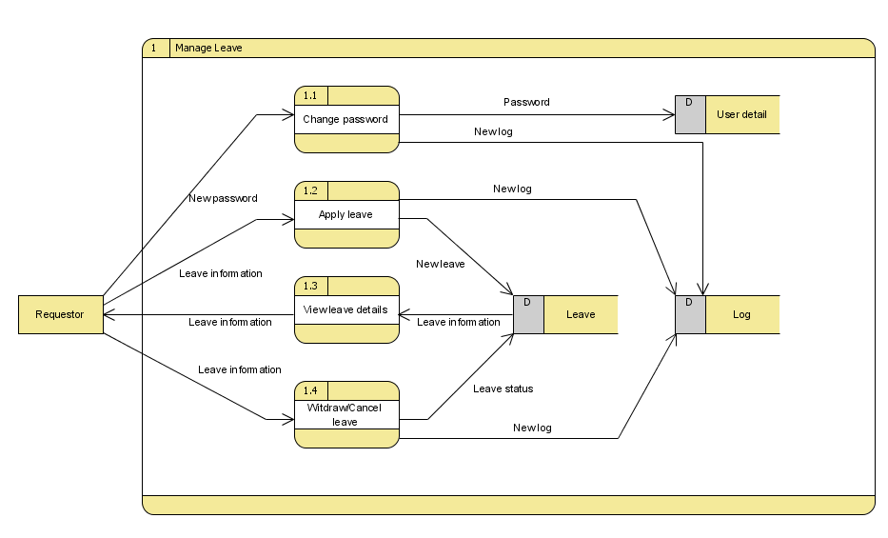

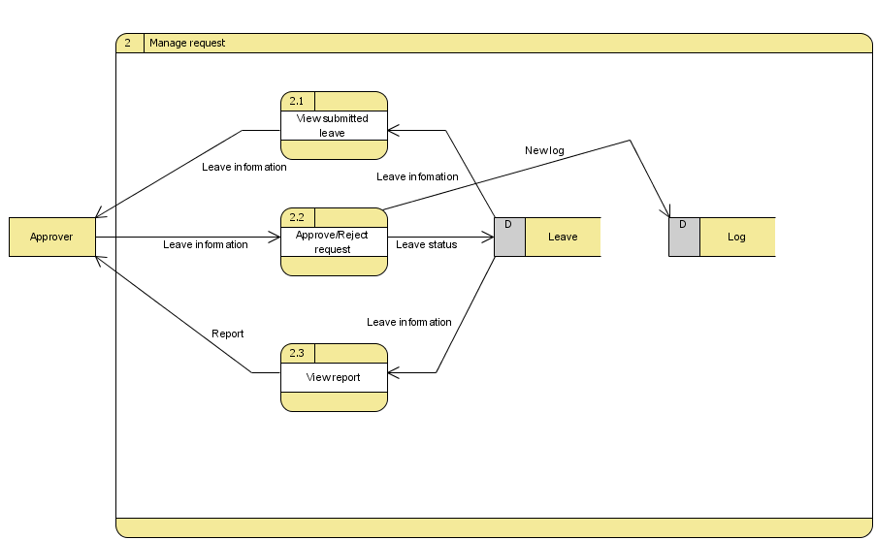

Entity Relationship Diagram

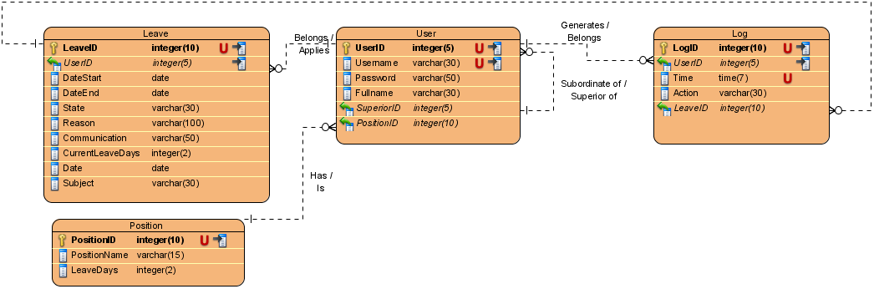

Database Design
Database: LeaveManagementSystem
Tables Summary: Leave, User, Log, Position
Table Details:

Leave
Name | DataType | Constraints | Null | Comment
LeaveID | integer(10) | PKUnique | No | Auto increment
UserID | integer(5) | FK (User.UserID) | No | Leave’s owner
DateStart | date |  | No
DateEnd | date |  | No
State | integer(2) |  | No | State of leave
Subject | varchar(30) |  | No
Reason | varchar(100) |  | No
Communication | varchar(50) |  | No | How to contact
CurrentLe-aveDays | integer(2) |  | No | Leave policy may change in future so this field is used to review leave in past
Date | date |  | No | Day when applying leave

User
Name | DataType | Constraints | Null | Comment
UserID | integer(5) | PKUnique | No | Auto increment
Username | varchar(30) | Unique | No
Password | varchar(50) |  | No
Fullname | varchar(30) |  | No
SuperiorID | integer(5) | FK (User.UserID) | No
PositionID | integer(10) | FK (Position.PositionID) | No

Log
Name | DataType | Constraints | Null | Comment
LogID | integer(10) | PKUnique | No | Auto increment
UserID | integer(5) | FK (User.UserID) | No
Time | time(7) | Unique | No
Action | varchar(30) |  | No
LeaveID | integer(10) | FK (Leave.LeaveID) | Yes | For leave-related action

Position
Name | DataType | Constraints | Null | Comment
PositionID | integer(10) | PKUnique | No
PositionName | varchar(15) |  | No
LeaveDays | integer(2) |  | No

System Prototype
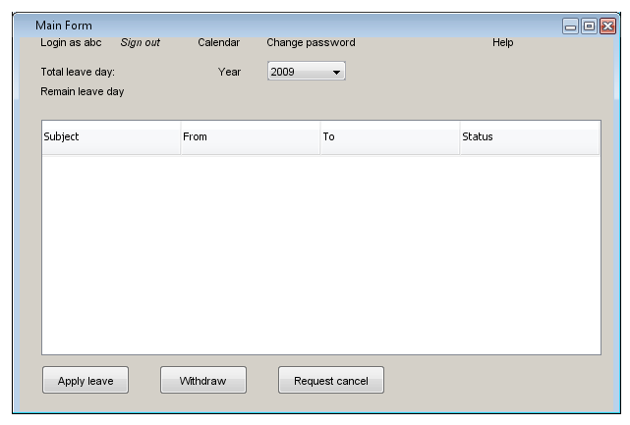

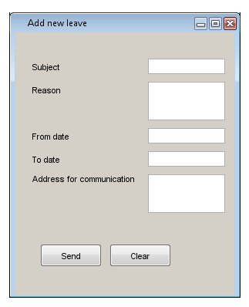

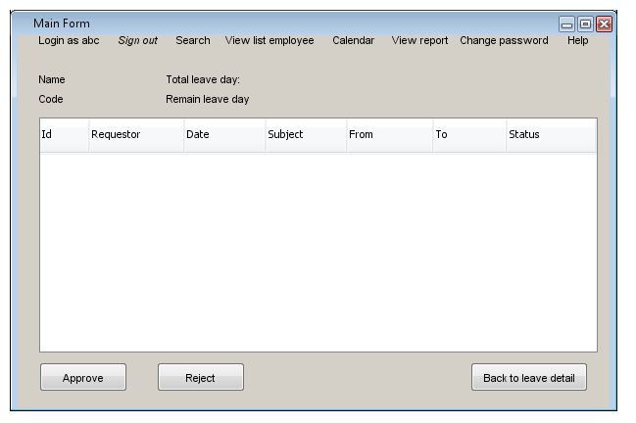
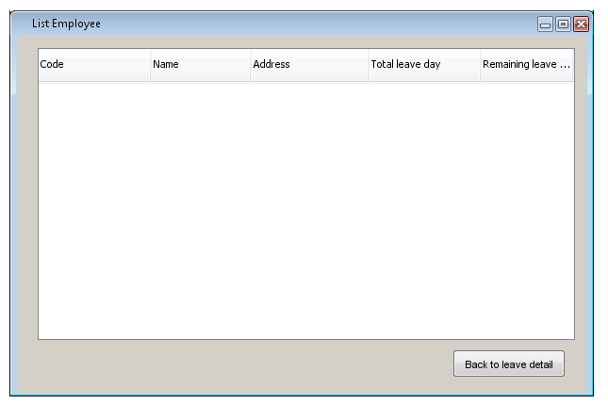

Management and Project Planning

Management Approach
Our team (Group 1) has 3 members and is self-managed. Before assign tasks to each member, we have a face to face meeting to discuss and analyze fact professional jobs that one leave manager requires and does. The requirements that we get basically are from the fact in our companies and from our experiences. Then, after analysis, we sum up the information and make “to do list” for the project which mention the step that we have to do clearly such as: contact to Indian side, write report, make diagram, construct database base on analysis above, coding … And, depend on each member ability, we assign the tasks to each member under the agreement of whole team. From the beginning to project submission time, we have 3 meetings. In the first meeting, we analyze the project requirements base on fact experiences to make the first report. In the second meeting, after the first report submission, we discuss about the project requirements once more time to perfect the ideal and outline the “to do list”, draft database, diagrams and GUI. In the third meeting, before the last report submission, we sum up all tasks that we did to make the final report.

Project Plan
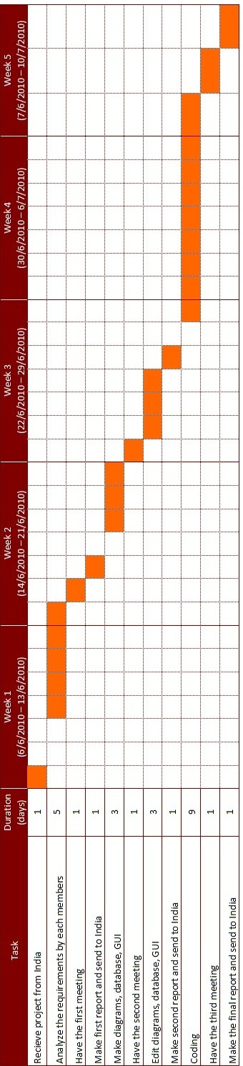

Task Sheet
Task | Person in charge | Beginning day | Status
Make activity diagram and report | HungLQ | 14/6/2010 | Finished
Make Use case diagram and GUI | HungMN | 14/6/2010 | Finished
Make class diagram, entity relation diagram and database design | PhuongND, HungMN | 14/6/2010 | Finished
Make GUI package | HungNM | 29/6/2010 | Finished
Make data package and business package | PhuongND | 29/6/2010 | Finished
Make database | HungLQ | 24/6/2010 | Finished
Complete report | HungLQ | 10/7/2010 | Finished

Checklists
- For requester:
- Sign in
- Change password
- Apply a leave
- Send request to cancel a leave
- Withdraw a accepted leave
- View calendar
- View status of leave
- For approver:
Beside the function like requester, approver also has the function below:
- Accept a leave request
- Reject a leave request
- Accept a cancel request
- Reject a cancel request
- View list of employee
- View employee log
- View report

Screenshots
Form Login:
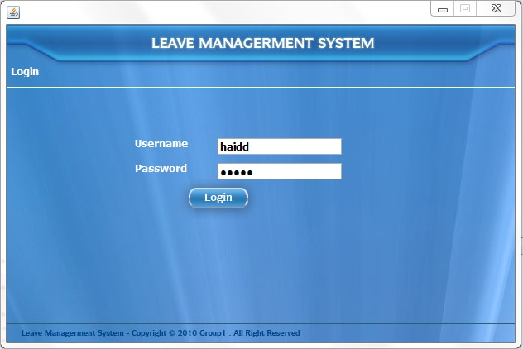

Form Main for superior:
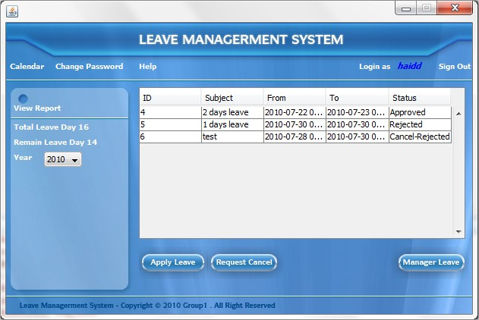

Form Main for sub-ordinate:
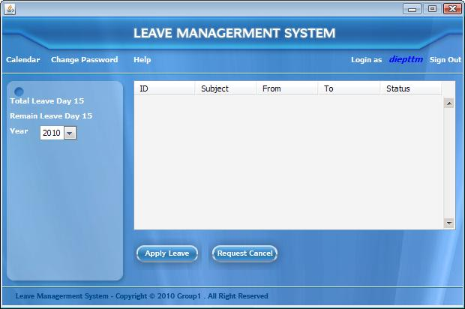

Form Change Password:
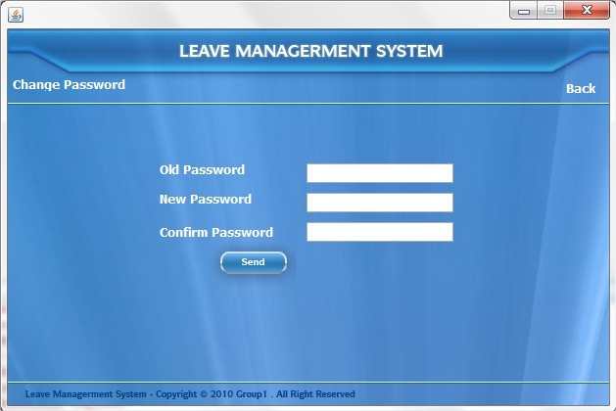

Form Calendar:
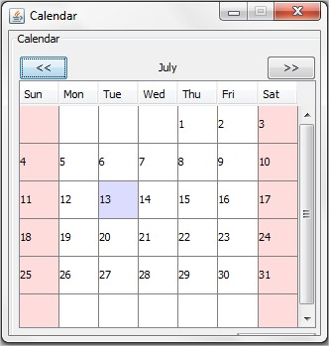

Form Apply a new leave:
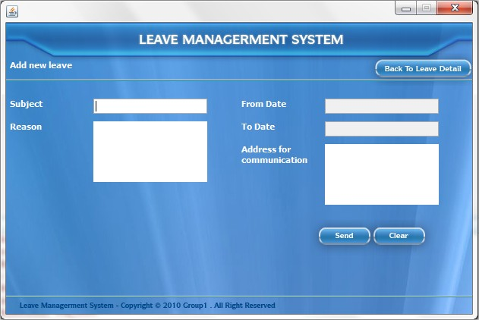

Form Manage leave for superior:
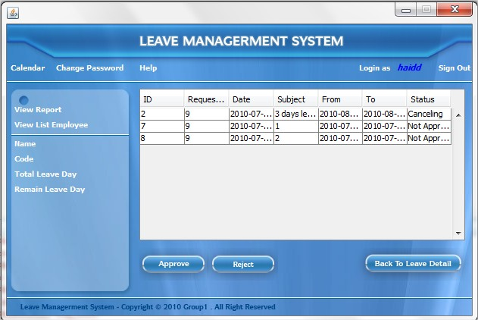

Form View Report for superior:
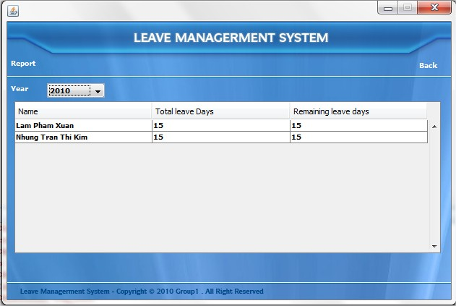

Form View list of sub-ordinate of a superior:
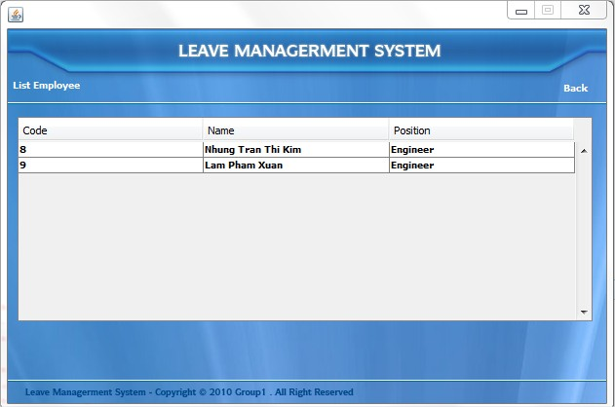

Form View log of sub- ordinate of a superior:
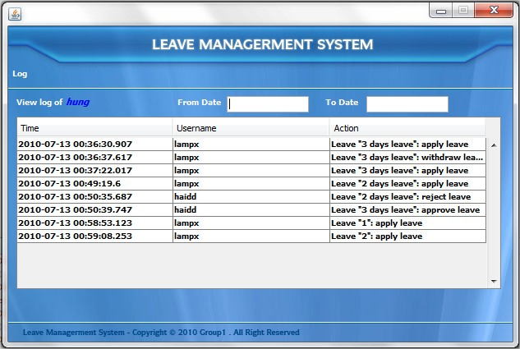

Coding Convention
Java Standard

