WEEK 1 INTERNSHIP REPORT
Data Cleaning and Preliminary Analysis with R
Virtual R Data Analyst Internship
Dataset: IBM Telco Customer Churn

1. Introduction
This report presents the Week 1 work completed for the Virtual R Data Analyst Internship. The objective was to practice data cleaning, preprocessing, exploratory analysis, descriptive statistics, outlier detection, normalization, categorical-variable handling, visualization, and interpretation using R. The IBM Telco Customer Churn dataset was selected because it contains customer demographic, service, contract, billing, and churn information with both numerical and categorical variables. The dataset contains 7,043 customer records and 21 columns. It is publicly available through IBM's GitHub repository.

2. Dataset Overview
Each row represents a telecom customer. Important variables include tenure, monthly charges, total charges, contract type, internet service, payment method, and the target variable Churn. The data contains a useful mixture of numerical and categorical variables, making it appropriate for data-cleaning and preliminary-analysis practice.
Item | Value | Description
Rows | 7,043 | Customer records before cleaning
Columns | 21 | Customer attributes
Missing values | 11 | Blank TotalCharges values
Duplicate customer IDs | 0 | No duplicate IDs detected
Rows after cleaning | 7,032 | Rows retained after removing missing TotalCharges
Dataset source: IBM public GitHub repository. https://github.com/IBM/telco-customer-churn-on-icp4d

3. Data Cleaning and Preprocessing
The dataset was inspected for structure, data types, duplicate customer IDs, and missing values. The TotalCharges field was initially stored as text because blank cells were present. Blank strings were converted to missing values (NA), and the column was then converted to numeric format.
Exactly 11 records had missing TotalCharges values. Because these records represent a very small portion of the dataset, they were removed for the preliminary analysis, leaving 7,032 complete records.
Categorical variables were converted to factors in R. SeniorCitizen was also treated as a categorical variable with No/Yes labels. Churn was additionally converted into a binary 0/1 variable for analytical use.

4. Duplicate Check
CustomerID was checked for duplicate records. The number of unique customer IDs equals the number of rows, so no duplicate customer IDs were found.

5. Outlier Detection
The Interquartile Range (IQR) method was used for tenure, MonthlyCharges, and TotalCharges. For each variable, observations below Q1 − 1.5×IQR or above Q3 + 1.5×IQR were considered potential outliers.
Variable | Q1 | Q3 | IQR Outliers
tenure | 9.00 | 55.00 | 0
MonthlyCharges | 35.59 | 89.86 | 0
TotalCharges | 401.45 | 3794.74 | 0
No IQR-based outliers were detected in these three numerical variables. Therefore, no numerical observations were removed because of outlier detection.

6. Normalization and Encoding
Min-max normalization was applied conceptually to tenure, MonthlyCharges, and TotalCharges using the formula (x − min(x)) / (max(x) − min(x)), producing values between 0 and 1. This transformation is useful when numerical variables are later used together in algorithms that are sensitive to scale. Categorical variables were converted to factors, and Churn was binary encoded as No = 0 and Yes = 1.

7. Descriptive Statistics
Variable | Mean | Std. Dev. | Min | Median | Max
tenure | 32.42 | 24.55 | 1.00 | 29.00 | 72.00
MonthlyCharges | 64.80 | 30.09 | 18.25 | 70.35 | 118.75
TotalCharges | 2283.30 | 2266.77 | 18.80 | 1397.47 | 8684.80

8. Exploratory Analysis and Initial Insights
After cleaning, 1,869 customers had churned and 5,163 had not churned. The overall churn rate was 26.58%.
Contract type showed a strong difference in churn behaviour. The churn rate within the month-to-month group was 42.71%, compared with 11.28% for one-year contracts and 2.85% for two-year contracts. This indicates that longer contracts are associated with substantially lower churn in this dataset.
Customers who churned had a higher average MonthlyCharges (74.44) than customers who did not churn (61.31). The median monthly charge was also higher among churned customers (79.65 versus 64.45).
Tenure showed an opposite pattern. Churned customers had an average tenure of 17.98 months, while non-churned customers averaged 37.65 months. The median tenure was 10 months for churned customers and 38 months for non-churned customers. This suggests that newer customers are more likely to leave.

9. Correlation Analysis
 | Tenure | MonthlyCharges | TotalCharges
tenure | 1.000 | 0.247 | 0.826
MonthlyCharges | 0.247 | 1.000 | 0.651
TotalCharges | 0.826 | 0.651 | 1.000
The strongest relationship among the numerical variables was between tenure and TotalCharges (r = 0.826), which is expected because total charges accumulate over the customer's time with the company. MonthlyCharges and TotalCharges also showed a positive relationship (r = 0.651).

10. Visualizations
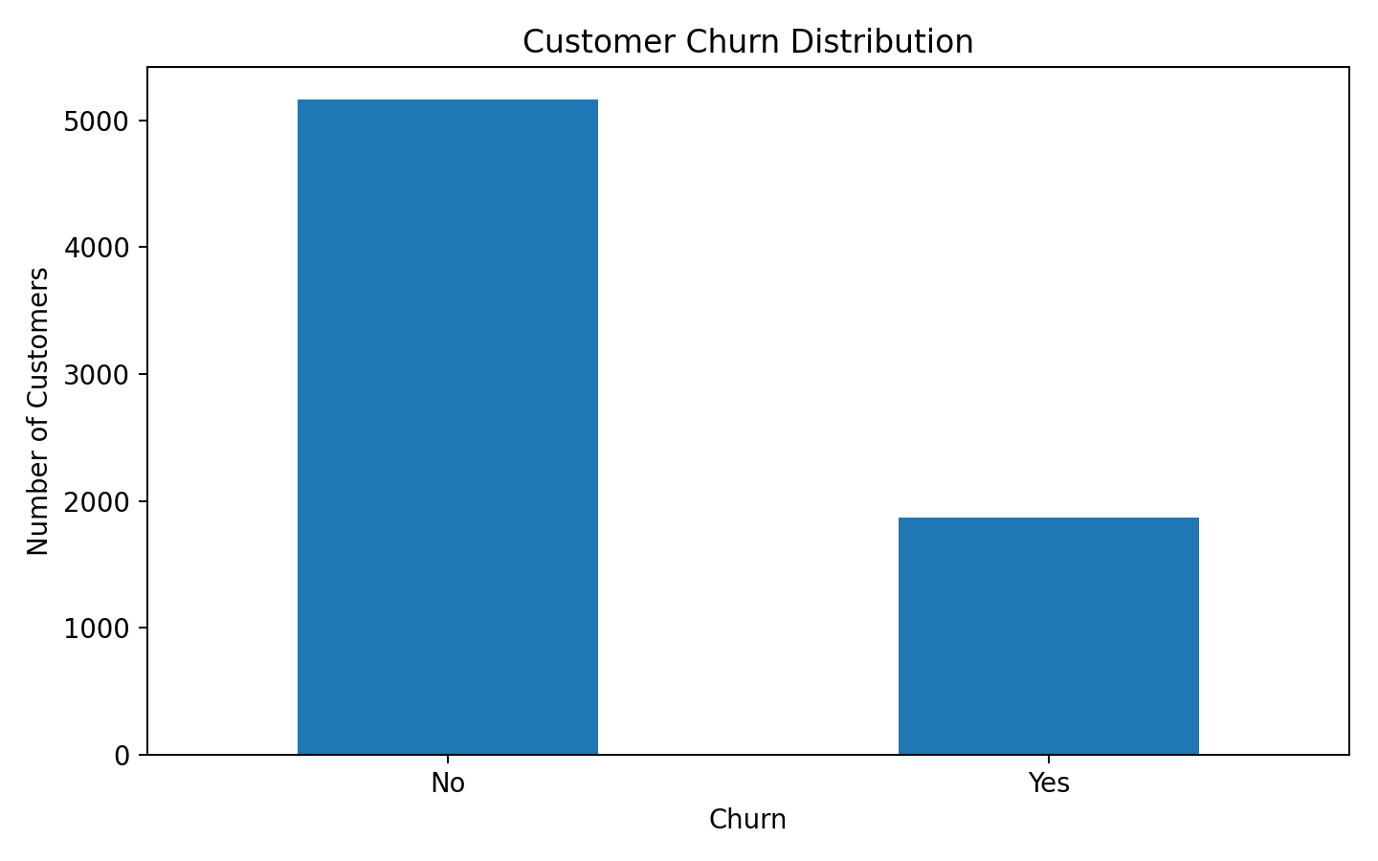
Figure 1. Distribution of customers by churn status.
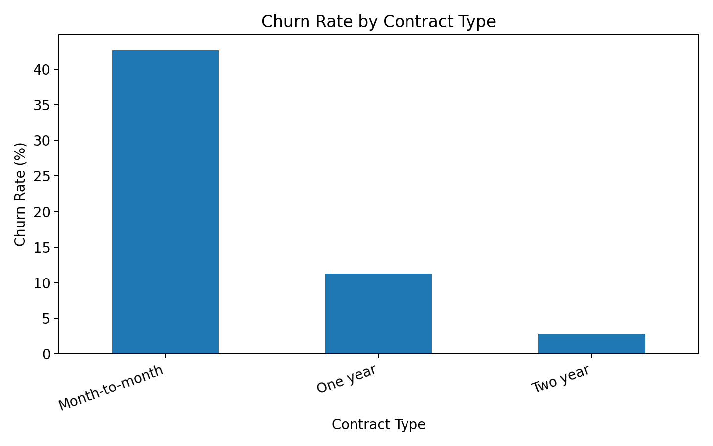
Figure 2. Churn rate within each contract type.
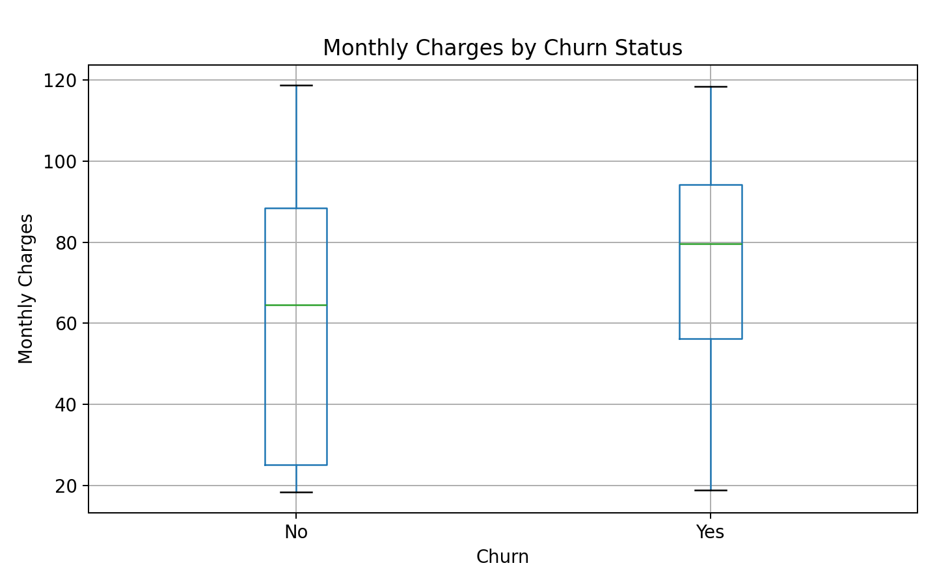
Figure 3. Monthly charges by churn status.
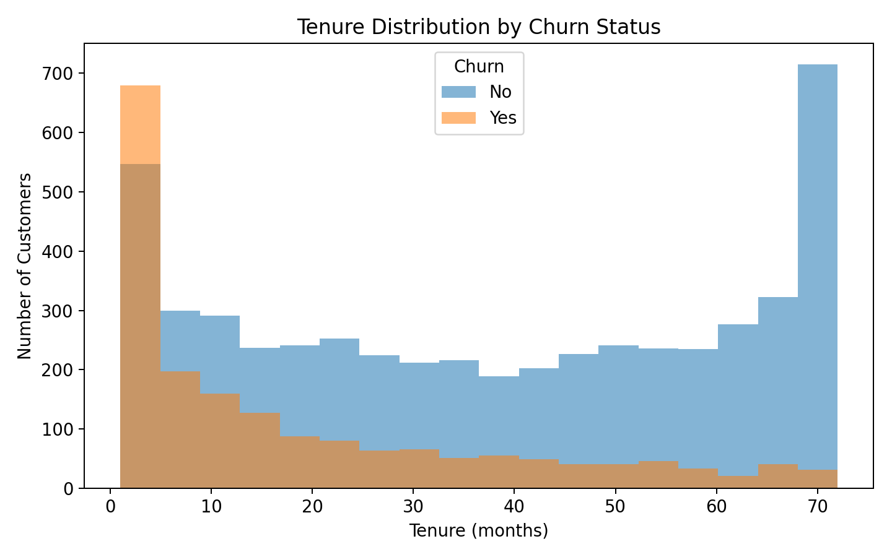
Figure 4. Tenure distribution by churn status.

11. R Code Used
# Week 1 - Data Cleaning and Preliminary Analysis with R
# Dataset: IBM Telco Customer Churn
# Source: https://raw.githubusercontent.com/IBM/telco-customer-churn-on-icp4d/master/data/Telco-Customer-Churn.csv
# 1. Load packages
library(dplyr)
library(ggplot2)
# 2. Load dataset
url <- "https://raw.githubusercontent.com/IBM/telco-customer-churn-on-icp4d/master/data/Telco-Customer-Churn.csv"
df <- read.csv(url, stringsAsFactors = FALSE)
# 3. Initial inspection
dim(df)
str(df)
summary(df)
# 4. Check duplicates
sum(duplicated(df$customerID))
# 5. Handle blank values in TotalCharges and convert to numeric
df$TotalCharges <- trimws(df$TotalCharges)
df$TotalCharges[df$TotalCharges == ""] <- NA
df$TotalCharges <- as.numeric(df$TotalCharges)
# Check missing values
colSums(is.na(df))
# 6. Remove rows with missing TotalCharges
df_clean <- df %>% filter(!is.na(TotalCharges))
# 7. Convert categorical variables to factors
factor_cols <- c("gender","Partner","Dependents","PhoneService",
"MultipleLines","InternetService","OnlineSecurity",
"OnlineBackup","DeviceProtection","TechSupport",
"StreamingTV","StreamingMovies","Contract",
"PaperlessBilling","PaymentMethod","Churn")
df_clean[factor_cols] <- lapply(df_clean[factor_cols], factor)
# Treat SeniorCitizen as categorical
df_clean$SeniorCitizen <- factor(df_clean$SeniorCitizen,
levels = c(0,1),
labels = c("No","Yes"))
# 8. Outlier detection using IQR
outlier_iqr <- function(x) {
q1 <- quantile(x, 0.25, na.rm=TRUE)
q3 <- quantile(x, 0.75, na.rm=TRUE)
iqr <- q3-q1
lower <- q1 - 1.5*iqr
upper <- q3 + 1.5*iqr
sum(x < lower | x > upper, na.rm=TRUE)
}
outlier_iqr(df_clean$tenure)
outlier_iqr(df_clean$MonthlyCharges)
outlier_iqr(df_clean$TotalCharges)
# 9. Min-max normalization for numerical variables
minmax <- function(x) (x-min(x, na.rm=TRUE))/(max(x, na.rm=TRUE)-min(x, na.rm=TRUE))
df_clean$tenure_norm <- minmax(df_clean$tenure)
df_clean$MonthlyCharges_norm <- minmax(df_clean$MonthlyCharges)
df_clean$TotalCharges_norm <- minmax(df_clean$TotalCharges)
# 10. Binary encoding example
df_clean$Churn_binary <- ifelse(df_clean$Churn == "Yes", 1, 0)
# 11. Summary statistics
summary(df_clean[, c("tenure","MonthlyCharges","TotalCharges")])
# 12. Churn distribution
table(df_clean$Churn)
prop.table(table(df_clean$Churn))*100
# 13. Churn by contract
contract_churn <- prop.table(table(df_clean$Contract, df_clean$Churn), margin=1)*100
round(contract_churn, 2)
# 14. Grouped statistics
df_clean %>%
group_by(Churn) %>%
summarise(
mean_tenure = mean(tenure),
median_tenure = median(tenure),
mean_monthly = mean(MonthlyCharges),
median_monthly = median(MonthlyCharges)
)
# 15. Correlation
cor(df_clean[, c("tenure","MonthlyCharges","TotalCharges")])
# 16. Visualizations
ggplot(df_clean, aes(x=Churn)) +
geom_bar() +
labs(title="Customer Churn Distribution", x="Churn", y="Number of Customers")
ggplot(df_clean, aes(x=Contract, fill=Churn)) +
geom_bar(position="fill") +
scale_y_continuous(labels=scales::percent) +
labs(title="Churn Rate by Contract Type", y="Percentage")
ggplot(df_clean, aes(x=Churn, y=MonthlyCharges)) +
geom_boxplot() +
labs(title="Monthly Charges by Churn Status")
ggplot(df_clean, aes(x=tenure, fill=Churn)) +
geom_histogram(bins=18, alpha=0.55, position="identity") +
labs(title="Tenure Distribution by Churn Status")

12. Conclusion
The Week 1 analysis successfully completed the required data-cleaning and preliminary-analysis workflow. The dataset was inspected, missing TotalCharges values were handled, duplicate IDs were checked, numerical variables were assessed for outliers, categorical variables were converted to appropriate types, numerical normalization was demonstrated, and descriptive and correlation analyses were performed. Visualizations helped identify clear preliminary patterns: month-to-month contracts have substantially higher churn, churned customers tend to have higher monthly charges, and churn is concentrated among customers with shorter tenure. These findings can guide further analysis in later stages, although they should not be interpreted as causal conclusions.

13. References
IBM Telco Customer Churn dataset: https://github.com/IBM/telco-customer-churn-on-icp4d
Raw CSV: https://raw.githubusercontent.com/IBM/telco-customer-churn-on-icp4d/master/data/Telco-Customer-Churn.csv

