WEEK 2 INTERNSHIP REPORT
Data Visualization and Insight Communication using R
Virtual R Data Analyst Internship
Dataset: IBM Telco Customer Churn

1. Objective
This project focuses on communicating data-driven insights through clear and informative visualizations using R and ggplot2. The cleaned IBM Telco Customer Churn dataset from Week 1 is continued. Multiple chart types were selected to communicate distributions, comparisons, relationships, trends, and differences in variability to both technical and non-technical audiences.

2. Data Overview
The dataset contains customer demographic, service, contract, billing, tenure, and churn information. After converting TotalCharges to numeric and removing 11 records with missing TotalCharges, 7,032 customer records were used. Key variables include Churn, tenure, TotalCharges, MonthlyCharges, and Contract.

3. Visualization Design
Six complementary visualizations were created: bar chart, histogram, scatter plot, contract-level bar chart, line chart, and box plot. Each chart answers a different analytical question and uses readable titles and axis labels.

4. Visualization 1 — Customer Churn Distribution
A bar chart compares customers who churned with customers who stayed. It provides the basic context for all later churn analysis.
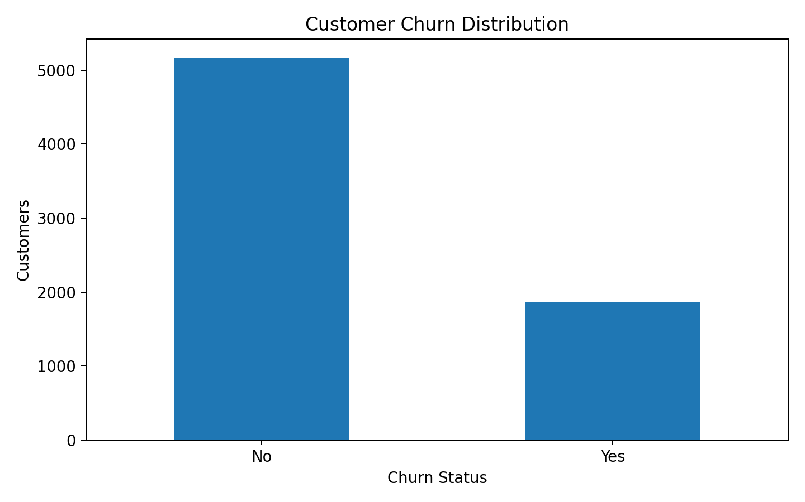
Figure 1: Customer Churn Distribution

5. Visualization 2 — Distribution of Customer Tenure
A histogram shows how customer tenure is distributed and whether the portfolio is concentrated among newer or longer-tenured customers.
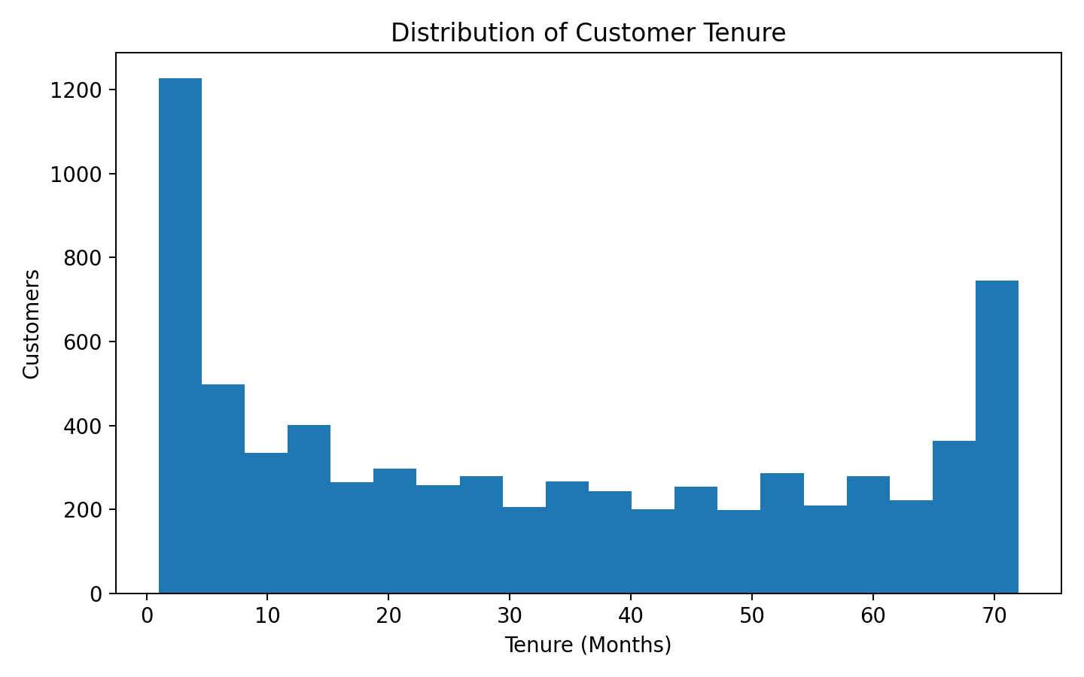
Figure 2: Distribution of Customer Tenure

6. Visualization 3 — Tenure vs Total Charges
A scatter plot examines the relationship between tenure and total charges. The overall pattern is strongly positive because customers with longer tenure generally accumulate higher total charges.
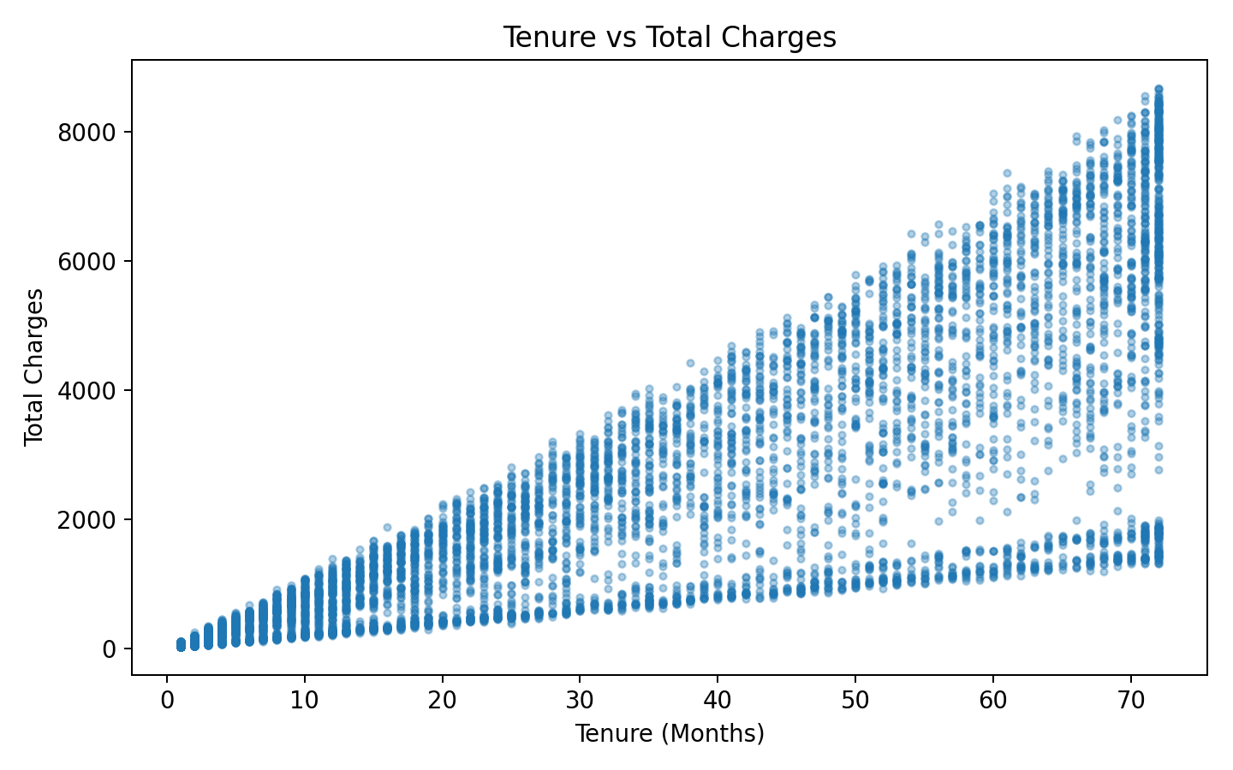
Figure 3: Tenure vs Total Charges

7. Visualization 4 — Churn Rate by Contract Type
A bar chart compares churn rates across contract categories. Month-to-month customers show substantially higher churn than one-year and two-year customers.
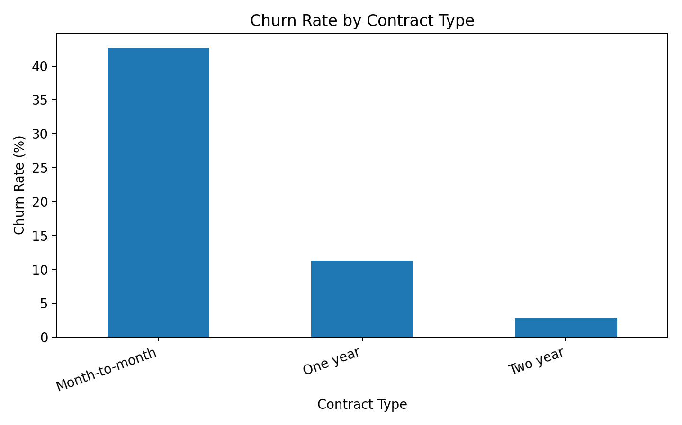
Figure 4: Churn Rate by Contract Type

8. Visualization 5 — Average Monthly Charges by Tenure
A line chart shows how average monthly charges vary across tenure. The ordered x-axis makes changes across the customer lifecycle easy to follow.
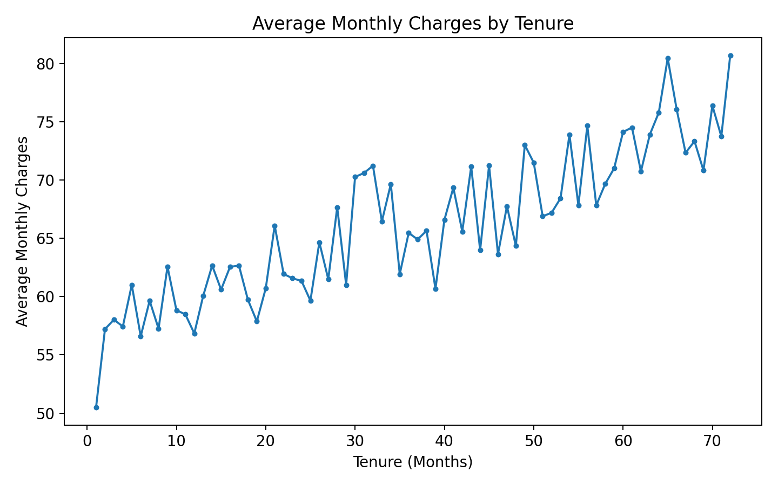
Figure 5: Average Monthly Charges by Tenure

9. Visualization 6 — Monthly Charges by Churn Status
A box plot compares the distribution of monthly charges for churned and non-churned customers, showing differences in median and spread.
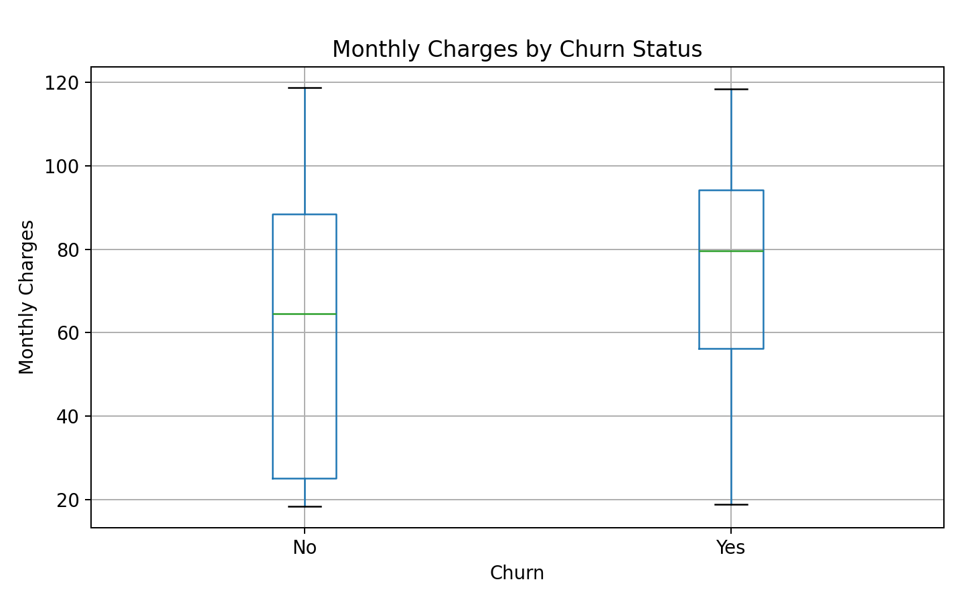
Figure 6: Monthly Charges by Churn Status

10. Key Insights for a Non-Technical Audience
The visual analysis highlights three practical patterns. First, churn is much higher among month-to-month customers than customers with longer contracts. Second, churned customers generally have higher monthly charges, suggesting that pricing or perceived service value may deserve further investigation. Third, tenure and total charges rise together because longer relationships accumulate more billed months. These are associations in the dataset and should not be interpreted as proof of causation.

11. R Code
# Week 2 - Data Visualization and Insight Communication using R
library(dplyr)
library(ggplot2)
url <- "https://raw.githubusercontent.com/IBM/telco-customer-churn-on-icp4d/master/data/Telco-Customer-Churn.csv"
df <- read.csv(url, stringsAsFactors=FALSE)
df$TotalCharges <- trimws(df$TotalCharges)
df$TotalCharges[df$TotalCharges==""] <- NA
df$TotalCharges <- as.numeric(df$TotalCharges)
df <- df %>% filter(!is.na(TotalCharges))
# 1. Bar chart
ggplot(df, aes(x=Churn)) + geom_bar() +
labs(title="Customer Churn Distribution", x="Churn Status", y="Number of Customers") +
theme_minimal()
# 2. Histogram
ggplot(df, aes(x=tenure)) + geom_histogram(bins=20) +
labs(title="Distribution of Customer Tenure", x="Tenure (Months)", y="Number of Customers") +
theme_minimal()
# 3. Scatter plot
ggplot(df, aes(x=tenure, y=TotalCharges)) +
geom_point(alpha=0.35) + geom_smooth(method="lm", se=FALSE) +
labs(title="Tenure vs Total Charges", x="Tenure (Months)", y="Total Charges") +
theme_minimal()
# 4. Churn rate by contract
contract_summary <- df %>% group_by(Contract) %>% summarise(ChurnRate=mean(Churn=="Yes")*100)
ggplot(contract_summary, aes(x=Contract, y=ChurnRate)) + geom_col() +
labs(title="Churn Rate by Contract Type", x="Contract Type", y="Churn Rate (%)") +
theme_minimal()
# 5. Line chart
monthly_summary <- df %>% group_by(tenure) %>% summarise(AvgMonthlyCharges=mean(MonthlyCharges))
ggplot(monthly_summary, aes(x=tenure, y=AvgMonthlyCharges)) +
geom_line() + geom_point() +
labs(title="Average Monthly Charges by Tenure", x="Tenure (Months)", y="Average Monthly Charges") +
theme_minimal()
# 6. Box plot
ggplot(df, aes(x=Churn, y=MonthlyCharges)) + geom_boxplot() +
labs(title="Monthly Charges by Churn Status", x="Churn", y="Monthly Charges") +
theme_minimal()

12. Conclusion
The Week 2 task demonstrates how R and ggplot2 can turn customer data into clear visual stories. The selected charts cover categorical comparisons, distributions, relationships, trends, and variation. Together they make churn patterns easier to communicate than tables alone, while embedded R code keeps the analysis reproducible.

13. Dataset Reference
IBM Telco Customer Churn dataset: https://github.com/IBM/telco-customer-churn-on-icp4d

