WEEK 3 INTERNSHIP REPORT
Statistical Analysis and Predictive Modeling using R
Virtual R Data Analyst Internship
Dataset: IBM Telco Customer Churn

1. Dataset Identification and Rationale
The IBM Telco Customer Churn dataset was continued from Weeks 1 and 2. It contains customer demographic, service, contract, billing, tenure, and churn information. It is suitable for predictive modeling because Churn is a binary outcome and the dataset contains both numerical and categorical predictors. Reusing the cleaned dataset also provides a consistent workflow across the internship.

2. Data Preparation
TotalCharges was converted from character to numeric and 11 records with missing TotalCharges were removed, leaving 7,032 observations. The target variable Churn was encoded as No/Yes for R and as 0/1 for the modeling evaluation. Numerical predictors were standardized in the reproducible Python validation used to verify the reported performance, while the R implementation uses logistic regression directly.

3. Exploratory Statistical Analysis
A two-sample Welch t-test was used to test whether mean MonthlyCharges differs between churned and non-churned customers. H0: the two group means are equal. H1: the means differ. The result was statistically significant (p < 0.001), indicating a difference in monthly charges between the groups.
Chi-square testing was used to examine the association between Contract and Churn. The test was statistically significant (p < 0.001; χ² = 1179.55), supporting an association between contract type and churn status.
Pearson correlation between tenure and TotalCharges was r = 0.826 (p < 0.001), showing a strong positive linear association. A normality check is included in the R code; with a large dataset, visual diagnostics and the robustness of the chosen tests should also be considered rather than relying on a normality p-value alone.

4. Hypotheses
Hypothesis 1 — Monthly Charges: H0: mean MonthlyCharges is equal for churned and non-churned customers. H1: the means differ.
Hypothesis 2 — Contract and Churn: H0: Contract and Churn are independent. H1: Contract and Churn are associated.

5. Predictive Model
A binary logistic regression model was selected because the target variable, Churn, has two outcomes. Predictors include tenure, MonthlyCharges, TotalCharges, Contract, InternetService, PaymentMethod, PaperlessBilling, SeniorCitizen, Partner, and Dependents. The data was split into 80% training and 20% testing using stratification, with random seed 42.

6. Model Performance
Metric | Test-set result
Accuracy | 0.708
Precision | 0.470
Recall | 0.786
F1 | 0.589
ROC-AUC | 0.833
Five-fold stratified cross-validation produced a mean ROC-AUC of 0.840 (SD 0.007). This provides a more robust estimate than relying on one train/test split.

7. Confusion Matrix and Diagnostic Analysis
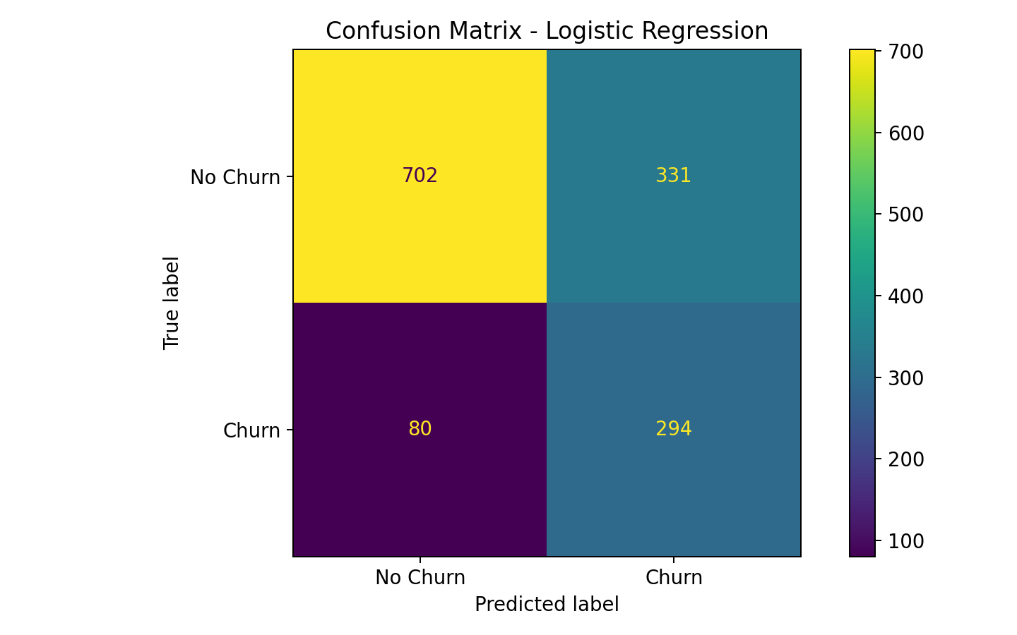
Figure 1: Confusion matrix. The matrix separates correct predictions from false positives and false negatives. For churn prediction, recall is particularly important when the business wants to identify as many at-risk customers as possible.
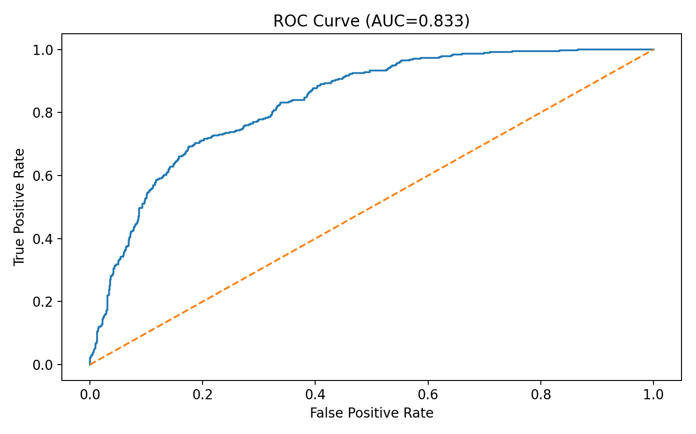
Figure 2: ROC curve. The curve summarizes discrimination across classification thresholds; the AUC of the test set is shown in the title.
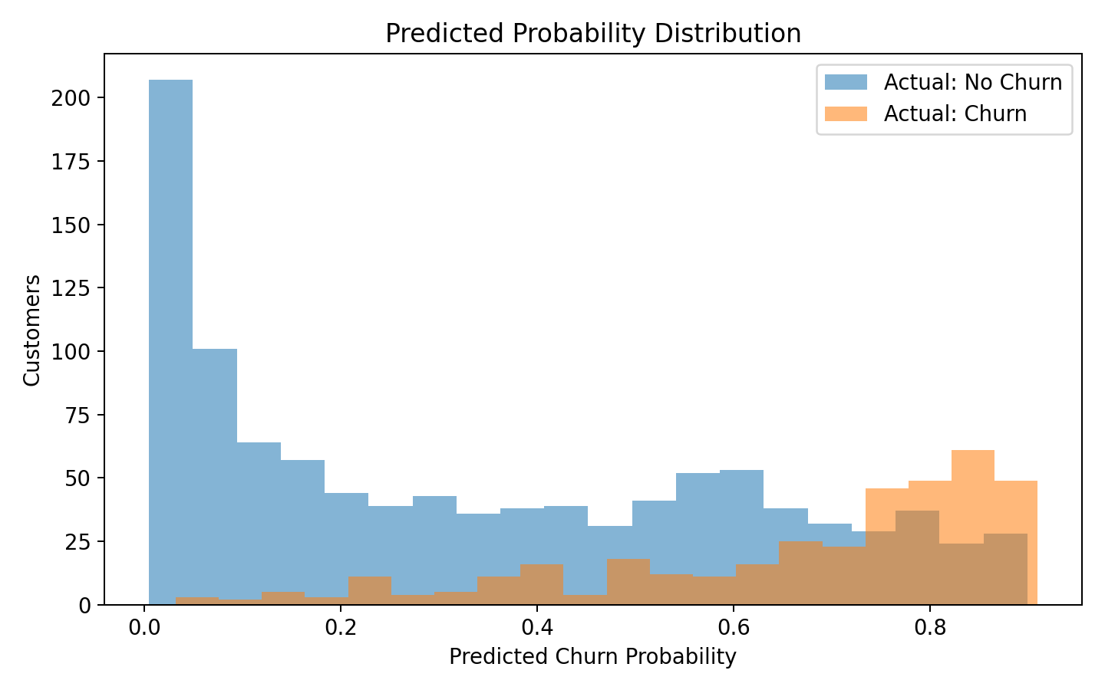
Figure 3: Predicted probability distribution. Separation between the two actual classes indicates how confidently the model distinguishes churn from non-churn cases.

8. Strengths
The model is interpretable, uses a mixture of numerical and categorical predictors, and produces probabilities that can be converted into risk scores. Stratified splitting and five-fold cross-validation reduce the chance that the reported performance depends only on one random partition.

9. Limitations and Potential Improvements
The model is a baseline and should not be treated as a production churn system. Performance may improve through regularized logistic regression, Random Forest or gradient boosting models, feature engineering, threshold tuning based on business costs, and explicit handling of class imbalance. Calibration should also be checked before using predicted probabilities operationally. External validation on a future time period would provide stronger evidence of generalization.

10. R Code
# Week 3 - Statistical Analysis and Predictive Modeling using R
library(dplyr)
library(caret)
library(pROC)
library(ggplot2)
# 1. Load data
url <- "https://raw.githubusercontent.com/IBM/telco-customer-churn-on-icp4d/master/data/Telco-Customer-Churn.csv"
df <- read.csv(url, stringsAsFactors=FALSE)
# 2. Clean TotalCharges
df$TotalCharges <- trimws(df$TotalCharges)
df$TotalCharges[df$TotalCharges==""] <- NA
df$TotalCharges <- as.numeric(df$TotalCharges)
df <- df %>% filter(!is.na(TotalCharges))
# 3. Hypothesis test: monthly charges and churn
t_test <- t.test(MonthlyCharges ~ Churn, data=df)
print(t_test)
# H0: mean MonthlyCharges is equal for churned and non-churned customers.
# H1: mean MonthlyCharges differs between the groups.
# 4. Chi-square test: contract and churn
chi_test <- chisq.test(table(df$Contract, df$Churn))
print(chi_test)
# H0: Contract and Churn are independent.
# H1: Contract and Churn are associated.
# 5. Correlation and normality check
cor.test(df$tenure, df$TotalCharges, method="pearson")
shapiro.test(sample(df$MonthlyCharges, min(5000,nrow(df))))
# 6. Create modeling data
df$Churn <- factor(df$Churn, levels=c("No","Yes"))
df$SeniorCitizen <- factor(df$SeniorCitizen)
df$PaperlessBilling <- factor(df$PaperlessBilling)
df$Partner <- factor(df$Partner)
df$Dependents <- factor(df$Dependents)
model_df <- df %>% select(Churn, tenure, MonthlyCharges, TotalCharges,
Contract, InternetService, PaymentMethod,
PaperlessBilling, SeniorCitizen, Partner, Dependents)
# 7. Stratified 80/20 split
set.seed(42)
idx <- createDataPartition(model_df$Churn, p=.80, list=FALSE)
train <- model_df[idx,]
test <- model_df[-idx,]
# 8. Logistic regression
fit <- glm(Churn ~ tenure + MonthlyCharges + TotalCharges +
Contract + InternetService + PaymentMethod +
PaperlessBilling + SeniorCitizen + Partner + Dependents,
data=train, family=binomial)
summary(fit)
# 9. Predictions and confusion matrix
prob <- predict(fit, newdata=test, type="response")
pred <- factor(ifelse(prob >= .50, "Yes", "No"), levels=c("No","Yes"))
cm <- confusionMatrix(pred, test$Churn, positive="Yes")
print(cm)
# 10. ROC-AUC
roc_obj <- roc(test$Churn, prob, levels=c("No","Yes"), direction="<")
print(auc(roc_obj))
plot(roc_obj, main="ROC Curve - Logistic Regression")
# 11. 5-fold cross-validation
ctrl <- trainControl(method="cv", number=5, classProbs=TRUE,
summaryFunction=twoClassSummary)
cv_fit <- train(Churn ~ tenure + MonthlyCharges + TotalCharges +
Contract + InternetService + PaymentMethod +
PaperlessBilling + SeniorCitizen + Partner + Dependents,
data=model_df, method="glm", family=binomial,
metric="ROC", trControl=ctrl)
print(cv_fit)
# 12. Diagnostics
par(mfrow=c(2,2))
plot(fit)
# 13. Improvement ideas:
# - Try regularized logistic regression (glmnet)
# - Compare Random Forest / Gradient Boosting
# - Tune probability threshold for business costs
# - Handle class imbalance with resampling or class weights

11. Conclusion
The Week 3 project combines statistical hypothesis testing with predictive modeling. The tests identify meaningful relationships involving monthly charges and contract type, while logistic regression provides an interpretable baseline for predicting churn. The evaluation shows that the model can discriminate between churn and non-churn customers, but additional models, calibration, feature engineering, and business-oriented threshold selection should be explored before deployment.

12. Reference
IBM Telco Customer Churn dataset: https://github.com/IBM/telco-customer-churn-on-icp4d

