**Mayur Jagtap**

**Senior software engineer**

**Docker file**

**Docker File-Container 🡪 Build and Execution**

Topic will cover docker file build-execution and bridge between two or more docker containers and its communication.

* Create Ubuntu 16.04 machine.
* Login to instance as sudo user: **sudo su –**
* For Example, we create Flask Application and run on Ubuntu using docker file
* Create directory “**dockerdemo/flask-demo**” in **/opt**: **mkdir dockerdemo/flask-demo**



* First Create Docker file**: vi Dockerfile**

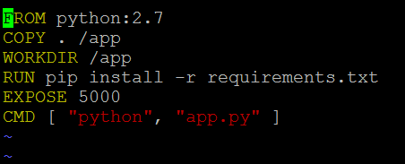

* Second create python app file: **vi app.py**

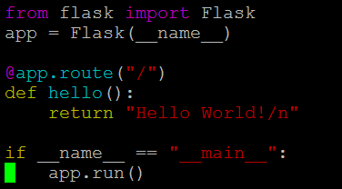

* Third Create Requirement Flask: **vi requirement.txt 🡪** which run necessary flask files



* Now build docker file: **docker build . -t pythondemo:V.1.0**

**Docker build . -t(tag name) pythondemo(NameOfApp):latest(Version)**



Docker image will get created with name “**pythondemo“**

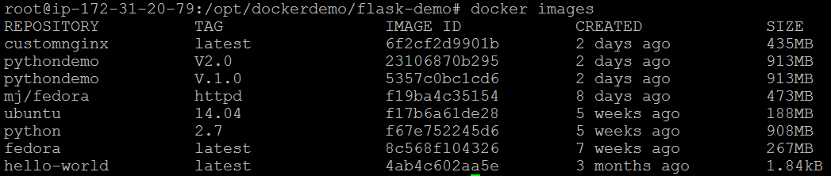

* Now RUN docker images: **docker run --name test-python -d ImageId**



* Now Execute Docker container: **docker exec -it container_id /bin/bash**





* Once we will execute docker container, to check application output:

**curl localhost:5000**

(RUN above command inside docker, we have mapped outside port as 5000)



* Docker Bridging 🡪

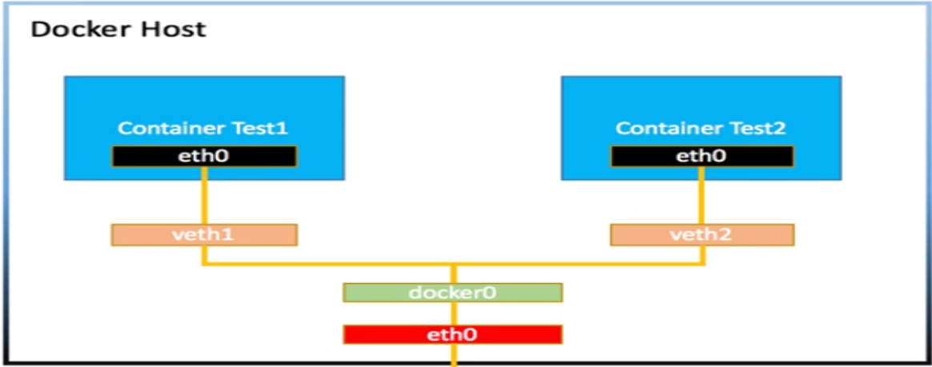

* Df
* Asdf
* S
* Df
* Asdf