**D. Y. Patil College of Engineering, Akurdi**

Department of Information Technology

Academic Year 2025-26

*A mini project on report on “Library Management System”*

*Submitted in partial fulfillment of the requirement*

*for Database Management System*

Submitted by:

Name: Mayur Gorakh Kadam (SY24INT036)

Yash Prashant Kamble (SY24INT022)

Chaitanya Kolhe (SY24INT037)

Guide by : Mrs. Abhilasha Kore

**CERTIFICATE**

*This is to certify that the project entitled “Library Management System” has been successfully completed by Mr. Mayur Kadam, Yash Kamble, Chaitanya Kolhe during the academic year 2025–26 in partial fulfillment of the requirements of the Database Management System mini project.*

*The work has been carried out under my guidance and supervision.*

(Signature of guide)

Date : ___________

**Acknowledgment**

We would like to express our sincere gratitude to our respected guide **Mrs. Abhilasha Kore** for providing continuous guidance and support. We also thank our Head of Department, Principal, and all faculty members for their valuable suggestions. Finally, we thank our family and friends for their encouragement.

The **Library Management System** is a database-driven application designed to manage library records digitally. Traditional manual systems face problems like mismanagement of books, delays in issuing and returning, and lack of accurate data.  
This project uses **DBMS concepts** to store, retrieve, and manage information about books, students, and transactions. Features include: maintaining book records, issuing/returning books, tracking due dates, and generating reports.  
It ensures efficiency, accuracy, and easy access, thereby enhancing the quality of education by providing systematic management of library resources.

**INDEX**

1. Introduction
2. Problem statement
3. Objectives of Project
4. Scope of Project
5. System Requirements
6. System Design
7. Implementation
8. Real Library Observation
9. Application and Advantages
10. Future Scope
11. SDG mapping
12. References

**Introduction**

In today’s era of digital transformation, every sector including education is shifting towards computerized systems to improve efficiency and accuracy. Libraries, which are considered as the **knowledge hub of any educational institution**, also require an efficient system to handle their day-to-day operations. Traditionally, libraries have been managed manually by maintaining registers or logbooks to keep track of books, students, and transactions. While this method works for small-scale setups, it becomes highly inefficient as the number of books and students increases.

A manual library system faces challenges such as:

* Difficulty in searching for a specific book in a large collection.
* Inaccurate or incomplete records due to human errors.
* Delay in issuing or returning books.
* Lack of quick reports on available or issued books.
* Time-consuming calculations of fines and due dates.

To overcome these drawbacks, the **Library Management System (LMS)** has been developed as a **database-oriented application**. The system leverages the principles of **Database Management Systems (DBMS)** to organize, store, and retrieve data efficiently. It uses structured queries to perform operations like adding a new book, updating student details, issuing/returning a book, and generating reports.

The main aim of this project is to demonstrate how DBMS concepts can be applied to real-life problems in an educational context. By creating relational tables for entities like *Books*, *Students*, and *Issues*, and establishing relationships among them, we can ensure consistency, reliability, and accuracy of data. Queries and constraints help to maintain data integrity, while reports provide meaningful insights to both students and librarians.

The **Library Management System** not only saves time but also improves the user experience by making the system faster, more reliable, and easier to use. Additionally, it supports scalability and can be extended to include advanced features like barcode scanning, RFID tracking, and integration with e-libraries.

Thus, this project plays a significant role in bridging the gap between manual record-keeping and digital database solutions, ensuring that educational institutions can manage their libraries effectively and provide **better access to learning resources for students and faculty**.

**Problem Statement**

The traditional management of libraries relies heavily on **manual record keeping**, where data related to books, students, and transactions is maintained in registers or files. While this system may work in small libraries with limited resources, it becomes extremely inefficient and unreliable when the library grows in size.

Manual systems have several critical limitations:

1. **Time-Consuming Process** – Searching for a specific book in registers or verifying whether it is issued or available consumes a lot of time. Similarly, issuing and returning books manually involves lengthy procedures, which causes inconvenience for both students and staff.
2. **Prone to Human Errors** – Since the system depends on manual entry, there are chances of errors such as duplicate records, incorrect data entry, or missing details. These errors may lead to confusion and mismanagement of books.
3. **Difficulty in Tracking** – Tracking issued books, overdue books, or fines becomes difficult without a computerized system. Sometimes, students may not return books on time, and without proper records, the library staff cannot efficiently calculate fines or identify defaulters.
4. **Poor Data Management** – With the growing number of students and books, maintaining registers becomes tedious. Manual registers are not scalable, and retrieving old records for analysis or reporting is very difficult.
5. **Lack of Reports** – Generating important reports like *total issued books*, *available stock*, or *students with pending returns* is almost impossible in a manual system. This makes it hard for the management to take informed decisions.
6. **Security Issues** – Manual records are vulnerable to damage, loss, or tampering. If registers are misplaced, the library can lose important data permanently.

Considering these challenges, it becomes essential to move from a manual system to a **computerized database management system**. A **Library Management System (LMS)** designed using DBMS concepts can resolve these issues by:

* Providing quick and accurate information.
* Maintaining integrity and security of data.
* Reducing paperwork and manual workload.
* Allowing easy updates, insertions, and retrievals.
* Generating meaningful reports for better decision-making.

Thus, the problem at hand is the **inefficient and error-prone manual library system**, and the solution is to design a **DBMS-based Library Management System** that can store, manage, and retrieve information effectively while saving time and improving accuracy.

**Objectives of Project**

The objectives of the Library Management System are:

1. To automate the process of issuing and returning books.
2. To maintain accurate records of books, students, and staff.
3. To reduce manual work and paperwork.
4. To provide a quick search facility for books and students.
5. To improve the efficiency of library operations.
6. To generate reports such as available books, issued books, and defaulters.

**Scope of Project**

The **Library Management System (LMS)** developed using DBMS concepts has a wide scope in the real world. It is not limited to small educational institutions but can be applied to large-scale libraries, universities, and even public libraries. The system can be further expanded with advanced features to meet the growing demands of modern libraries.

The detailed scope of the project is as follows:

1. **Educational Institutions (Schools, Colleges, and Universities):**
   * The system can be implemented in schools and colleges to manage thousands of books and student records.
   * It can handle book issue/return processes, maintain student details, and generate reports efficiently.
   * Universities with multiple libraries across departments can use a centralized system to manage resources.
2. **Public and Government Libraries:**
   * Large libraries with extensive collections can adopt the system to replace manual registers.
   * It can maintain membership records of readers and track multiple transactions daily without errors.
3. **Scalability for Large Databases:**
   * The system can easily be scaled to manage huge amounts of data as the library expands.
   * Thousands of books and hundreds of daily transactions can be stored and retrieved without affecting performance.
4. **Integration with Technology:**
   * The project can be extended with **barcode scanners** and **RFID technology** to automate book identification and reduce manual effort.
   * A notification system can be added to remind students of due dates through SMS or email.
5. **Digital and E-Library Management:**
   * The scope is not limited to physical books; it can be extended to manage e-books, online journals, and digital study material.
   * Students and faculty can access resources remotely using a secure login system.
6. **Administrative Applications:**
   * The system can generate useful reports like *daily issued books*, *defaulters list*, *books in demand*, and *annual stock verification*.
   * These reports help library staff and management make data-driven decisions about purchasing, discarding, or shifting resources.
7. **Future Enhancements:**
   * Can be integrated with **mobile applications** for remote access.
   * Cloud-based deployment can allow students and staff to check availability of books anytime, anywhere.
   * Integration with financial systems for automatic fine calculation and payment collection.

**System Requirements**

**Hardware Requirements:**

* Processor: Intel Core i3 or above
* RAM: Minimum 4 GB
* Hard Disk: 250 GB or more
* Input/Output Devices: Keyboard, Mouse

**Software Requirements:**

* Operating System: Windows / Linux
* Database: MySQL / Oracle / PostgreSQL
* Programming Language: SQL (Structured Query Language)
* ER Diagram Tool: Draw.io / MS Visio
* Text Editor: Notepad++ / Sublime / MySQL Workbench

**System Design**

* ER diagram

* Schema Diagram

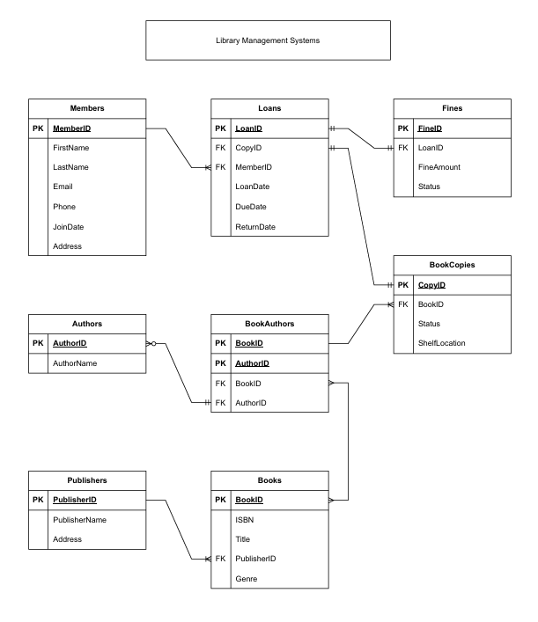

**Implementation**

The database is implemented in MySQL. Following SQL queries are used:

|  |  |
| --- | --- |
| 1  2  3  4  5  6  7  8  9  10  11  12  13  14  15  16  17  18  19  20  21  22  23  24  25  26  27  28  29  30  31  32  33  34  35  36  37  38  39  40  41  42  43  44  45  46  47  48  49  50  51  52  53  54  55  56  57  58  59  60  61  62  63  64  65  66  67  68  69  70  71  72  73  74  75  76  77  78  79  80  81  82  83  84  85 | **CREATE** **DATABASE** Library_Management;  USE Library_Management;  -- Table for Library Members  **CREATE** **TABLE**  Members (  MemberID INT **PRIMARY** **KEY** AUTO_INCREMENT,  FirstName VARCHAR(**50**) **NOT** **NULL**,  LastName VARCHAR(**50**) **NOT** **NULL**,  Email VARCHAR(**100**) **NOT** **NULL** **UNIQUE**,  Phone VARCHAR(**15**),  JoinDate DATE **NOT** **NULL**,  Address VARCHAR(**255**)  );  -- Table for Authors  **CREATE** **TABLE**  Authors (  AuthorID INT **PRIMARY** **KEY** AUTO_INCREMENT,  AuthorName VARCHAR(**100**) **NOT** **NULL**  );  -- Table for Publishers  **CREATE** **TABLE**  Publishers (  PublisherID INT **PRIMARY** **KEY** AUTO_INCREMENT,  PublisherName VARCHAR(**100**) **NOT** **NULL** **UNIQUE**,  Address VARCHAR(**255**)  );  -- Table for Book Titles  **CREATE** **TABLE**  Books (  BookID INT **PRIMARY** **KEY** AUTO_INCREMENT,  ISBN VARCHAR(**13**) **NOT** **NULL** **UNIQUE**,  Title VARCHAR(**255**) **NOT** **NULL**,  PublisherID INT,  PublicationYear **YEAR**,  Genre VARCHAR(**50**),  **FOREIGN** **KEY** (PublisherID) **REFERENCES** Publishers(PublisherID)  );  -- Junction table for the Many-to-Many relationship between Books and Authors  **CREATE** **TABLE**  BookAuthors (  BookID INT,  AuthorID INT,  **PRIMARY** **KEY** (BookID, AuthorID),  **FOREIGN** **KEY** (BookID) **REFERENCES** Books(BookID),  **FOREIGN** **KEY** (AuthorID) **REFERENCES** Authors(AuthorID)  );  -- Table for individual copies of each book  **CREATE** **TABLE**  BookCopies (  CopyID INT **PRIMARY** **KEY** AUTO_INCREMENT,  BookID INT,  Status ENUM('Available', 'Borrowed', 'Lost') **NOT** **NULL** **DEFAULT** 'Available',  ShelfLocation VARCHAR(**50**),  **FOREIGN** **KEY** (BookID) **REFERENCES** Books(BookID)  );  -- Table for loan transactions  **CREATE** **TABLE**  Loans (  LoanID INT **PRIMARY** **KEY** AUTO_INCREMENT,  CopyID INT,  MemberID INT,  LoanDate DATE **NOT** **NULL**,  DueDate DATE **NOT** **NULL**,  ReturnDate DATE,  **FOREIGN** **KEY** (CopyID) **REFERENCES** BookCopies(CopyID),  **FOREIGN** **KEY** (MemberID) **REFERENCES** Members(MemberID)  );  -- Table for fines  **CREATE** **TABLE**  Fines (  FineID INT **PRIMARY** **KEY** AUTO_INCREMENT,  LoanID INT,  FineAmount DECIMAL(**5**, **2**) **NOT** **NULL**,  Status ENUM('Unpaid', 'Paid') **NOT** **NULL** **DEFAULT** 'Unpaid',  **FOREIGN** **KEY** (LoanID) **REFERENCES** Loans(LoanID)  ); |

**Real Library Observation**

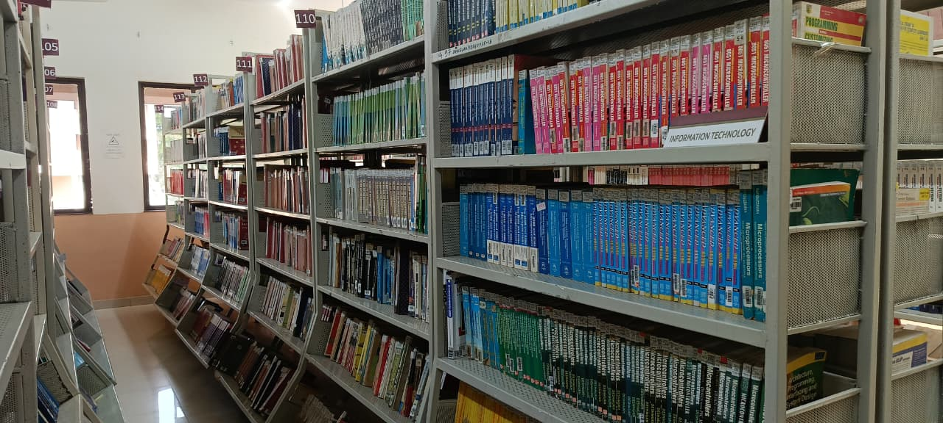During the project work, we visited the library and observed how books are stored, managed, and issued. We also took photographs of the library.

*“Organized bookshelf with academic books”*

*“Team members exploring books in the library.”*

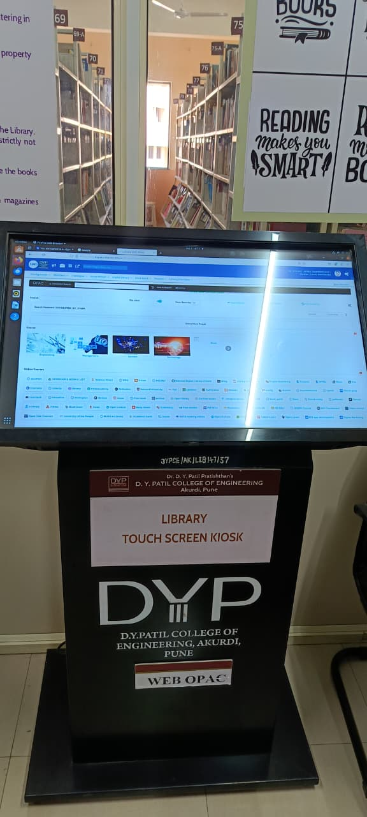

“*Online Public Access Catalog (OPAC) system”*

**Functions of OPAC:**

1. **Book Searching:** Users can search for books using title, author, subject, publisher, ISBN, or keywords.
2. **Availability Check:** OPAC displays whether a particular book is available or already issued.
3. **Book Location:** The system indicates the shelf or section where the book is kept.
4. **User Account Access:** Some OPAC systems allow students to access their accounts, view issued books, and request renewals or holds.
5. **24/7 Access:** OPAC can be accessed anytime and anywhere via the internet, providing convenience for users.

**Application and Advantages**

**Applications:**

* **Book Management:** Efficiently stores and updates book records including title, author, publisher, and copies.
* **Student and Staff Management:** Keeps track of students and staff borrowing books, their details, and history.
* **Issue and Return Automation:** Automates issuing and returning books, tracks due dates, and calculates fines.
* **Quick Search & Retrieval:** Allows fast search of books by title, author, subject, or ISBN.
* **Online Access (OPAC):** Users can search and reserve books digitally, improving accessibility.

**Advantage:**

1. Time-Saving: Reduces manual work for librarians and saves time for students.
2. Accuracy: Minimizes errors in book records and student data.
3. Easy Data Management: Organizes large volumes of books and user data efficiently.
4. Report Generation: Provides insights on issued books, overdue items, and stock availability.
5. Scalability & Security: Can handle growing collections and maintains secure, reliable data.

**Future Scope**

1. **Integration with Barcode/RFID Technology:**
   * Books can be issued and returned automatically using barcode or RFID scanning, reducing manual effort.
2. **Mobile Application Support:**
   * Students and staff can check book availability, issue status, and reserve books via smartphones.
3. **Cloud-Based Library Management:**
   * The system can be hosted on the cloud, allowing remote access to library resources anytime, anywhere.
4. **Automatic Fine Calculation and Payment:**
   * Late returns can be tracked automatically, and fines can be calculated and paid digitally.
5. **Digital Library and E-Resources:**
   * Integration with e-books, online journals, and digital content to support modern educational needs.
6. **Advanced Reporting and Analytics:**
   * Reports on book usage trends, student borrowing patterns, and popular books can help in informed decision-making.
7. **Scalability for Large Libraries:**
   * Can manage growing collections, multiple branches, and increasing number of users without performance issues.

**SDG Mapping**

The Library Management System contributes *to* ***United Nations Sustainable Development Goal (SDG) 4: Quality Education****.* SDG 4 aims to ensure inclusive, equitable, and quality education and promote lifelong learning opportunities for all.

By digitizing library operations, LMS provides **better access to educational resources** for students and faculty. It allows users to search, locate, and borrow books efficiently, ensuring that knowledge is **readily available to all learners**. The integration of features like OPAC and digital resources supports **remote and anytime learning**, making education more accessible and inclusive.

Moreover, LMS improves the efficiency and organization of libraries, allowing institutions to **manage a larger volume of resources effectively**, which supports higher-quality educational outcomes. By promoting easy access to books, journals, and study materials, the system directly contributes to **enhancing learning opportunities and supporting lifelong education**, aligning with the core objectives of SDG 4.

**References**

1. *Silberschatz, Korth, Sudarshan – Database System Concepts*
2. *MySQL Documentation: https://dev.mysql.com*
3. *Class Notes on DBMS – D. Y. Patil College of Engineering*