**EPCORN**

**EXPRESS PESTICIDES PVT. LTD.**

S-5 Khira Industrial Estate ,B.M.Bhargav Road, Santacruz (W),Mumbai-400 054 Tel: 6138 6600 Fax:6138 6601 [Email:epcorn@yahoo.com](mailto:epcorn@yahoo.com) Visit u[s:ww](http://www.epcorn.com/)w.[epcorn.com](http://www.epcorn.com/)



**Service / Callback Escalation Matrix**



Central Call Center

Coordinator

Chief Executive Operations-Pan India

* [epcorn@yahoo.in](mailto:epcorn@yahoo.in)
* 022 6138 6600
* Ref. Contact No.
* Miss. Sayalee k
* [natco.epcorn@gmail.com](mailto:natco.epcorn@gmail.com)
* 022 6138 3300
* Mr. Stelson Quadros
* [stq@epcorn.com](mailto:stq@epcorn.com)
* 9820061692

**RIM REPORT**

**Sodexo India Service Pvt Ltd**

# 1th floor,Genstar,Kanchpada Malad-(W)

* The objective of Photo Audit is to determine on visual basis the

various food spillage, pest entry points in order to depute resources for sealing entry points, deploy new strategy of trapping and safe use of insecticides.

**Inspection Done : {inspectionDate}**

**Inspection Done : {inspectionBy}**

**Meet At Site : {meetTo} / {meetContact} / {meetEmail}**

**Shown To : {shownTo} / {shownContact}** / **{shownEmail}**

Basics of Rodent Behavior

Constantly breeding.

Constantly expanding feed & breed zone. Constant Gnawing into solids.

A select location needs to be contained upto 96% for effective management of rodents.

Its neophobic & bait shy, making it difficult for quick

control, unless an integrated approach is adopted.

Fundamentals of

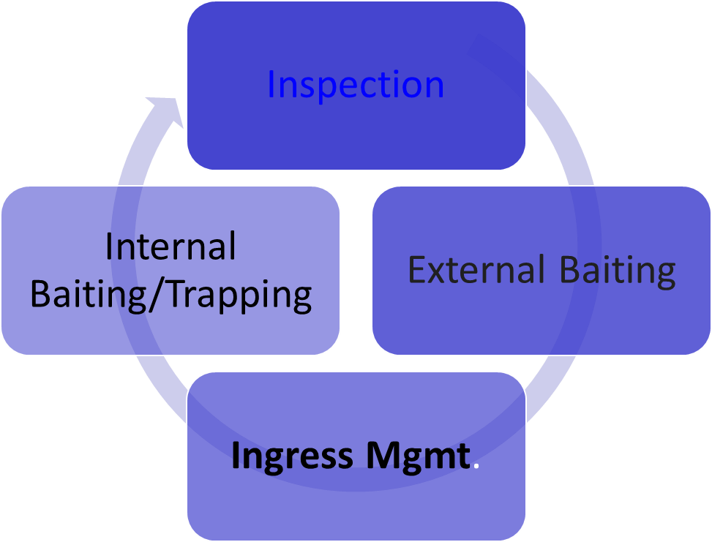Integrated Rodent Mgt.

Why & How RIM helps in Rodent Mgmt.

WHY…

Only natural way to disrupt rodent

behavior.

Creates better environment for bait picking.

It creates pressure on the colony to move away as their social behavior is forced to change.

It assists to bring down the rodent presence to less than 96%.

HOW…

Identify the Openings Tag the gaps.

Spray the repeller.

Fill each point with fillers, spacers, sealants.

Each sealed location is tracked and checked for activity for a year.

It ensures rodents are denied access to work areas.

{ FOR ship in data}



**Pest Name** - {INS $ship.pest}

|  |  |
| --- | --- |
| {IMAGE image($ship.image1)} | {IMAGE image($ship.image2)} |

**Floor** - {INS $ship.floor} **Sub Floor** – {INS $ship.subFloor} **Location** - {INS $ship.location}

**Our Finding** – { INS $ship.finding}

**Our Suggestion** – { INS $ship.suggestion}

{ END-FOR ship }





# RIM WORKS COSTING

**Sodexo India Service Pvt Ltd**

**1st floor, Genstar, Kanchpada Malad-(W)**

|  |  |
| --- | --- |
| **Name of Company** | **S. Mark Corporation** |
| **Description of Billing** | RIM – Specialised activity for Rodent Ingress Mgmt. |
| **Tax** | Not Applicable as below GST applicable limit |
|  | 40,500/- |
| **Total Cost** |  |
| **Company Address** | Office No:2,B-Wing,Hasmukh Nagar,21-Tagore Road. |
|  |  |



**THANK YOU**