- Copying data from SQL DB to Dataverse

- Scenario – while copying data from SQL DB to Dataverse (powerBI, microsoft power app) throwing following error

ErrorCode=DynamicsAlternateKeyNotFound,'Type=Microsoft.DataTransfer.Common.Shared.HybridDeliveryException,Message=Cannot retrieve key information of alternate key 'cr60e_branchid' for entity 'cr60e_auditbranchmaster'.,Source=Microsoft.DataTransfer.ClientLibrary.DynamicsPlugin,''Type=System.ServiceModel.FaultException`1[[Microsoft.Xrm.Sdk.OrganizationServiceFault, Microsoft.Xrm.Sdk, Version=9.0.0.0, Culture=neutral, PublicKeyToken=31bf3856ad364e35]],Message=Could not find an entity key with name cr60e_branchid and id 00000000-0000-0000-0000-000000000000 for entity cr60e_auditbranchmaster having objecttypecode 10181 and id afce2c77-fe99-ed11-aad1-000d3a4755c6.,Source=mscorlib,'

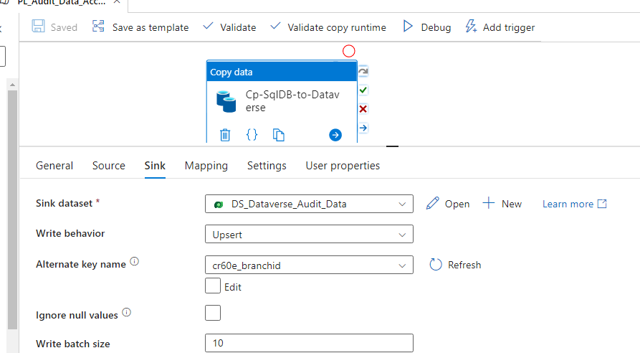

- Answer – Here we are upserting the data on dataverse and it require alternate key name that already created in dataverse.
In above scenario that was not created that’s why throwing above error

---Need to create alternate key on that basis we can upsert the data in dataverse

