- Copy data in json format from dynamic API (It will trigger pipeline with different API)

- Scenario – Copy data from dynamic API to Blob storage

- Solution --
- Create parameter in Linked Service
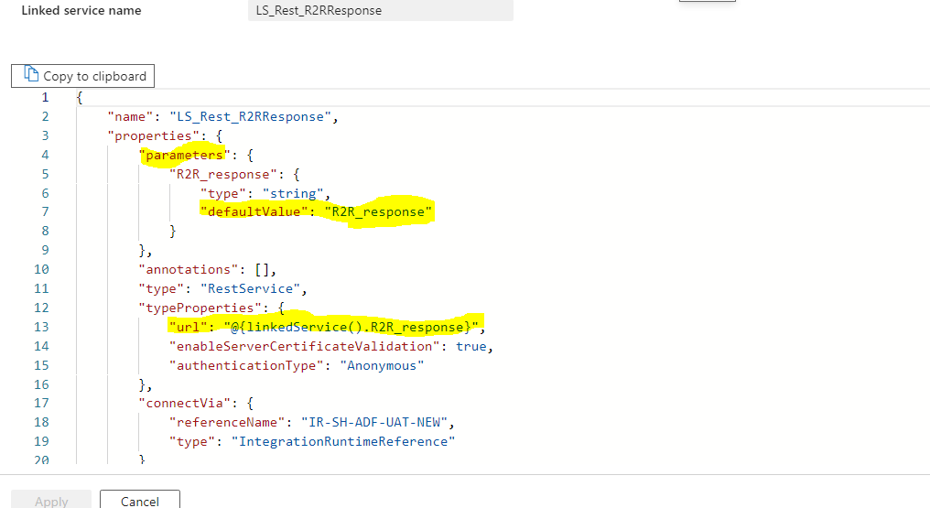

- Create another parameter in Dataset
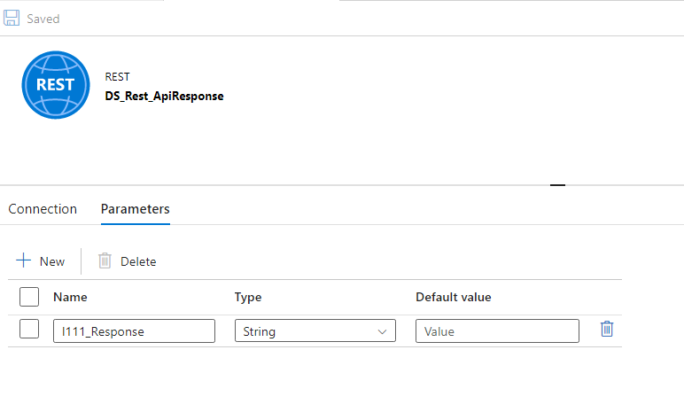
- Put value of Dataset parameter into Linked Service parameter
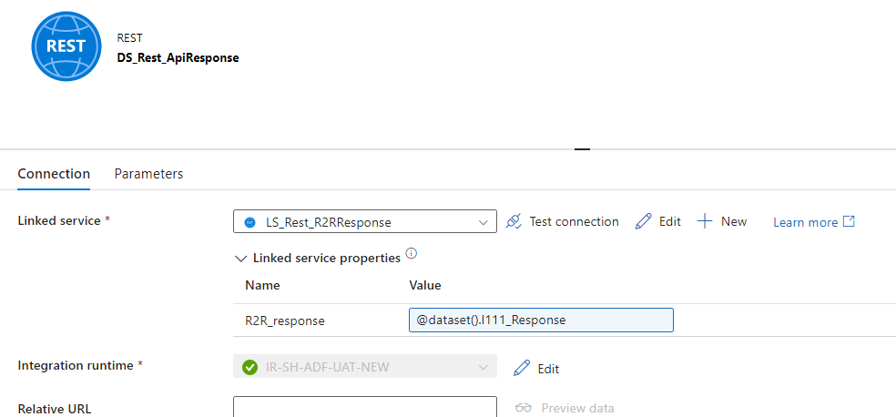

- Create one more parameter at pipeline level
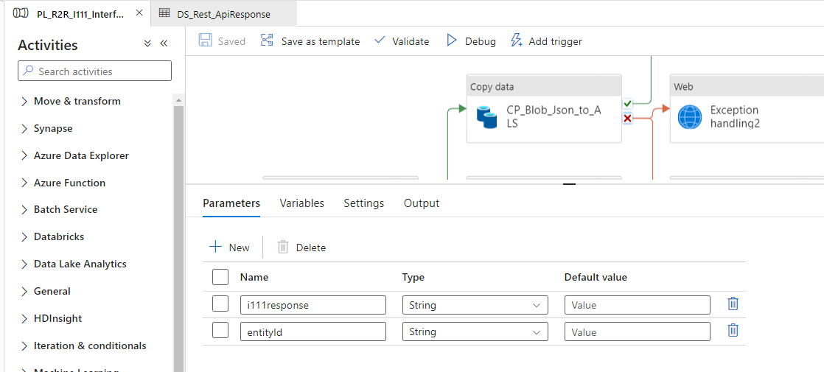

- Use pipeline level parameter in Dataset parameter
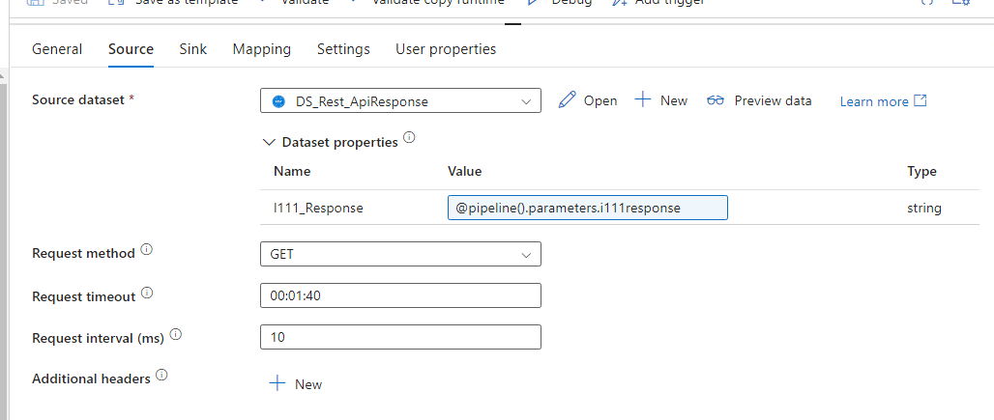
- We will get pipeline level parameter through LogicApp

