- Creating-json-hierarchical-data

- Scenario – Business requirement is to create shown json file with hierarchy
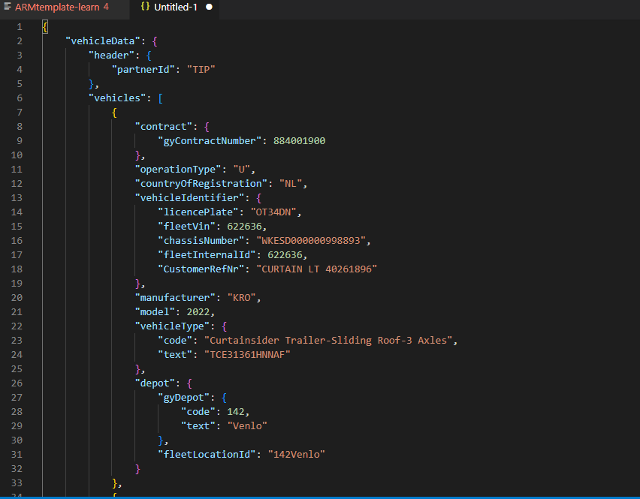

- Solution
- First we copied data from Sybase db into CSV file format
- Used Data Flow for creating hierarchical data structure
- In data flow derived Column, aggregate transformations are used

