Q) How to get Error details message in mail from Script Activity

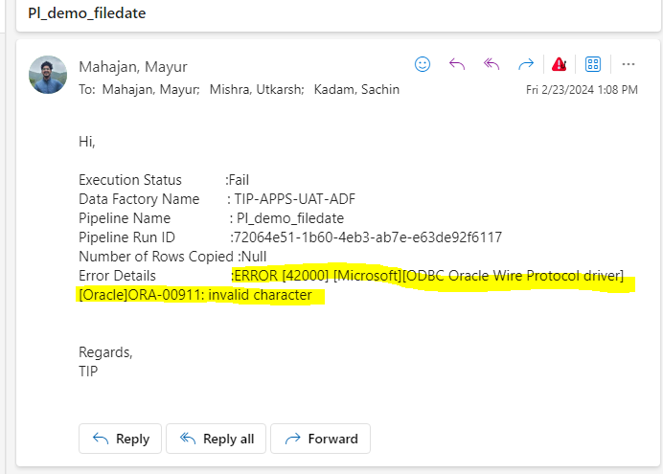
ANS:-
{
"ExecutionStatus":"Fail",
"DataFactoryName":"@{pipeline().DataFactory}",
"PipelineName":"@{pipeline().Pipeline}",
"Pipeline Run ID":"@{pipeline().RunId}",
"Number of Rows Copied":"Null",
"ErrorDetails":"@{activity('Insert-CPUser').error.message}"
}

