YouTube Educational Video
Summarization & Q&A
LangChain + RAG — Laptop-Optimized Implementation
Version 2.0
Architecture: Local-first / Laptop-friendly

Table of Contents
1. Project Objective 3
2. Key Architectural Decision 3
3. Target Laptop Architecture 4
4. Long-Video Architecture 4
5. Resumable Processing 5
6. Processing State (SQLite) 5
7. Caching 6
8. Storage Layout 6
9. Final Project Structure 7
10. Component Responsibilities 7
11. Whisper Strategy for Laptop Hardware 8
12. LangChain Document Creation 8
13. Text Splitting & Embeddings 9
14. FAISS Vector Store & Retriever 9
15. Gemini Integration & RAG Chain 10
16. Hierarchical Summarization 11
17. Conversational, Multi-Video & Chapter-Aware Retrieval 11
18. Source & Timestamp References 12
19. SQLite Schema 12
20. Error Handling & Logging 13
21. Laptop Performance Strategy 13
22. Testing & Evaluation 14
23. GitHub Actions CI 15
24. Milestone-Based Roadmap 15
25. Recommended Development Order 16
26. Final Architecture (Recap) 16
27. Future Upgrade Path 17
28. Build Philosophy 18
29. Final Definition of Done 18

1. Project Objective
Upgrade the existing YouTube educational-video summarization and Q&A application from a custom RAG implementation into a modular LangChain-based RAG system, while removing the current architectural limitations around long videos and repeated processing.

Capabilities in Scope
- YouTube video ingestion
- Audio extraction & speech-to-text transcription (timestamped)
- Long-video processing through audio segmentation
- LangChain document processing, text chunking, local embeddings
- FAISS vector search + Gemini-based RAG
- Educational-video summarization & conversational, multi-video Q&A
- Source/timestamp references
- Processing-state tracking, resume-after-failure, local caching
- Streamlit UI, automated testing, GitHub Actions CI
The architecture is deliberately laptop-first. It should not introduce Redis, Celery, Qdrant, PostgreSQL, Kubernetes, or microservices at this stage.

2. Key Architectural Decision
The biggest mistake would be to treat LangChain as a performance solution. LangChain will not make Whisper transcription or embedding generation inherently faster — it provides document abstractions, retrievers, prompts, chains, model integrations, structured output, and orchestration.
Performance improvements come instead from:
- Audio segmentation
- Caching
- Checkpointing
- Batch embeddings
- Appropriate Whisper model size
- Optional GPU acceleration
This gives the project two separate goals: (A) a LangChain upgrade — moving from custom RAG to LangChain RAG — and (B) a performance/scalability upgrade — moving from a 2-hour limitation to chunked, resumable, long-video-capable processing.

3. Target Laptop Architecture
Everything in the pipeline runs locally except the LLM call itself, which goes to the Gemini API. This avoids running a local LLM, which would add unnecessary RAM/GPU requirements.
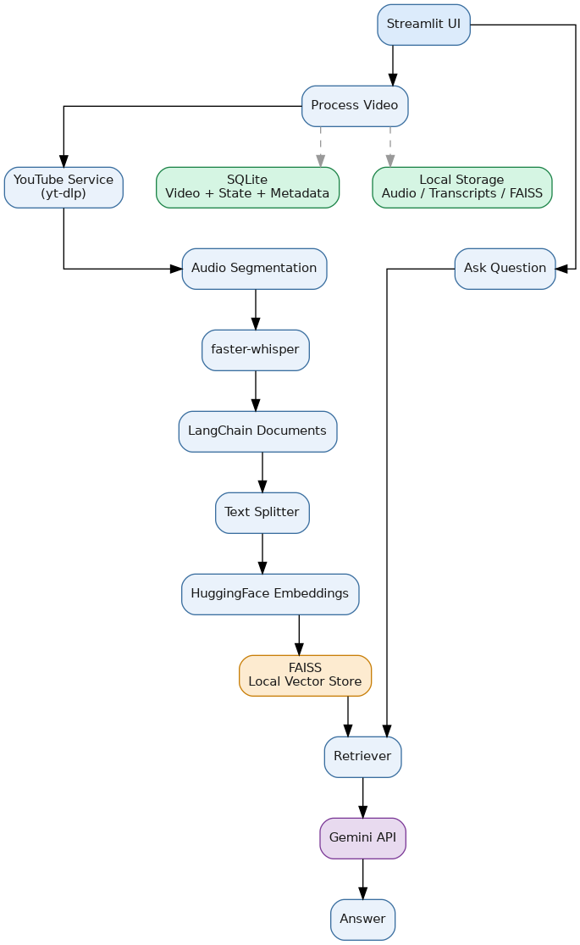
Figure 1 — End-to-end laptop architecture: Streamlit UI, ingestion pipeline, FAISS store, and Gemini-based RAG, with SQLite and local storage for state.

4. Long-Video Architecture
The old flow processed an entire (possibly multi-hour) audio file through Whisper as a single unit. The new flow splits audio into segments, transcribes each independently, and only then merges results before building documents — removing the dependency on treating a whole video as one processing unit.
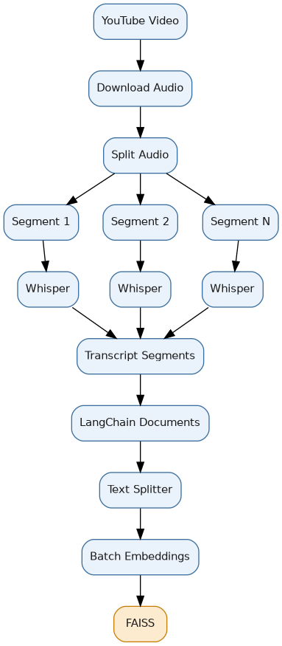
Figure 2 — Segmented long-video processing flow.

Strategy
Do not simply raise the duration ceiling (e.g. 2 hours → 6 hours) — that only moves the problem. Instead remove the arbitrary limit and combine audio segmentation, sequential processing, checkpointing, and caching. Example: a 4-hour video becomes 16 × 15-minute segments, each transcribed and checkpointed independently. Segment size should be benchmarked against actual laptop hardware.

5. Resumable Processing
Processing must not restart a long video from zero after a failure. Interruptions on a laptop are common: sleep, shutdown, app crash, network error, Whisper error, insufficient disk space, or API failure.
Figure 3 — On failure, resume from the last successful segment rather than restarting.

6. Processing State (SQLite)
SQLite tracks per-video state across the pipeline stages:
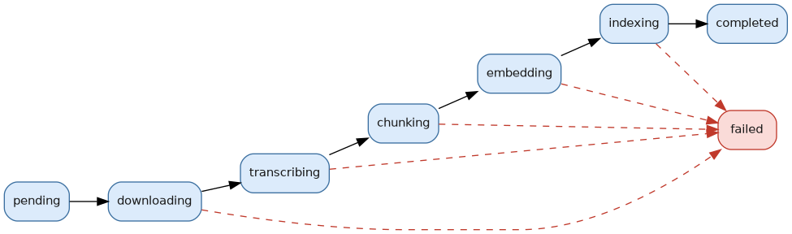
Figure 4 — Video processing state machine.
video_id = abc123
status = "transcribing"
transcription_status = "chunk_07"
embedding_status = "pending"
index_status = "pending"

7. Caching
If a user processes the same YouTube video twice, the application should not re-download or re-transcribe it. If status = completed, the existing FAISS index is loaded directly — turning a 3–5 minute processing job into a near-instant index load.
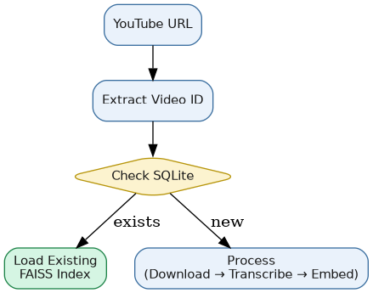
Figure 5 — Cache-check flow keyed on video ID.

8. Storage Layout

8.1 Audio Storage
Audio is chunked per video and deleted once transcribed, to keep disk usage manageable:
data/
└── audio/
└── <video_id>/
├── chunk_001.mp3
├── chunk_002.mp3
└── ...
Flow: Audio chunk → Whisper → Save transcript → Delete audio chunk

8.2 Transcript Storage
Each transcript segment preserves text, start_time, end_time, chunk_id, and video_id:
{
"chunk_id": 1,
"video_id": "abc123",
"start_time": 0.0,
"end_time": 15.0,
"text": "Today we will discuss..."
}

9. Final Project Structure
youtube-rag-langchain/
├── app/
│ ├── main.py, config.py
│ ├── ingestion/ (youtube.py, audio.py, transcription.py)
│ ├── rag/ (documents.py, embeddings.py, vectorstore.py,
│ │ retriever.py, prompts.py, chains.py, summarizer.py)
│ ├── database/ (sqlite.py)
│ ├── models/ (schemas.py)
│ └── utils/ (logging_config.py)
├── tests/ (test_youtube/audio/transcription/documents/retrieval/rag.py)
├── data/
│ ├── audio/<video_id>/
│ ├── transcripts/<video_id>/
│ ├── vectorstores/<video_id>/ (index.faiss, index.pkl)
│ └── database/youtube_rag.db
├── .github/workflows/ci.yml
├── .env, .env.example, requirements.txt, README.md, app.py

10. Component Responsibilities
Module | Responsibility
app.py | Streamlit entry point: Process Video / Analysis / Chat
app/config.py | Central config — API keys, model names, chunking params, paths
ingestion/youtube.py | extract_video_id(), get_video_metadata(), download_audio()
ingestion/audio.py | Full audio → segmentation into chunks (new vs. original architecture)
ingestion/transcription.py | Audio chunk → faster-whisper → timestamped transcript segments
rag/documents.py | Whisper segments → LangChain Document objects with metadata
rag/vectorstore.py | create_vectorstore(), save_vectorstore(), load_vectorstore()
rag/retriever.py | Top-K retrieval; later MMR, score threshold, metadata filtering
rag/chains.py | Retriever → context → prompt → Gemini → parsed output
database/sqlite.py | videos and chunks tables; processing state

11. Whisper Strategy for Laptop Hardware
Priority | Model | When to use
1st | base | Recommended starting point
2nd | tiny | If performance is poor
3rd | small | If accuracy is insufficient and hardware allows
Use a single Whisper worker initially — Whisper is CPU-bound, and parallel workers consume additional resources. Do not introduce multiple workers until benchmarking shows a clear benefit. If a suitable NVIDIA GPU is available, benchmark GPU inference later.

12. LangChain Document Creation
Whisper segments are converted into LangChain Document objects, each carrying metadata that lets the final answer point back to the relevant part of the source video:
Document(
page_content="The speaker explains embeddings...",
metadata={
"video_id": "abc123",
"title": "Introduction to RAG",
"start_time": 120.5,
"end_time": 135.2,
"source": "youtube"
}
)

13. Text Splitting & Embeddings
Start with RecursiveCharacterTextSplitter at chunk_size=1000, chunk_overlap=150 (starting values — benchmark 500/100, 1000/150, and 1500/200 later; a larger chunk is not automatically better).
Embeddings use the LangChain HuggingFace integration with all-MiniLM-L6-v2 (384-dimensional), matching the existing application. Embeddings are generated in batches rather than for the whole transcript at once — this bounds memory use and provides a natural checkpoint boundary.

14. FAISS Vector Store & Retriever
app/rag/vectorstore.py exposes create_vectorstore(), save_vectorstore(), and load_vectorstore(), storing each video's index under data/vectorstores/<video_id>/. The retriever starts with top_k = 5, with MMR, score thresholds, and metadata filtering as later refinements.

15. Gemini Integration & RAG Chain
The orchestration moves into LangChain while continuing to use Gemini for answer generation:
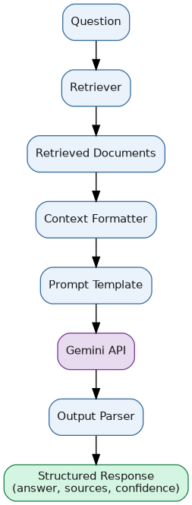
Figure 6 — RAG chain: retrieval → context formatting → prompt → Gemini → structured output.
The Streamlit layer only calls answer_question(question, video_id) — it should not know how FAISS, prompts, embeddings, or Gemini work internally.

Prompt Template
You are an educational YouTube-video assistant.
Answer the question using only the supplied transcript context.
Do not invent information.
If the answer cannot be found in the supplied context,
say that the information is not available.
When possible, provide the relevant video timestamp.
Context: {context}
Question: {question}

Structured Output
QAResponse { answer, sources, confidence } — where each Source carries { video_id, title, start_time, end_time }, giving the application a predictable response format.

16. Hierarchical Summarization
A multi-hour transcript should never be sent to Gemini in one shot. Instead, summarization happens hierarchically:
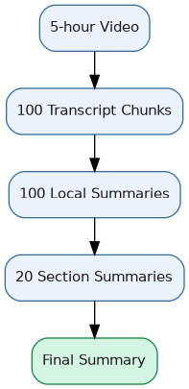
Figure 7 — Hierarchical summarization for long transcripts.
The final summary is structured as: Main Topic → Key Concepts → Important Insights → Examples → Conclusion — more useful for educational content than a single large paragraph.

17. Conversational, Multi-Video & Chapter-Aware Retrieval

17.1 Conversational RAG
Streamlit session state holds UI chat history. Each new question is rewritten in light of the conversation history before retrieval, so a follow-up like “Why is it useful?” is correctly interpreted after “What is RAG?”

17.2 Multi-Video RAG
Each video keeps a separate index initially (data/vectorstores/video_A, video_B, ...). Later, a combined store with video_id, title, chapter, timestamp, and content metadata enables cross-video questions such as “Compare how two videos explain vector databases.”

17.3 Chapter-Aware Retrieval
For long videos, YouTube chapter markers are stored as metadata (chapter, start_time, end_time), enabling two-level retrieval: question → relevant chapter → relevant transcript chunks → Gemini.

18. Source & Timestamp References
Every retrieved document preserves video_id, title, start_time, and end_time, displayed as:
Sources
1. 12:34 – 13:10
2. 18:22 – 19:05
Timestamps can later become clickable, linking directly to the YouTube URL at that offset.

19. SQLite Schema
Table: videos | Table: chunks
video_id, url, title, duration | id, video_id, chunk_index
status, audio_status, transcription_status | chunk_text, start_time, end_time
chunking_status, embedding_status, index_status | transcription_chunk
processed_date, error_message

20. Error Handling & Logging
Handled failure modes: invalid/private/unavailable URLs, download failure, audio segmentation failure, Whisper failure, empty transcript, embedding failure, FAISS failure, Gemini failure, invalid API key, corrupt vector index, insufficient disk space.
For every failure: log details → save state → show a user-friendly message. Raw stack traces are never surfaced to the user.
Logging tracks: video ID, download/transcription/embedding/FAISS/retrieval/Gemini durations, chunk and document counts, total processing time, and errors — essential for identifying the actual laptop bottleneck rather than assuming it's Whisper.

21. Laptop Performance Strategy
Phase | Focus
Phase 1 | 1 Whisper worker, base model, 15-min audio chunks, batch embeddings, FAISS, SQLite
Phase 2 | Benchmark tiny vs. base vs. small
Phase 3 | CPU Whisper vs. GPU Whisper (if a suitable NVIDIA GPU is available)
Phase 4 | Controlled parallel processing — only if benchmarking shows a benefit

Explicitly Out of Scope for This Version
Redis · Celery · Kafka · Kubernetes · PostgreSQL · Qdrant · microservices · local LLM · multiple Whisper workers initially — future scaling options, not requirements for the current project.

22. Testing & Evaluation

22.1 Test Suite
- test_youtube.py — URL → video ID
- test_audio.py — audio → correct segments
- test_documents.py — Whisper segments → LangChain Documents
- test_retrieval.py — query → relevant documents
- test_rag.py — context → valid response

22.2 Evaluation Dataset
~20–30 questions, each with an expected answer, expected source, and expected timestamp — used to compare the original RAG system against the LangChain RAG system.

22.3 Metrics
Category | Metrics
Retrieval | Recall@K, Precision@K, MRR (K = 3, 5, 10)
Generation | Answer correctness, faithfulness, context relevance, answer relevance
Latency | Retrieval latency, LLM latency, total response latency

22.4 Old vs. New Comparison Table
Metric | Original RAG | LangChain RAG
Recall@5 | XX% | XX%
MRR | XX | XX
Answer relevance | XX% | XX%
Faithfulness | XX% | XX%
Avg retrieval time | XX ms | XX ms
Avg answer time | XX sec | XX sec
2-hour processing | XX min | XX min
4-hour processing | Unsupported | XX min
The goal is not to claim LangChain is inherently faster — it is to show the new architecture is modular, testable, resumable, long-video capable, and easier to extend.

23. GitHub Actions CI
Push → Checkout → Setup Python → Install dependencies → Run tests → Build/check → Success / Failure
CI should not download YouTube videos, download Whisper models, or call Gemini unnecessarily — mock external dependencies where appropriate.

24. Milestone-Based Roadmap
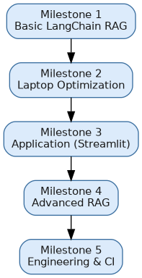
Figure 8 — Milestone sequence.
Milestone | Adds | Goal
1 — Basic LangChain RAG | YouTube → Whisper → Documents → Splitter → Embeddings → FAISS → Retriever → Gemini | One video → one RAG system
2 — Laptop Optimization | Audio segmentation, checkpointing, caching, batch embeddings, processing states | Longer videos without restarting from zero
3 — Application | Streamlit, summary, chat, sources, timestamps | Usable application
4 — Advanced RAG | Conversational retrieval, query rewriting, multi-video, chapter-aware retrieval, hierarchical summarization | Better RAG quality
5 — Engineering | Tests, evaluation, logging, benchmarking, GitHub Actions | Professional engineering project

25. Recommended Development Order
Project setup → venv → requirements.txt → .env/config → YouTube ingestion → Audio segmentation → Whisper transcription → Transcript checkpointing → LangChain Documents → Text splitting → Embeddings → Batch embedding → FAISS → Retriever → Gemini → RAG chain → Structured output → Summarization → Conversational RAG → Caching → Resume/recovery → Multi-video RAG → Streamlit UI → Testing → Evaluation → Performance benchmarking → GitHub Actions.

26. Final Architecture (Recap)
Figure 9 — Full pipeline, including the state and storage layers that back every stage.

27. Future Upgrade Path
Once the laptop version is stable, the architecture can evolve without discarding the core RAG code:
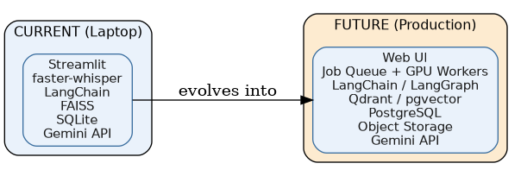
Figure 10 — Current laptop stack vs. potential future production stack.
Potential future additions: GPU transcription, background jobs, Redis/Celery, Qdrant/pgvector, LangGraph, Docker, cloud deployment, authentication, multi-user support. None of these should be built now — the laptop architecture should stay simple until the application actually needs them.

28. Build Philosophy
V1 Basic LangChain → V2 Long-video support → V3 Resumable + cached → V4 Advanced RAG → V5 Tested + evaluated → V6 Production architecture.
Key decision: keep compute local, keep vector storage local, use Gemini through the API, process long videos incrementally, and make every expensive processing stage resumable.

29. Final Definition of Done

Ingestion
- YouTube URL validation
- Video metadata extraction
- Audio download & segmentation
- faster-whisper transcription with timestamp preservation
- Transcript checkpointing & resume after failure
- Video caching

LangChain
- LangChain Documents, recursive text splitter
- HuggingFace embeddings, FAISS vector store
- Retriever, Gemini integration, prompt templates
- Structured output, RAG chain

Application
- Video processing with progress display
- Summarization; single-, conversational-, and multi-video Q&A
- Source and timestamp references

Long-Video Capability
- No arbitrary 2-hour limitation
- Audio chunking, sequential processing, checkpointing, resume
- Batch embeddings, local caching, disk-space management

Engineering
- SQLite state management, logging, error handling
- Unit & integration tests, evaluation dataset
- Retrieval & generation metrics, performance benchmark
- GitHub Actions, README

