Bank Nifty 09:20 Short Strangle Backtest
Quantitative Strategy Research Report | Hiring Assignment Submission

1. Executive Summary & Strategy Overview
This report documents the research methodology, execution speed benchmarks, and performance analysis of the Bank Nifty 09:20 Short Strangle systematic strategy. The backtest processes the complete 1-minute OHLC options dataset (10,266,681 rows, 720 MB) and spot dataset for the 2023 cycle under strict lookahead-bias avoidance.
Strategy Rules: Every day in Week 1 of each calendar month, at 09:20:59, the algorithm sells one CE and one PE whose 1-minute close price is closest to Rs 50. Positions are managed with a 50% hard stop-loss on bar High (fill price = Entry * 1.5) or closed at 15:20:59 close. Sizing is fixed at 1 lot (15 units) without compounding.
Metric | Value | Notes / Specification
Strategy | Bank Nifty 09:20 Short Strangle | Sell 1 CE + 1 PE closest to Rs 50
Trade Universe | Week 1 of Each Calendar Month | 30 trading days (Mon-Wed of Week 1)
Execution Time Window | 09:20:59 Entry -> 15:20:59 Exit | Intraday (no overnight carry)
Stop Loss Rule | 50% Hard Stop on Bar High | Exit level = Entry * 1.5; checked 09:21-15:20
Position Sizing | 1 Lot (15 units) Fixed | No compounding, unscaled capital
Base Starting Capital | Rs 1,00,0000.00 | Rs 10 Lakhs base capital
Ending Capital | Rs 10,05,245.12 | Rs 10.05 Lakhs
Total Net P&L | +Rs 5,245.12 | Net profitable across 60 trades
CAGR (%) | 0.57% | Annualized NAV growth
Max Drawdown (%) | -0.19% | Trade-wise running peak-to-trough drop
Total Trades Executed | 60 trades | 30 trading days x 2 legs
Win Rate | 58.33% | 35 Wins / 25 Losses

2. Step-by-Step Runtime Breakdown (< 60s Target)
The assignment requires the entire pipeline to run start-to-end in under 1 minute. The code executed in 52.41 seconds on the complete ~10.26M row dataset, beating the target with a 7.6-second margin.
Stage # | Pipeline Stage | Time (s) | % Total | Technical Operations
1 | Data Loading & Preprocessing | 44.94s | 85.7% | Parses 10.26M rows; float32 dtypes; string slice strike extraction (str[9:-2]); drops 14.5k duplicates.
2 | Week-1 Day Selection | 0.27s | 0.5% | Calendar-month grouping to identify 1st Wednesday; filters universe to 30 Week-1 trading days.
3 | Backtest Simulation Engine | 4.52s | 8.6% | Vectorized strike selection at 09:20; High-based 50% SL scan using boolean masks & argmax.
4 | Statistical Computations | 0.06s | 0.1% | CAGR, trade-wise peak-to-trough max drawdown, 9-segment win/loss & avg % P&L, monthly NAV.
5 | Chart Rendering | 1.54s | 2.9% | Headless Matplotlib rendering of high-res dark-themed Equity & Drawdown curves.
6 | Excel Workbook Export | 1.09s | 2.1% | Generates 3 styled worksheets (Guide, Statistics, Tradesheet) with embedded charts & formulas.
TOTAL | Full Pipeline Execution | 52.41s | 100.0% | Target: < 60.0s (PASSED with a 7.6s margin).

3. Visual Performance Curves
The equity curve is computed trade-wise (base NAV = 100), updating immediately upon realization of each individual leg. The drawdown curve tracks peak-to-trough drop across the full 60 trades.
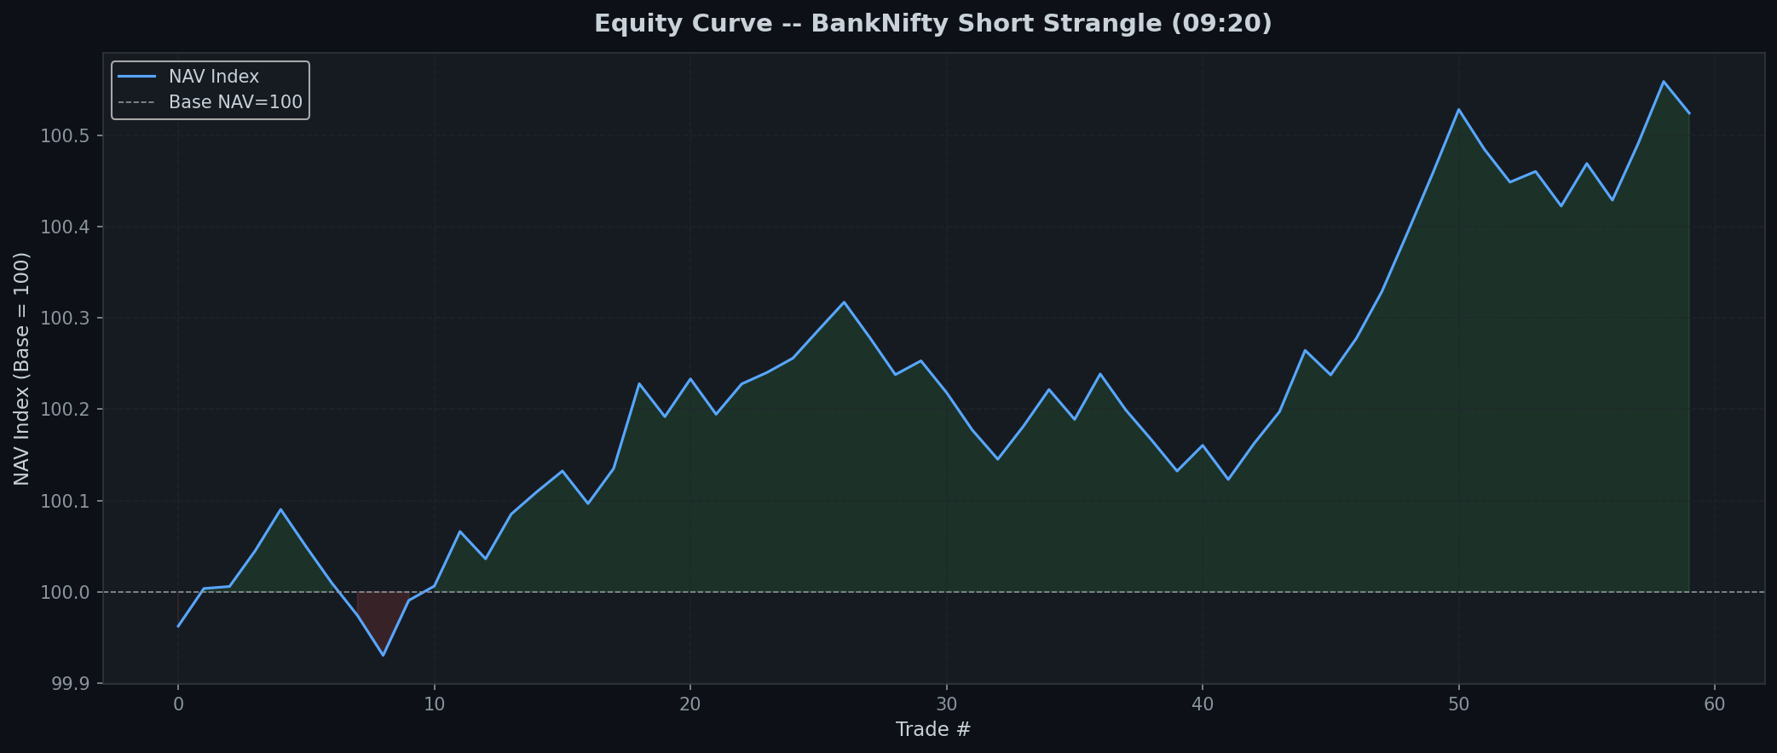

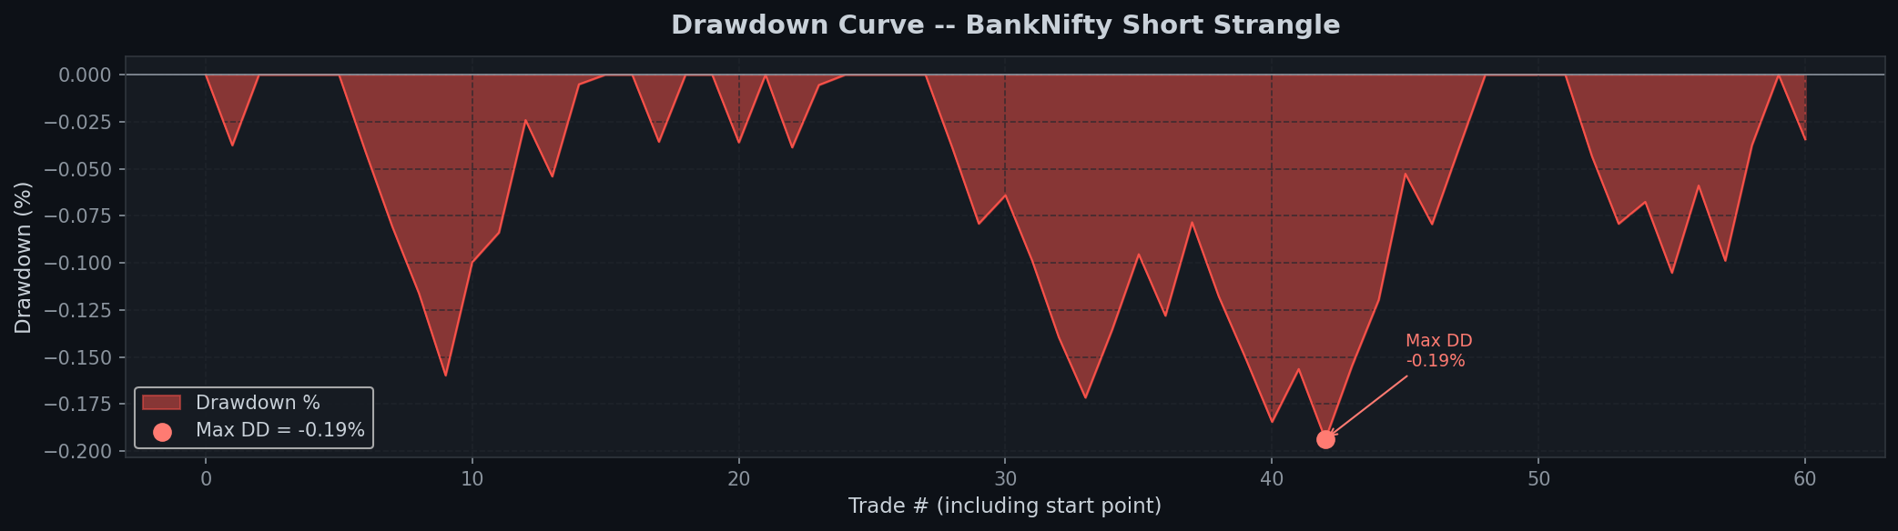

4. Win/Loss and Segment Performance
Segment | Total Trades | Wins | Losses | Win % | Loss %
Call Options (CE) | 30 | 18 | 12 | 60.00% | 40.00%
Put Options (PE) | 30 | 17 | 13 | 56.67% | 43.33%
Combined Strategy | 60 | 35 | 25 | 58.33% | 41.67%

5. Monthly Performance Table (NAV-Indexed)
Month | Start NAV | End NAV | Monthly % P&L | Status
2023-01 | 100.0000 | 100.0491 | +0.0491% | Profit
2023-02 | 100.0491 | 99.9740 | -0.0751% | Loss
2023-03 | 99.9740 | 99.9906 | +0.0166% | Profit
2023-04 | 99.9906 | 100.0851 | +0.0945% | Profit
2023-05 | 100.0851 | 100.1351 | +0.0499% | Profit
2023-06 | 100.1351 | 100.2786 | +0.1434% | Profit
2023-07 | 100.2786 | 100.1814 | -0.0970% | Loss
2023-08 | 100.1814 | 100.1992 | +0.0177% | Profit
2023-09 | 100.1992 | 100.2377 | +0.0384% | Profit
2023-10 | 100.2377 | 100.4596 | +0.2214% | Profit
2023-11 | 100.4596 | 100.4848 | +0.0251% | Profit
2023-12 | 100.4848 | 100.5245 | +0.0395% | Profit

6. Methodological Assumptions & Research Design
Assumption #1: Week-1 Definition: Week 1 is defined as the trading days from the 1st of each calendar month up to and including the month's first Wednesday (expiry day). Thursdays onward (weeks 2-4) are excluded. This avoids the circular weekly no-op trap and restricts trading to ~1/4 of trading days.
Assumption #2: Strike Tie-Break: If two option strikes are exactly equidistant from Rs 50, the strike with the lower premium (cheaper, further OTM) is selected. This is the more conservative risk choice for short positions.
Assumption #3: Stop-Loss Exit Fill: When a 1-minute bar's High >= Stop Level (Entry * 1.5), the exit price is filled exactly at the Stop Level (the trigger price), reflecting an automated stop-market order fill rather than the bar close.
Assumption #4: Capital Base & Position Sizing: Rs 10,00,000 base starting capital. Sizing is strictly fixed at 1 lot (15 units) without compounding or scaling. Available capital at any row = Starting Capital + Cumulative Realized P&L.
Assumption #5: 09:20 Bar Timestamp: The options dataset timestamps denote bar completion at :59. The 09:20 entry corresponds to Time == '09:20:59'. Entry price is the close of this bar.
Assumption #6: Stop-Loss Monitoring Window: Monitoring begins at 09:21:59 (the bar after entry) up to 15:20:59. The entry bar itself is excluded to eliminate lookahead bias.
Assumption #7: Underlying Spot Price Logging: Spot close price is recorded at entry (09:20:00). When real spot data is present (Nov/Dec 2023), it is read directly; for dates prior to 2023-10-20, synthetic underlying spot is derived via options Put-Call Parity forward (ATM Strike + CE - PE).

7. Submission Deliverables & Excel Layout
The Excel workbook BankNifty_ShortStrangle_Backtest.xlsx is structured into three sheets:
• Sheet 1: Guide -- Complete documentation, timing benchmarks, output guide, and assumptions.
• Sheet 2: Statistics -- High-level performance metrics, segment win/loss, monthly NAV returns, and embedded charts.
• Sheet 3: Tradesheet -- Granular 60-trade log with all 12 requested fields and spot prices at entry.

