

**School of Computer Science and Engineering**

CSE310

SUBMISSION REPORT

Project: Scientific Calculator

Using Java

**Submitted By:**

|  |  |  |
| --- | --- | --- |
| Registration Number | Name | Roll Number |
| 12115953 | Mayur | A33 |
| 12116081 | Bhumika | B52 |
| 12113688 | Arpan Chaudhary | A11 |

**Submitted to:** Dr. Jeevan Bala (26699)

**Contents**

1. Cover page
2. Acknowledgement
3. Introduction to Technology
4. Introduction to project
5. Abstract

- Procedure

-Source Code

-Output

1. Gantt Chart
2. Role Of Members

***Acknowledgement***

Dr. Ahmad Khusro sir thank you for your leadership and knowledge that helped us complete this project successfully, we are grateful to have had the privilege of learning from a wonderful teacher such as yourself!

Thank you, Dr. Ahmad Khusro sir, for all your guidance throughout our work on this project including advice and support when needed!

And finally, thank you again to everyone involved in making it happen because without them we would not be here today with an amazing project completed!”

**Introduction to Technology**

Java is a software development-oriented computer/programming language. Java has so many features including object-oriented programming, Robust, Platform independent, and High Performance, and also provides a very wide range of toolkits or software development kits (SDK) for example java awt or java swing which are going to use later in this project.

**Introduction to project**

The calculator is like a part of every daily life, it is a very powerful and general-purpose tool. We as human beings tend to forget many things hence calculation is also a part of it. And what makes this project more interesting is that we are building a Scientific Calculator. Unlike basic calculators that can only handle smaller values, a scientific calculator can handle numbers on a much vaster scale, which can be useful when it comes to collecting data or working as a physicist or chemist.

**Abstract**

For the GUI of this java project, we will use the java swing toolkit

IntelliJ IDE will be suggested to use as it is faster and integrates the environment in a better manner

Procedure

Step — 1:-

Create a file named project.java inside IntelliJ IDE, Where we are going to write all the code for the project

Step — 2:-

Import all the packages that are useful for the project

Step — 3:-

Write the body matter for the project:-

Given all the commented code

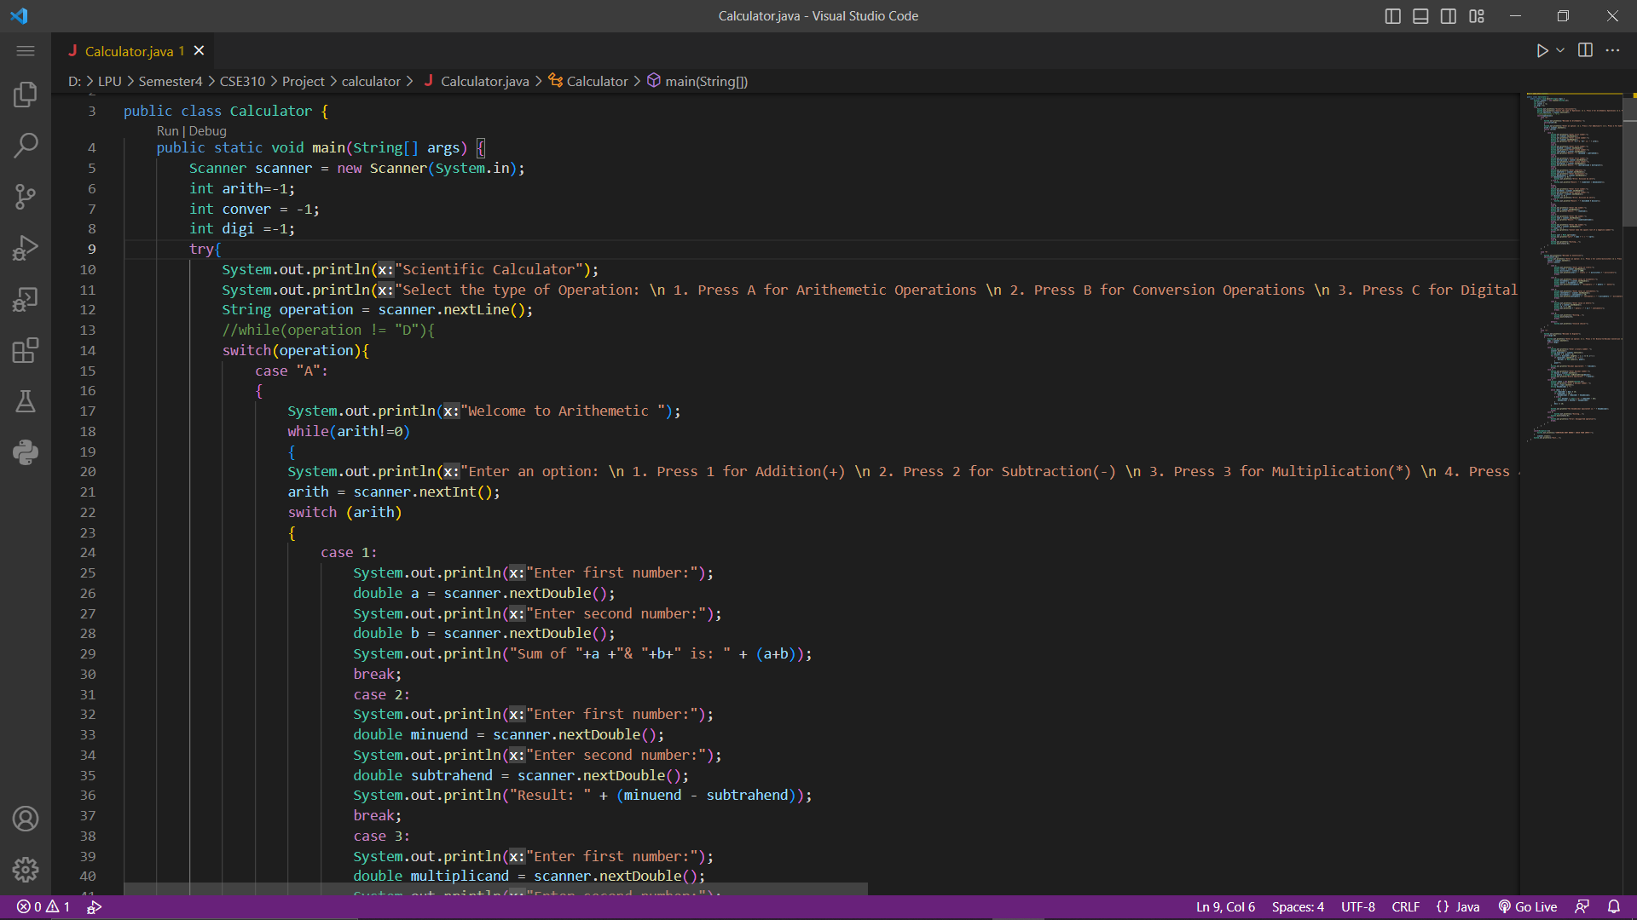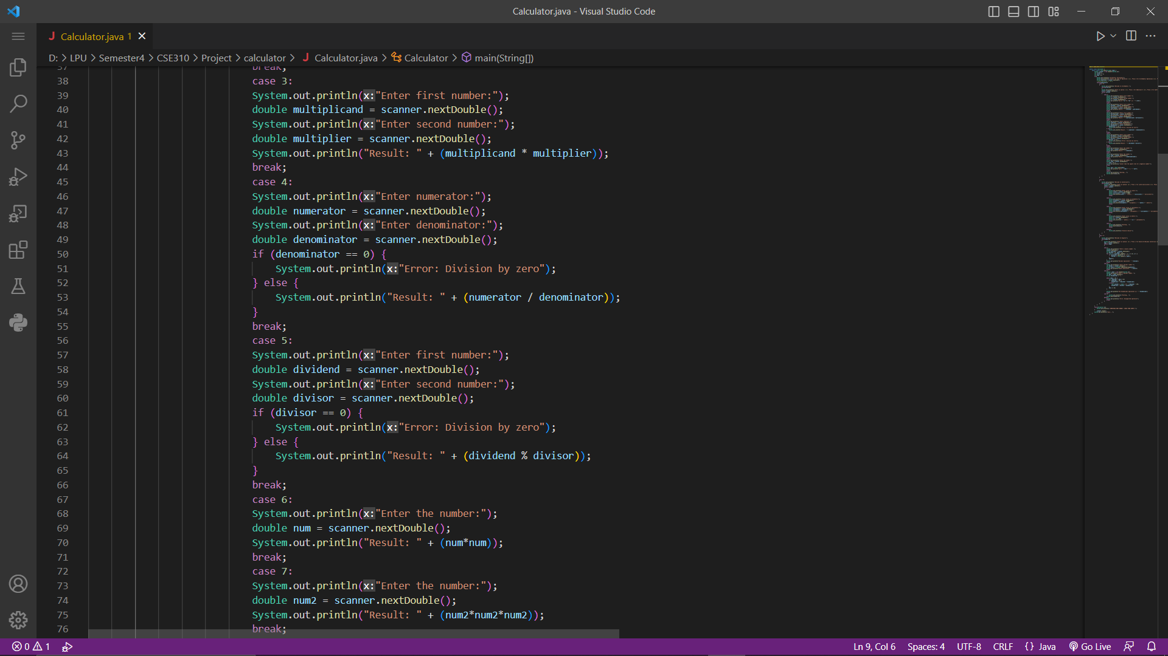

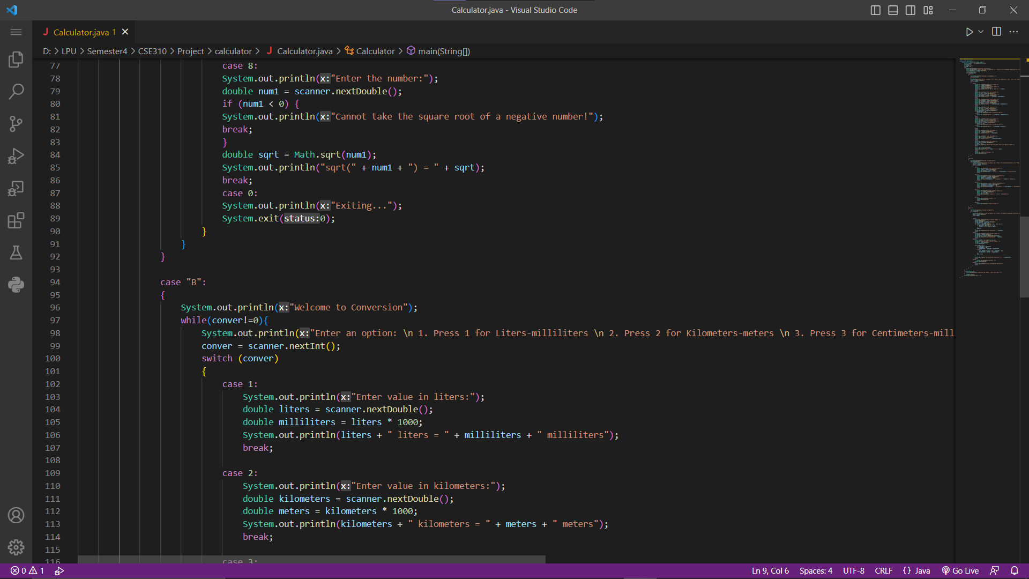

Source Code

Output

**Gantt Chart**

**Role Of Members**