Code :
Problem Statement 1 :
class Book {
int bookId;
String title;
String author;
void getBookDetails(int id, String t, String a) {
bookId = id;
title = t;
author = a;
}
void displayBookDetails() {
System.out.println(&quot;Book ID: &quot; + bookId);
System.out.println(&quot;Title: &quot; + title);
System.out.println(&quot;Author: &quot; + author);
}
}
class IssuedBook extends Book {
String issueDate;
String returnDate;
void getIssuedDetails(String issue, String ret) {
issueDate = issue;
returnDate = ret;
}
void displayIssuedDetails() {
displayBookDetails();
System.out.println(&quot;Issue Date: &quot; + issueDate);
System.out.println(&quot;Return Date: &quot; + returnDate);
}
}
public class inheritance {
public static void main(String[] args) {
IssuedBook b = new IssuedBook();
b.getBookDetails(101, &quot;Java Programming&quot;, &quot;James Gosling&quot;);
b.getIssuedDetails(&quot;01-04-2026&quot;, &quot;10-04-2026&quot;);
System.out.println(&quot;Issued Book Details:&quot;);
b.displayIssuedDetails();
}
}
Problem statement 2 :
class Product {
int productId;
String productName;
double price;
void setProductDetails(int id, String name, double price) {
this.productId = id;
this.productName = name;
this.price = price;
}
void displayProduct() {
System.out.println(&quot;Product ID: &quot; + productId);
System.out.println(&quot;Product Name: &quot; + productName);
System.out.println(&quot;Price: &quot; + price);
}
}
class Electronics extends Product {
int warrantyPeriod; // in months
void setElectronicsDetails(int id, String name, double price, int
warranty) {
setProductDetails(id, name, price);
this.warrantyPeriod = warranty;
}
void displayElectronics() {
displayProduct();
System.out.println(&quot;Warranty Period: &quot; + warrantyPeriod + &quot;
months&quot;);
}
}
class Clothing extends Product {
String size;
String fabricType;
void setClothingDetails(int id, String name, double price, String size,
String fabric) {
setProductDetails(id, name, price);
this.size = size;
this.fabricType = fabric;
}
void displayClothing() {
displayProduct();
System.out.println(&quot;Size: &quot; + size);
System.out.println(&quot;Fabric Type: &quot; + fabricType);
}
}
public class OnlineShoppingSystem {
public static void main(String[] args) {
Electronics e = new Electronics();
e.setElectronicsDetails(101, &quot;Laptop&quot;, 75000, 24);
System.out.println(&quot;Electronics Product Details:&quot;);
e.displayElectronics();
System.out.println();
Clothing c = new Clothing();
c.setClothingDetails(202, &quot;T-Shirt&quot;, 999, &quot;M&quot;, &quot;Cotton&quot;);
System.out.println(&quot;Clothing Product Details:&quot;);
c.displayClothing();
}
}

Output :
Problem Statement 1 :
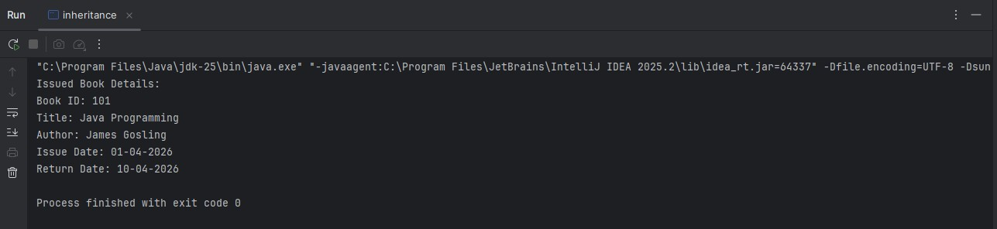

Problem Statement 2:
Electronics Product Details:
Product ID: 101
Product Name: Laptop
Price: 75000.0
Warranty Period: 24 months
Clothing Product Details:
Product ID: 202
Product Name: T-Shirt
Price: 999.0
Size: M
Fabric Type: Cotton

