[Problem Statement 1] :
class Student {
String name;
int marks;
void displayDetails() {
System.out.println("Student Name: " + name);
System.out.println("Marks: " + marks);
}
public static void main(String[] args) {
Student s = new Student();
s.name = "Mayur";
s.marks = 90;
s.displayDetails();
}
}

[Problem Statement 2] :
class BankAccount {
String accountHolderName;
long accountNumber;
double balance;
void deposit(double amount) {
System.out.println("Deposited Amount: " + amount);
balance = balance + amount;
}
void withdraw(double amount) {
System.out.println("Withdrawn Amount: " + amount);
balance = balance - amount;
}
void displayDetails() {
System.out.println("\nBank Account Details");
System.out.println("Account Holder Name: " + accountHolderName);
System.out.println("Account Number : " + accountNumber);
System.out.println("Current Balance : " + balance);
}
public static void main(String[] args) {
BankAccount acc = new BankAccount();
acc.accountHolderName = "Mayur Dighore";
acc.accountNumber = 24070634;
acc.balance = 50000.0;
acc.displayDetails();
acc.deposit(20000.0);
acc.withdraw(15000.0);
acc.displayDetails();
}
}
Output :
[Problem Statement 1] :
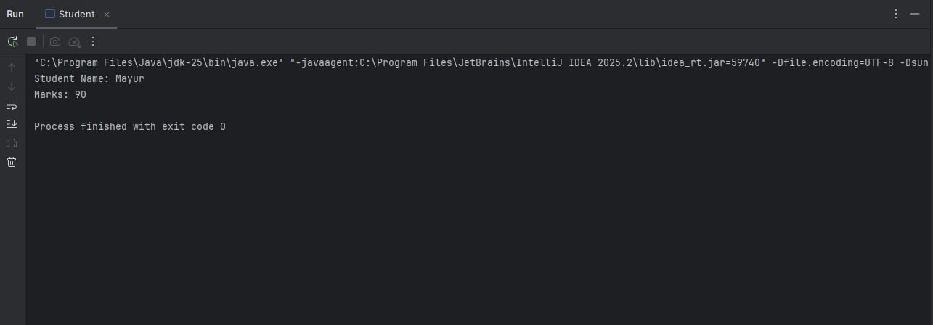
[Problem Statement 2] :
