Prac -9 : JDBC
1.Start
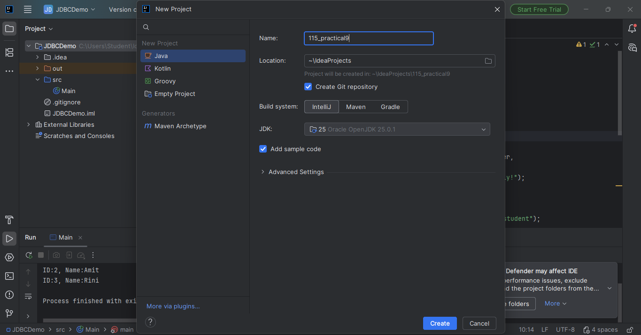
2. Establish Connection:
Create a connection to the MySQL database using URL, username, and password..
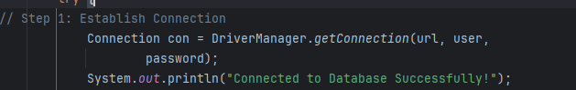
3. Create Statement:
Create a Statement object to execute SQL queries.
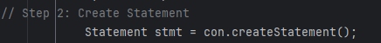.
4. Execute Query:
Execute the SQL SELECT query to fetch data from the table.
5. Process Result:
Traverse the result set and display the retrieved data.
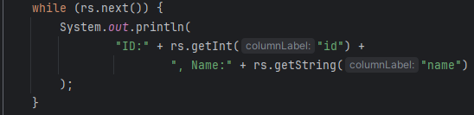
5. Close Connection:
Close the connection to free resources.

Code:

import java.sql.Connection;
import java.sql.DriverManager;
import java.sql.ResultSet;
import java.sql.Statement;

public class Main {
public static void main(String[] args) {
String url = "jdbc:mysql://localhost:3306/testdb";
String user = "root";
String password = "root"; // Change if different

try {
// Step 1: Establish Connection
Connection con = DriverManager.getConnection(url, user, password);
System.out.println("Connected to Database Successfully!");

// Step 2: Create Statement
Statement stmt = con.createStatement();

// Step 3: Execute Query
ResultSet rs = stmt.executeQuery("SELECT * FROM student");

// Step 4: Process Result
while (rs.next()) {
System.out.println(
"ID:" + rs.getInt("id") +
", Name:" + rs.getString("name")
);
}

// Step 5: Close Connection
con.close();

} catch (Exception e) {
e.printStackTrace();
}
}
}

Output:
