Code :
Linear Search
public class linse {
static int linearSearch(int[] arr, int key) {
for (int i = 0; i < arr.length; i++) {
if (arr[i] == key) {
return i;
}
}
return -1;
}
public static void main(String[] args) {
int[] A = {99, 7, 6, 1, 100, 108};
int key = 1;
int result = linearSearch(A, key);
if (result != -1) {
System.out.println("Element found at index " + result);
} else {
System.out.println("Element not found");
}
}
}

Binary search :
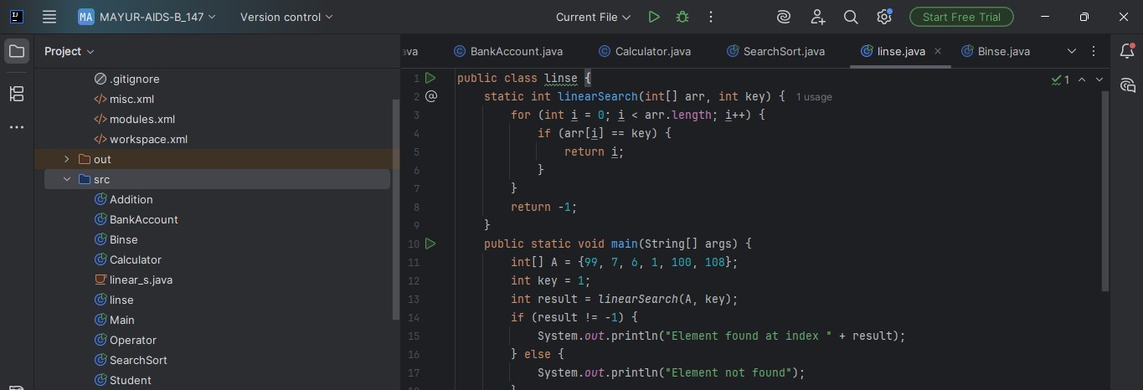

Output :
Linear search :
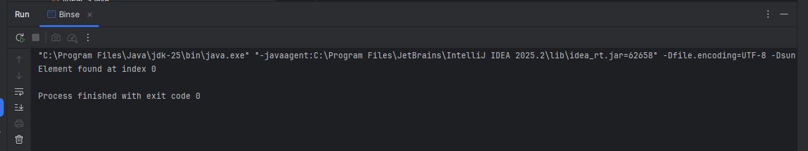
Binary Search :
