**Lesson 08 Demo 03**

**Configuring Multibranch Jenkins Pipeline Job**

**Objective:** To configure a Multibranch Jenkins pipeline job to facilitate managing multiple projects within a single job setup

**Tools required:** Jenkins, Git, and GitHub

**Prerequisites:** None

Steps to be followed:

1. Create a Git repository
2. Push the code file into the Git repository
3. Create a Multibranch Pipeline

**Step 1: Create a Git repository**

|  |
| --- |
| **Note**: If you do not have a GitHub account, visit the official website at https://github.com/signup and create a new account |

1. Open the browser in your lab, go to **github.com**, and sign in to your account  
     
   A screenshot of a login form

   Description automatically generated
2. Click on **New** as shown in the screenshot below:

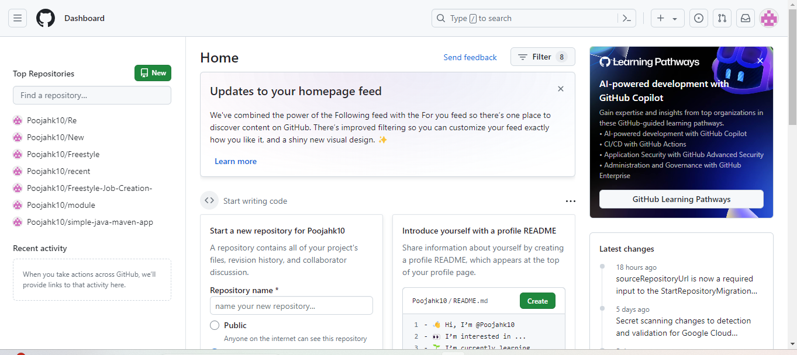

1. Enter a desired name for your repository and choose **Public** as shown in the screenshot below:

1. Click on **Add a README** **file** and then click on **Create repository** as shown in the screenshot below:

1. Click on **Code** as shown in the screenshot below:

1. Copy the repository URL as shown in the screenshot below:

**Step 2: Push the code file into the Git repository**

1. Open the Linux terminal in your lab and clone the repository using the below command:  
   **git clone RepositoryURL**

1. Navigate inside the repository that you had created using the below command:  
    **cd RepositoryName**
2. Initialize the Git using the below command:  
   **git init**



1. Create a file using the below command:  
   **nano demofile**



1. Paste the below pipeline script inside the file as shown in the screenshot below:

**pipeline {**

**agent any**

**stages {**

**stage('Checkout') {**

**steps {**

**// Checkout your source code from version control**

**git 'https://github.com/your/repository.git'**

**}**

**}**

**stage('Build') {**

**steps {**

**// Use Maven to build your project**

**sh 'mvn clean package'**

**}**

**}**

**stage('Test') {**

**steps {**

**// Run tests if applicable**

**sh 'mvn test'**

**}**

**}**

**stage('Deploy') {**

**steps {**

**// Deploy your artifact, if necessary**

**// Example: sh 'mvn deploy'**

**}**

**}**

**}**

**post {**

**success {**

**// This block will be executed if the pipeline runs successfully**

**echo 'Pipeline executed successfully!'**

**}**

**failure {**

**// This block will be executed if the pipeline fails**

**echo 'Pipeline failed!'**

**}**

**}**

|  |
| --- |
| **Note**: Ensure you provide your Git repository URL on line7, save, and exit the page by clicking on **ctrl+S** to save and **ctrl+X** to exit |

**}**

1. Stage and commit the changes using the below commands:  
   **git add .**

**git commit -m “initial commit”**  
  
1. Push the file to the Git repository using the below command:

**git push**

1. Navigate to your Git repository to check for the file that is pushed:  
     
   A screenshot of a computer

   Description automatically generated

**Step 3: Create a Multibranch Pipeline**

|  |
| --- |
| **Note**: Use the given credentials to access Jenkins in the lab: **Username** is admin and **Password** is admin |

1. Open the browser, go to the Jenkins **Dashboard** by typing **localhost:8080** in your browser, provide the credentials, and click the **Sign in** button   
     
   A screenshot of a login page

   Description automatically generated
2. Click on **New Item** as show in the screenshot below:  
     
   A screenshot of a computer

   Description automatically generated
3. Enter a desired name for the project as shown in the screenshot below:  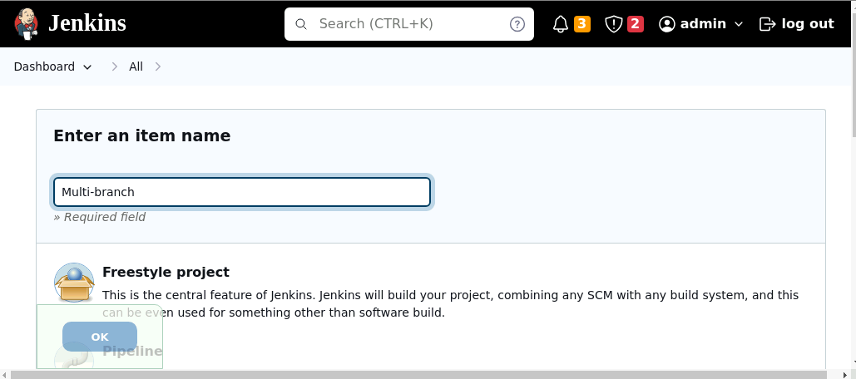
4. Scroll down to **Multibranch Pipeline**,click on it, and then click on the **OK** button asshown in the screenshot below: 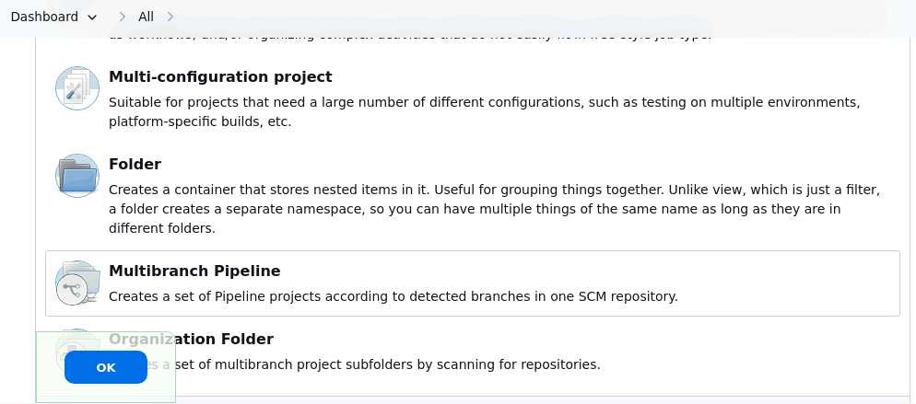
5. Enter a desired name for **Display Name** as shown in the screenshot below:  
     
   **A screenshot of a computer

   Description automatically generated**
6. Scroll down to **Branch Sources** and then click on **Add source** as shown in the screenshot below:  
    **A screenshot of a computer

   Description automatically generated**
7. Click on **GitHub** as shown in the screenshot below:  
    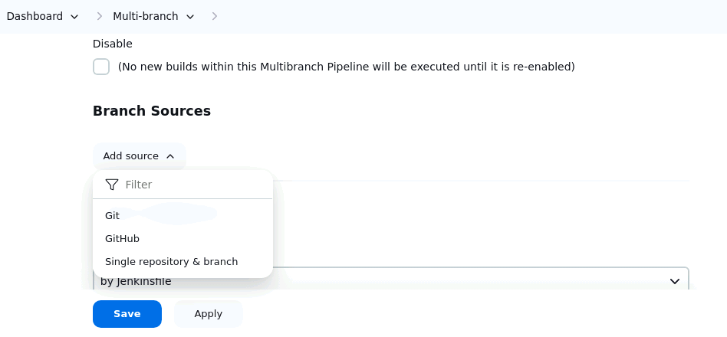
8. Scroll down to **Repository HTTPS UR**L as shown in the screenshot below**:  
     
   A screenshot of a chat

   Description automatically generated**
9. Enter the repository URL and then click on the **Save** button as shown in the screenshot below:  
    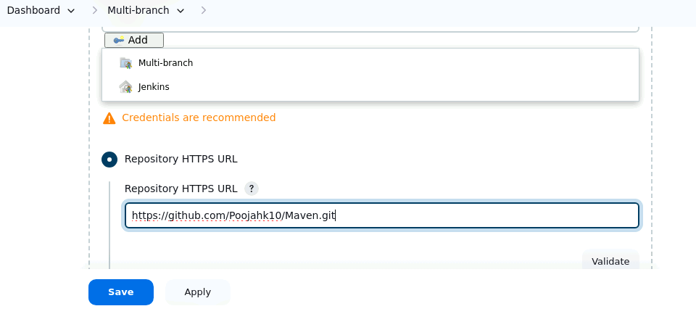
10. Click on **Scan Repository Log** as shown in the screenshot below: 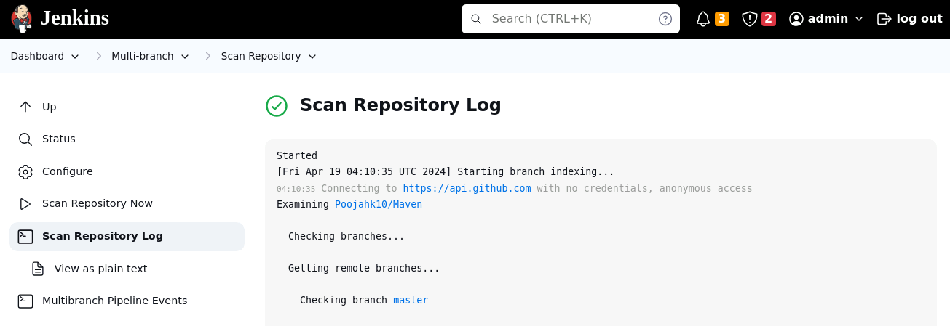
11. Scroll down to verify that the status is displayed as **SUCCESS** as shown in the screenshot below:  
    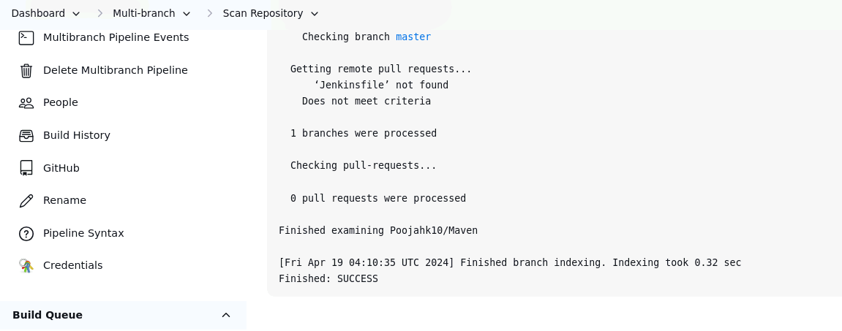  
    By following these steps, you have successfully configured a Multibranch Jenkins pipeline job to facilitate managing multiple projects within a single job setup.