**Teacher dashboard - Main page**

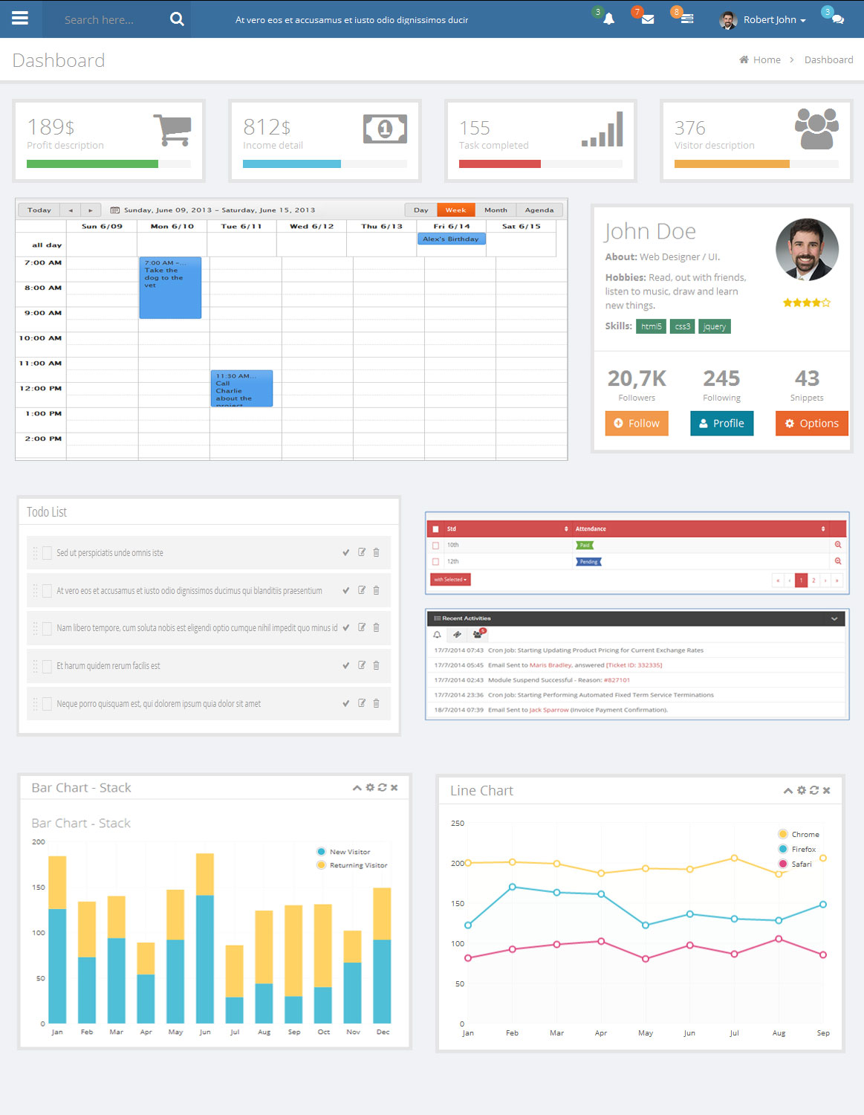

**Class Routine**

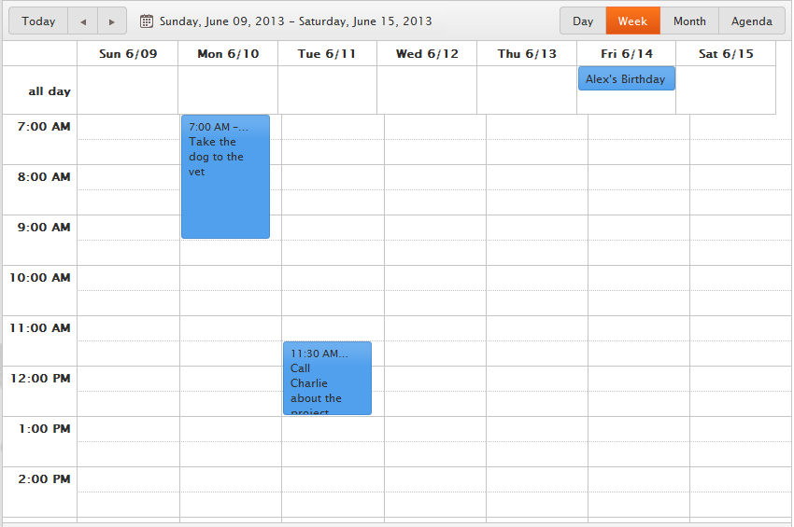

**Attendance (time table)**

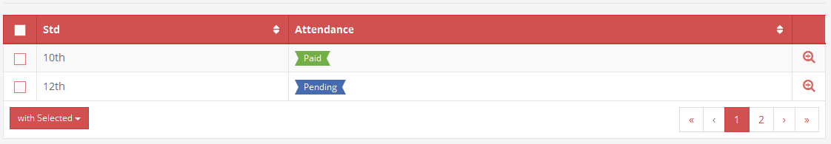

**Teacher Profile**

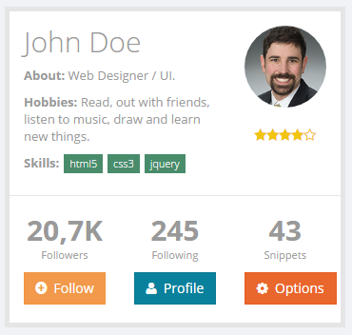

**Notification:**

We suggest providing more option (use icon, vector) [No images]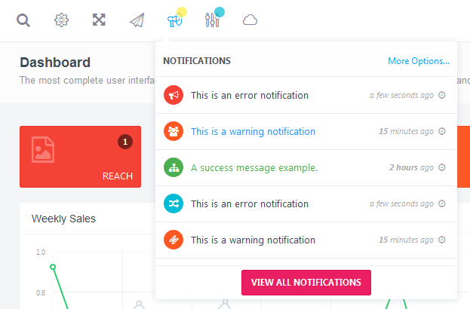

**Recent Activities**

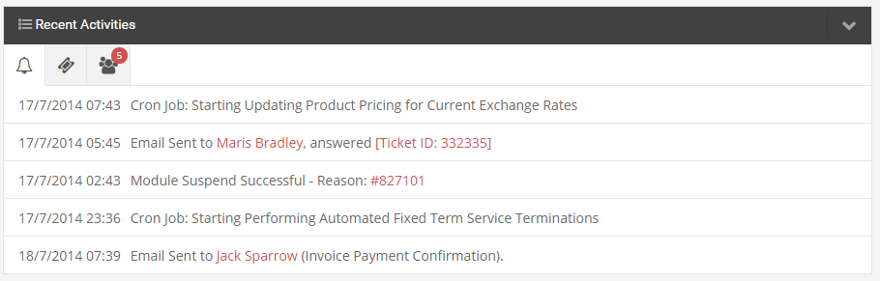

**Graph Report**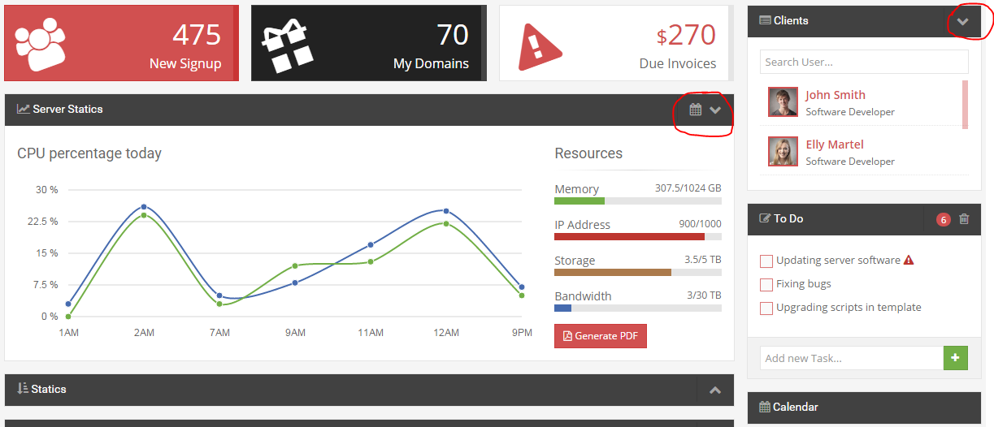

**Todolist**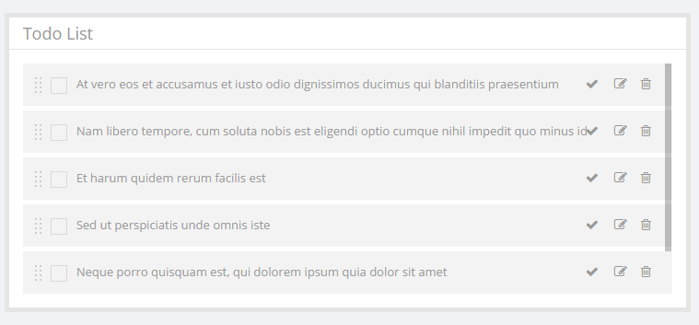

**Exam / Marks section**

