**ADMIN Side**

1. **Participate Management**

* In edit, do ajax filtering of the student by semester and batch
* In add participate, do same thing as mention above.
* In edit, form validation of date of submission, and file upload and its types

1. **Library Management**

* In add library, do ajax filtering of student by semester and batch
* In edit library, do same thing

1. **CMS**

* Edit page not displaying in modal
* Edit modal not showing

1. **Backup/Restore**

* Note: Give me the list of exclude table name (From: Mayur Ghadiya)

1. **Student**

* In add student make validation of profile photo. Profile pic only takes image file (gif|jpg|png)
* Edit student, admin cant upload profile pic of the student (Ref. System setting -> Photo)
* Edit student, admission type is not auto selected
* In add student, do proper validation of Name field
* Make sure admin should not be entering duplicate student. i.e email

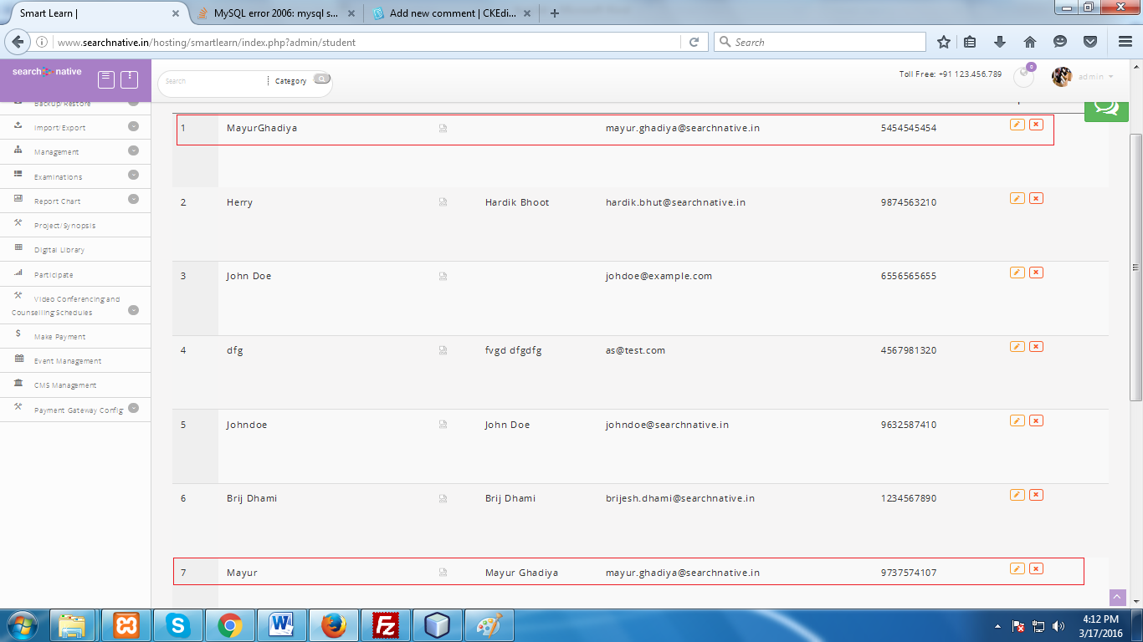

* First name, and Last name field validation

1. **Assignment**

* Validate `Assignment title` properly.
* In edit assignment, validation submission date and file upload (Note: file format: gif|jpg|png|pdf|xlsx|xls|doc|docx|ppt|pptx|pdf|txt) and possible document format.
* **Note:** Assignment url would be full path of the uploaded file. So, student can view or download that particular file. When admin edit the assignment then we have update that assignment url with new uploaded file path.
* Do `Assignment url` field validation

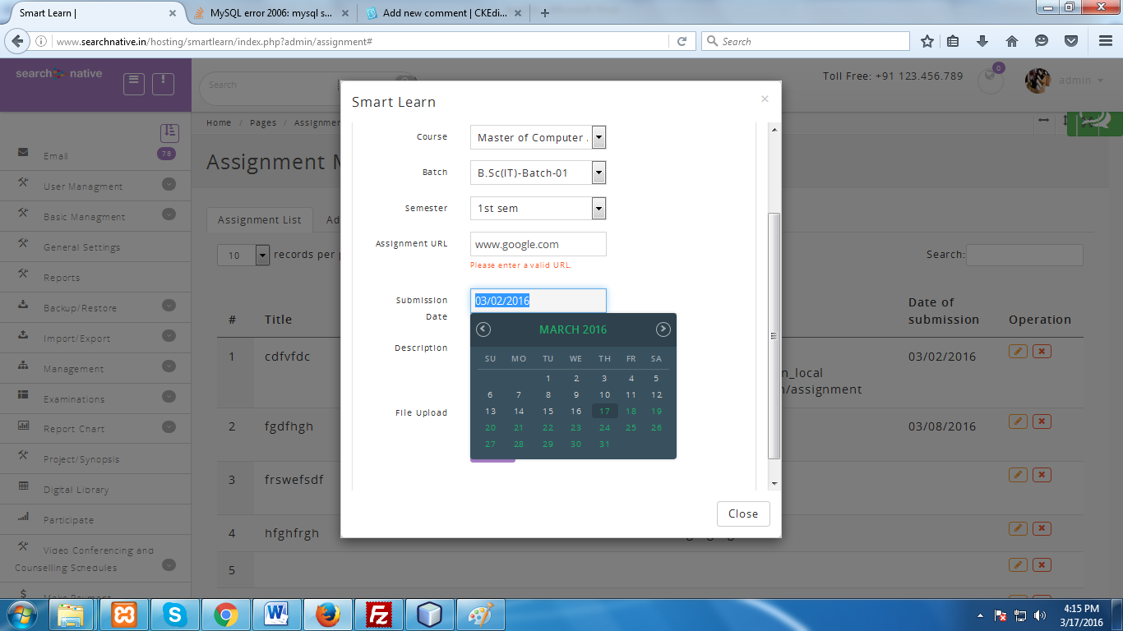

1. **Study Recourse**

* In edit student resource, validate file upload with specific file format.
* In add study resource, make sure page url should be unique for each study resources and it will be auto generated.

1. **Digital library**

* Same as above for page url.
* In edit, validate file upload and its allowed types.

1. **Live streaming and broadcast**

* Validate live broadcast field.
* Validation of course, semester and broadcast name.

1. **Report Chart**

* Remove exam option from it.

1. **Project Management**

* In add, ajax filter for student by semester and batch
* In edit, same as above ajax filtering for student.
* **Note:** What is the purpose of page url?

1. **Make Payment**

* Validation for authorized payment process
* Authorized.net library not found
* Authorized.net payment process error (MySQL server has gone away)

1. **CMS Management**

* Page content validation
* In edit, perform page validation

1. **Email**

* Delete email and mass delete.

1. **Import & export**

* Give me the table field for export file (Mayur Ghadiya)
* Give me the backup table list for backup and restore (Mayur Ghadiya)

1. **Subject Management**

* Subject duplication is there. I.e. same subject, same code, same course and semester.

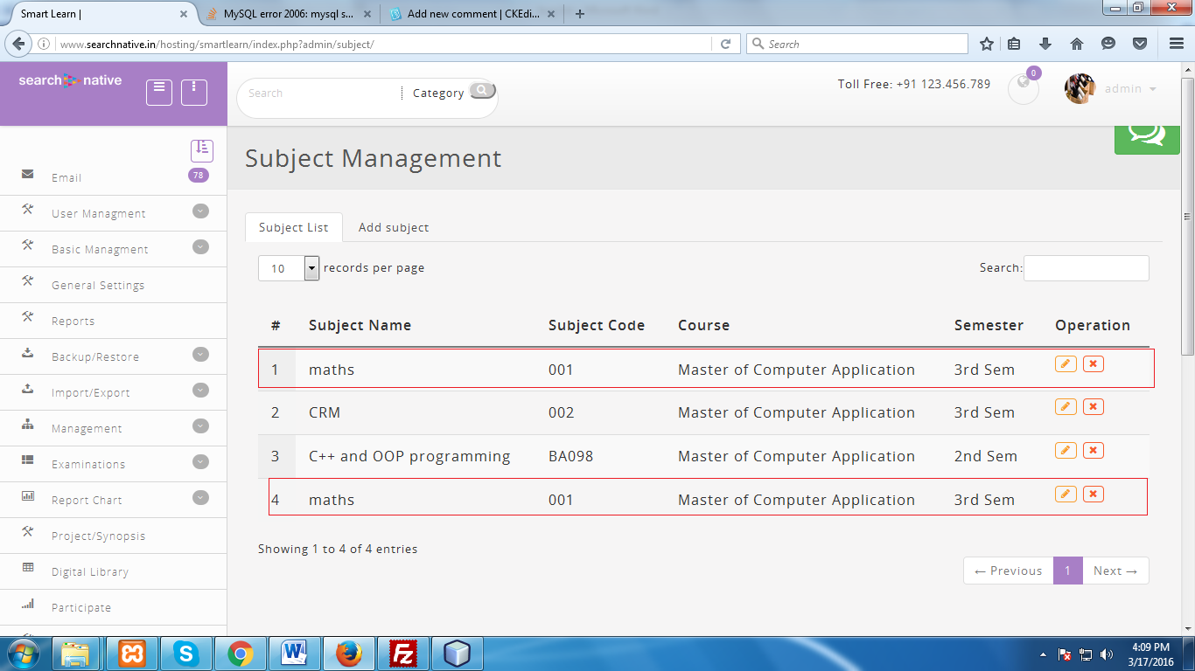

1. **Assign User**

* Do form validation and resolve following db error.

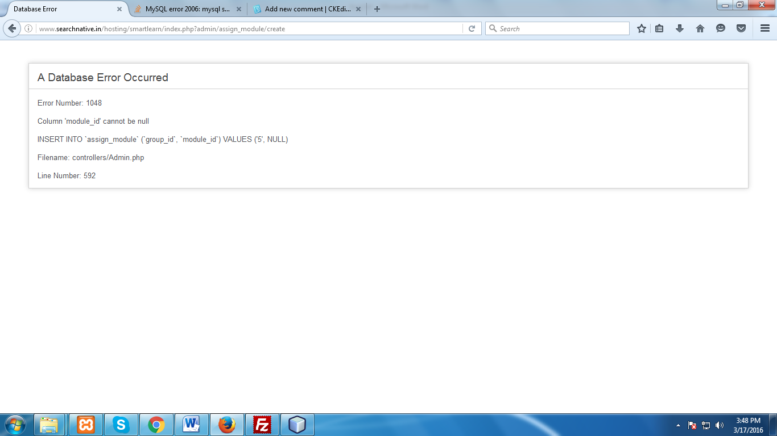

1. **Common**

* Design
* Remove chat message icon.

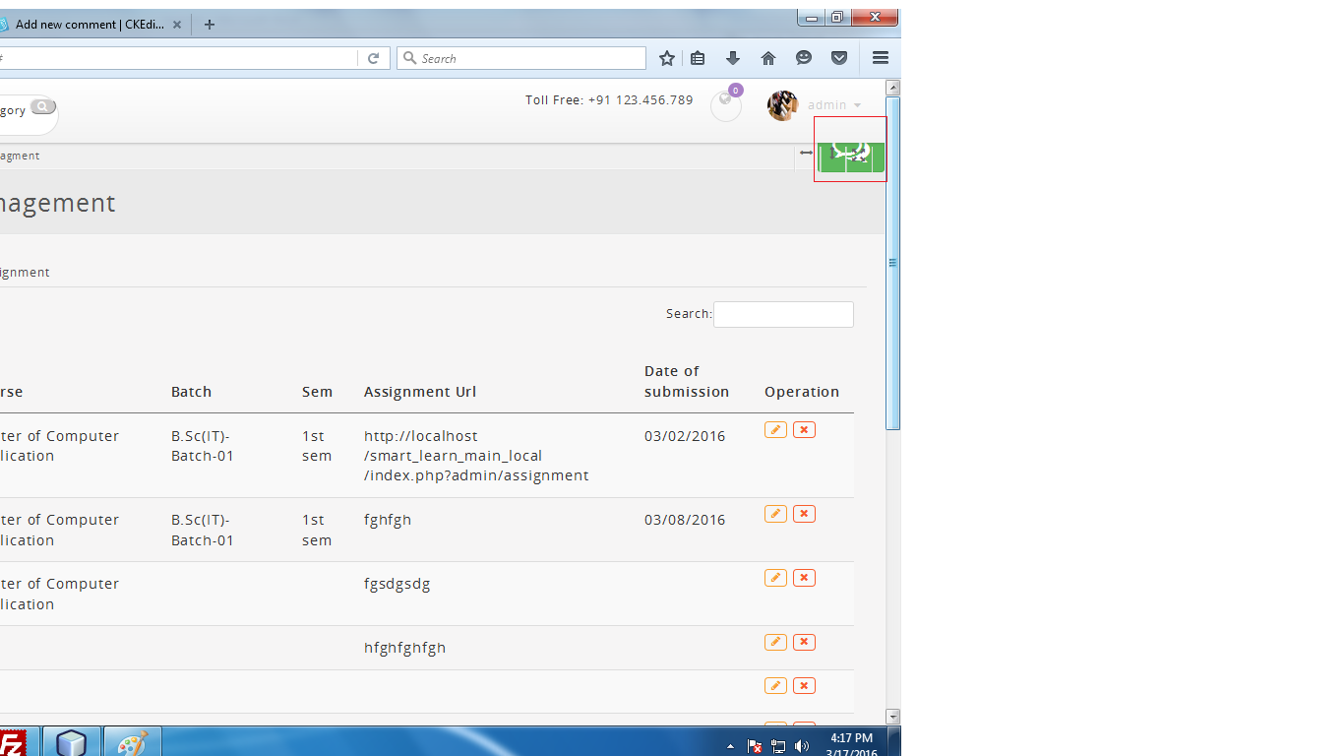

**Student Side**