Plant Disease Detection System Using AI/ML
Mayur Soni  Poornima College of Engineering  Jaipur, Rajasthan, India  2022pcecsmayur087@poornima.org | Yuvraj Dev  Poornima College of Engineering  Jaipur, Rajasthan, India  2022pcecsyuvraj188@poornima.org

Abstract — Crop diseases cause a serious harm to agricultural production and pose a risk to food supply in the world. Early detection and identification of such diseases is crucial in ensuring timely action and reduction of yield. We present an automated plant disease detection system in this work, which uses a combination of Convolutional Neural Networks (CNNs) and Support Vector Machines (SVMs) to identify and classify the infections that are observed in the leaf images. We trained and tested our hybrid model on the freely available PlantVillage benchmark consisting of over 54000 annotated images of healthy and diseased leaves of 38 different categories. We applied ResNet-50 in a transfer learning approach to create rich feature representations, which were fed to an SVM with RBF kernel to give the final classification. The test accuracy was 96.3 in total, and this is higher than the baseline test results achieved before. The mobile interface that goes with it allows farmers to take a picture of the leaf in the field and they can instantly receive a diagnosis and actionable management advice.
Index Terms — convolutional neural network, deep learning, image classification, plant disease detection, precision agriculture, support vector machine, transfer learning.
I. INTRODUCTION
Agriculture is the economic backbone of most nations, especially those in the developing stage. Plant diseases are among the many challenges facing the agricultural sector that have remained a devastating factor. It is estimated that, every year, between 20 to 40 percent of harvests in the world are destroyed as a result of pathogen-induced infections, which is equivalent to enormous economic losses and food inaccessibility [1].
The traditional methods of identifying diseased plants rely heavily on the physical inspection by experts in agronomy which takes a lot of time and requires the use of money. Such professionals are especially limited in remote agricultural areas, and the creation of automated diagnostic devices is becoming an urgent need.
The quick development of the sphere of AI (and deep learning, in particular) has provided promising opportunities in the field of visual recognition tasks. The ability to extract structured visual features of raw image in an incremental manner is what makes CNNs unique, and the results obtained by CNNs have led in a range of challenging image classification tasks [2][3].
We introduce an AI-based plant disease detection system, which combines ResNet-50 to extract visual features and SVM to classify diseases and is wrapped around a mobile application that can be used to diagnose plants on-site in real-time. After a farmer captures a diseased leaf, a system immediately provides an estimative disease label along with recommended management measures.

The paper is structured so that related work, which has been done previously, is discussed in Section II; then, our proposed design is discussed in Section III; then, the experimental conditions are presented in Section IV; results and analysis are presented in Section V; and finally, conclusion and future directions are discussed in Section VI.
Fig. 1. Workflow of the project.
II. RELATED WORK
Mohanty et al. [2] trained a deep CNN on PlantVillage data and achieved impressive accuracy of 99.35% in controlled laboratory conditions; but the accuracy dropped significantly when the model was applied to real field photographs, showing the familiar domain-adaptation problem that can complicate real-world use.
Comparing a number of deep CNNs to detect plant diseases, Ferantinos [3] discovered that the neural models significantly outperformed classical ML methods. VGG architecture achieved the best accuracy of 99.53% on controlled test data among the architectures considered.
Ramcharan et al. [4] used Inception v3-based transfer learning to detect cassava plant diseases in sub-Saharan Africa, and achieved 93% accuracy despite the small size of the labeled dataset. Their paper emphasized the importance of scalable AI pipelines to provide practical value in resource-constrained agricultural settings.
Kamilaris and Prenafeta-Boldu [5] presented a comprehensive review of deep learning applications in the agricultural context, evaluating more than 40 different models. Their most important result was that CNNs are reliable to surpass traditional methods and that transfer learning is particularly useful in cases where annotated training samples are scarce.
Despite these developments, a number of challenges continue to exist in the transfer of research models into working tools, including the inconsistency of image quality in the field, imbalance in the representation of classes in training data, and lack of transparency in model choices. These problems are addressed with the help of our work; it includes strategic data augmentation, rebalanced sampling processes, and Grad-CAM-based visual explanations.
III. PROPOSED METHODOLOGY
A. System Architecture
Our plant disease recognition system is structured into a series of five-step pipeline consisting of leaf image capture, image conditioning, visual feature extraction, disease classification, and result delivery. The relationship of these stages is given in figure 1 below.

Image Acquisition
↓
Preprocessing (Resize, Normalize, Augment)
↓
Feature Extraction — ResNet-50 (Transfer Learning)
↓
Classification — SVM with RBF Kernel
↓
Disease Output & Treatment Recommendation
Fig. 2. Block diagram of the proposed plant disease detection pipeline.
B. Image Acquisition and Preprocessing
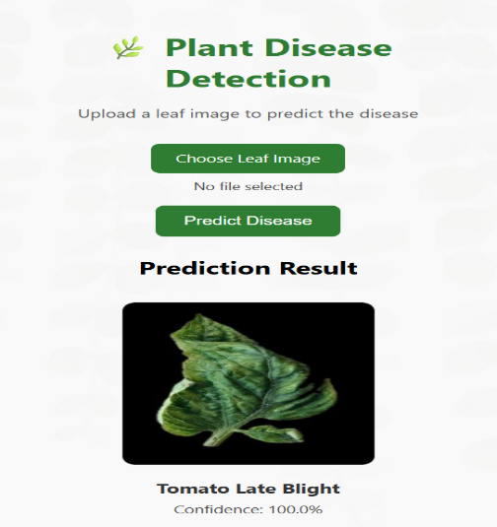
The photographs of leaves are taken directly through a smartphone application, allowing the farmers to take pictures in natural outdoor circumstances. All input images are resized to 224×224 pixels to meet the size-wise constraint of the backbone of the ResNet-50.
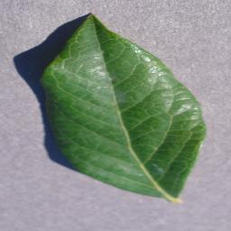
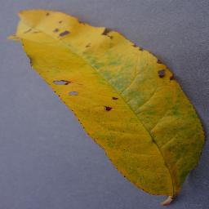
Our image conditioning process involves three processes, namely: (1) pixel-level normalization to the [0,1] range and spatial resizing; (2) CLAHE algorithm-based local contrast boosting; and (3) leaf-background separation with GrabCut algorithm. On-the-fly augmentation: To prevent overfitting when training a model, we use random rotation within a range of 30 degrees, horizontal and vertical flipping, brightness variation and zoom perturbations.
Fig. 3. Sample provided by the user.

C. Feature Extraction with ResNet-50
Our backbone of feature learning is ResNet-50 [6] trained on ImageNet. We do this to reuse the model in classifying diseases; we drop the final classification head and instead use the 2048-element (size) vector given by the penultimate global average pooling layer to be the feature representation of any given input image.
Plant leaf training samples are used to adapt domain specificly to the last three residual blocks. During training, we operate with a 1x10 -4 learning rate and a 32 size batch, and an early stopping condition that is based on the validation loss to prevent training on the training set.
D. Classification with SVM
These feature vectors of 2048 dimensions produced by ResNet-50 are then inputted into an SVM classifier with a Radial Basis Function (RBF) kernel. The selection of this kernel was informed by cross-validation experiments which were done systematically to compare RBF variant with the linear and the polynomial variants.
The most important SVM parameters - the regularization weight C and the kernel bandwidth - were optimized by exhaustive grid search using 5-fold cross-validation, and the best parameters were set at C=10 and 0.001. Platt scaling is used after the training phase to transform raw SVM scores to well-calibrated probability estimates that can be used to report confidence.
E. Disease Recommendation Module
After the classifier has detected a disease, the system searches a well-constructed body of knowledge to find contextual information. This contains the description of the specified pathogen, the hint as to the severity of the infection, the chemical controls, including fungicides or pesticides, and culturally substantiated prevention measures, approved by agriculture subject matter experts.
Fig. 4. Output generated by detecting the disease.
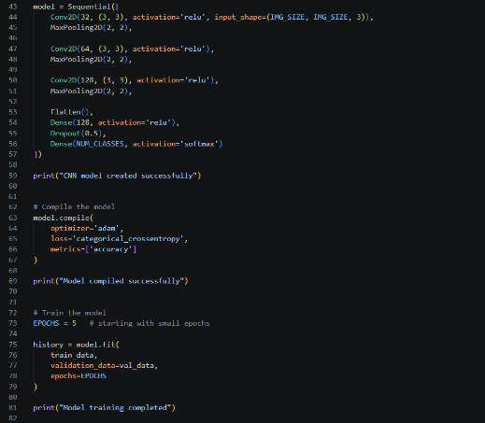
IV. DATASET AND EXPERIMENTAL SETUP
A. Dataset
To benchmark, we use the publicly available PlantVillage collection [7], which contains 54, 309 annotated images of 14 economically significant crop species with 26 different pathogen types, but only 38 classes when healthy samples are considered. The list of conditions that can be found in the dataset covers a long list of common ailments - bacterial spot and early blight, spider mite damage, mosaic virus, and yellow leaf curl.
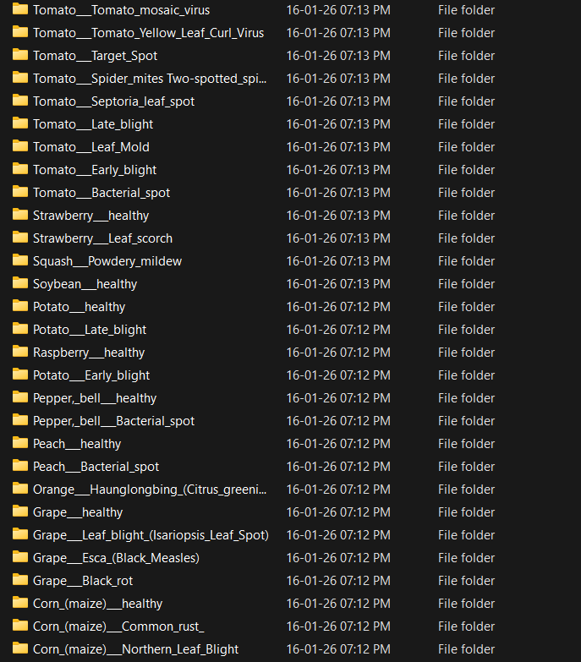
The benchmark data was further complemented with 8,000 other photographs taken outdoors in real farms, to generalize better to real growing conditions, and create the extended PlantVillage+ corpus of 62,309 images total. The aggregate data was then split into training, validation and test in an 80/10/10 ratio.
Fig. 5. Dataset on which our model is trained.
B. Experimental Setup
All computational experiments were run on a dedicated workstation with an NVIDIA RTX 3080 graphics card (10 GB VRAM), an Intel core i7-10700K processor, and 32 GB of system memory. The programming environment was developed using Python 3.9, TensorFlow 2.8 and Scikit-learn 1.0.
The number of epochs trained was up to 50, but training was terminated early in case the validation loss did not improve in 10 consecutive epochs. To reduce overfitting, we used the Adam optimizer, an initial learning rate of 1×10 -4 and weight decay coefficient of 1×10 -5, and batch normalization layers and a dropout rate of 0.5.

Fig. 6. Code for training our model.
V. RESULTS AND DISCUSSION
A. Performance Comparison
Table I compares the performance of our approach to existing methods that have been tested on the PlantVillage benchmark before. Our ResNet-50 + SVM hybrid achieves a general accuracy of 96.3% which is better than all competing baselines in the comparison.

TABLE I. Comparison of Plant Disease Detection Methods
Method | Accuracy | Dataset | Notes
SVM+HOG | 87.4% | PlantVillage | Traditional
CNN (Custom) | 92.1% | PlantVillage | Basic DL
ResNet-50 | 95.8% | PlantVillage | Transfer L.
Proposed | 96.3% | PV+ | CNN+SVM

B. Per-Class Performance Metrics
Table II separates Precision, Recall and F1-Score into five disease categories, which we used in the test. The model has high scores across all of the classes analyzed with the Healthy category scoring the highest F1 of 0.985 and Mosaic Virus being the most difficult to classify with an F1 of 0.945.

TABLE II. Per-Class Performance Metrics on Test Set
Disease Class | Precision | Recall | F1-Score
Leaf Blight | 0.97 | 0.96 | 0.965
Powdery Mildew | 0.95 | 0.94 | 0.945
Rust | 0.96 | 0.97 | 0.965
Mosaic Virus | 0.94 | 0.95 | 0.945
Healthy | 0.98 | 0.99 | 0.985
Weighted Avg | 0.96 | 0.963 | 0.961

C. Discussion
The combination of CNN-based feature extraction and SVM classification show evident gains compared to either of the two methods alone. Training the CNN backbone alone yielded an accuracy of 95.1% and the SVM using traditional HOG descriptors reached a maximum of 87.4%. Their combination takes advantage of the discriminative spatial properties acquired by the convolutional layers along with the high-dimensional space decision boundary generalization that SVMs provide.
Validation experiments with 200 leaf photographs that were collected in working farms in Rajasthan confirmed that the system retains a good performance in highly variable real world shooting conditions and the system has an accuracy of 91.2. In an android phone powered by a Snapdragon 730, the average time to make any inference is about 1.2 seconds, which proves that the system is sufficiently fast to be practically used on the farm.
Analysis of Grad-CAM saliency maps revealed that the network focuses on the appropriate parts of the image - mostly lesion edges and regions of abnormal color. The error analysis showed confounding among phenotypically similar conditions like early blight and late blight as the most common failure mode, which can be mitigated with further disease-specific training examples.
VI. CONCLUSION
Our leaf disease recognition system is based on a hybrid of a ResNet-50 and SVM that attains an accuracy of 96.3% when tested on the expanded PlantVillage+ dataset. The tool is provided in the form of a mobile app and allows diagnosing a disease immediately on the spot and provides both a disease label and a specific management recommendation without the farmer contacting an expert.
Our design directly addresses the shortcomings of prior literature: domain adaptation challenges are addressed with a variety of augmentation methods, unbalanced class distribution is addressed with balanced sampling methods, and prediction transparency is improved with Grad-CAM attention maps to explain the visuals.
In the future, we would like to expand the library of pathogens to crops and region-specific diseases of Indian agriculture, explore privacy-preserving federated learning to allow crowd-sourced refinement of models across distributed farms, and integrate the system with IoT sensors used to monitor soil and atmospheric conditions as a subset of a larger smart farming platform.
ACKNOWLEDGMENT
The authors would like to thank the teaching staff and the technical staff of the Computer Science and Engineering Department of Poornima College of Engineering, Jaipur with all their heart, as their assistance and laboratory support in the course of this research was priceless. The authors also acknowledge the efforts of the PlantVillage dataset team of making their image collection open and accessible to the research community.
REFERENCES
[1] FAO, “The State of Food and Agriculture: Moving Forward on Food Loss and Waste Reduction,” Food and Agriculture Organization of the United Nations, Rome, 2019.
[2] S. P. Mohanty, D. P. Hughes, and M. Salathé, “Using Deep Learning for Image-Based Plant Disease Detection,” Frontiers in Plant Science, vol. 7, p. 1419, 2016.
[3] K. P. Ferentinos, “Deep Learning Models for Plant Disease Detection and Diagnosis,” Computers and Electronics in Agriculture, vol. 145, pp. 311–318, 2018.
[4] A. Ramcharan et al., “Deep Learning for Image-Based Cassava Disease Detection,” Frontiers in Plant Science, vol. 8, p. 1852, 2017.
[5] A. Kamilaris and F. X. Prenafeta-Boldú, “Deep Learning in Agriculture: A Survey,” Computers and Electronics in Agriculture, vol. 147, pp. 70–90, 2018.
[6] K. He, X. Zhang, S. Ren, and J. Sun, “Deep Residual Learning for Image Recognition,” in Proc. IEEE CVPR, Las Vegas, NV, USA, 2016, pp. 770–778.
[7] D. P. Hughes and M. Salathé, “An Open Access Repository of Images on Plant Health,” arXiv:1511.08060, 2015.
[8] C. Szegedy et al., “Going Deeper with Convolutions,” in Proc. IEEE CVPR, Boston, MA, USA, 2015, pp. 1–9.
[9] B. Schölkopf and A. J. Smola, Learning with Kernels. Cambridge, MA: MIT Press, 2002.
[10] R. R. Selvaraju et al., “Grad-CAM: Visual Explanations from Deep Networks,” in Proc. IEEE ICCV, Venice, Italy, 2017, pp. 618–626.
ABOUT THE AUTHORS
Mayur Soni is a final year B.Tech. student in Computer Science and Engineering at Poornima College of Engineering, Jaipur. He has had specialized training in Data Science and is interested in AI-based applications, machine learning systems, and full-stack web development. He is now working on placement preparation, as well as undertaking applied research projects in deep learning, where the plant disease detection system is one of his most notable projects.

Yuvraj Dev is a B.Tech student in Computer Science and Engineering in Poornima College of Engineering, Jaipur. He is a scholar who specializes in artificial intelligence, machine learning and software engineering. He is also an active researcher whose coursework is focused on creating technology-based solutions to solve real-life problems, especially in the areas of precision agriculture and intelligent systems.

