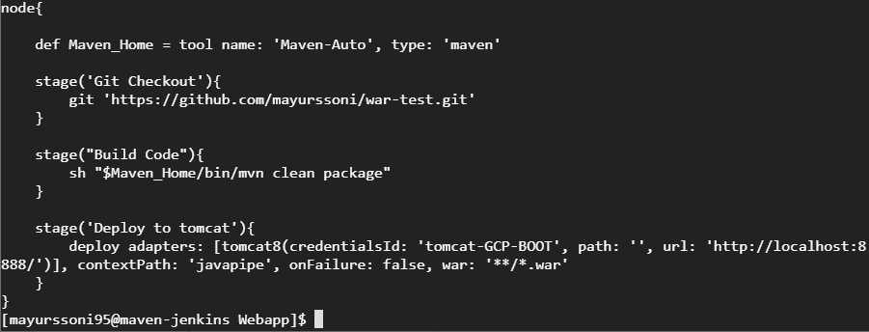

Jenkins pipeline code to deploy war on local tomcat.