A Mini Project Report

on

**“WEBSITE TO COMPARE DIFFERENT MODELS OF AUTOMOBILE”**

Third Year of Engineering

In

Mechanical Engineering

By

Rudra Singh (22)

Sandesh Singh (23)

Vikas Singh (24)

Sharafat Syeed (25)

Mayur Tarfe (27)

**Name of Department**

**Thakur College of Engineering and Technology, Kandivali**

**2019-20**

**CERTIFICATE**

This is to certify that the students of Third Year **“Mechanical”**  Engineering at Thakur College of Engineering and Technology, have satisfactorily completed the requirements of the PROJECT under Employability Skills Development Programme - 2020 while working on **Project Title “WEBSITE TO COMPARE DIFFERENT MODELS OF AUTOMOBILE.”**

**(Faculty Name)**

**T&P Coordinator**

**Mr. Amol Dapkekar**

**Training Coordinator**

**Dr. Zahir Aalam**

**Professor (TPO)**

**Dr. B. K. Mishra**

**Principal**

**Internal Examiner:**

**Signature with Date: ……………..**

**Name: ……………………………..**

**External Examiner:**

**Signature with Date: ………….. Name: ………………………….**

PLACE: Mumbai

DATE:



INDEX

|  |  |
| --- | --- |
| **Sr No** | **Title** |
|  | Executive Summary |
|  | Problem Statement |
|  | Description |
|  | Finding |
|  | Implementation |
| 6. | Result & Discussion |
| 7. | Impact Study |
| 8. | Conclusion |
| 9. | References |

**EXECUTIVE SUMMARY**:

1. In today's world car has become a essential thing for a human being. So to buy a car human visit various website and shop to see the car and get details about it.
2. So to ease it me and my team has created a website which displays comparison between two car of model which user want. The user just has to visit the website and then choice the car name and model and then they will get the information about car.
3. The name of the website is **"Cardekho.com"**.

**PROBLEM STATEMENT:**

* A **problem statement** is a concise description of an issue to be addressed or a condition to be improved upon. It identifies the gap between the current (problem) state and desired (goal) state of a process or product. Focusing on the facts, the problem statement should be designed to address the [Five Ws](https://en.m.wikipedia.org/wiki/Five_Ws). The first condition of solving a problem is understanding the problem, which can be done by way of a problem statement.
* As a user I main issue will be rooming here and there in search of different type of cars in my desired seggment (i.e if I want to buy a xuv I have pay a visit to diffent companies showroom to get knowledge about different xuvs from the respective companies) considering the 4 w’s.

1. who – the person who is a potential buyer will visit our website
2. what – the person visiting our website will get a ample amount of information.
3. where – people can find as on internet
4. why – people will come to use because we have made their life easy with all information under a roof.

**DESCRIPTIONS:**

* So when the user visit the website first he/she will the front webpage consist of different options such has contact, home, about ,etc.
* In the centre of the webpage, two box will be displayed consisting of 2 option for brand and 2 option for the model of the car.
* After selecting the brand and model of the car then the user has to press the submit button. After submitting a different webpage will display which will consist the compared of the car which the user has choiced.
* The comparison table will consist of car name, fuel tank size,milega, price,etc.
* It can be helpful for the people to get the knowledge of different car by just sitting at home and will compare different car model by just one click.

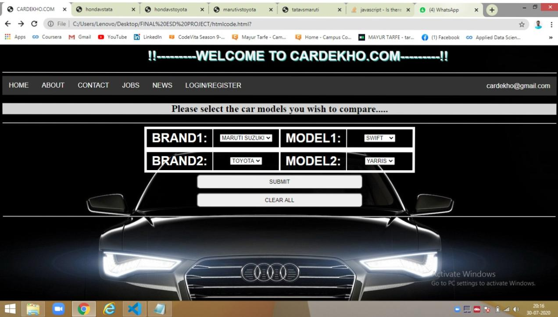

**FINDING:**

* We had studied the original website of cardekho.com. It is an Indian Automobile buying and selling website.
* The finding that we got from the review of their website was we need to mention the details on the navigation bar.
* The website must be attractive and should provide information as much as possible.

**IMPLEMENTATION:**

* The software which was used to do the code is visual studio code.

It is mainly used to develop computer programs, web services, web apps, mobile apps. The team developed a website using programming concepts such as javascript,CSS.

* The programming language used is Html, CSS and JavaScript.

1. **CSS:**

* CSS stands for Cascading Style Sheets.
* CSS describes how HTML elements are to be displayed on screen, paper, or in other media.
* CSS saves a lot of work. It can control the layout of multiple web pages all at once.
* External stylesheets are stored in CSS files.

1. **JavaScript:**

* JavaScript is a scripting or programming language that allows you to implement complex features on web pages
* JavaScript is a scripting language that enables you to create dynamically updating content, control multimedia, animate images, and pretty much everything else.

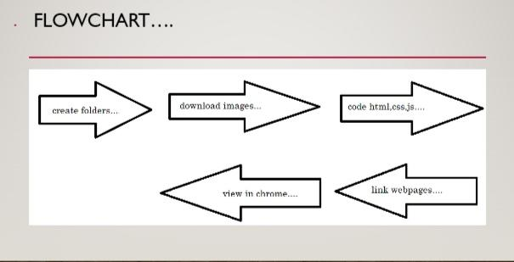

**RESULT & DISCUSSION:**

* **RESULT**: A website for comparing the automobile brands is created. The website is a collection of the webpages of about, contact, job, news etc. Its a fully functioning website. You can compare the price, mileage, bootspace, speed, etc for your chosen brand. You also have an option to register for the site and apply for jobs in company.Discuss on future scope of your project.
* **OUTPUT**: When the webpage is displayed the title is displayed. after that there is a navigation bar. The navigation bar consists of the home about contact jobs etc. Visitor can hover over the options. when he clicks on the about page it directs to the about details of the site. when visitor clicks on contact the contact details will be displayed. when the job button is clicked a form for filling details is displayed. when clicked on the news the automobile news is displayed. there. below that user will have the option to chose the vehicle brands he wish to compare. Then click on submit to get the details.

**IMPACT STUDY:**

* As the demand of the car is increasing day by day so to get good and affordable car people visit various shop. So to overcome the this website is being developed. You can easily visit the website put the car brand and model and compare the car specifications.
* The group members enjoyed working on making the website. We learned different programming language such as html, css and JavaScript.

**CONCLUSION:**

* A website for comparing the automobile brands is created. The website is a collection of the webpages of about, contact,job, news etc etc. Its a fully functioning website. You can compare the price, mileage, bootspace, speed, etc for your chosen brand. You also have an option to register for the site and apply for jobs in company.
* So the knowledge that we have gained in these 5 days is implemented properly.
* We have tried our best to detail the site.
* Due to lack of time we have just gave a option to compare 4 brands. But its just a prototype when one wishes to host he or she can add the webpages and link them.

**REFERENCE:**

1. <https://www.w3schools.com/js/js_intro.asp>
2. <https://www.w3schools.com/html/default.asp>
3. <https://www.w3schools.com/css/default.asp>
4. <https://www.youtube.com/watch?v=zxfhf-V4JFQ>
5. www.cardekho.com