System Requirements Statement (SRS) –

Trek Hub

1. Introduction 3

2. Functional Requirements 4

2.1 Trekker Module 5

2.2 Guide Module 9

2.3 admin Module 12

2.4 UseCaseDiagram..................................................................................................................................13

THIS DOCUMENT CONTAINS 11 NUMBERED PAGES

1. **Introduction**

This document explains the system requirements and scope for developing Trek-Hub.

Trek Hub could divide the three main parts:- Trekker part, Guide part, Admin part.

1. **Functional Requirements**

The Account part of Trek Hub has three modules which are divided 22 processes described as below.

|  |  |  |
| --- | --- | --- |
| **No** | **BRS requirement ID** | **Description** |
| **2.1** | **Trekker Module** | |
| **2.1.1** | **F1** | **Account Creation Process** |
| **2.1.2** | **F2** | **Login Process** |
| **2.1.3** | **F3** | **Forgot Password Process** |
| **2.1.4** | **F4** | **Change Password Process** |
| **2.1.5** | **F5** | **Update Account Process** |
| **2.1.6** | **F6** | **Search Package** |
| **2.1.7** | **F7** | **Book Trek** |
| **2.2** | **Guide Module** | |
| **2.2.1** | **F9** | **Login Process** |
| **2.2.2** | **F10** | **Forgot Password Process** |
| **2.2.3** | **F11** | **Change Password Process** |
| **2.2.4** | **F12** | **Update Account Process** |
| **2.2.4** | **F13** | **View Assigned packages** |
| **2.3 Admin Module** | | |
| **2.3.1** | **F13** | **Login Process** |
| **2.3.2** | **F14** | **Add Trek** |
| **2.3.4** | **F16** | **Plan Trek** |
| **2.3.5** | **F17** | **Manage Package** |
| **2.3.6** | **F18** | **Track Packages** |
| **2.3.7** | **F19** | **Create Guide** |
| **2.3.8** | **F20** | **Manage Guide** |
| **2.3.9** | **F21** | **Track Bookings** |
| **2.3.10** | **F22** | **Track Payments** |

* 1. **Trekker Module**
* Trekkers are the user of system who wants to go for trekking.
* They are able to view and search the packages.
  + 1. **Account Creation Process**
* Trek Hub compels to login before booking a event. So, Trek Hub should provide the function which makes trekkers creates new account.
* When trekker creates new account, the function demands following information described as below.

1. Username
2. Password
3. First Name
4. Last Name
5. E-mail address
6. Address
7. Phone No
   * All items are compulsory demanded.
8. Username

* The Username should be unique. If the Username corresponds with not case-sensitive to other which is previously registered, the Username should not be registered as an account.

1. Password

* The Password has a constraints which makes the Password consists of more than or equal 8 and less than or equal 16 characteristics including characters described as below.
* Numeric figure (at least one)
* Capital alphabet (A-Z)(at least one)
* Small alphabet (a-z)(at least one)
* Special character (#, $, %, &, etc.) (at least one)
* The Password is masked by dummy characters. The re-entering Password is demanded.

1. First name

* First name has the constraints which contain max size of 15 characters.

1. Last name

* First name has the constraints which contain max size of 15 characters.

1. Email Address

* Email address should be valid

1. Address

* Address has the constraints which contain max size of 200 characters.

1. Phone no

* Phone number has the constraints which contain exactly 10 digit.
  + 1. **Login Process**
* The user authentication demands Username and Password. The Username and the Password should be checked as below.
  + The Username and the Password should be existed and correct.
* If The Username and the Password are not equal to what the user has registered, the user authentication cannot be provided.
* The “Home Page” provides the some items described as below.

1. A trigger to logout
2. A trigger to profile
3. A trigger to Search package
4. A trigger to Update Profile
5. A trigger to home page
   * 1. **Forgot Password Process**

* When system user lost their Password, the recovery method should be provided by Trek Hub.

The recovery method is described as below.

* + First, system user enters their Username for Trek Hub.
  + Next, Trek Hub demands email id , which has been registered since when the Account was created.
  + Trekker get the new password by E-mail.
  + The new password is automatically generated by Trek Hub.
* Of course, the new password should consist of more than or equal 8 and less than or equal 16 characteristics.
* As a consequence, The Trekker can re-login using the new password.
  + Then, the trekker had better change the new password manually.
    1. **Change Password Process**
* When Trekker wants to change their Password, the measure should be provided by Trek Hub.
* Therefore, Trek Hub should provide the function which is available after the Trekker logs in.
* The function demands the current password and the new password.
  + The new password should consist of more than or equal 8 and less than or equal 16 characteristics including at least a numeric figure, a capital alphabet, a small alphabet, and a special character.
  + The current password and the new password are masked by using dummy characters.
  + The new password is demanded to enter twice to avoid a typing error.
* Only when the current password is correct, Trekker could change their Password.

* + 1. **Update Account Process**
* TrekHub should provide the function which makes the account updated for Trekkers.
* The information Trekkers could update is described below.

1. Login information
2. User information

* The Login information

The updatable items as described below.

1. Username
2. Password
   * All items are compulsory demanded, but updating is optional.

* The User information

The updatable items as described below

1. First Name
2. Last Name
3. Contact
4. E-mail address
   * All items are compulsory demanded, but updating is optional.
     1. **Search Package**

* Search conditions are described as below.

1. Date
2. Location
   * 1. **Book Trek**

* After selecting package, all details will get displayed.
* According to date, location and mode of transport customization feature is available.
* At time of booking trekker login is required.
  1. **Guide Module**
     1. **Login Process**
* Trek Hub always compels guide authentication before using itself.
* The user authentication demands Username and Password. The Username and the Password should be checked as below.
  + The Username and the Password should be existed and correct.
* If The Username and the Password are not equal to what the user has registered, the user authentication cannot be provided.
* The “Home Page” provides some items described as below.

1. A trigger to logout
2. A trigger to profile
3. A trigger to view assigned treks
4. A trigger to see update profile
5. A trigger to home page
   * 1. **Forgot Password Process**

* When system user lost their Password, the recovery method should be provided by Trek Hub.

The recovery method is described as below.

* + First, system user enters their Username for Trek Hub.
  + Next, Trek Hub demands email id , which has been registered since when the Account was created.
  + Guide get the new password by E-mail.
  + The new password is automatically generated by Trek Hub.
* Of course, the new password should consist of more than or equal 8 and less than or equal 16 characteristics.
* As a consequence, The Guide can re-login using the new password.
  + Then, the Guide had better change the new password manually.
    1. **Change Password Process**
* When Guide wants to change their Password, the measure should be provided by Trek Hub.
* Therefore, Trek Hub should provide the function which is available after the Guide logs in.
* The function demands the current password and the new password.
  + The new password should consist of more than or equal 8 and less than or equal 16 characteristics including at least a numeric figure, a capital alphabet, a small alphabet, and a special character.
  + The current password and the new password are masked by using dummy characters.
  + The new password is demanded to enter twice to avoid a typing error.
* Only when the current password is correct, Guide could change their Password.

***2.2.4.* Update Account Process**

* TrekHub should provide the function which makes the account updated for Guide.
* The following information can be updated by the guide .

1. Login information
2. User information
   * All items are compulsory demanded, but updating is optional.

* The Login information

The updatable items as described below.

1. Password

* The User information

The updatable items as described below.

1. First Name
2. Last Name
3. Contact
4. E-mail address
   * 1. **View Assigned Packages**

* Trek Hub should provide the functionality to guide to see all his assigned events
* Trek Hub should provide the functionality to guide to see event related information.
* Trek Hub should provide the functionality to guide to update the status of trek.
  1. **Admin Module**

* + 1. **Login Process**
* The admin authentication demands Username and Password. The Username and the Password should be checked as below.
  + The Username and the Password should be existed and correct.
* The “Home Page” provides some items described as below.

1. A trigger to logout
2. A trigger to add guide
3. A trigger to see guide list
4. A trigger to plan trek
5. A trigger to add trek
6. A trigger to track bookings
7. A trigger to track payment
   * 1. **Add Package**

Trek Hub Provides a feature by using which admin can add new packages .

* Name of trek
* capacity
* Duration
* Description
* location
* Trek-level
* image
  + 1. **Remove Package**
* Trek Hub provide feature which is used by admin to remove package if required.
  + 1. **Manage Package**
* Admin can manage the package if trekker capacity is full.
  + 1. **Track Package**

Trek Hub Provides a feature by using which Admin Track packages .

* + Completed events
  + Scheduled events
  + Upcoming events
    1. **Create Guide**
* Admin can create new guide
* When admin creates new guide account, admin can fill below details of guide the function demands following information described as below.
  + 1. Username
    2. Password
    3. First Name
    4. Last Name
    5. Email
    6. Contact
    7. Aadhar-number
    8. Gender
    9. Address
    10. Pincode
    11. **Manage Guide**
* Admin can delete guide
  + 1. **Track Bookings**
* Admin can manage all the bookings made by customers.
  + 1. **Track payments**
* Admin can generate payment reports
  1. **Use Case Diagram**

***2.4.1* Trekker :**

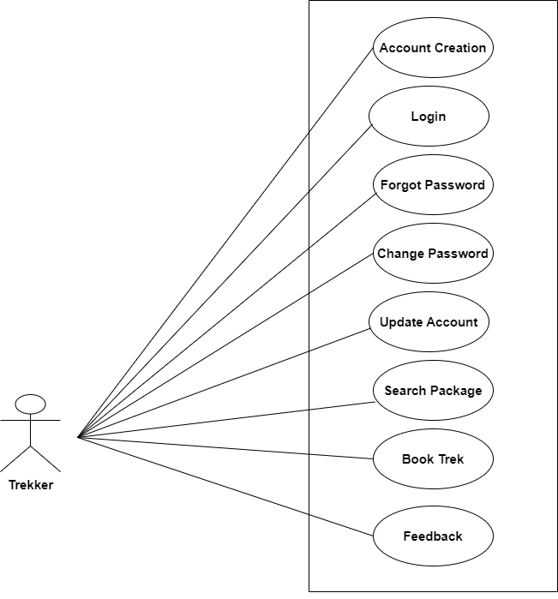

*Fig. Use case diagram for trekker*

1. In Trekker use case diagram Trekker is the Actor.
2. Trekker can handle following use cases:
3. Register
4. Login
5. Forgot Password
6. Change Password
7. Update Account Process
8. Search Package
9. Book Trek
10. FeedBack
    * 1. **Guide :**

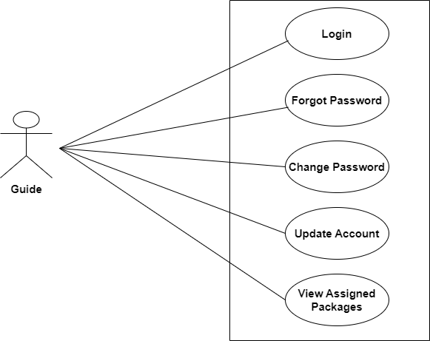

*Fig. Use case diagram for guide*

1. In Guide use case diagram Guide is the Actor**.**
2. Guide can handle following use cases:
3. Login
4. Forgot Password
5. Change Password
6. Update Account Process
7. View Assigned Treks
   * 1. **Admin :**

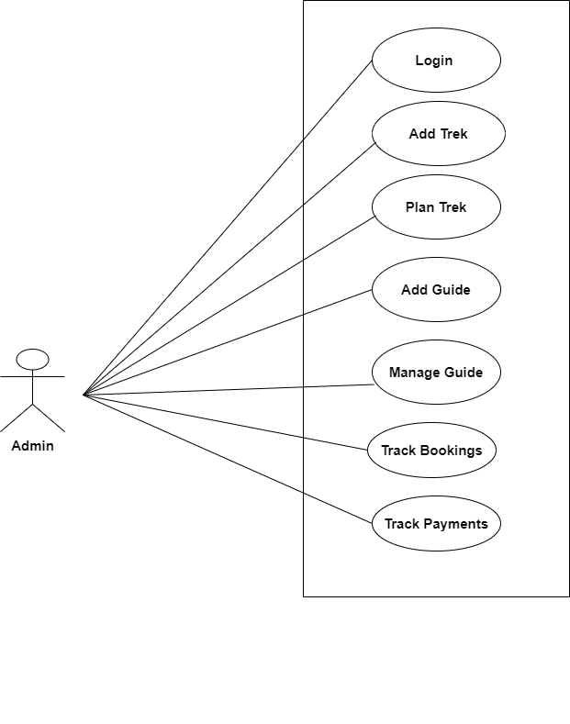

*Fig. Use case diagram for Admin*

1. In Admin use case diagram Admin is the Actor.
2. Admin can handle following use cases:
3. Login
4. Add Treks
5. Plan Treks
6. Create Guide
7. Manage Guide
8. Track Bookings
9. Track Payments