<https://packetlife.net/blog/2010/jun/7/understanding-tcp-sequence-acknowledgment-numbers/>

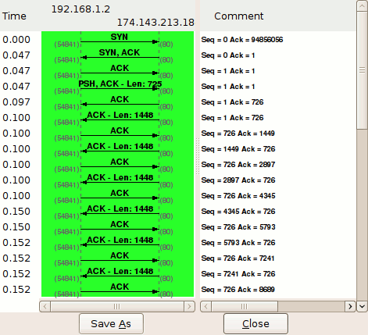https://wiki.sans.blue/Tools/pdfs/ScapyCheatSheet_v0.2.pdf