**MIDTERM LAB EXAMINATION**

**IT 413 – ADVANCED INFORMATION ASSURANCE AND SECURITY**

**IT DEPARTMENT**

**1st Semester AY 2024-2025**

11/21/2024

Casao, John Dell A.

Name : _____________________________________ Date : ____________________

IT – BA - 4106

Section: _____________________________________ Score : ____________________

**General Directions:**

1. Use the provided **Answer Sheet**.
2. Read, understand, analyze, and follow the instructions. Failure to comply with the instructions will be marked wrong.
3. Cheating or any form of academic dishonesty is not allowed. Anyone caught doing such will be subjected to disciplinary actions based on the Student Discipline Manual 2017 Edition
4. Do not use pencils, friction pens, or any erasable pens in answering.
5. No extra sheets of paper allowed. Use the back page of your test paper if needed. Erasures, alterations of any form are not allowed, and will not be considered.

**Laboratory Exam: Using Diagnostic Commands in Packet Tracer**

**Objective:**  
Students will learn to use diagnostic commands to gather information about end-user devices, network devices, and diagnose connectivity issues within a network using Cisco Packet Tracer.

**Instructions:**  
Complete each part of this exam step-by-step, following the specific commands for each device type and section. After completing each part, document your findings and answer the provided questions.

**Part 1: Gather End User Device Settings**

**Objective:**

Use diagnostic commands to gather information about IP configuration and connectivity on end-user devices.

**Steps:**

1. **Open Packet Tracer and Load the Network Topology.**  
   Open the network topology provided by your instructor or create a simple network with at least two PCs connected to a switch and a router.

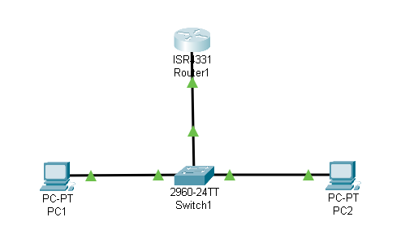

1. **Select an End User Device (PC1).**

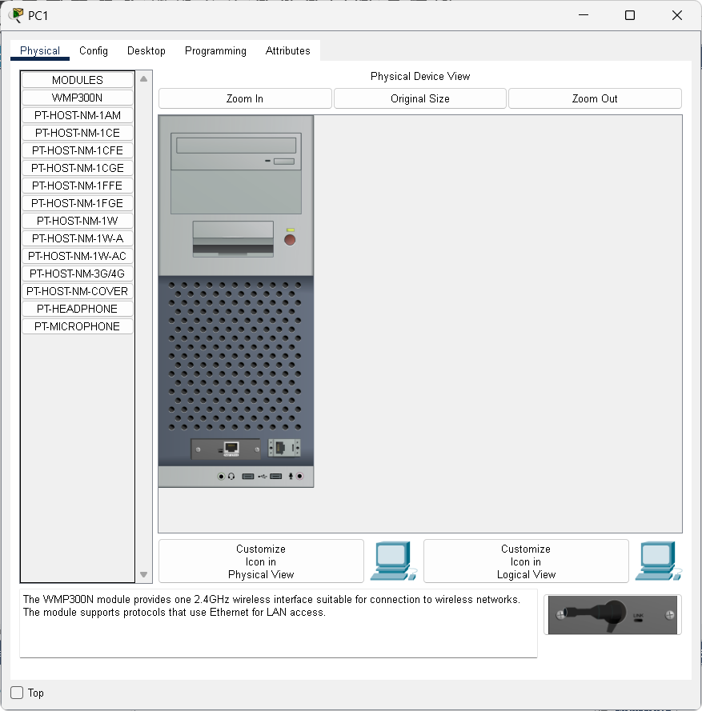

1. **Open the Command Prompt on the Device:**
   * On PC1, click **Desktop** > **Command Prompt**.

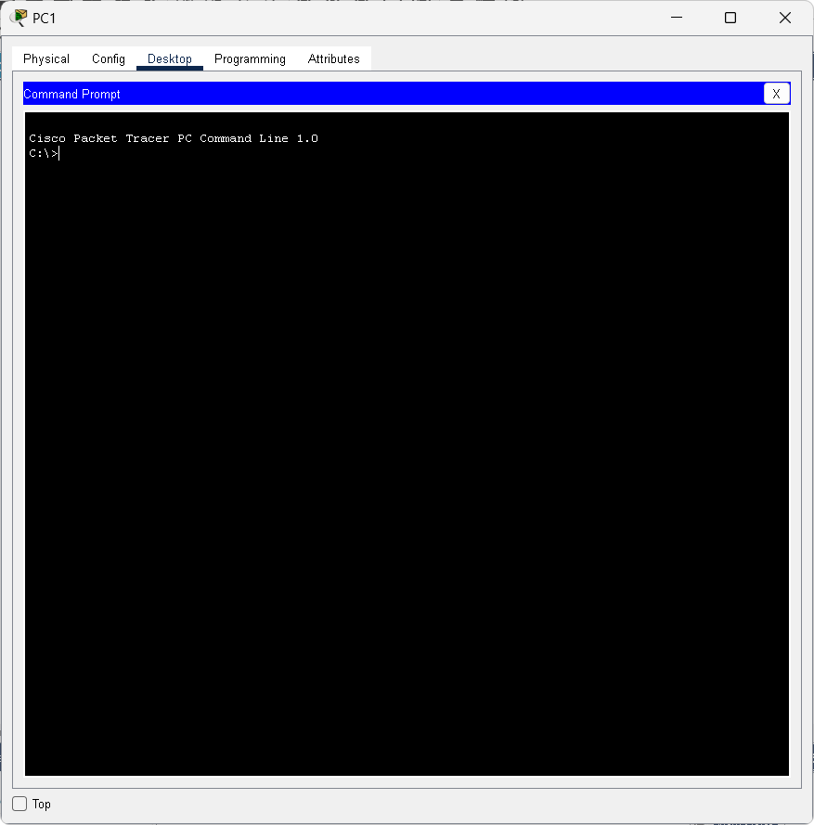

1. **Use the ipconfig Command:**
   * In the command prompt, type ipconfig and press **Enter**.
   * Note the following:
     + **IP Address**
     + **Subnet Mask**
     + **Default Gateway**

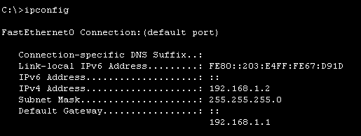

1. **Document Your Findings for PC1.**  
   Write down the IP configuration information you retrieved for reference.
   * + **IP Address:** 192.168.1.2
     + **Subnet Mask:** 255.255.255.0
     + **Default Gateway:** 192.168.1.1
2. **Repeat for Additional PCs (PC2, etc.).**
   * Use the same ipconfig command on any additional PCs and document their settings.

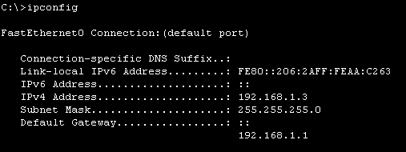

**Provide the following Output for both PCs:**

* **PC1:**

192.168.1.2

* + **IP Address:** _________________________

255.255.255.0

* + **Subnet Mask:** ________________________

192.168.1.1

* + **Default Gateway:** ________________________
* **PC2:**

192.168.1.3

* + **IP Address:** ________________________

255.255.255.0

* + **Subnet Mask:** ________________________

192.168.1.1

* + **Default Gateway:** ________________________

**Part 2: Gather Information about Network Devices**

**Objective:**

Use diagnostic commands to gather information about network device configurations, including routers and switches.

**Steps:**

1. **Select a Network Device (Router1).**

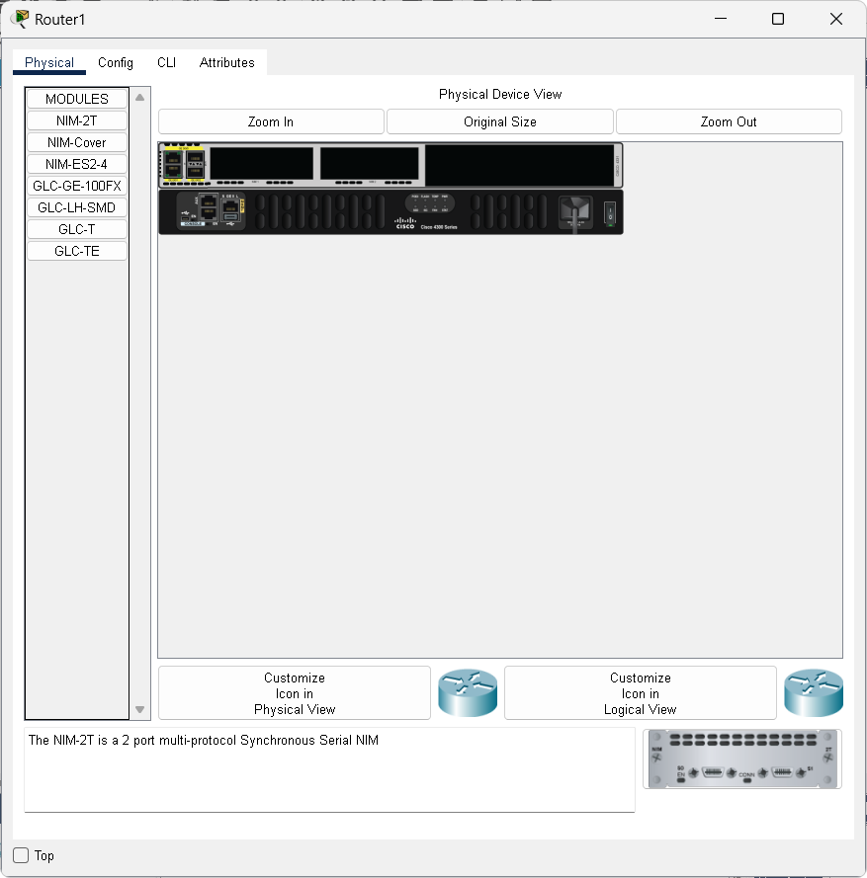

1. **Access the CLI on the Router:**
   * Click on **Router1** > **CLI**.

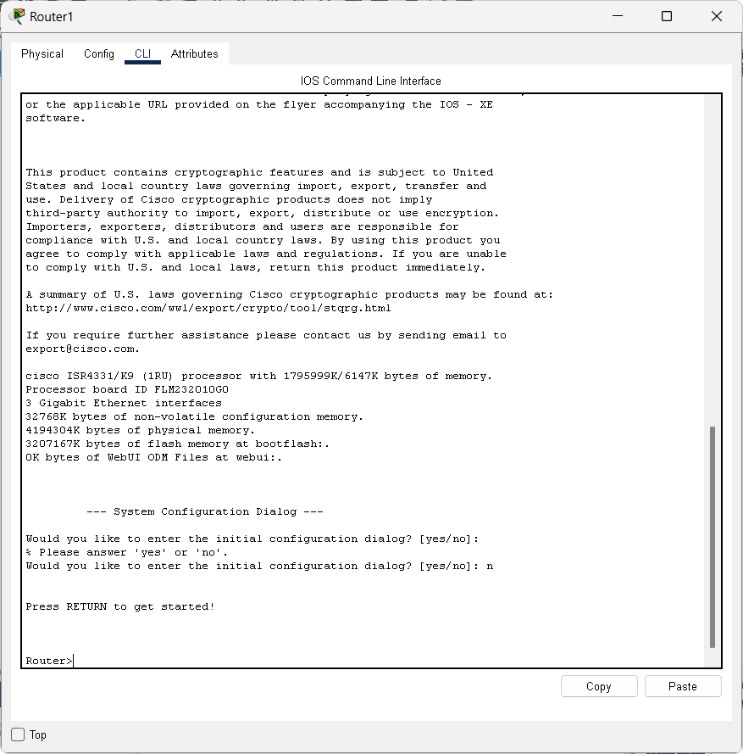

1. **Use the show ip interface brief Command:**
   * Type show ip interface brief and press **Enter**.
   * Note the interface statuses and IP addresses.

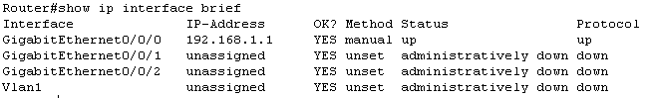

1. **Use the show running-config Command:**
   * Type show running-config and press **Enter**.
   * Review the output to locate:
     + **Interface IP Configurations**
     + **Routing Protocols (if any)**
     + 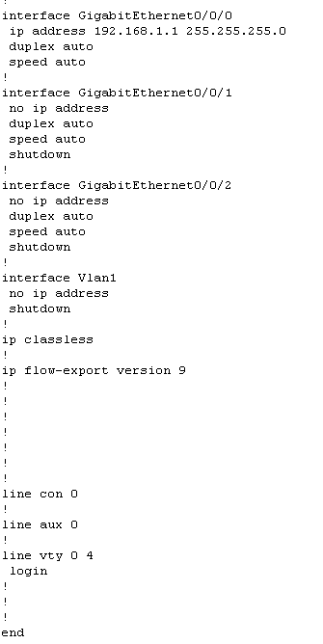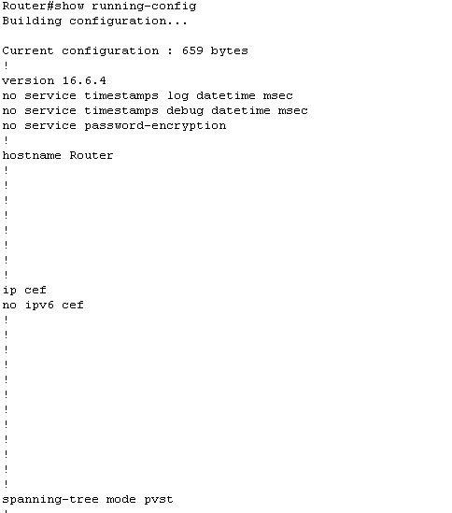**Access Control Lists (if any)**
2. **Repeat for Additional Network Devices (Switches).**
   * 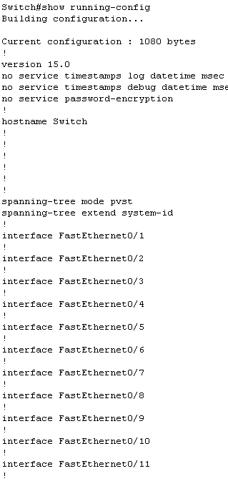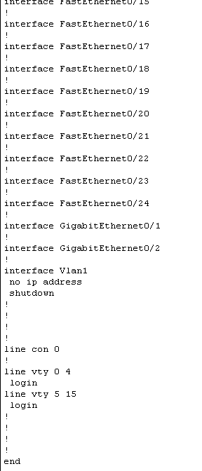Use show running-config and show vlan brief commands on any switches to check VLANs an

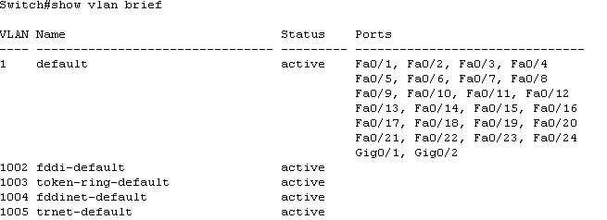

**Provide the following Output for Network Devices:**

* **Output for Router (show ip interface brief):**



* 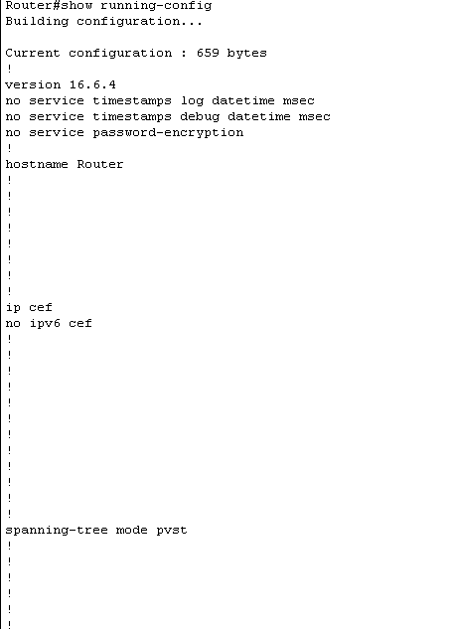**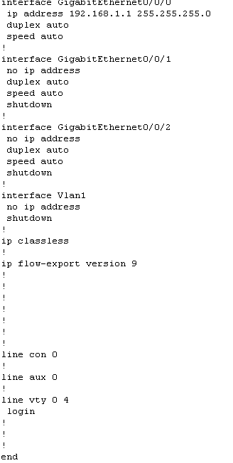Output for Router (show running-config):**

**Part 3: Diagnose Connectivity Issues**

**Objective:**

Use diagnostic commands to identify and resolve connectivity issues in the network.

**Steps:**

1. **Use the ping Command to Test End-to-End Connectivity:**
   * On **PC1**, open **Command Prompt** and type ping <IP Address of PC2> (replace <IP Address of PC2> with the actual IP).
   * Observe the results:
     + If successful, there should be replies from the destination IP.
     + If it fails, note any error messages like "Request timed out."

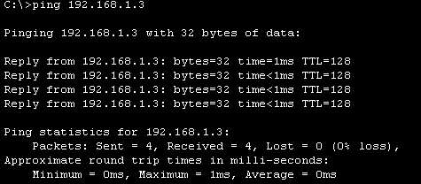

1. **Identify the Connectivity Issue (If Any):**
   * If the ping test fails, use the following steps to diagnose:
     + **Check IP Configuration:** Re-run ipconfig on both PCs to ensure IP addresses and default gateways are correct.
     + **Ping the Default Gateway:** On each PC, ping the default gateway. If this fails, there may be an issue with the router.
2. **Use tracert (Traceroute) to Locate Network Breakpoints:**
   * On **PC1**, in the command prompt, type tracert <IP Address of PC2>.
   * Analyze each hop:
     + If the trace stops at a specific device, investigate that device’s settings and connectivity.

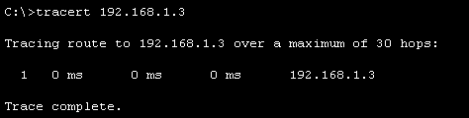

1. **Use the show ip route Command on the Router:**
   * On **Router1**, access the CLI and type show ip route.
   * Ensure the router has routes to each network. If there’s a missing route, add it (using ip route for static routes).

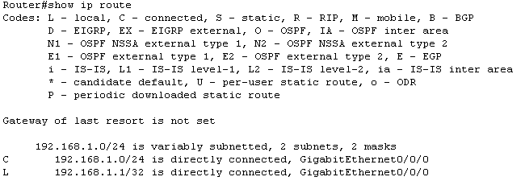

**Provide a result:**

* **Ping Test on PC1:**



* **Output and Screenshot for Traceroute Output on PC1:**



Prepared by:

**Mr. GERALD JAMES Q. DAÑO**

Course Facilitator

**Mr. JEROME M. FABREGAR**

Course Facilitator

**Mr. ARJONEL M. MENDOZA**

Course Facilitator

Reviewed by:

**Dr. MARICEL GRACE Z. FERNANDO**

Program Chair, IT

Approved by:

**Dr. PRINCESS MARIE B. MELO**

Dean, CICS