**Introduction**

Project Idea :-

The idea is to predict the number of dengue cases in a particular city on the coming weeks. Also help the users to take preventive measures against the disease and for the treatment of it.

Problem Statement:

Dengue fever is a mosquito-borne tropical disease caused by the dengue virus. Each year between 50 and 528 million people are infected and approximately 10,000 to 20,000 die. Predicting dengue cases can be tricky and it would be nice if we can just ask a computer to tell us the predictions.

Goal:

The goal is to predict the total dengue cases for each (city, year, week of the year) in the test set. There are two cities, San Juan and Iquitos, with test data for each city spanning 5 and 3 years respectively. The data for each city have been concatenated along with a city column indicating the source: ‘sj’ for San Juan and ‘iq’ for Iquitos. The test set is a pure future hold-out, meaning the test data are sequential and non-overlapping with any of the training data.

Accurate dengue predictions would help public health workers and people around the world take steps to reduce the impact of these epidemics. But predicting dengue is a hefty task that calls for the consolidation of different data sets on disease incidence, weather, and the environment.

**Sustainable Development Goals Achieved** :-

**Goal 3**: Ensuring healthy lives and promote well-being for all at all ages.

Targets achieved ~

* By 2030, end the epidemics of AIDS, tuberculosis, dengue and neglected tropical diseases and combat hepatitis, water-borne diseases and other communicable diseases.
* Achieve universal health coverage, including financial risk protection, access to quality essential health-care services and access to safe, effective, quality and affordable essential medicines and vaccines for all.
* Strengthen the capacity of all countries, in particular developing countries, for early warning, risk reduction and management of national and global health risk.

Extra Features :-

* Requesting an appointment, checking location of the nearby hospitals.
* Vaccination appointment.
* Calling ‘Bug Exterminators’.
* Symptoms and the causes.
* Suggestions for the prevention

Tech Stack :-

* Deep learning
* Neural Networks
* Rigorous Feature Engineering
* Flask
* Frontend using HTML, CSS, Javascript
* ML algos (RandomForest Regressor, DecisionTree Regressor, SVR,GradientBoosting Regressor)
* Libraries like scikit-learn, pandas, numpy, missingno, matplotlib, seaborn, Plotly.

**Screenshot Table**

|  |  |  |  |
| --- | --- | --- | --- |
| Screen shot image | What does it do. | Any inputs that it takes &  processing that it might  perform | What is the output / where  does the output values /  variables go. |
| Image_1,2,3 | First Screen of our Web application. | No Inputs. | Options for finding doctors, locating nearby hospitals,  And health library. |
| Image_4 | Health Library. | No Inputs. | Learning more about the dengue fever. |
| Image_5,6,7 | About the disease. | No Inputs. | Diagnosis,  Treatment,  What to expect from the doctor. |
| Image_8 | Doctors. | No Inputs. | Contacts,  Addresses of the doctors. |
| Image_9 | Appointments and Access. | No input. | Details about the appointment in the nearby areas. |
| Image_10,11,12,13 | Online Request Form | Personal details with medical history. | Requests for the appointment in the nearby area. |
| Image_14 | Bug Exterminator. | No Input. | Information about the bug exterminators in the area. |
| Image_15 | Location. | Any Information related addresses of any hospital. | Gives the names including locations of the nearby hospitals. |
| Image_16,17,18,19 | Different Graphs of the number of dengue cases. | Takes input of the type of graph (Bar, Line, Area) that you want to see. | Draws the asked graph in the new page. |
| Image_20,21,22,23,24 | Number of dengue cases. | Inputs the city name, year and the week. | Shows the number of dengue cases in that particular week and alerts if the number is high. |
| Image_25,26 | Visualization of ML algos | Graph of predicted vs original data | RMSE 0.62  RMSE 0.43. |
| Image_27,28,29 | Visualization of data | Heat map for correlation of data,  Visualization of missing data,  Histograms of all the features | Shows respective figures. |

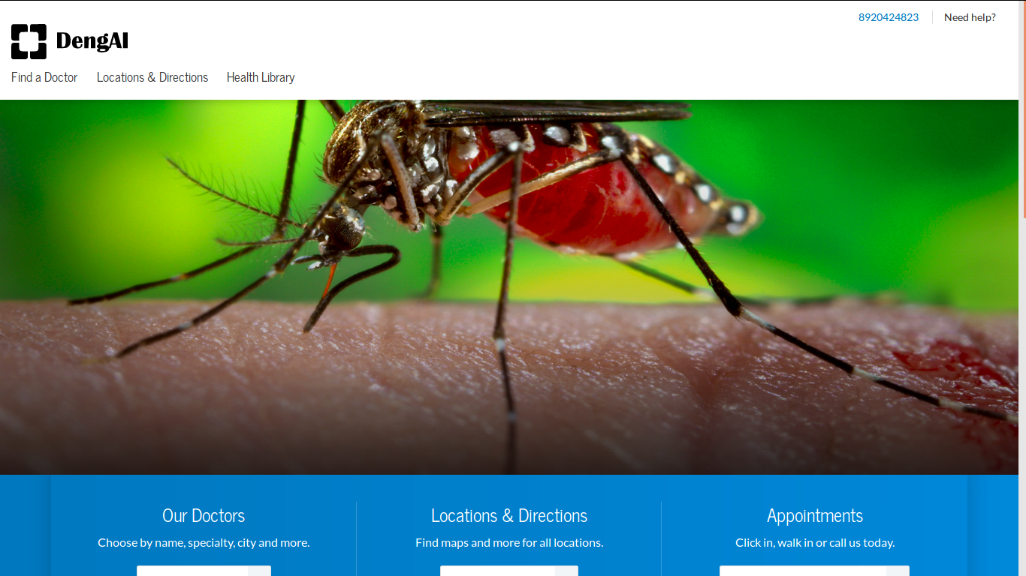

Image_1

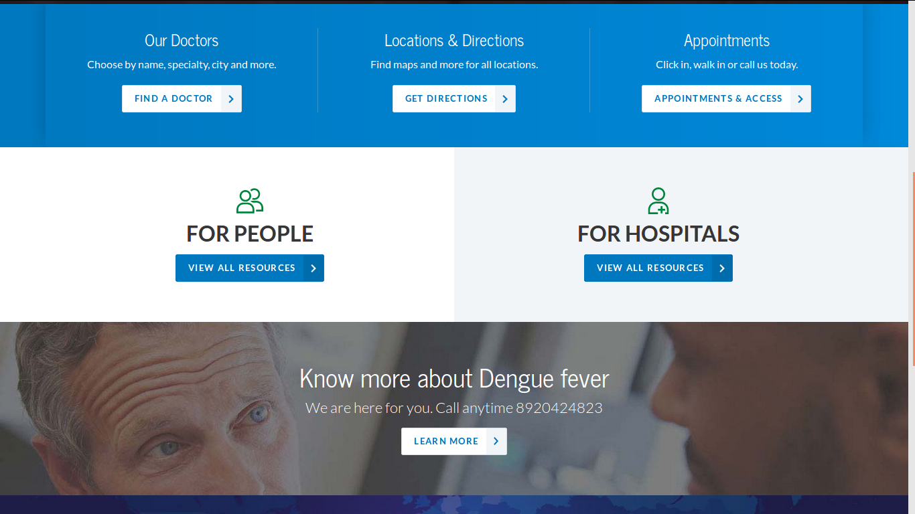

Image_2

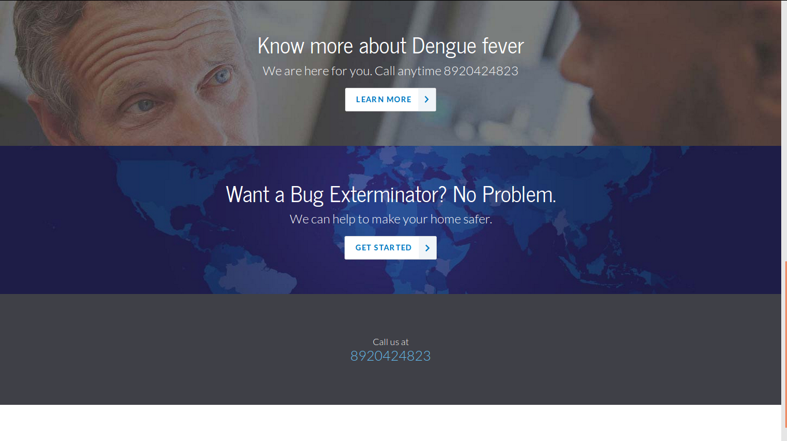

Image_3

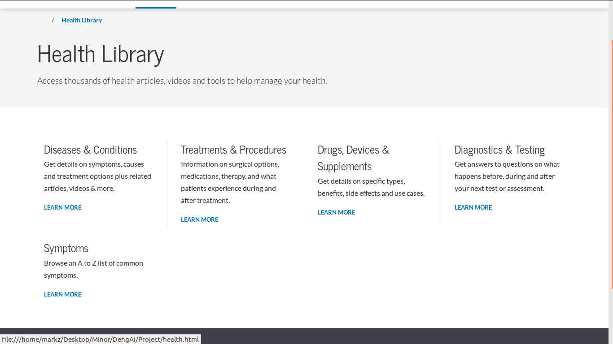

Image_4

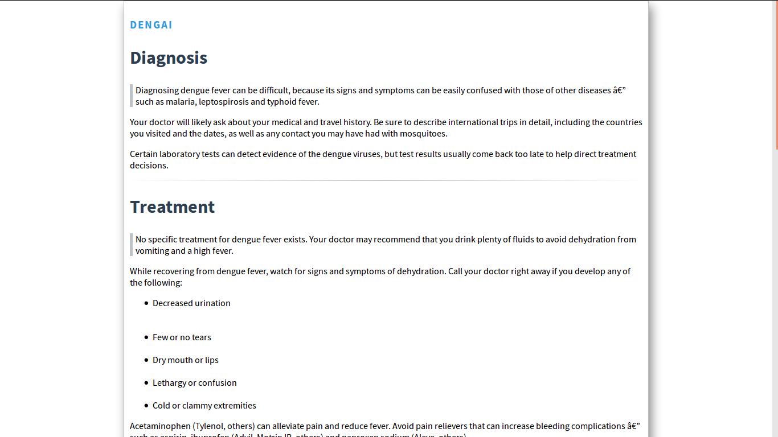

Image_5

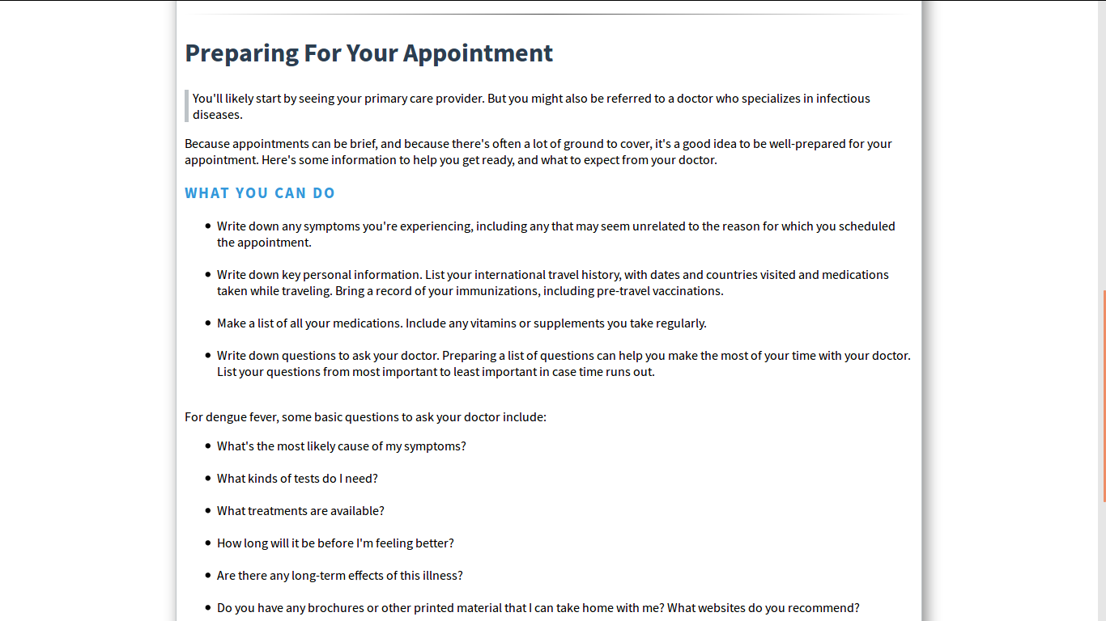

Image_6

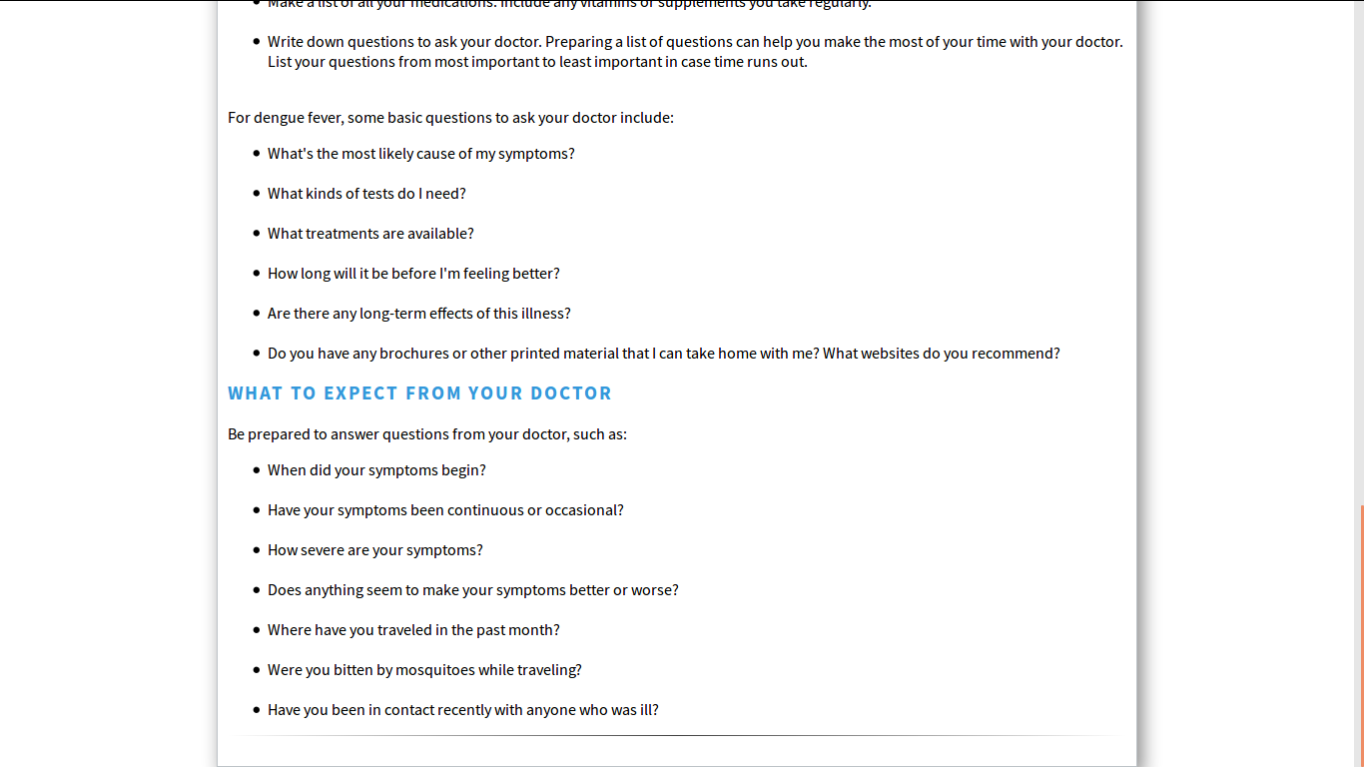

Image_7

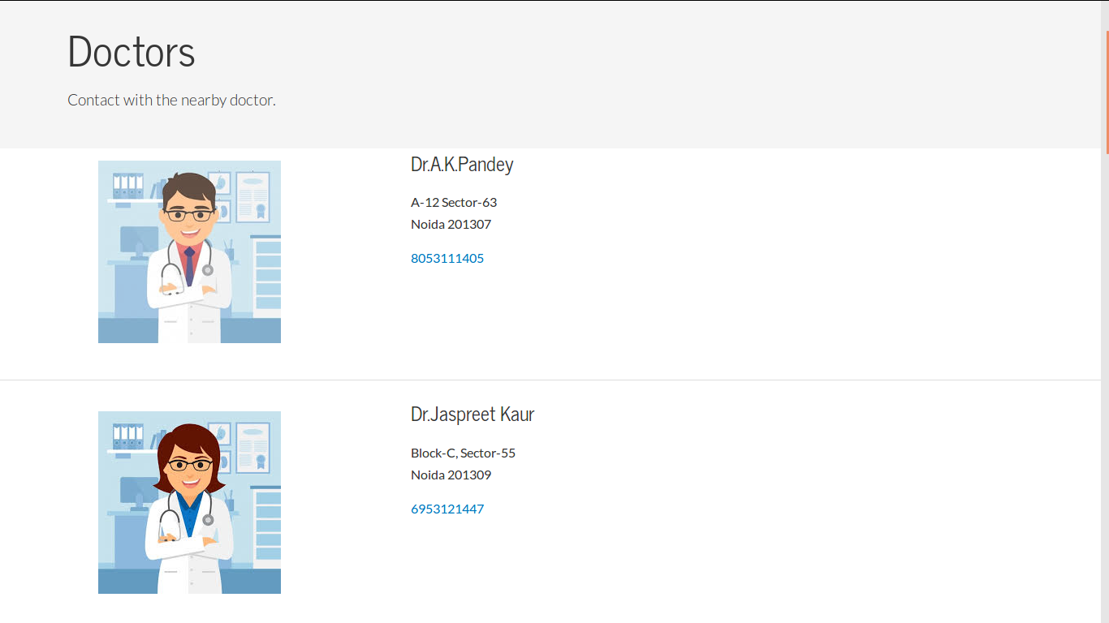

Image_8

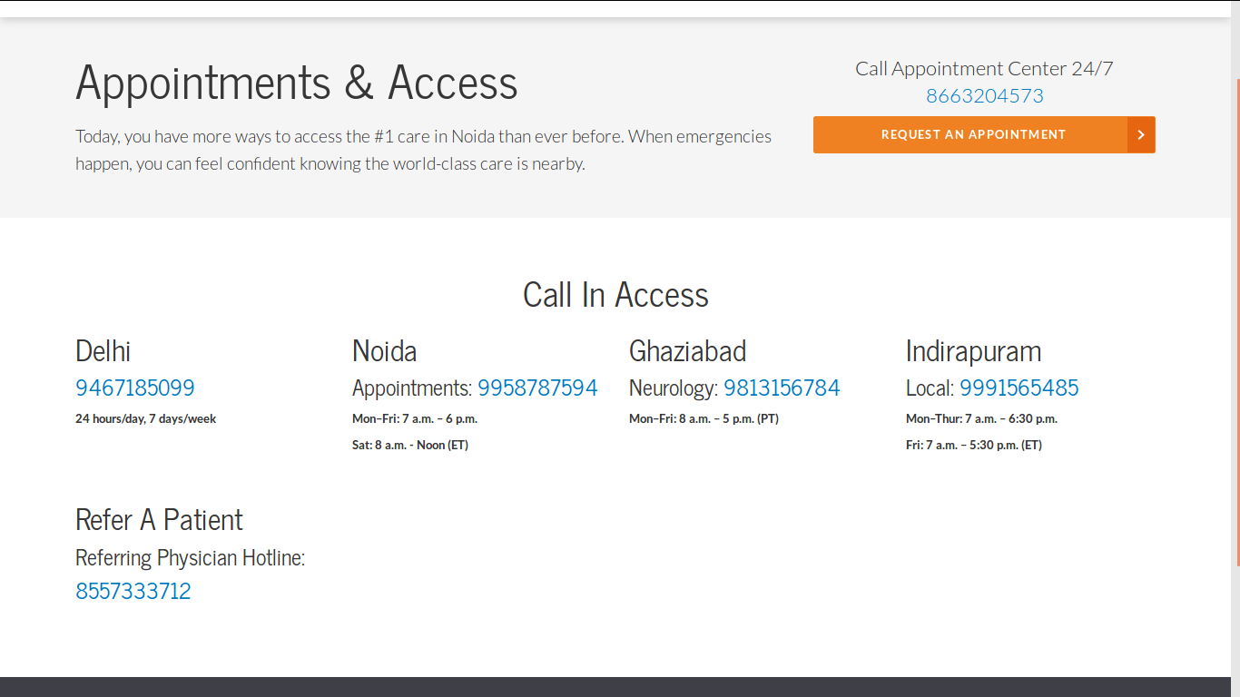

Image_9

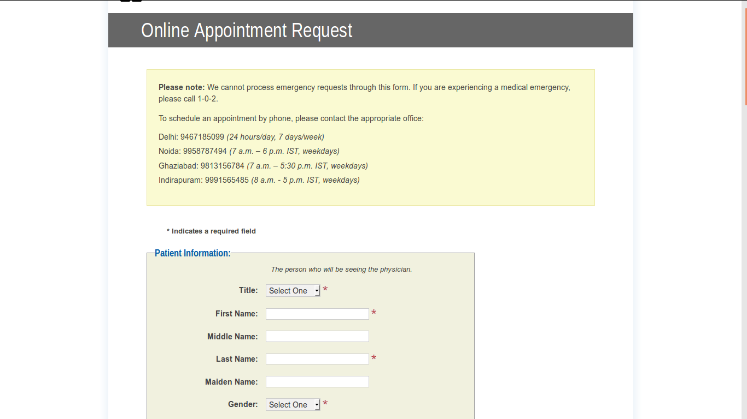

Image_10

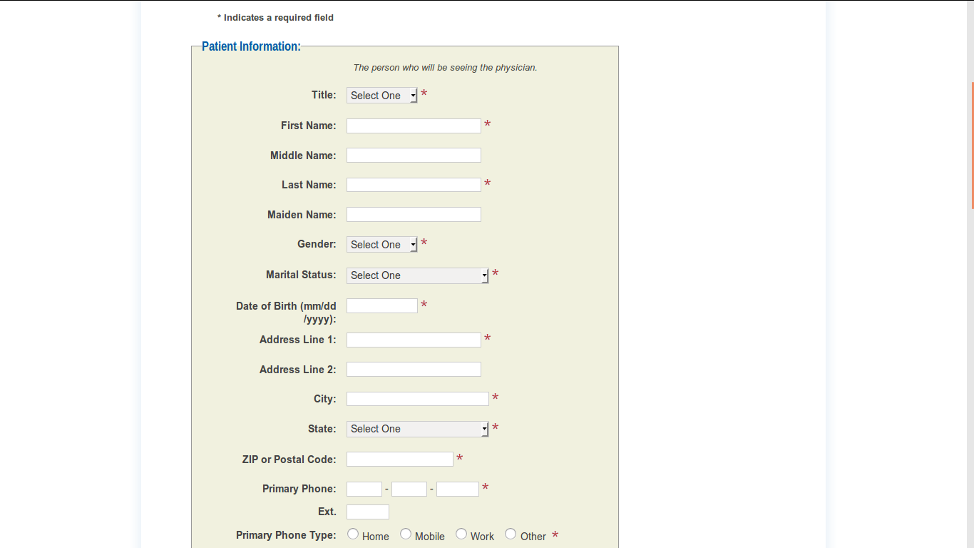

Image_11

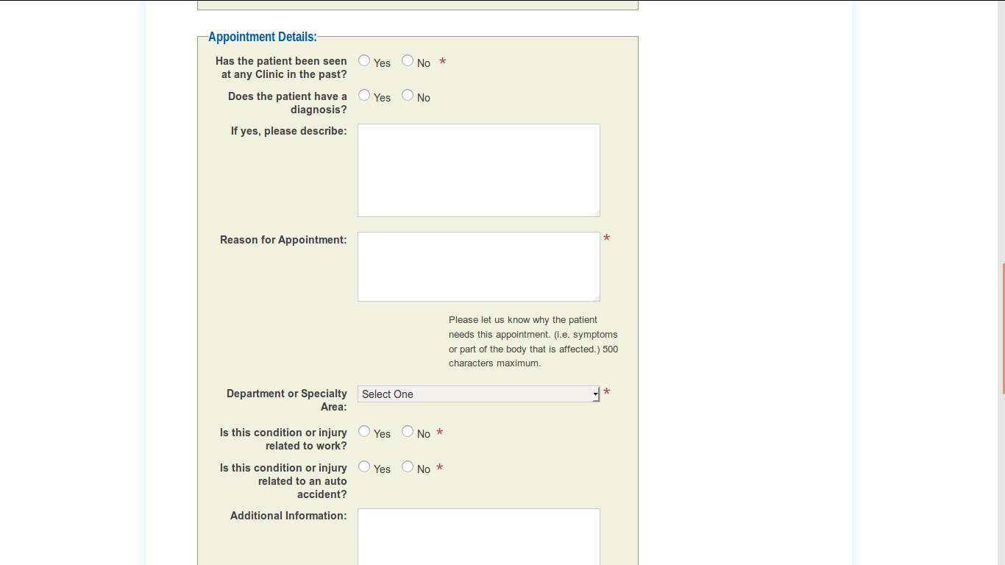

Image_12

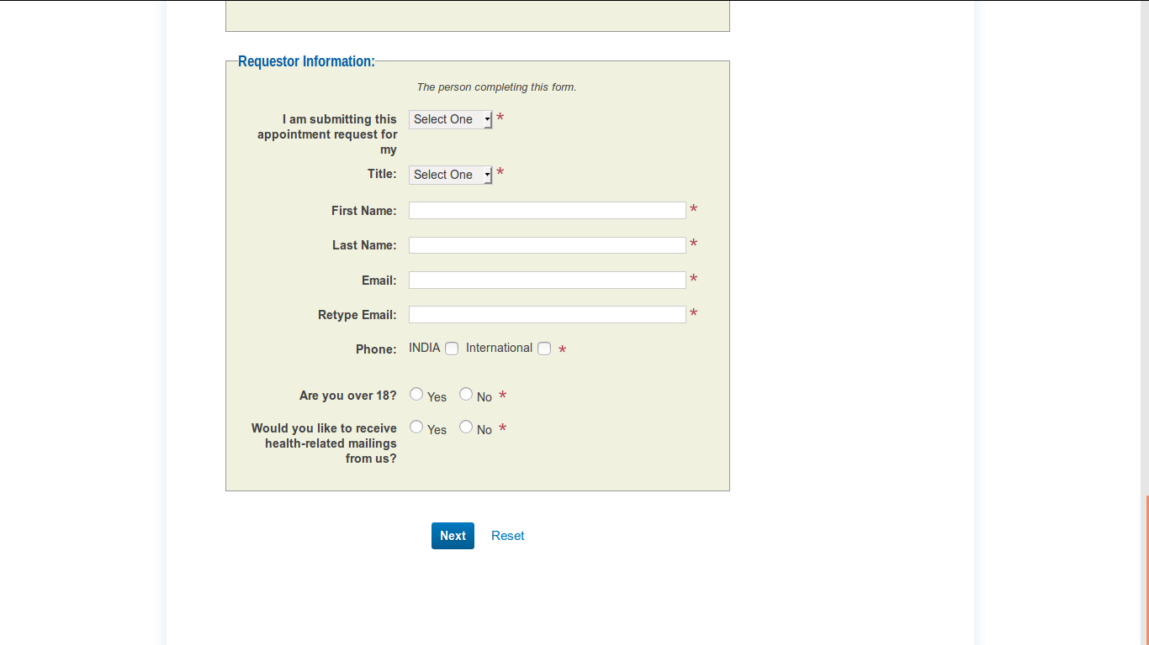

Image_13

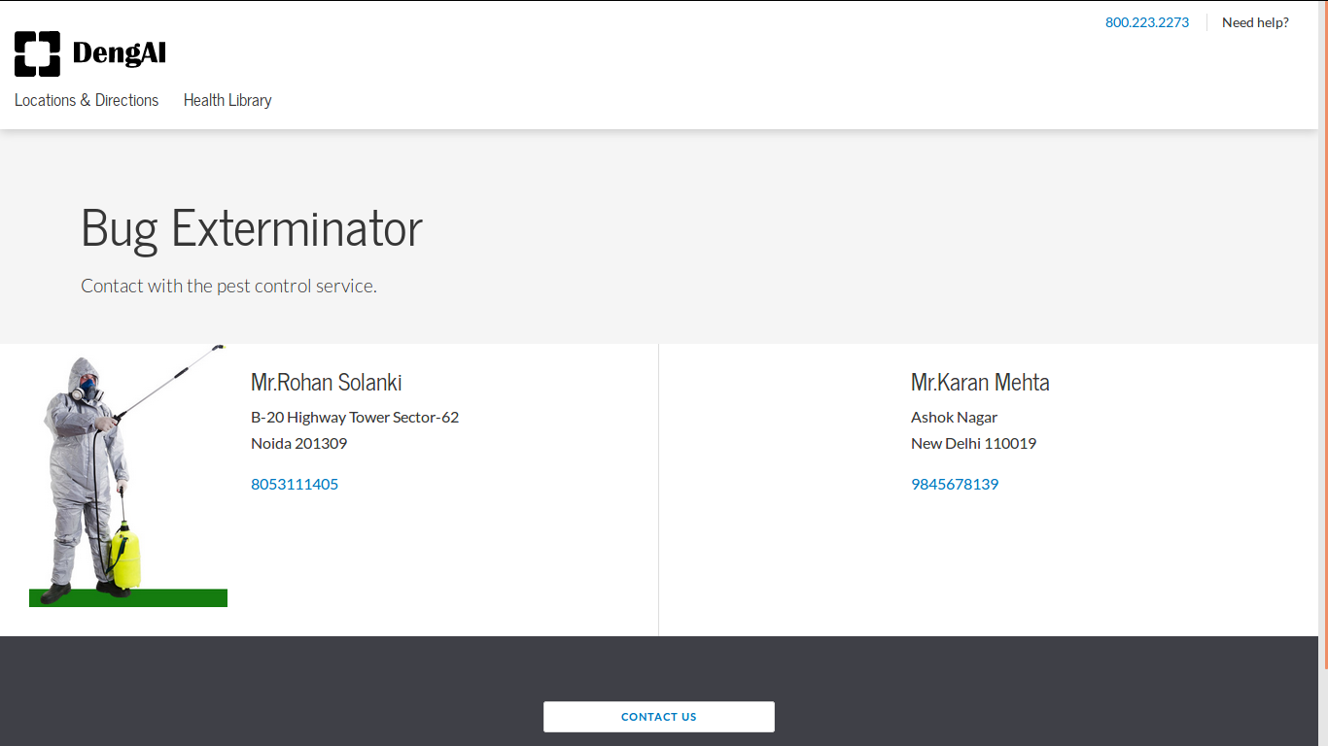

Image_14

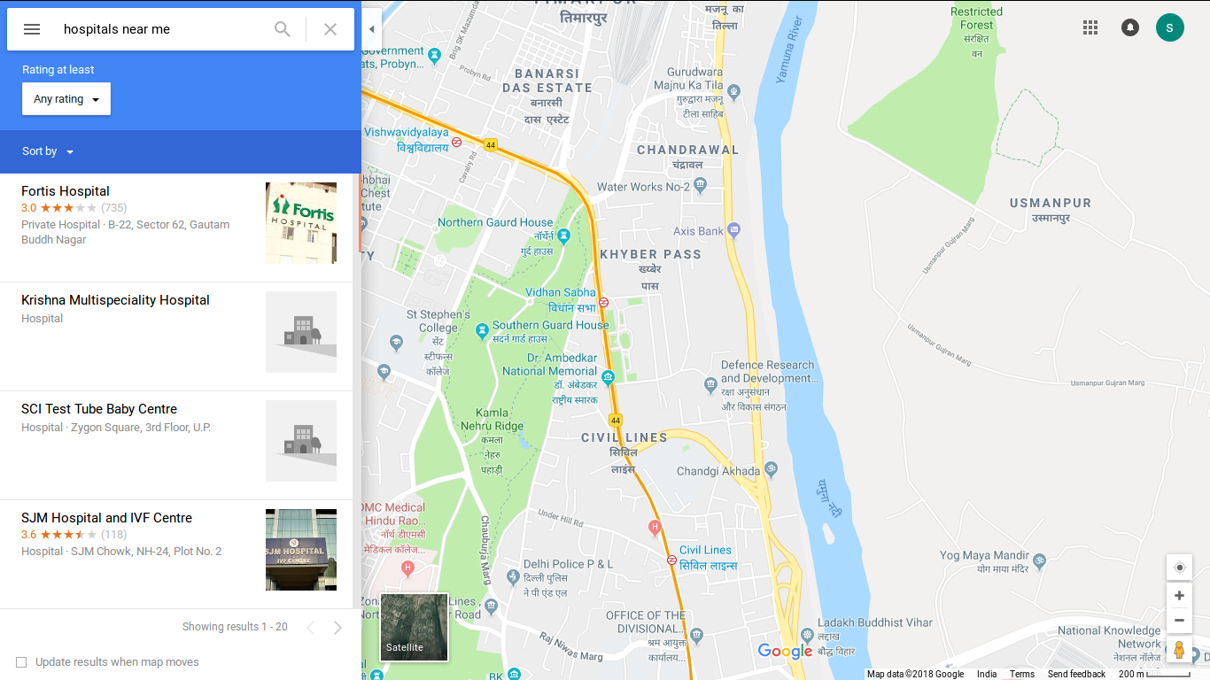

Image_15

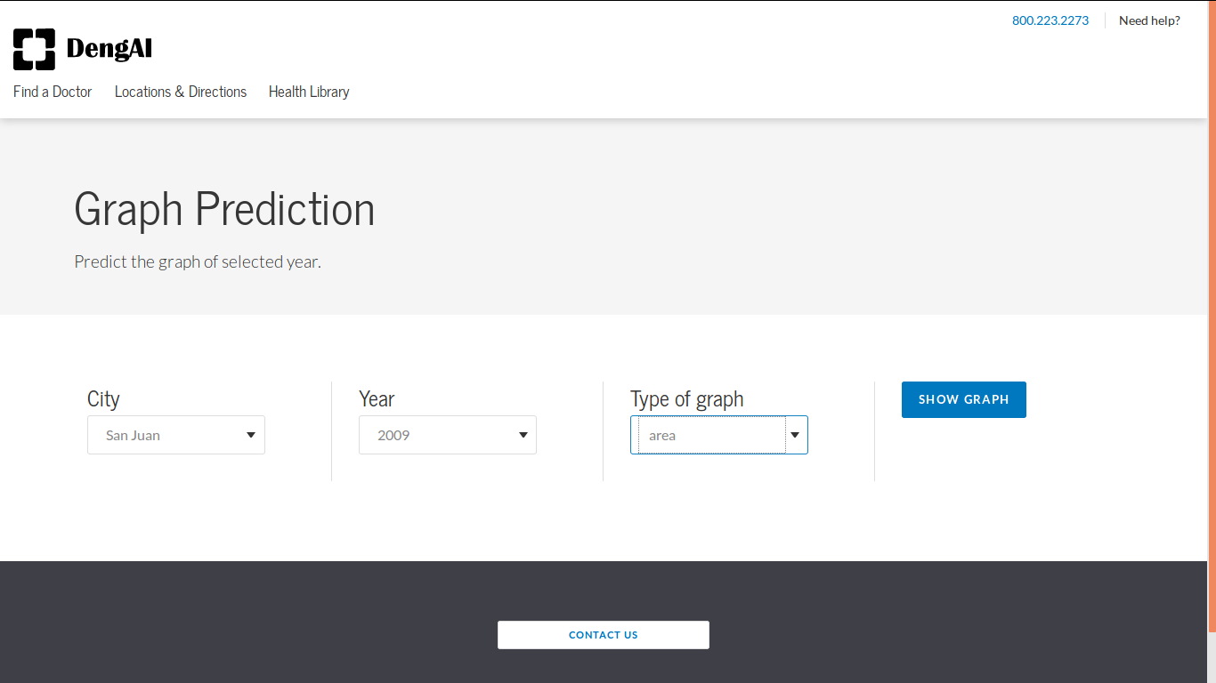

Image_16

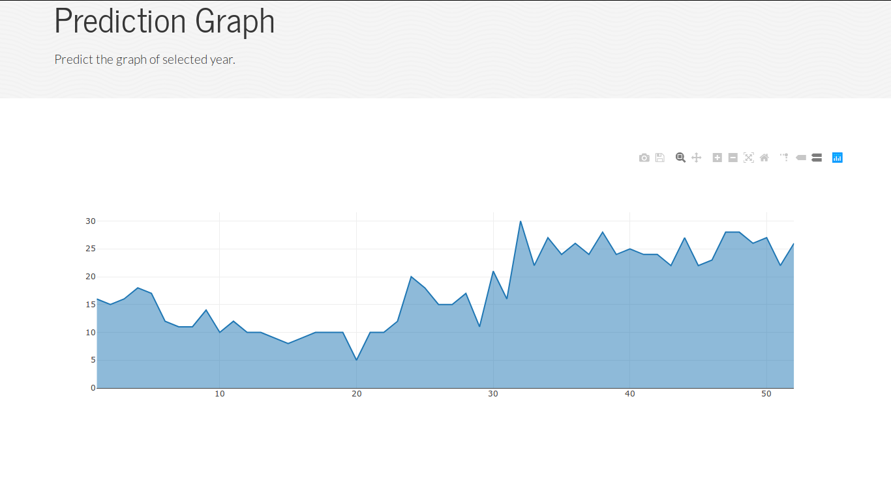

Image_17

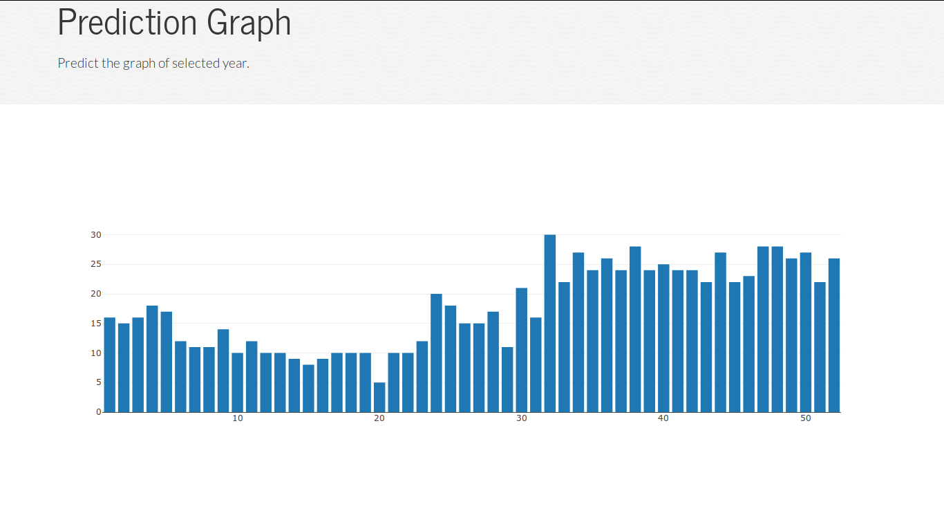

Image_18

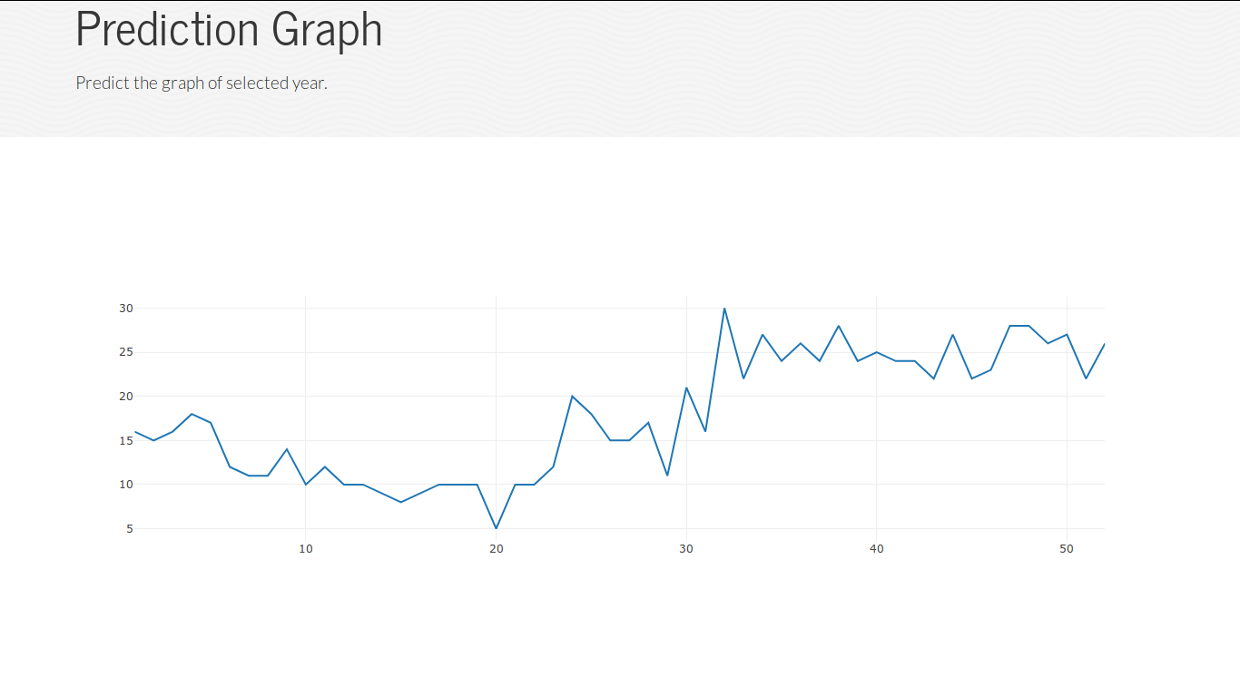

Image_19

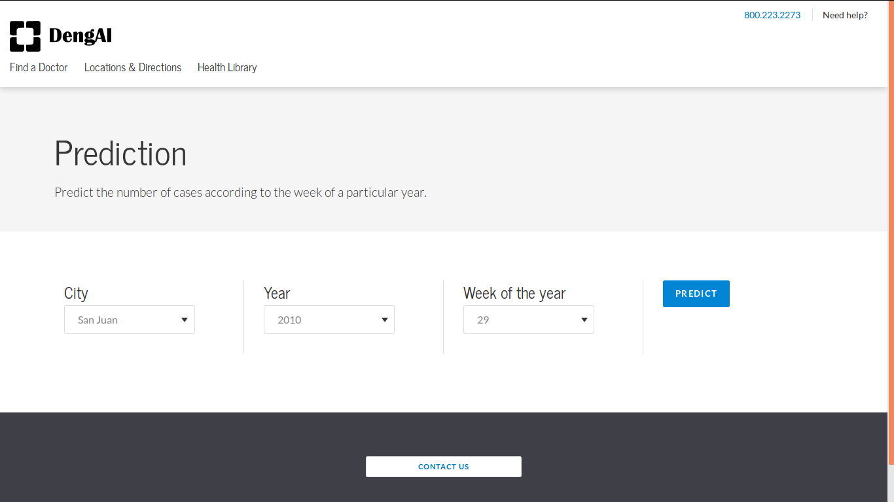

Image_20

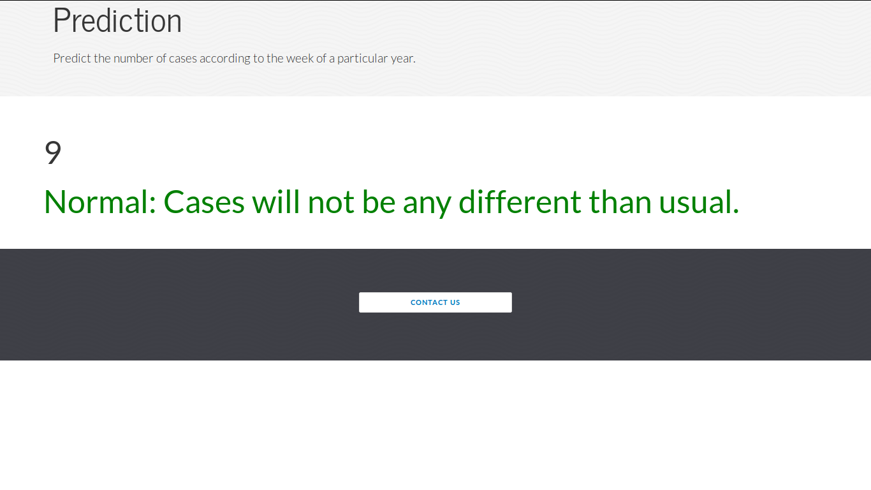

Image_21

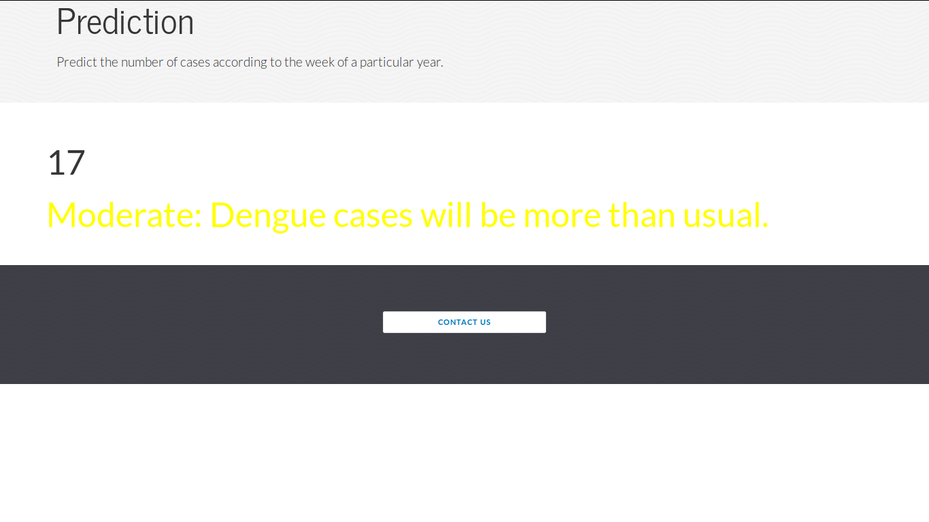

Image_22

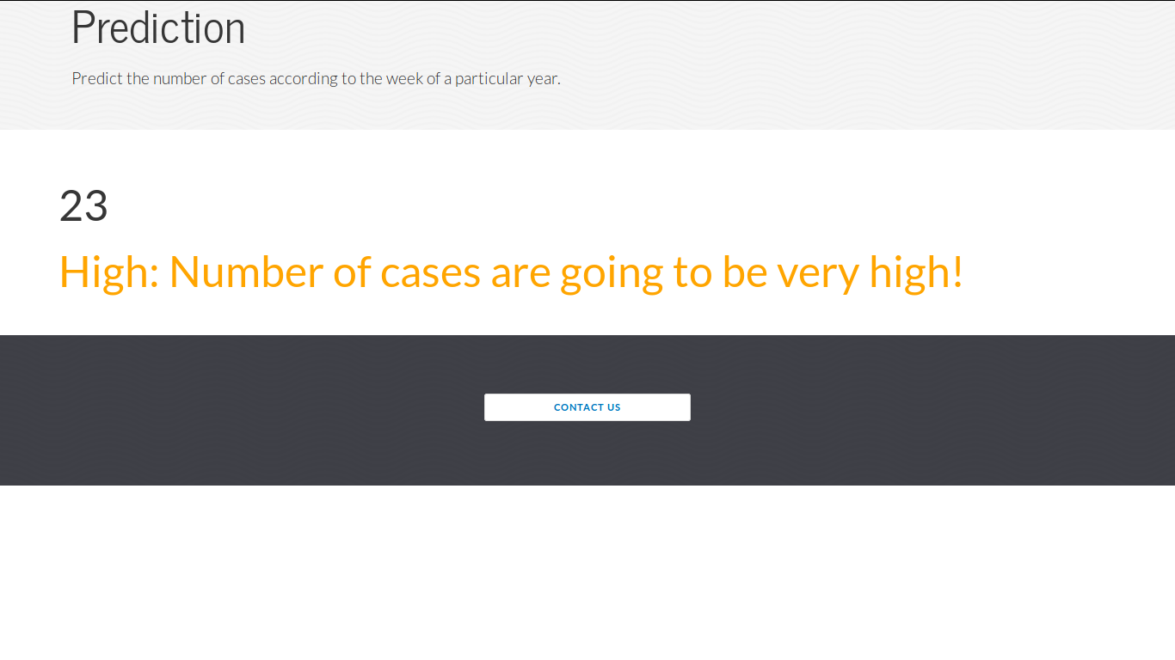

Image_23

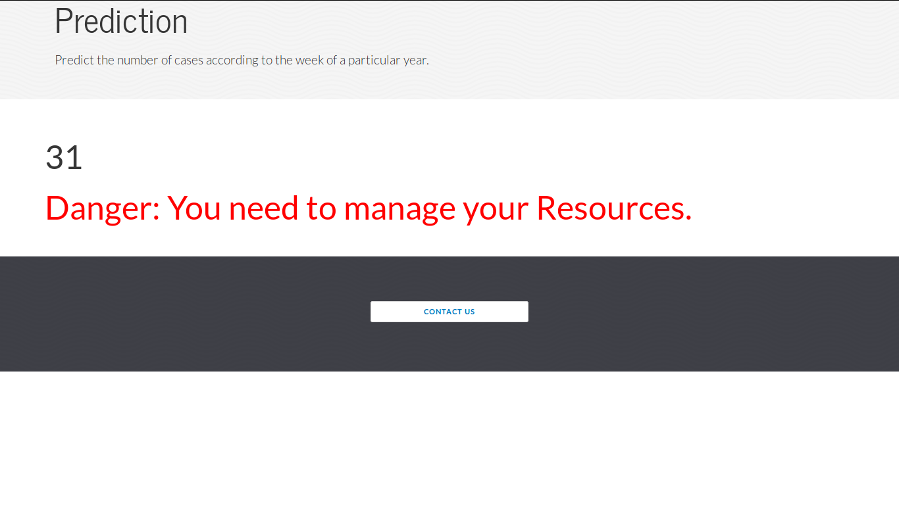

Image_24

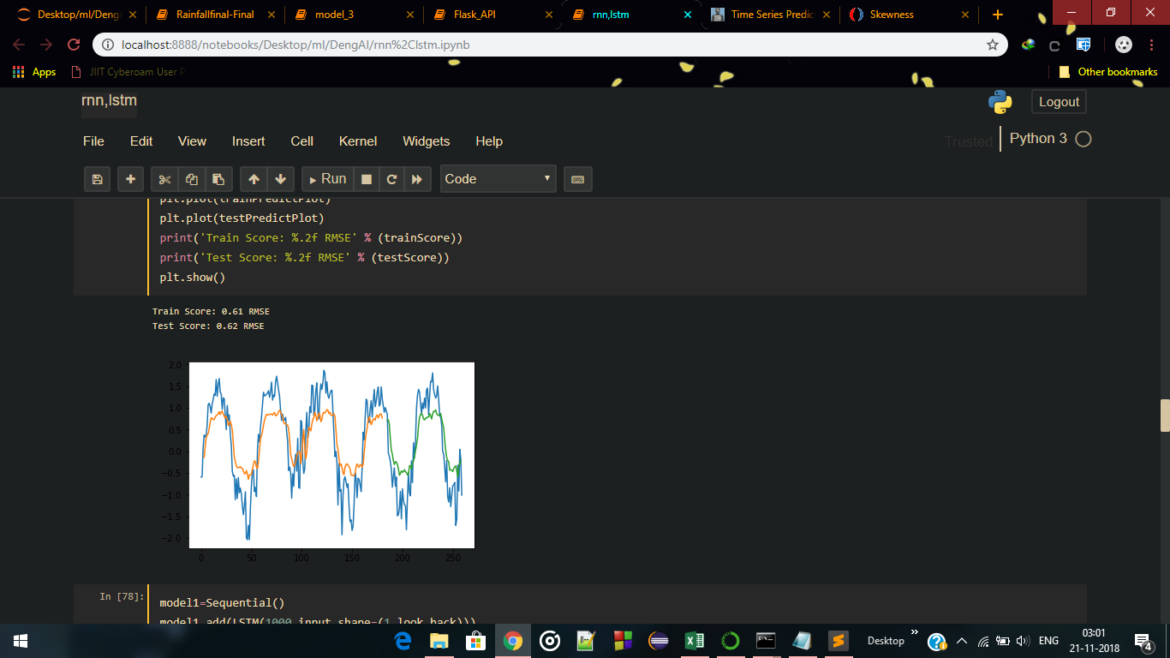

Image_25

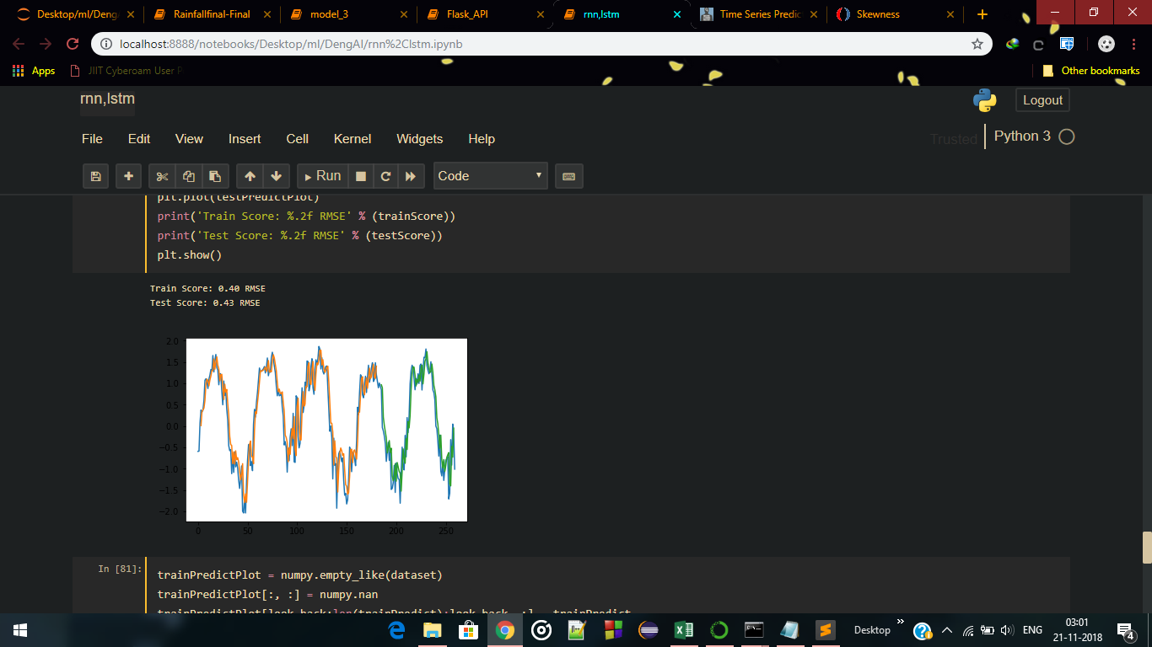

Image_26

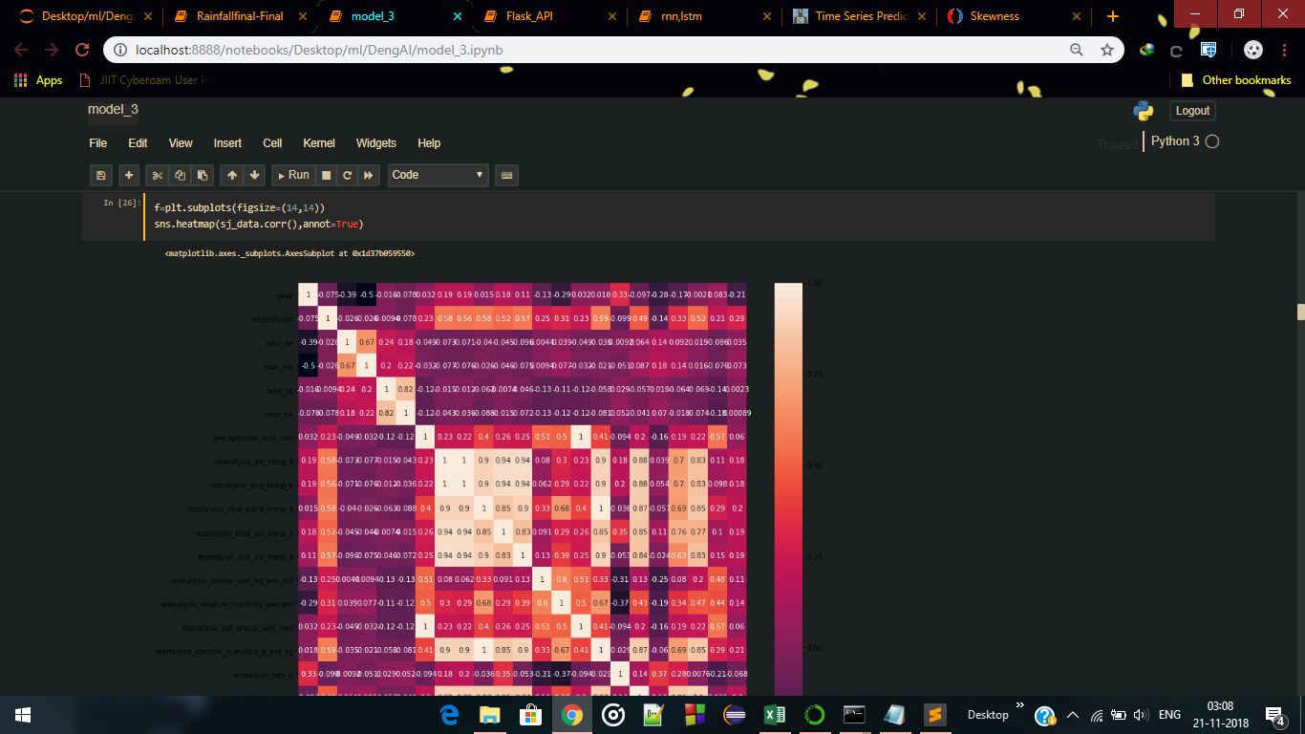

Image_27

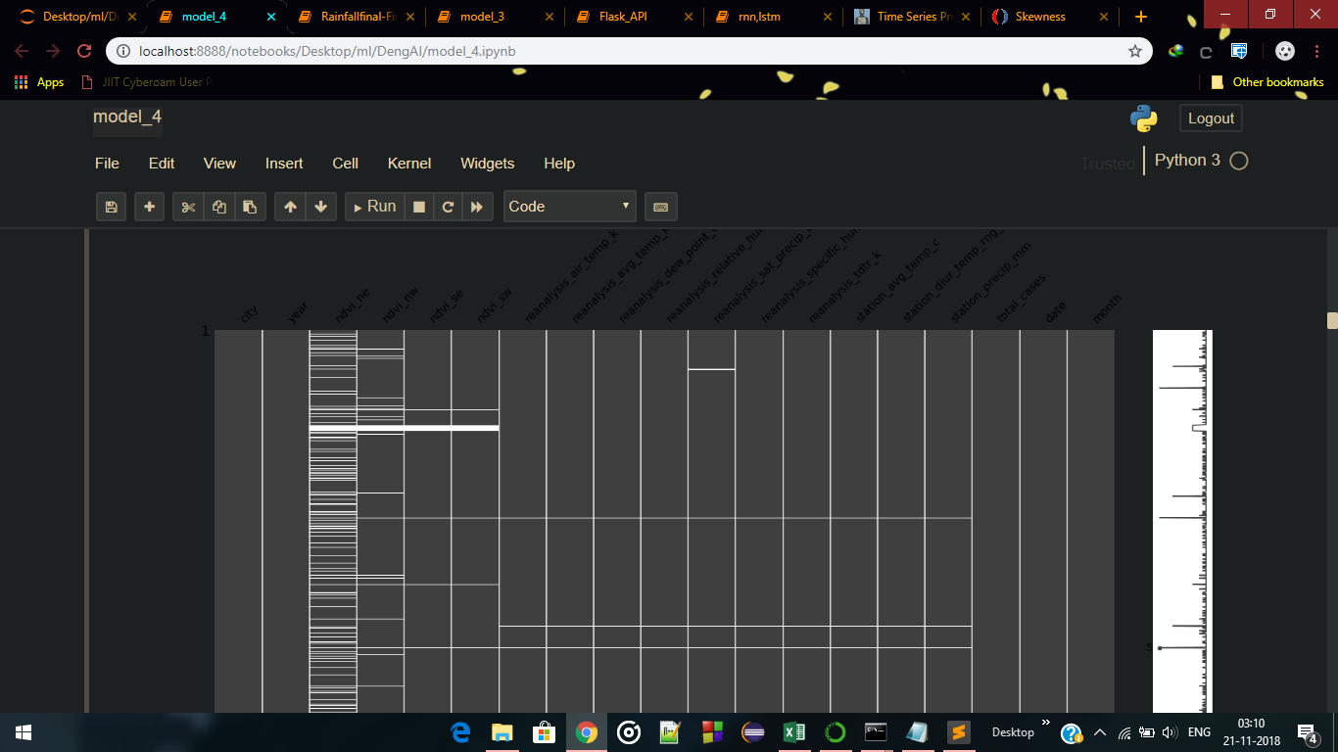

Image_28

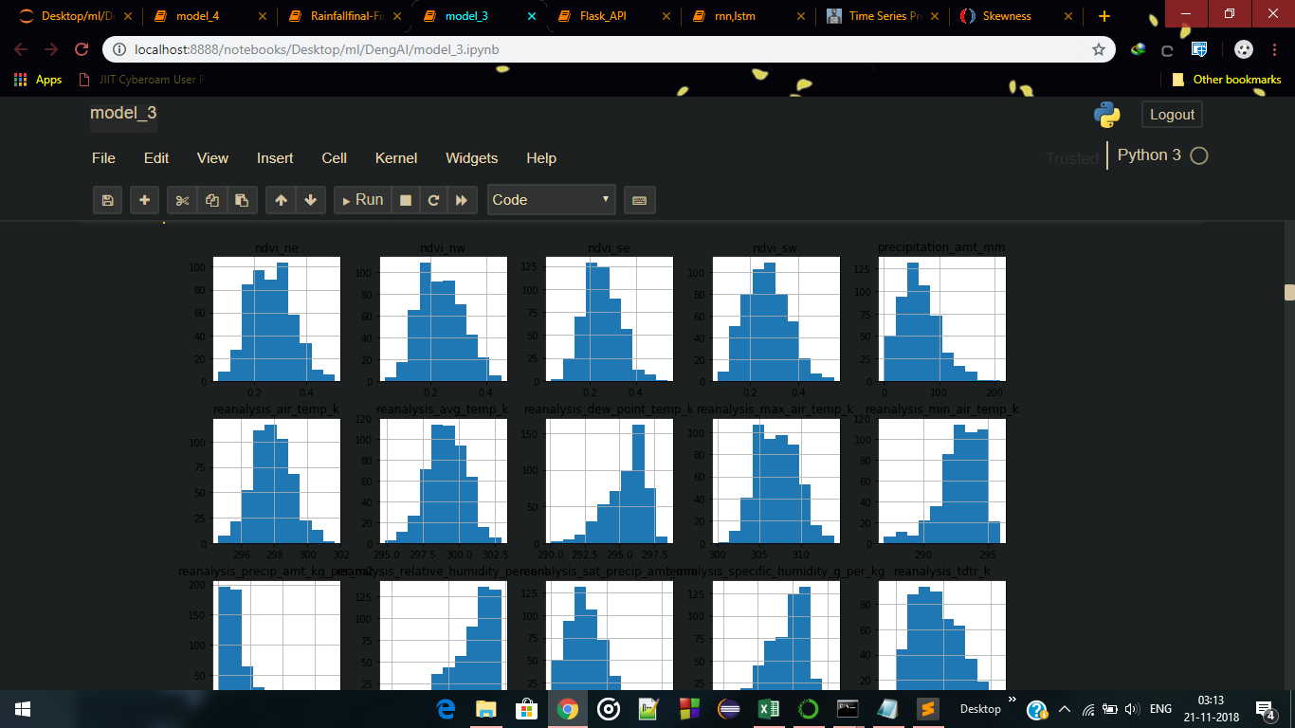

Image_29

**Conclusion**

Dengue is proved to be a deadly disease in many countries. According to the World Health Organisation , about 20000 people including children have died last year all over the world. Using this Project , many people can be benefitted just by knowing what may come in the future to an almost accurate prediction. Hospitals can be alerted about the increasing number of cases that they may face so that they can manage their resources accordingly. Help can be sent through the medical camps where the hospitals are not available and many lives can be saved. People in their homes can take preventive measures by keeping themselves and their children from mosquitoes, by keeping their surroundings clean etc. This way we will have one less disease to be worried about so that we can focus on several other deadly diseases to fight with.

**Future Scope**

Currently our project is able to detect number of dengue cases bases on features such as rainfall and temperature.

Since we had the dataset for some future time too from weather forecasting and weather surveying departments but they can tell the exact predictions for a distant future. So to overcome this problem we have added a LSTM model to perform time series forecasting of rainfall and temperature.

But since we had 24 features in our dataset and predicting and inter-convertibility of one feature to another would require vast knowledge of weather data so this is for future development.

Readings and SourceS:

* <https://www.drivendata.org/44/dengai-predicting-disease-spread/page/82/>
* <http://dengueforecasting.noaa.gov/>
* Developing a dengue forecast model using machine learning: A case study in China by *Pi Guo , Tao Liu*
* Machine Learning For Dengue Outbreak Prediction: An Outlook by Naiyar Iqbal, Mohammad Islam