School of Computing and Information Technology Session: **Summer 2019**

University of Wollongong Lecturer: **Janusz R. Getta**

**CSCI835 Database Systems (Bridging Subject)**

**Practice**

22 July 2019

**Task 1**

**CREATE TABLE statement**

Consider a conceptual schema given below.

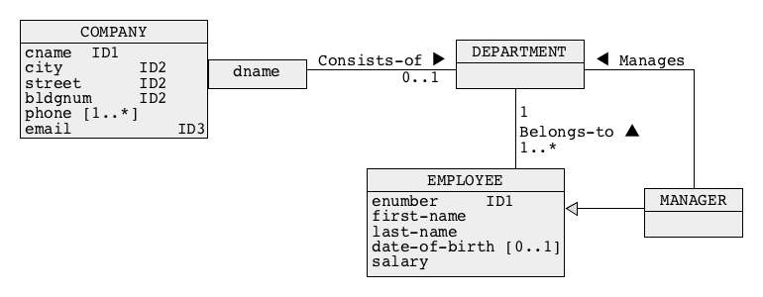

Perform logical database design and transform a conceptual schema given above into a collection of relational schemas. No report is expected from logical design. Use a **subset** method for implementation of generalization.

Next, use the relational schemas obtained in the previous step to create SQL script solution1.sql with CREATE TABLE statements that implement the relational schemas.

Note, that you MUST use only CREATE TABLE statements and no other statement of SQL.

When a script file solution1.sql is ready connect to Oracle either through command line interface SQLPlus or graphical user interface SQL Developer and process your script file.

To list the names of relational tables created you can use a script list.sql.

If processing of the file returns the errors then you must eliminate the errors! Processing of your script must return NO ERRORS !

It is recommended to create a script drop.sql that drops all relational tables created by processing of a script solution1.sql and it is recommend to execute drop.sql after each processing of solution1.sql

**Task 2**

**ALTER TABLE statement**

Download the files dbcreate2.sql and dbdrop2.sql.

Connect to Oracle database server either through command line interface SQLPlus or graphical user interface SQL Developer.

SQL script dbcreate2.sql contains CREATE TABLE statements that can be used to create a small relational that contains information about banks, employees, customers, accounts and dependants. A conceptual schema of the database is given below.

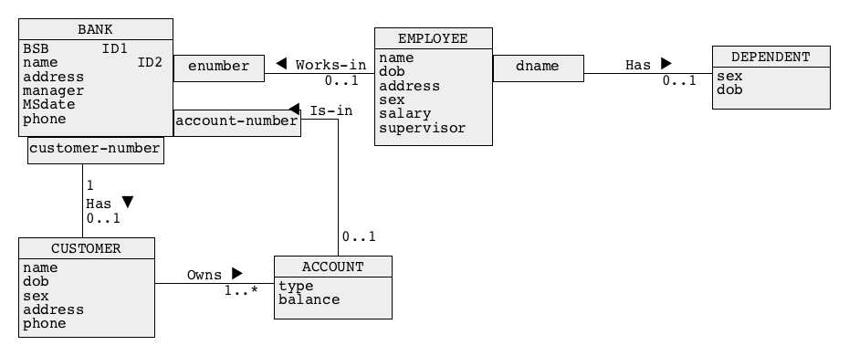

Analyse, the contents of a script dbcreate2.sql to find out how the relational tables are implemented and then execute a script dbcreate2.sql to create the relational tables. A script dbdrop2.sql can be used to drop all relational tables created by a script dbcreate2.sql. Do not drop the tables now !

Connect to Oracle database server either through command line interface SQLPlus or graphical user interface SQL Developer.

Your task is to implement SQL script solution2.sql with only (!) ALTER TABLE statements that implement the following modifications of the original relational tables included in the sample database.

(1) We would like to be able to add information about the total number of employees working at a particular bank for each bank.

(2) We would like to increase the maximum length of bank name to 50 characters;

(3) We would like to define a supervisor of each employee as one of the employees in a bank.

(4) We would like to increase maximum balance of an account up to $99999999.99.

(5) We would like to allow for automatic deletion of a row from Dependent table when a row from Employee table is deleted.

When SQL script file solution2.sql is ready process your script file.

It is recommended to use a script dbdrop2.sql to drop all relational tables modified during the processing of a script solution2.sql and then to re-create the original database with a script dbcreate2.sql. In such a way your script always operates on the original structures of the sample database.

**Task 3**

**Simple data manipulation statements**

Download the files dbcreate.sql, dbdrop.sql, and dbload.sql.

Connect to Oracle database server either through command line interface SQLPlus or graphical user interface SQL Developer.

To create and to load the relational tables of a sample database, process SQL script dbcreate.sql and dbload.sql. A script dbdrop.sql can be used to drop the relational tables. Do not drop the relational tables now.

The script files create and load data into a database that contain information about a company and its employees. The company consists of several departments located in the cities all over the world. The database also contains information about the present and past jobs of its employees and about the present managerial structure. A conceptual schema of the database is given below.

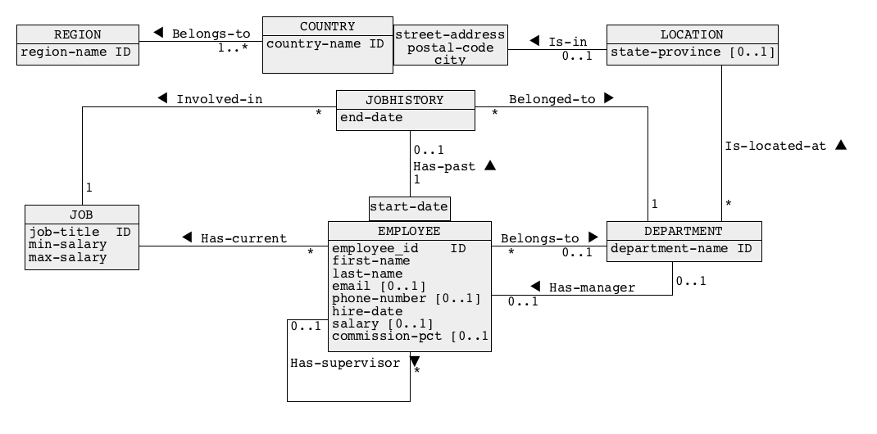

Your task is to use INSERT and/or DELETE and/or UPDATE statements of SQL to implement a script file solution3.sql that performs the data manipulations listed below. You must drop all tables of the sample database, re-create all tables of the database and load data into the database with dbcreate.sql script before implementation of this task.

Your SQL statements must operate on the sample database loaded with data.

An important condition is that you must only use INSERT and/or DELETE and/or UPDATE statements of SQL. No other statements of SQL are allowed. It means that you are not allowed to change any consistency constraints imposed on the contents of the data base like, for example suspension of foreign key constraints, etc.

Note, that implementation of the actions listed below may require more than one SQL statement.

(1) Insert into the database information about an employee.

Harry Potter, employee id 300, phone number 515.123.8182, hired at 10 February 2010. His email is harrypotter@gmail.com. He has been hired as a Programmer. His salary is 7000 and his commission percentage is 50%. He works in the department of Information Technology and his supervisor id is 103.

(2) An employee with an employee id equal to 206 is not a supervisor of any other employee. The employee decided to leave a company. Remove from a database all information about the employee.

(3) A department Human Resources has been moved to a new location. The new address is 100 Century Avenue, Shanghai, China. Post code is 200120.

When ready save the statements in SQL script file solution3.sql and process the script file.

**Task 4**

**SELECT statement: statements with WHERE, GROUP BY and HAVING clauses**

Download the files dbcreate.sql, dbdrop.sql, and dbload.sql.

Connect to Oracle database server either through command line interface SQLPlus or graphical user interface SQL Developer.

To create and to load the relational tables of a sample database, process SQL script dbcreate.sql and dbload.sql. A script dbdrop.sql can be used to drop the relational tables. Do not drop the relational tables now.

The script files create and load data into a database that contain information about a company and its employees. The company consists of several departments located in the cities all over the world. The database also contains information about the present and past jobs of its employees and about the present managerial structure. A conceptual schema of the database is given below.



Connect to Oracle database server either through command line interface SQLPlus or graphical user interface SQL Developer.

Your task is to implement the following queries as SELECT statements of SQL, save the statements in SQL script file solution4.sql and process the script file.

(1) Find the names of departments located in Sydney, Australia.

(2) Find the titles of jobs that offer salary in a range between 7500 and 8500 inclusive. Note, that a job with a salary range between 7600 and 8000 should be included in the answer.

(3) Find the full names of employees who are the topmost level supervisors, i.e. who are not supervised by any other employee.

(4) Find the employee ids and job titles of employees whose jobs ended in 1998.

(5) List the full names of all departments and full names of employees working in each department. The results should be displayed in the descending order of department names and the full names of employees from the same department must be listed in the ascending order of the last names.

(6) Find the names of departments located either in Japan or Singapore.

(7) Find the names of departments and names of countries located in Americas.

(8) Find the full names of employees who work in New York.

(9) Find the full names of employees whose commission percentage (commission_pct) is not empty.

(10) Find the job titles and total number of employees for each job title. The results will be sorted by the job titles in ascending order.

(11) Find the names of departments, names of countries and total number of employees for each department that hires more than three employees.

(12) Find the job titles, minimum and maximum salaries for each job title that has more than 5 employees hired for such jobs.

(13) Find the employee ids, full names of employees who completed their jobs. **Note:** Information about employees who have already completed their jobs is stored in a table JOBHISTORY.

(14) Find the employee id, first name and last name for each employee who is directly managed by Alberto Errazuriz.

(15) Find the employee ids, first names, last names of employees who are working on their jobs. **Note:** The employees who are working on their jobs either have no record in a table JOBHISTORY or their hire dates are later than their last jobs’ end date.

**Task 5**

**SELECT statement: joins, antijoins, GROUP BY and HAVING clauses**

Download the files dbcreate.sql, dbdrop.sql, and dbload.sql.

Connect to Oracle database server either through command line interface SQLPlus or graphical user interface SQL Developer.

To create and to load the relational tables of a sample database, process SQL script dbcreate.sql and dbload.sql. A script dbdrop.sql can be used to drop the relational tables. Do not drop the relational tables now.

The script files create and load data into a database that contain information about a company and its employees. The company consists of several departments located in the cities all over the world. The database also contains information about the present and past jobs of its employees and about the present managerial structure. A conceptual schema of the database is given below.



Your task is to implement the following queries as SELECT statements of SQL, save

and save the statements in SQL script file solution5.sql and process the script file.

The queries listed below must be implemented as SELECT statements with JOIN operation.

(1) Find the full names of employees who have been hired or who had their jobs in 1995.

(2) Find the names of departments together with the total number of employees working at each department. Include the departments that have no employees.

(3) Find the full names of supervisors together with the total number of employees directly supervised by each one of them.

(4) Find the full names of employees who had completed their jobs and worked for more than 1000 days.

(5) Find the full names of all employees who currently working in Canada. **The query must be implemented as a nested query.**

(6) Find the full names of all employees who have no information about themselves recorded in JOBHISTORY table. **The query must be implemented as a correlated nested query with a negated existential quantifier**.

(7) Find the full names of all employees who have completed two jobs. **The query must be implemented as a nested query.**

(8) Find the names of regions together with the names of departments located in each region. **The query must be implemented as a join query.**

(9) Find the names of departments located in Europe. **The query must be implemented as nested query with an existential quantifier.**

**Task 6**

**Advanced data manipulations**

Download the files dbcreate.sql, dbdrop.sql, and dbload.sql.

Connect to Oracle database server either through command line interface SQLPlus or graphical user interface SQL Developer.

To create and to load the relational tables of a sample database, process SQL script dbcreate.sql and dbload.sql. A script dbdrop.sql can be used to drop the relational tables. Do not drop the relational tables now.

The script files create and load data into a database that contain information about a company and its employees. The company consists of several departments located in the cities all over the world. The database also contains information about the present and past jobs of its employees and about the present managerial structure. A conceptual schema of the database is given below.



Your task is to implement the following advanced manipulations on data in SQL, save your implementations in SQL script file solution6.sql and process the script.

(1) Use a single SQL statement to create a relational table EMPCONTACT that consists of the columns EID, FNAME, LNAME, EMAIL, and PHONENUM and such that it contains all appropriate data copied from a relational table EMPLOYEE. When ready, enforce appropriate consistency constraints on a relational table EMPCONTACT.

(2) Create an empty relational table SALESEMPLOYEE, which has the following columns: EID, FNAME, LNAME, and JOBTITLE with the same types as the columns with the respective names in a relational table EMPLOYEE. Enforce primary key and referential integrity constraints on a relational table SALESEMPLOYEE. Copy information about all employees who have job related to Sales into SALESEMPLOYEE. Note that if an employee has a job related with Sales then it means that job title contains a word Sales.

(3) Use a single UPDATE statement to increase salary by 500 for all employees that have been hired in 1998 and earlier.

(4) Add a column TOTSTAFF to a relational table DEPARTMENT. A type of the column must be DECIMAL(3)with no other constraints imposed on the column. Next, insert into a column TOTSTAFF the total number of employees in each department.

(5) Use a single DELETE statement to remove all data from JOBHISTORY related to the employees who completed at least one jobs before 1996.

### End of specification