**ASP.NET MVC TaskS**

Note: Create new folder “ASP.NET_MVC_tasks” contains MVC_Task2 file in your repo with the bellow:

First

1. Create class with name Student with the bellow proparties:
   1. ID
   2. Name
   3. Major
   4. Faculity
2. Add sample data in your code.
3. View the data in table

Second

1. Design the tow tables in your database

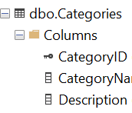

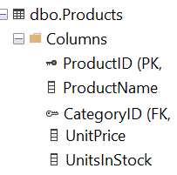

1. Create CRUD Application using Entity Framework for tables.