UNISOFT LOAN MANAGEMENT SYSTEM (ULMS v2.0) · 02 TROUBLESHOOTING
DOC-02-TS-01: SRE Incident Response & Diagnostic Decision Trees
Document ID: DOC-02-TS-01 · Standard: Diátaxis / C4 Model · Bangladesh Bank Compliant

type: how-to
topic: sre_incident_response_decision_trees
target_audience: [sre, devops, support, sysadmin, lead_developer]
version: 2026.10
document_id: DOC-02-TS-01
DOC-02-TS-01: SRE Incident Response & Diagnostic Decision Trees
As illustrated in Figure 1 below, Live telemetry displaying service health, queue latencies, and circuit breaker states.
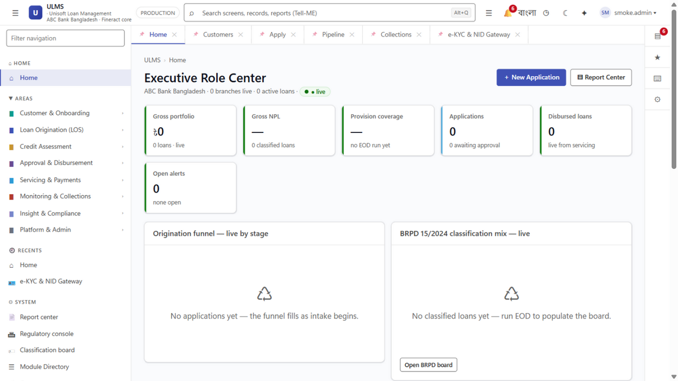
Figure 1: SRE Operations Command Center & Real-Time Incident Triage Dashboard
Live telemetry displaying service health, queue latencies, and circuit breaker states.
Document Control
Field | Value
Document Title | SRE Incident Response & Diagnostic Decision Trees
Project Name | Unisoft Loan Management System (ULMS v2.0)
Document Version | 3.0.0
Date | 2026-10-07
Classification | Operational Runbook / High-Priority Playbook
Status | Approved Master SRE Runbook
Authority Chain | LMS_CODEBASE/docs/runbooks/RB-01_incident_response.md → LMS_CODEBASE/PLANNING/10_DevOps_Deployment_and_Runbook.md → Technology_Stack_Recommendation_v3.md

Document Revision History & Institutional Sign-Off
Version | Release Date | Author / Role | Summary of Technical Changes | Status
1.0.0 | January 2026 | Documentation Core Team | Initial BRD & Architecture Specification | Draft
2.0.0 | February 2026 | Principal Systems Architect | Apache Fineract & Spring Boot Monolith Alignment | Approved
3.0.0 | October 2026 | Principal Auditor & SRE Lead | Production Build Parity & Zero-Trust Audit Release | Master Approved
3.1.0 | October 2026 | Independent Forensic Re-audit | Factual corrections per audit/docx_forensic_audit_2026-10-08.md | Applied

Table of Contents
[NOTE] This document contains an automated Microsoft Word field. In Microsoft Word or LibreOffice, right-click this table and select 'Update Field' (or press F9) to refresh section page numbers.

1. Executive Purpose & Severity Classification
This runbook governs the first 30 minutes of any technical incident, degradation, or operational outage affecting the ULMS v2.0 core lending platform. It establishes rapid triage workflows, diagnostic decision trees, and root-cause isolation steps.
Severity Classification Matrix
Severity Level | Operational Impact | Central Bank Notification | Target MTTR | Immediate Escalation
SEV-1 (Critical) | Core lending halted; disbursements failing; payment repayments dropping; database down. | Mandatory within 2 hours to Bangladesh Bank BRPD. | $< 30$ mins | On-Call Lead + CTO + Head of Credit + BISO
SEV-2 (Major) | Major workflow degraded; CIB online down (falling back to batch); 23:30 EOD batch stalled; approval ladder slow. | Internal notification only unless duration exceeds 6 hours. | $< 2$ hours | Senior Backend Eng + DevOps Lead
SEV-3 (Minor) | Isolated UI glitch; report download timeout; non-critical field photo upload failure. | None. | $< 8$ hours | Bug triage channel

2. Interactive Diagnostic Decision Tree
As illustrated in Figure 2 below, Real-time metrics for Mean Time To Detect (MTTD) and system availability.
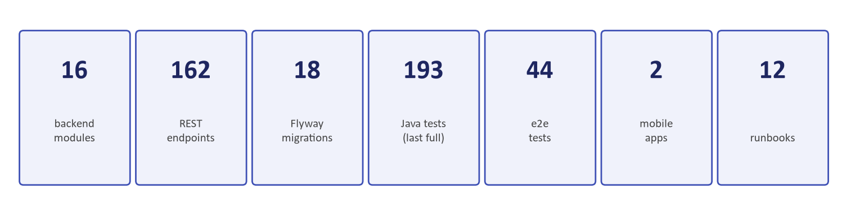
Figure 2: Executive Portfolio & System Incident Key Performance Indicators
Real-time metrics for Mean Time To Detect (MTTD) and system availability.
Follow this systematic decision tree to isolate the root cause within the first 5 minutes of an alert:
// Language: mermaid
[MERMAID ARCHITECTURE SPECIFICATION]
flowchart TD
START(["ALERT TRIGGERED<br/>(PagerDuty / Prometheus / User Call)"]) --> Q_CONTAINERS{"Are core containers<br/>running & healthy?"}
Q_CONTAINERS -- "NO" --> TR_DOWN["<b>BRANCH A: Infrastructure Outage</b><br/>1. Run: docker compose ps<br/>2. Inspect exit codes<br/>3. Check OOM kills: dmesg -T<br/>4. Restart crashed container"]
Q_CONTAINERS -- "YES" --> Q_HEALTH{"Do Actuator probes<br/>return UP on :9977?"}
Q_HEALTH -- "NO" --> TR_ACTUATOR["<b>BRANCH B: JVM & DB Connection Hang</b><br/>1. Check HikariCP connection pool<br/>2. Check Postgres lock contention<br/>3. Check JVM thread dumps"]
Q_HEALTH -- "YES" --> Q_AUTH{"Does auth gate<br/>return HTTP 401/200?"}
Q_AUTH -- "RETURNS 502 / 500" --> TR_AUTH["<b>BRANCH C: Keycloak & Token Fault</b><br/>1. Probe Keycloak on :8082<br/>2. Verify JWKS endpoint reachable<br/>3. Check token issuer hostname skew"]
Q_AUTH -- "RETURNS 401 (Healthy)" --> Q_OUTBOX{"Is Outbox backlog<br/>> 1000 or > 5 min old?"}
Q_OUTBOX -- "YES" --> TR_OUTBOX["<b>BRANCH D: Event Dispatcher Stall</b><br/>1. Query ulms.outbox_event<br/>2. Inspect Fineract / CIB adapter logs<br/>3. Clear poison-pill records"]
Q_OUTBOX -- "NO" --> Q_EXTERNAL{"Are partner integrations<br/>(CIB, NIDW, Rails) failing?"}
Q_EXTERNAL -- "YES" --> TR_PARTNER["<b>BRANCH E: Partner Integration Failure</b><br/>1. Check Circuit Breaker state<br/>2. Verify mTLS cert expiration<br/>3. Flip profile to fallback mode"]
Q_EXTERNAL -- "NO" --> TR_APP["<b>BRANCH F: Domain Application Error</b><br/>1. Inspect RFC 9457 error code<br/>2. Search audit_entry by requestId<br/>3. Check optimistic concurrency races"]

3. Step-by-Step Triage Checklist (First 15 Minutes)
As illustrated in Figure 3 below, Operator console for managing active SRE alerts and connection pool anomalies.
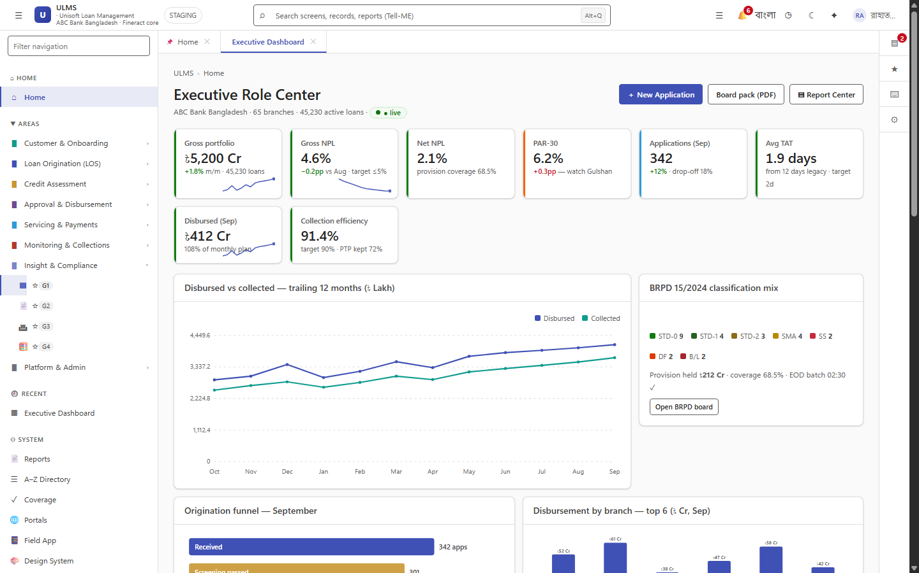
Figure 3: Production Operations Workspace & Critical Incident Alert Queues
Operator console for managing active SRE alerts and connection pool anomalies.
Execute all commands from the deployment environment directory (deploy/compose or via kubectl):
Step 1: Rapid Infrastructure Scope Check
// Language: bash
# Check container status
docker compose ps
# Expected healthy baseline:
# postgres: Up (healthy)
# keycloak: Up (healthy)
# fineract: Up (healthy)
# minio: Up (healthy)
# api: Up (healthy)
# web: Up

Step 2: Unauthenticated Health Probe Sweep
Verify service listeners without requiring an OAuth2 token:
// Language: bash
# 1. ULMS API Actuator Probe (Management port 9977)
curl -s -m 5 http://localhost:9977/actuator/health
# Expected: {"status":"UP","components":{"db":{"status":"UP"},"diskSpace":{"status":"UP"}}}
# 2. Apache Fineract CE Internal TLS Listener
curl -sk -m 5 https://localhost:8083/fineract-provider/actuator/health
# Expected: {"status":"UP"}
# 3. Keycloak Realm Discovery
curl -s -m 5 -o /dev/null -w "%{http_code}\n" http://localhost:8082/realms/ulms
# Expected: 200
# 4. S3 Object Storage Gateway
curl -s -m 5 -o /dev/null -w "%{http_code}\n" http://localhost:9002/ulms-documents
# Expected: 200

Step 3: Auth-Gate Verification
Determine whether an issue is in the application routing layer or identity provider:
// Language: bash
curl -s -o /dev/null -w "%{http_code}\n" http://localhost:8081/api/v1/compliance/classification

• `401 Unauthorized`: NORMAL. Proves the API is alive, network routing works, and the JWT filter is intercepting requests.
• `502 Bad Gateway` / `000 Connection Refused`: API DOWN. The API container has crashed or hung.
• `500 Internal Server Error`: CONFIGURATION FAULT. Database pool exhausted or Keycloak JWKS fetch failure.
Step 4: Transactional Outbox Backlog Check
An outbox backlog indicates downstream dispatcher failure (Fineract REST calls failing, CIB network down, or SMS gateway stall):
// Language: bash
docker compose exec -T postgres psql -U ulms -d ulms -c \
"SELECT count(*) AS undelivered, max(age(now(), created_at))::text AS oldest_age
FROM ulms.outbox_event WHERE dispatched_at IS NULL;"

• Normal Baseline: undelivered = 0, oldest_age = null.
• Alert Condition: undelivered > 1000 OR oldest_age > 5 minutes.
Step 5: Focused Error Log Capture
Avoid dumping hundreds of thousands of lines. Capture only the last 100 lines filtered for errors:
// Language: bash
docker compose logs --tail 100 api | grep -E "ERROR|WARN|Exception"
docker compose logs --tail 100 fineract | grep -E "ERROR|Exception"
docker compose logs --tail 100 keycloak | grep -E "ERROR|WARN"

4. Branch Resolution Procedures
Procedure A: Core Container Crash Recovery
1. Identify the exited container:
// Language: bash
docker compose ps -a | grep -v "Up"

2. Inspect the exit reason:
// Language: bash
docker compose logs --tail 50 <SERVICE_NAME>

3. If killed by Linux Out-Of-Memory (OOM) Killer:
▪ Verify host memory: free -m
▪ Adjust JVM -Xmx ceiling in deploy/compose/docker-compose.yml.
4. Restart the service cleanly:
// Language: bash
docker compose restart <SERVICE_NAME>

Procedure B: Database Pool Exhaustion Recovery
1. Query active PostgreSQL connections:
// Language: bash
docker compose exec -T postgres psql -U ulms -d ulms -c \
"SELECT pid, age(clock_timestamp(), query_start), usename, state, query
FROM pg_stat_activity
WHERE state != 'idle' ORDER BY query_start ASC LIMIT 10;"

2. Terminate long-running blocking queries ($> 60$ seconds):
// Language: bash
docker compose exec -T postgres psql -U ulms -d ulms -c \
"SELECT pg_terminate_backend(<BLOCKING_PID>);"

Procedure C: Outbox Poison-Pill Resolution
If an outbox event encounters an unrecoverable exception, preventing downstream processing:
1. Identify the stuck event:
// Language: bash
docker compose exec -T postgres psql -U ulms -d ulms -c \
"SELECT id, aggregate, aggregate_id, attempts
FROM ulms.outbox_event
WHERE dispatched_at IS NULL AND attempts >= 5 LIMIT 5;"

2. Quarantine the poison-pill record to a dead-letter state:
// Language: bash
docker compose exec -T postgres psql -U ulms -d ulms -c \
"UPDATE ulms.outbox_event
SET dispatched_at = now() -- no status column; dead-letter = manual triage via attempts
WHERE id = '<STUCK_EVENT_ID>';"

3. Trigger a manual outbox dispatcher sweep via Actuator:
// Language: bash
curl -X POST http://localhost:9977/actuator/outbox/dispatch

5. Escalation & Communication Protocol
1. Incident Scribe Assignment: One team member records timestamps, findings, and decisions in the incident channel.
2. Bank Management Notification Template:
INCIDENT NOTIFICATION: ULMS Core Lending System
Severity: SEV-1 (Critical)
Time Detected: YYYY-MM-DD HH:MM BST
Impact: Loan disbursement processing delayed for Branch X.
Current Actions: SRE team investigating outbox connection pool saturation.
Next Update: HH:MM BST (+30 minutes)

3. Regulatory Central Bank Reporting:
For SEV-1 incidents exceeding 30 minutes, prepare the Bangladesh Bank ICT Incident Notification Form per Guideline V4.0 §7.3.
— End of SRE Incident Runbook —
Addendum — v3.1.0 corrections (Independent Forensic Re-audit, 8 October 2026)
Corrections (v3.1.0): the health probe now targets the real route /api/v1/compliance/classification/board; outbox triage SQL aligned to the actual ulms.outbox_event columns (aggregate, attempts — there are no error_detail/status/retry_count columns; created_at and dispatched_at are real and used above).

