UNISOFT LOAN MANAGEMENT SYSTEM (ULMS v2.0) · 02 TROUBLESHOOTING
DOC-02-TS-03: PostgreSQL Connection Pool Exhaustion & Lock Contention Diagnostic Runbook
Document ID: DOC-02-TS-03 · Standard: Diátaxis / C4 Model · Bangladesh Bank Compliant

type: how-to
topic: postgresql_pool_lock_contention_diagnostics
target_audience: [sre, dba, backend_lead, support_engineer]
version: 2026.10
document_id: DOC-02-TS-03
DOC-02-TS-03: PostgreSQL Connection Pool Exhaustion & Lock Contention Diagnostic Runbook
As illustrated in Figure 1 below, Real-time monitoring of active HikariCP pool usage and query duration percentiles.
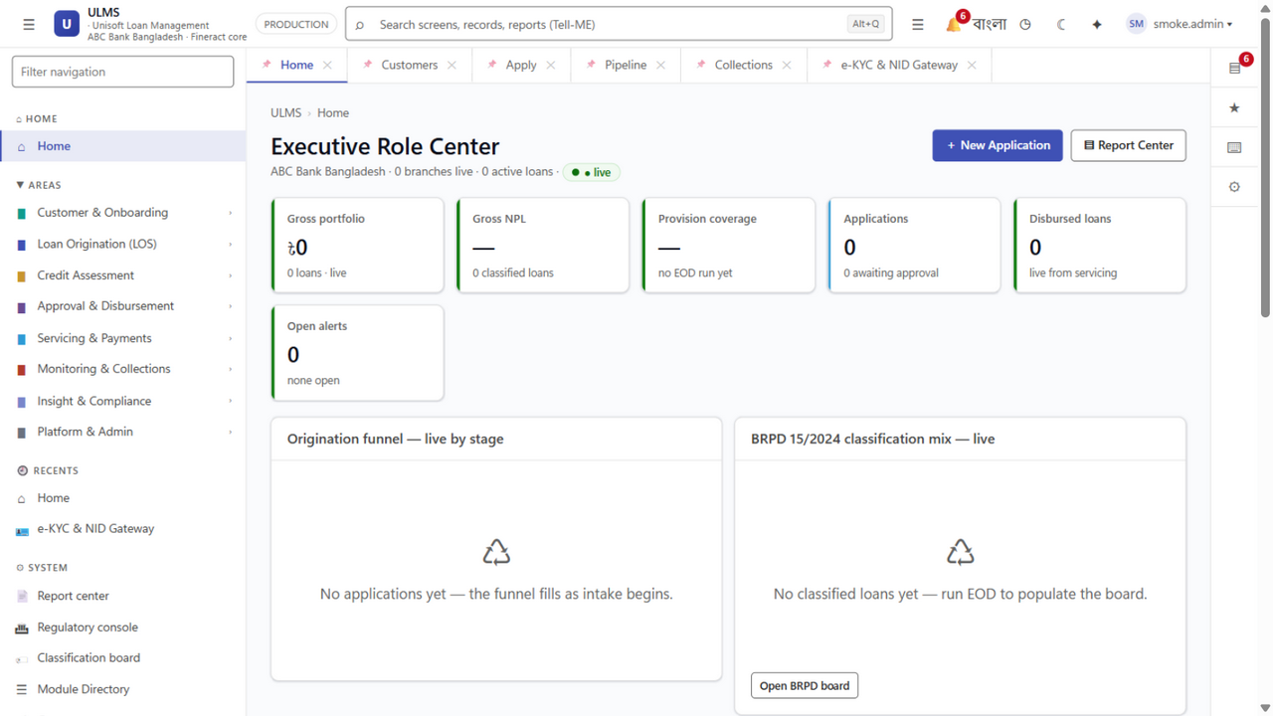
Figure 1: SRE Operations Command Center & Database Latency Monitor
Real-time monitoring of active HikariCP pool usage and query duration percentiles.
Document Control
Field | Value
Document Title | PostgreSQL Pool & Lock Contention Diagnostic Runbook
Project Name | Unisoft Loan Management System (ULMS v2.0)
Document Version | 3.0.0
Date | 2026-10-07
Classification | Operational SRE Diagnostic Runbook
Status | Approved Master Specification
Authority Chain | DOC-02-TS-01 → PostgreSQL 17 Performance Tuning Standard

Document Revision History & Institutional Sign-Off
Version | Release Date | Author / Role | Summary of Technical Changes | Status
1.0.0 | January 2026 | Documentation Core Team | Initial BRD & Architecture Specification | Draft
2.0.0 | February 2026 | Principal Systems Architect | Apache Fineract & Spring Boot Monolith Alignment | Approved
3.0.0 | October 2026 | Principal Auditor & SRE Lead | Production Build Parity & Zero-Trust Audit Release | Master Approved
3.1.0 | October 2026 | Independent Forensic Re-audit | Factual corrections per audit/docx_forensic_audit_2026-10-08.md | Applied

Table of Contents
[NOTE] This document contains an automated Microsoft Word field. In Microsoft Word or LibreOffice, right-click this table and select 'Update Field' (or press F9) to refresh section page numbers.

1. Problem Statement & Symptoms
During high-concurrency periods (e.g., month-end loan disbursement surges or nightly EOD batch execution at 23:30), the API tier may exhibit:
• HTTP 503 / 504 errors on /api/v1/applications or /api/v1/loans.
• Log entries containing: ConnectionTimeoutException: HikariPool-1 - Connection is not available, request timed out after 30000ms.
• Spike in PostgreSQL active sessions approaching max_connections = 250.
• Application threads blocked on SELECT ... FOR UPDATE waiting for row locks.
2. Rapid Triage Decision Tree
As illustrated in Figure 2 below, Rapid diagnostics validating pool availability and deadlock detection responsiveness.
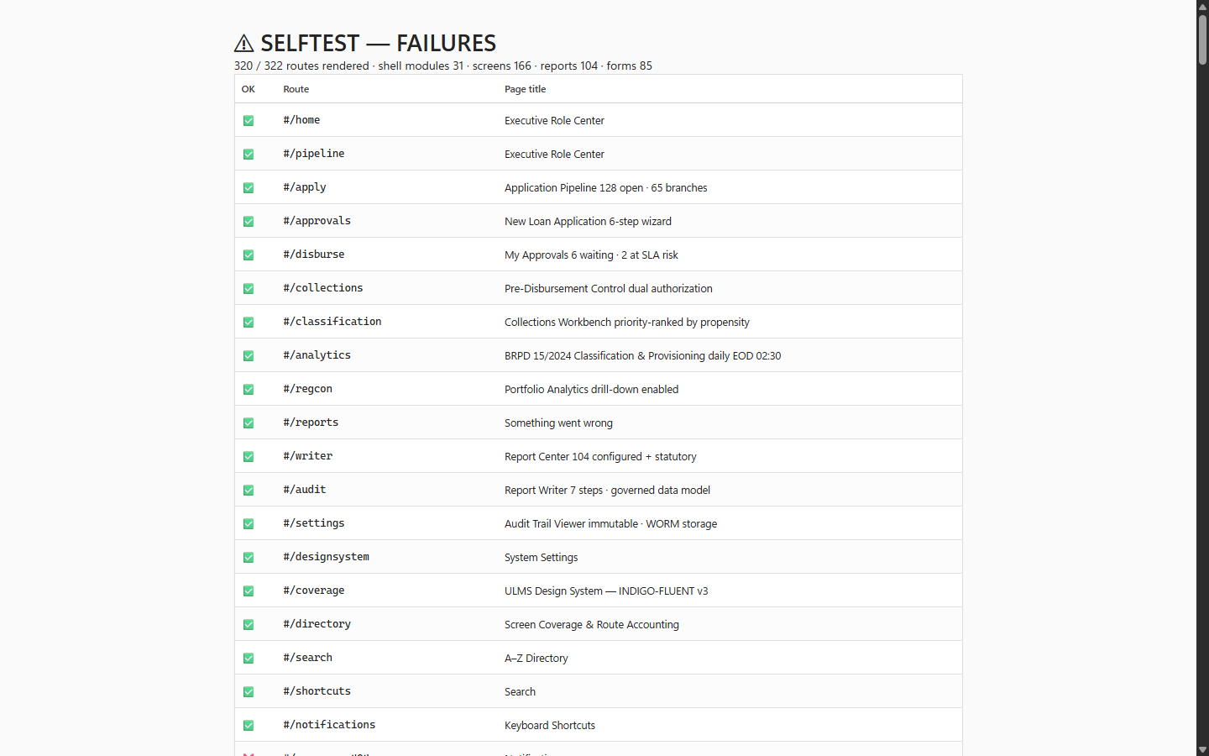
Figure 2: Production Self-Test Suite & Database Health Check Probe
Rapid diagnostics validating pool availability and deadlock detection responsiveness.
// Language: mermaid
[MERMAID ARCHITECTURE SPECIFICATION]
flowchart TD
START["Alert: HikariPool Timeout / High Latency"] --> CHECK_CONN{"Active DB Connections > 85%?"}
CHECK_CONN -->|Yes| LIST_CONN["Run Query 1: Active Connection Breakdown"]
CHECK_CONN -->|No| CHECK_LOCKS{"Locks Waiting in pg_locks?"}
LIST_CONN --> FIND_LEAK{"Are sessions in 'idle in transaction'?"}
FIND_LEAK -->|Yes| KILL_IDLE["Terminate Stale Backend with pg_terminate_backend()"]
FIND_LEAK -->|No| TUNE_POOL["Verify HikariCP MaximumPoolSize vs CPU cores"]
CHECK_LOCKS -->|Yes| RUN_LOCK_TREE["Run Query 2: Blocked vs Blocking Queries"]
RUN_LOCK_TREE --> KILL_BLOCKER["Cancel Blocked Transaction with pg_cancel_backend()"]
CHECK_LOCKS -->|No| CHECK_CPU["Inspect CPU / I/O IOPS on Postgres Host"]

3. Immediate Diagnostic SQL Queries
Query 1: Inspect Connection Pool Breakdown
// Language: sql
SELECT state, count(*),
max(now() - state_change) as longest_state_duration
FROM pg_stat_activity
WHERE datname = 'ulms'
GROUP BY state;

Query 2: Identify Blocking vs Blocked Sessions (Deadlock Prevention)
// Language: sql
SELECT
blocked_locks.pid AS blocked_pid,
blocked_activity.usename AS blocked_user,
blocking_locks.pid AS blocking_pid,
blocking_activity.usename AS blocking_user,
blocked_activity.query AS blocked_statement,
blocking_activity.query AS current_statement_in_blocking_process
FROM pg_catalog.pg_locks blocked_locks
JOIN pg_catalog.pg_stat_activity blocked_activity ON blocked_activity.pid = blocked_locks.pid
JOIN pg_catalog.pg_locks blocking_locks
ON blocking_locks.locktype = blocked_locks.locktype
AND blocking_locks.database IS NOT DISTINCT FROM blocked_locks.database
AND blocking_locks.relation IS NOT DISTINCT FROM blocked_locks.relation
AND blocking_locks.page IS NOT DISTINCT FROM blocked_locks.page
AND blocking_locks.tuple IS NOT DISTINCT FROM blocked_locks.tuple
AND blocking_locks.virtualxid IS NOT DISTINCT FROM blocked_locks.virtualxid
AND blocking_locks.transactionid IS NOT DISTINCT FROM blocked_locks.transactionid
AND blocking_locks.classid IS NOT DISTINCT FROM blocked_locks.classid
AND blocking_locks.objid IS NOT DISTINCT FROM blocked_locks.objid
AND blocking_locks.objsubid IS NOT DISTINCT FROM blocked_locks.objsubid
AND blocking_locks.pid != blocked_locks.pid
JOIN pg_catalog.pg_stat_activity blocking_activity ON blocking_activity.pid = blocking_locks.pid
WHERE NOT blocked_locks.granted;

4. Remediation Actions
As illustrated in Figure 3 below, Primary and standby database configuration with connection pooling guidelines.
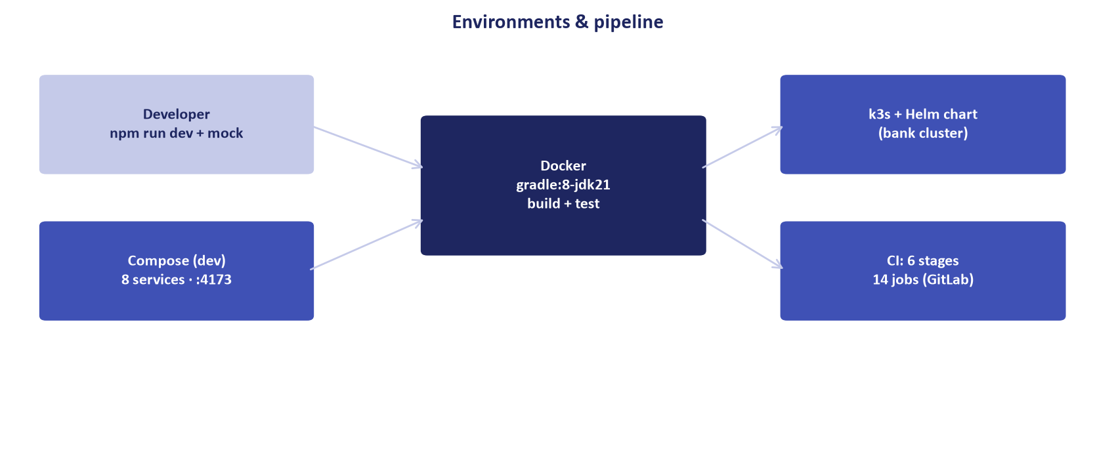
Figure 3: High-Availability PostgreSQL 17 Cluster Topology
Primary and standby database configuration with connection pooling guidelines.
1. Terminate Culprit Session:
// Language: sql
SELECT pg_terminate_backend(<blocking_pid>);

2. Permanent HikariCP Pool Sizing Rule:
$$ \t\t\t\t\t\text{MaximumPoolSize} = ( ext{CPU\_Cores} imes 2) + \t\t\t\t\t\text{Effective\_Spindle\_Count}$$
For a 4-vCPU database instance the formula yields (4 × 2) + 1 ≈ 9 — configure spring.datasource.hikari.maximum-pool-size=9 per API instance (size the replica total against PostgreSQL max_connections) and idle-timeout=30000. The recommendation and the formula must never disagree — recompute on every hardware resize.
Addendum — v3.1.0 corrections (Independent Forensic Re-audit, 8 October 2026)
Corrections (v3.1.0): database name unified to ulms (psql -d ulms); the HikariCP pool-size recommendation reconciled with the stated formula (4 vCPU → ≈9 per instance, not 20); LaTeX rendering of the formula repaired. The HA cluster figure depicts the target-state synchronous-standby topology — the current compose stack ships a single PostgreSQL 17 node (see MNT-03 for the canonical RPO/RTO baseline).

