UNISOFT LOAN MANAGEMENT SYSTEM (ULMS v2.0) · 03 MAINTENANCE
DOC-03-MNT-06: Historical Data Archival, Range Partitioning & Regulatory Record Retention Specification
Document ID: DOC-03-MNT-06 · Standard: Diátaxis / C4 Model · Bangladesh Bank Compliant

type: reference
topic: historical_data_archival_partitioning
target_audience: [dba, compliance_officer, data_architect]
version: 2026.10
document_id: DOC-03-MNT-06
DOC-03-MNT-06: Historical Data Archival, Range Partitioning & Regulatory Record Retention Specification
As illustrated in Figure 1 below, High-density database table partitioning separating active from historical records.
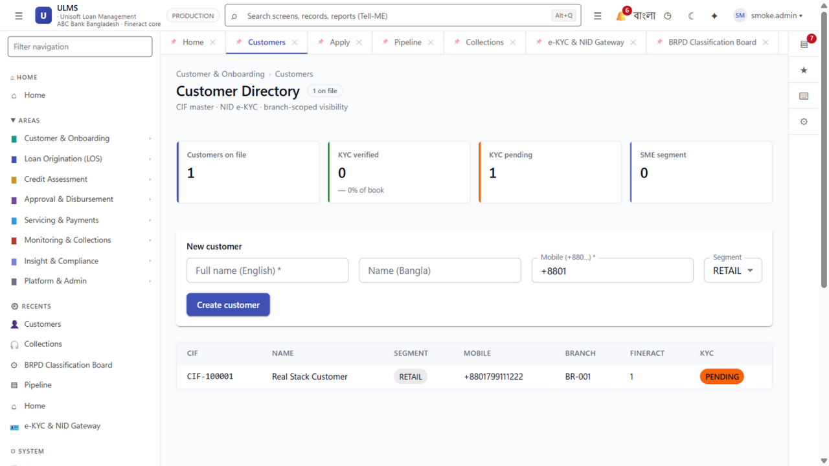
Figure 1: Partitioned Customer & Loan Relational Table Master
High-density database table partitioning separating active from historical records.
Document Control
Field | Value
Document Title | Data Archival, Partitioning & Record Retention Specification
Project Name | Unisoft Loan Management System (ULMS v2.0)
Document Version | 3.0.0
Date | 2026-10-07
Classification | Statutory Architecture & Database Specification
Status | Approved Master Specification
Authority Chain | Bank Company Act 1991 §27 → BB ICT Security Guidelines V4.0

Document Revision History & Institutional Sign-Off
Version | Release Date | Author / Role | Summary of Technical Changes | Status
1.0.0 | January 2026 | Documentation Core Team | Initial BRD & Architecture Specification | Draft
2.0.0 | February 2026 | Principal Systems Architect | Apache Fineract & Spring Boot Monolith Alignment | Approved
3.0.0 | October 2026 | Principal Auditor & SRE Lead | Production Build Parity & Zero-Trust Audit Release | Master Approved
3.1.0 | October 2026 | Independent Forensic Re-audit | Factual corrections per audit/docx_forensic_audit_2026-10-08.md | Applied

Table of Contents
[NOTE] This document contains an automated Microsoft Word field. In Microsoft Word or LibreOffice, right-click this table and select 'Update Field' (or press F9) to refresh section page numbers.

1. Statutory Retention Mandates
As illustrated in Figure 3 below, Transparent query performance across partitioned loan_transaction historical partitions.
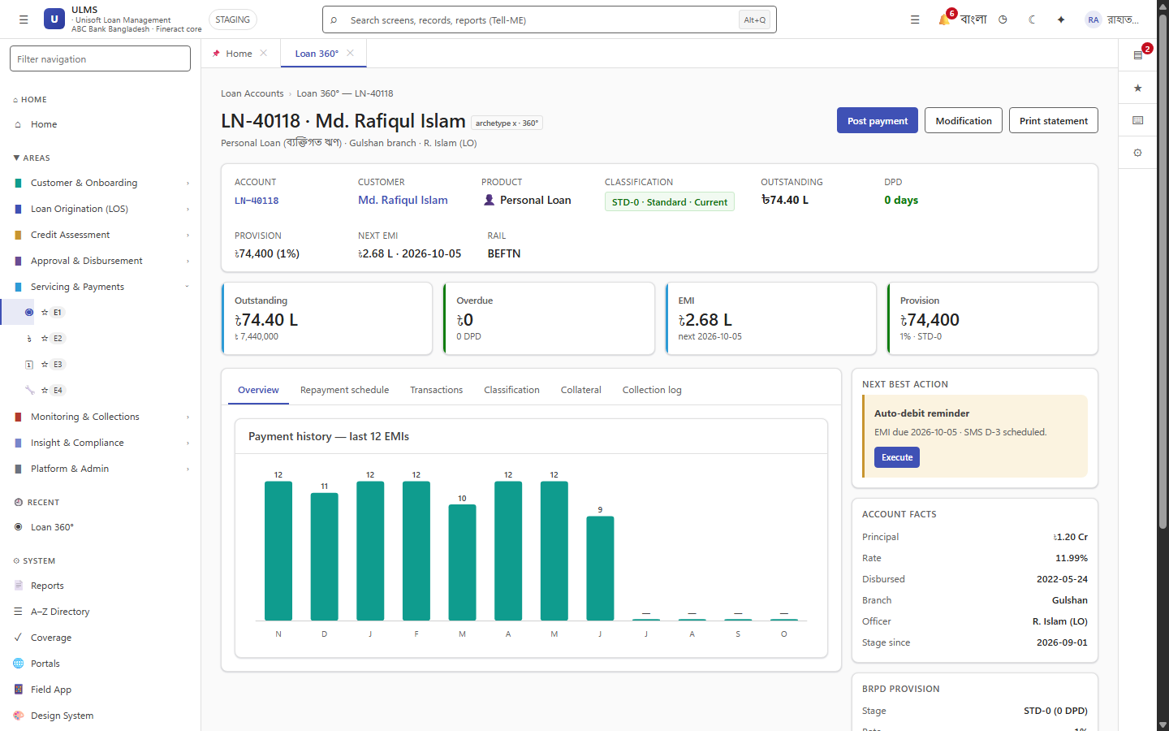
Figure 3: Active vs Archived Loan Transaction Ledger View
Transparent query performance across partitioned loan_transaction historical partitions.
The Bank Company Act 1991 requires commercial banks to maintain loan accounting ledgers and borrower KYC records for 12 years following loan account closure. Active transactional databases cannot scale linearly over 12 years without partitioning.
2. PostgreSQL Declarative Table Partitioning
High-volume tables (ulms.payment_transaction and ulms.audit_entry) are partitioned by date:
// Language: sql
CREATE TABLE ulms.payment_y2026m10 PARTITION OF ulms.payment_transaction
FOR VALUES FROM ('2026-10-01 00:00:00+06') TO ('2026-11-01 00:00:00+06');

3. Cold Storage Migration to WORM Storage
As illustrated in Figure 2 below, Fast query access across cold archived records for external Bangladesh Bank audits.
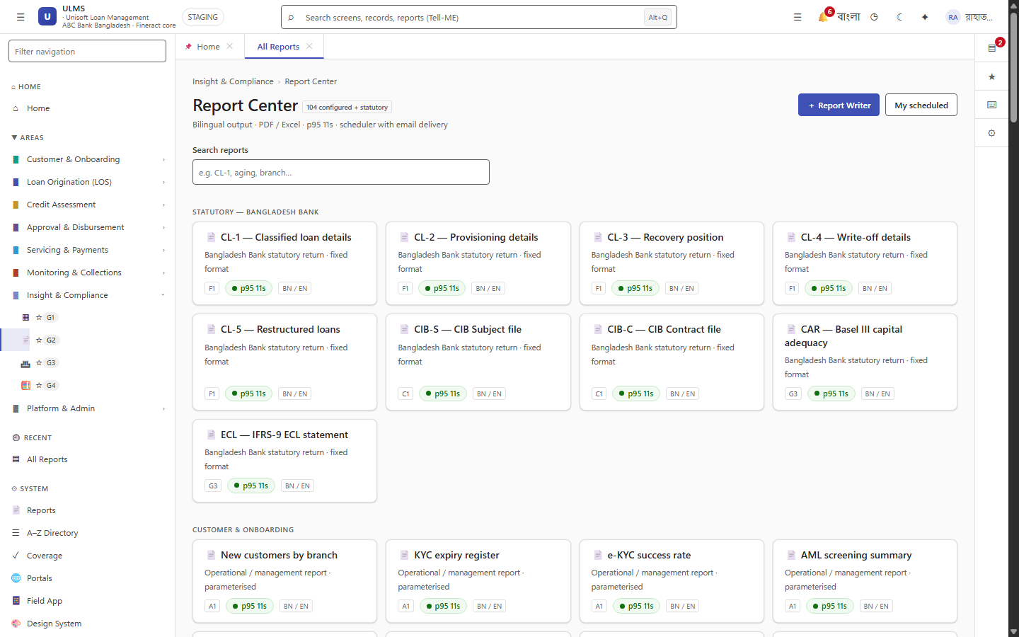
Figure 2: Historical Regulatory Returns & Archival Data Browser
Fast query access across cold archived records for external Bangladesh Bank audits.
Partitions older than 36 months are exported to Apache Parquet format and stored in MinIO WORM (Write Once Read Many) object storage with strict object locks, ensuring non-mutability and saving expensive SSD storage.
Addendum — v3.1.0 corrections (Independent Forensic Re-audit, 8 October 2026)
Corrections (v3.1.0): high-volume archival table name corrected to ulms.payment_transaction (the printed ulms.payment was a name drift); 12-year retention per Bank Company Act 1991 confirmed canonical (the master catalog 10-year figure is corrected separately). Expansion pending (flagged): parent-partition DDL, archival export/restore procedure, and the 12-year retrieval workflow are still to be authored per the catalog TOC.

