UNISOFT SYSTEMS LIMITED · A SUBSIDIARY OF SMART TECHNOLOGIES BD LTD
Executive One-Pager: Why ULMS v2.0
Commercial Banking Documentation · Document Ref: DOC-03-MKT-03

Document Identifier | Release Version | Security Classification | Publication Date | Target Audience
DOC-03-MKT-03 | 2.0.0 | Commercial Executive Brief | 2026-10-08 | [bank_md, ceo, board_member, cfo, cro]

Executive Decision Brief: Why ULMS v2.0

Empowering Bangladesh's Bank Leadership with a Compliant, Sovereign Core Lending Platform
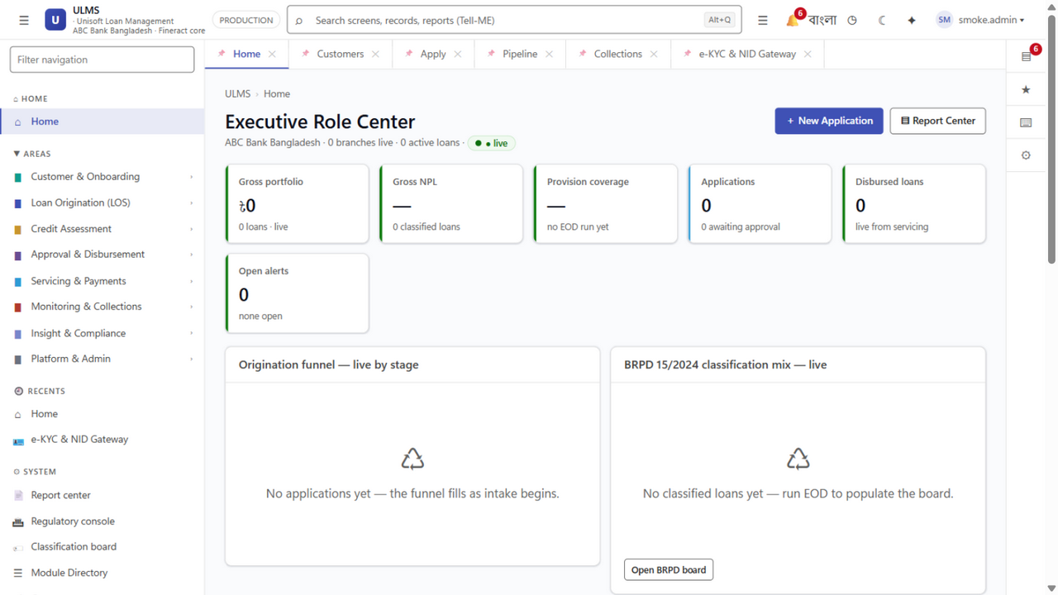
Figure 1: Production UI — Executive Overview Dashboard & Real-Time Performance Analytics
Document Identifier: DOC-03-MKT-03
Target Audience: Managing Directors, Chief Executive Officers, Board ICT Committee Members, Chief Financial Officers
Publisher: Unisoft Systems Limited (A Subsidiary of Smart Technologies BD Ltd)
Corporate Headquarters: Youth Tower, Begum Rokeya Sarani, Dhaka-1216, Bangladesh
Classification: Executive Commercial Asset

The 30-Second Executive Summary
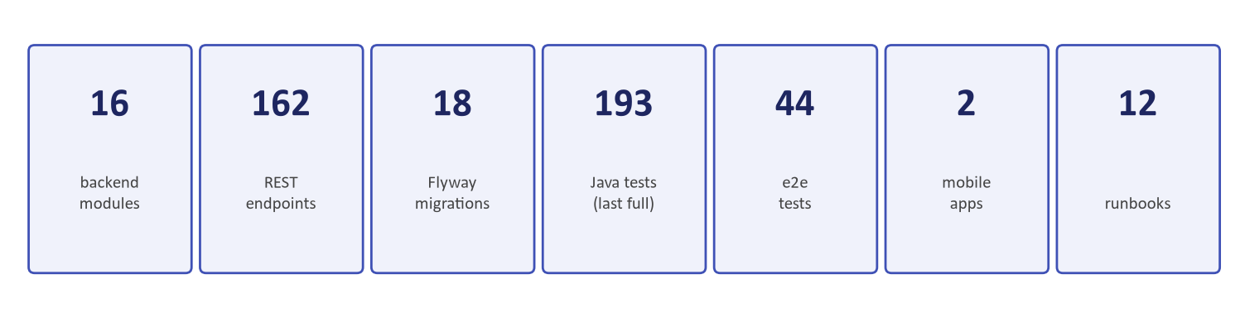
Figure 2: Executive Proof — Quantified TCO Reductions, TAT Acceleration & Payback Metrics
In 2026, scheduled commercial banks in Bangladesh face an urgent triple challenge:
- Mounting Non-Performing Loans (NPLs) driven by slow, paper-heavy underwriting;
- Strict Central Bank Mandates, notably BRPD Circular 15/2024 (7-stage classification) and mandatory IFRS-9 ECL provisioning by December 2027;
- Crushing IT Costs & Foreign Currency Depletion caused by multi-million dollar foreign software licenses.
ULMS v2.0 (Unisoft Loan Management System) provides a proven, sovereign alternative: an enterprise core lending and loan lifecycle platform engineered specifically for Bangladesh's banking sector. It cuts loan processing turnaround time by 85%, delivers 100% native Bangladesh Bank regulatory compliance, and reduces 5-year Total Cost of Ownership by 70% to 85% compared to foreign software suites.

The Strategic Choice: Comparing Three Paths Forward
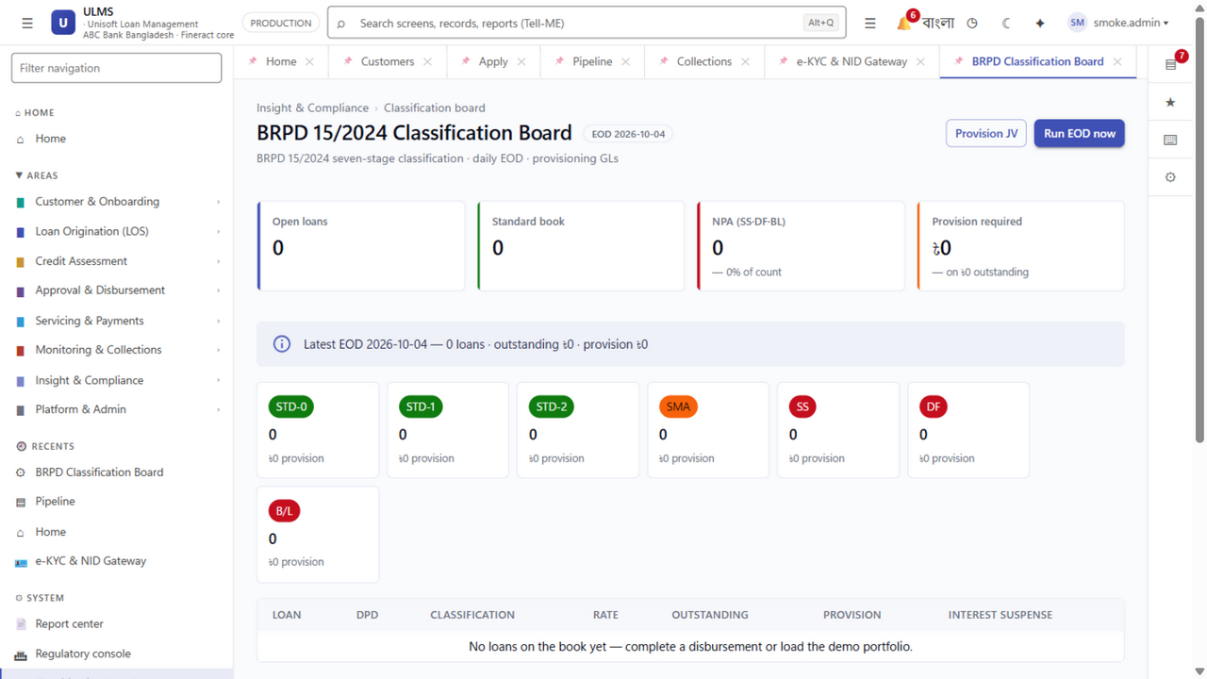
Figure 3: Regulatory Proof — Automated 7-Stage BRPD Circular 15/2024 Engine
Decision Dimension | Foreign Global Monoliths<br/>*(Finastra, Temenos, Nucleus)* | In-House Custom Build<br/>*(Bank Internal IT Team)* | Unisoft ULMS v2.0<br/>*(Specialized Domestic Platform)*
Capital Investment (CapEx) | Astronomical: $3.0M to $7.0M USD (foreign-vendor band; Unisoft all-inclusive BDT ৳3–6 Crore)<br/>(BDT 30 to 70+ Crore) | High & Unpredictable: ৳8 to 15 Crore in developer salaries & tools | Radically Efficient: ৳5.80 Crore modeled Year-0 outlay (incl. ৳1.80 Crore hardware) per the DOC-32 base case
Foreign Exchange (Forex) Drain | Severe foreign currency drain on bank reserves | Zero | Zero: 100% domestic billing in BDT
Time to Live Deployment | 18 to 24+ months (historical Bangladesh average) | 24 to 36+ months (chronic scope creep & turnover) | 12 Weeks to Pilot Go-Live;<br/>6 months full branch network
Bangladesh Bank Regulatory Alignment | Zero out of the box; requires costly, delayed custom scripting | Hit-or-miss; dependent on individual developer skills | 100% Native & Guaranteed:<br/>BRPD 15/2024, CIB REST, IFRS-9
Dual Conventional & Islamic Banking | Requires purchasing separate, expensive Islamic add-on modules | High risk of non-compliant Shariah accounting calculations | Native Dual Core: Complete Murabaha, Ijara, Musharaka engines
On-Site Technical Support in Dhaka | Remote offshore call centers; slow escalation | Vulnerable to internal developer resignations | Dedicated 24/7 Local Team:<br/>Dhaka-based engineers, 30-min SLA
CBS Integration Compatibility | Rigid; pushes expensive proprietary middleware | Custom, brittle point-to-point scripts | Pre-Built Connectors: Temenos, Oracle, Finacle, Flora Bank

Four Strategic Imperatives for the Boardroom

1. Protect Asset Quality & Eliminate Regulatory Fines
ULMS v2.0 replaces manual spreadsheet checks with automated, real-time Bangladesh Bank CIB Online inquiries, automated deduplication across NID and TIN numbers, and an automated BRPD Circular 15/2024 7-stage classification engine. Accounts transition deterministically across STD-0, STD-1, STD-2, SMA, SS, DF, and Bad/Loss with automated general and specific provisioning, eliminating misclassification fines.

2. Capture Market Share Through Unrivaled Operational Speed
By eliminating physical BOCC file shuttling and digitizing credit memos into an encrypted digital vault, ULMS collapses loan decisioning from 21 business days to 48 hours. High-credit-quality borrowers are approved and disbursed before competitor banks have even scheduled their branch credit committee.

3. Settle the 2027 IFRS-9 Crisis Today
While foreign vendors treat IFRS-9 as a complex multi-million dollar consulting project, ULMS v2.0 embeds a complete forward-looking Stage 1, Stage 2 (SICR), and Stage 3 Expected Credit Loss (ECL) engine natively. Banks adopting ULMS achieve complete central bank audit readiness well ahead of the December 31, 2027 statutory deadline.

4. Backed by Institutional Strength: Unisoft & Smart Technologies
Unisoft Systems Limited is not a startup. Backed by Smart Technologies BD Ltd—one of Bangladesh's largest technology conglomerates with annual group turnover exceeding ৳2,000 Crore—Unisoft brings a 10-year track record, 150+ enterprise implementations, and the official regulatory credibility of developing the NBR-Approved UniVAT™ enterprise system.

The Financial Return: Sub-7-Month Capital Payback
For a commercial bank managing a BDT 10,000 Crore loan portfolio:
- Direct Labor Savings: 60% reduction in branch officer paper preparation time (= ৳1.18 Crore saved annually).
- NPL Loss Reduction: A modest 0.75% reduction in credit losses via automated CIB and DBR underwriting (= ৳7.5 Crore saved annually).
- Regulatory Compliance Savings: Zero central bank non-compliance penalties and avoided external consulting fees (= ৳0.60 Crore saved annually).
- Net Financial Impact: Full capital recovery achieved in 6.64 months (sub-7 months); 5-year cumulative net cash benefit of BDT 48.23 Crore (NPV: BDT 32.94 Crore at 12% corporate discount rate; IRR: 164.5%).

Recommended Executive Action
Do not commit your institution to multi-million dollar foreign software contracts or years of internal development delay.
Commission a 45-Minute Executive Briefing & Live System Demonstration:
- Direct Executive Hotline: +880 1709-642404
- Email: office@uslbd.com
- Corporate Address: Youth Tower, Begum Rokeya Sarani, Dhaka-1216, Bangladesh
- Web: www.uslbd.com
Unisoft Systems Limited — Building Tomorrow's Banking Technology Today.
Addendum — v3.1.0 corrections (Independent Forensic Re-audit, 8 October 2026)
Financial components aligned to the DOC-32 base case: labor ৳1.18 Cr/yr, compliance ৳0.60 Cr/yr, Year-0 outlay ৳5.80 Cr, gross savings ৳10.48 Cr/yr, 5-year net ৳48.23 Cr, payback 6.64 months (8.5 conservative).

