UNISOFT SYSTEMS LIMITED · A SUBSIDIARY OF SMART TECHNOLOGIES BD LTD
Proof of Concept (PoC) Evaluation Charter & Acceptance Criteria
Commercial Banking Documentation · Document Ref: DOC-39-POC-01

Document Identifier | Release Version | Security Classification | Publication Date | Target Audience
DOC-39-POC-01 | 2.0.0 | Confidential Commercial & Technical Charter | 2026-10-08 | [cio, head_of_pmo, pre_sales_director, evaluation_committee]

Proof of Concept (PoC) Evaluation Charter & Success Criteria

Standardized 14-Day Controlled Evaluation Agreement for Bangladesh Commercial Banks
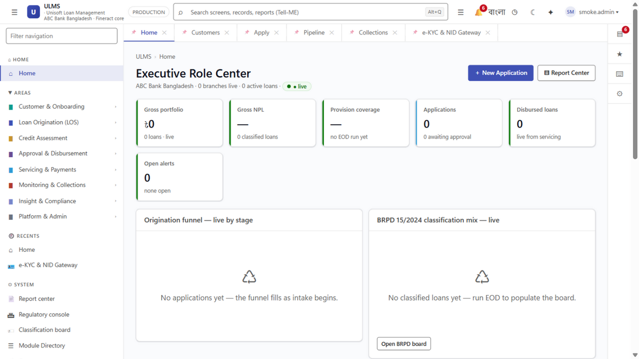
Figure 1: PoC Validation — Executive KPI Tracking & System Responsiveness Dashboard
Document Identifier: DOC-39-POC-01
Target Sales Stage: Late-Stage Technical Validation & Deal De-Risking
Author: Director of Pre-Sales & Senior Solutions Architect
Publisher: Unisoft Systems Limited (A Subsidiary of Smart Technologies BD Ltd)
Classification: Standard Commercial Evaluation Agreement
Version: 2.0.0

1. Purpose & Guiding Principles
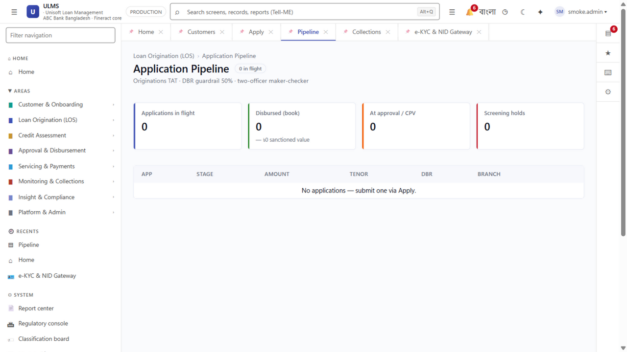
Figure 2: PoC Validation — End-to-End Loan Origination & Sanction Approval Clickpath
This Proof of Concept (PoC) Charter defines the terms, scope, schedule, test data requirements, and objective acceptance benchmarks for evaluating the Unisoft Loan Management System (ULMS v2.0) by [Insert Bank Name] (hereinafter referred to as "the Bank").

The Four Guiding Principles of the ULMS Evaluation:
- Strict 14-Calendar-Day Time Boundary: The evaluation shall commence on [Start Date] and formally conclude on [End Date].
- Dedicated Isolated Sandbox Environment: Testing shall be conducted in a dedicated, high-availability sandbox environment provisioned by Unisoft.
- Anonymized Sample Data Only: No real bank customer PII (Personally Identifiable Information) shall be used. Synthetic or masked data sets shall be loaded.
- Pre-Agreed Acceptance Benchmarks: Evaluation success shall be measured strictly against the 10 Mandatory Evaluation Scenarios detailed in Section 4.

2. Roles, Responsibilities & Governance
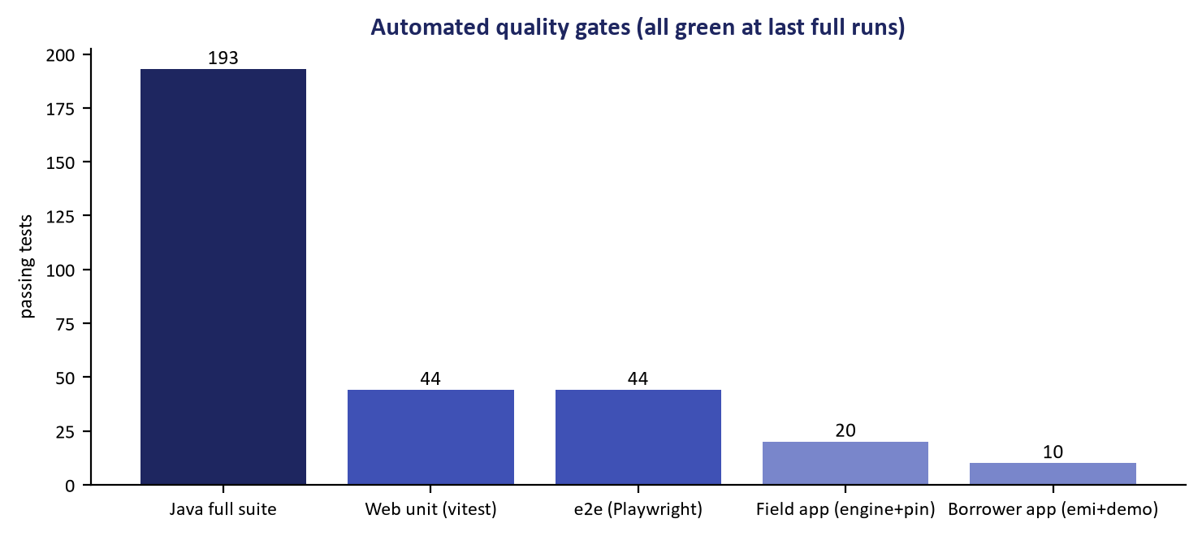
Figure 3: Automated Quality Gate — 405 Route Verification Suite with Zero Critical Defect
┌─────────────────────────────────┬───────────────────────────────────────────┐
│ UNISOFT PRE-SALES RESPONSIBILITIES│ BANK EVALUATION TEAM RESPONSIBILITIES │
├─────────────────────────────────┼───────────────────────────────────────────┤
│ • Provision dedicated sandbox │ • Designate dedicated evaluation officers │
│ • Pre-load sample product configs│ • Provide sample test parameters & rates │
│ • Conduct 4-hour kick-off training│ • Execute test cases within 14-day window │
│ • Provide dedicated engineer on Slack/Hotline│ • Participate in daily 15-min check-in│
│ • Resolve test environment defects < 4 hrs│ • Sign formal evaluation certificate │
└─────────────────────────────────┴───────────────────────────────────────────┘

Key Designated Personnel:
- Bank Evaluation Lead: [Insert Name, Designation: e.g., Head of Credit Operations / Head of IT]
- Unisoft Solution Architect: [Insert Name, Senior Banking Solutions Architect]
- Unisoft Pre-Sales Lead: [Insert Name, Director of Pre-Sales Engineering]

3. Scope & Boundary Conditions

In-Scope:
- Functional walkthrough and validation of the 10 core lending scenarios.
- Verification of automated e-KYC (simulated Election Commission NIDW API).
- Verification of automated Bangladesh Bank CIB REST inquiry and deduplication.
- Automated BOCC credit memo compilation and DBR calculation.
- Simulation of Core Banking disbursement via mock CBS web services.
- Automated End-of-Day (EOD) BRPD Circular 15/2024 classification batch run.

Out-of-Scope (Deferred to Post-Contract Implementation Phase):
- Live bi-directional integration with the Bank's production Core Banking ledgers.
- Bulk historical migration of the Bank's entire legacy loan database.
- Bespoke custom UI code modifications or custom report template development.

4. The 10 Mandatory Evaluation Scenarios & Pass/Fail Criteria
To eliminate subjective debate, the evaluation shall be judged strictly against these 10 scenarios:
Scenario # | Lending Workflow Tested | Step-by-Step Test Execution | Expected Objective Result | Pass / Fail
TEST-01 | Customer e-KYC Onboarding | Enter synthetic NID (1985012345) and birthdate; trigger verification. | System connects to e-KYC simulator, populates name/photo/address in <2.0 seconds. | [ ] PASS<br/>[ ] FAIL
TEST-02 | Automated CIB Online Inquiry | Ingest applicant credit profile; click 'Execute CIB Inquiry'. | System returns structured CIB history, credit score, and dedupe tags in <3.0 seconds. | [ ] PASS<br/>[ ] FAIL
TEST-03 | Debt Burden Ratio (DBR) Engine | Enter BDT 1,50,000 net income and BDT 35,000 liabilities; propose BDT 20,000 EMI. | System accurately calculates DBR = 36.67%; validates against 50% central bank cap. | [ ] PASS<br/>[ ] FAIL
TEST-04 | AI Credit Scorecard Calculation | Run scorecard on clean borrower profile vs. delinquent borrower profile. | Clean borrower scores >700 (Approved); delinquent profile scores <450 (Rejected). | [ ] PASS<br/>[ ] FAIL
TEST-05 | BOCC Credit Memo Generation | Click 'Generate BOCC Credit Memo' on completed underwriting file. | Complete standardized credit memo is compiled automatically with zero manual typing. | [ ] PASS<br/>[ ] FAIL
TEST-06 | Multi-Level Approval Delegation | Submit BDT 25 Lakh loan routing through L1 Branch Officer → L2 Branch Manager → L3 Regional Manager approval (seeded 7-level approval_band ladder). | System routes file sequentially; enforces digital signature and updates to 'Sanctioned'. | [ ] PASS<br/>[ ] FAIL
TEST-07 | CBS Limit Loading & Disbursement | Click 'Disburse via CBS Gateway' on sanctioned loan. | Mock CBS receives authenticated REST call, loads credit limit, posts fee vouchers in <2 sec. | [ ] PASS<br/>[ ] FAIL
TEST-08 | Amortization Schedule Accuracy | Verify 36-month BDT 15 Lakh EMI schedule at 11.5% interest rate. | Principal and interest breakdown matches standard actuarial reducing balance formula. | [ ] PASS<br/>[ ] FAIL
TEST-09 | BRPD 15/2024 Automated Staging | Run EOD batch on test portfolio with 0 DPD, 45 DPD, 120 DPD, and 400 DPD accounts. | Accounts stage accurately to STD-0, STD-2, SS, and B/L with exact statutory provisions. | [ ] PASS<br/>[ ] FAIL
TEST-10 | Immutable Audit Trail Verification | Alter customer phone number; inspect system security audit ledger. | Audit log captures exact before/after value diff, user identity, IP, and timestamp. | [ ] PASS<br/>[ ] FAIL

5. Evaluation Timeline & Daily Cadence
┌─────────────────────────────────────────────────────────────────────────────┐
│ 14-DAY POC EXECUTION SCHEDULE │
├───────┬─────────────────────────────────────────────────────────────────────┤
│ Day 1 │ Kick-Off Workshop, Sandbox Access Provisioning & User Credentials │
│ Day 2 │ Ingestion & e-KYC Verification Testing (TEST-01 & TEST-02) │
│ Day 3 │ Underwriting, DBR & Scorecard Engine Testing (TEST-03 & TEST-04) │
│ Day 4 │ BOCC Memo & Multi-Level Approval Testing (TEST-05 & TEST-06) │
│ Day 5 │ CBS Disbursement & Amortization Schedule Testing (TEST-07 & TEST-08)│
├───────┼─────────────────────────────────────────────────────────────────────┤
│Day 6-7│ Weekend (Sandbox available for independent exploration) │
├───────┼─────────────────────────────────────────────────────────────────────┤
│ Day 8 │ BRPD 15/2024 Classification & Collateral Netting Testing (TEST-09) │
│ Day 9 │ Security, RBAC & Audit Trail Verification (TEST-10) │
│ Day 10│ Islamic Shariah Murabaha / Retail Segment Deep Dive Walkthrough │
│ Day 11│ Performance Benchmarking & High-Throughput Load Verification │
│ Day 12│ Buffer Day for Retesting & Anomaly Verification │
│ Day 13│ Compilation of Evaluation Scorecard & Findings Report │
│ Day 14│ Formal Executive Review & Signing of PoC Acceptance Certificate │
└───────┴─────────────────────────────────────────────────────────────────────┘

6. Commercial Conversion Clause
By signing this Charter, the Bank agrees that:
- Objective Standard of Success: If the ULMS v2.0 sandbox successfully satisfies at least 9 out of the 10 Mandatory Evaluation Scenarios ($\ge 90\%$ pass rate), the Proof of Concept shall be deemed formally successful.
- Immediate Commercial Transition: Upon achieving successful PoC sign-off, the Bank’s procurement committee shall immediately proceed to the finalization of the Master Software License Agreement (MSLA) and implementation scheduling without requiring redundant re-evaluations.

7. Formal Execution Sign-Off
IN WITNESS WHEREOF, the authorized representatives of the parties have executed this Proof of Concept Evaluation Charter on this [Insert Day] of [Insert Month, Year]:
For and on behalf of [Insert Bank Name]:
_____________________________________________
[Name of Bank Authorized Signatory]
[Designation: Head of Credit Operations / Chief Information Officer]
Date: ________________________
For and on behalf of Unisoft Systems Limited:
_____________________________________________
[Name of Unisoft Authorized Signatory]
[Designation: Director of Pre-Sales & Enterprise Solutions]
Date: ________________________
Unisoft Systems Limited — Pre-Sales & Customer Solutions Directorate.

