UNISOFT LOAN MANAGEMENT SYSTEM (ULMS v2.0) · 01 ARCHITECTURE
DOC-01-ARCH-03: National Payment Rails, Bangladesh Bank RTGS, BEFTN & NPSB Integration Architecture
Document ID: DOC-01-ARCH-03 · Standard: Diátaxis / C4 Model · Bangladesh Bank Compliant

type: explanation
topic: payment_rails_clearing_integration
target_audience: [architect, developer, integration_specialist, core_banking_team]
version: 2026.10
document_id: DOC-01-ARCH-03
DOC-01-ARCH-03: National Payment Rails, Bangladesh Bank RTGS, BEFTN & NPSB Integration Architecture
As illustrated in Figure 1 below, Real-time clearing and installment collection through tokenized bKash and Nagad rails.
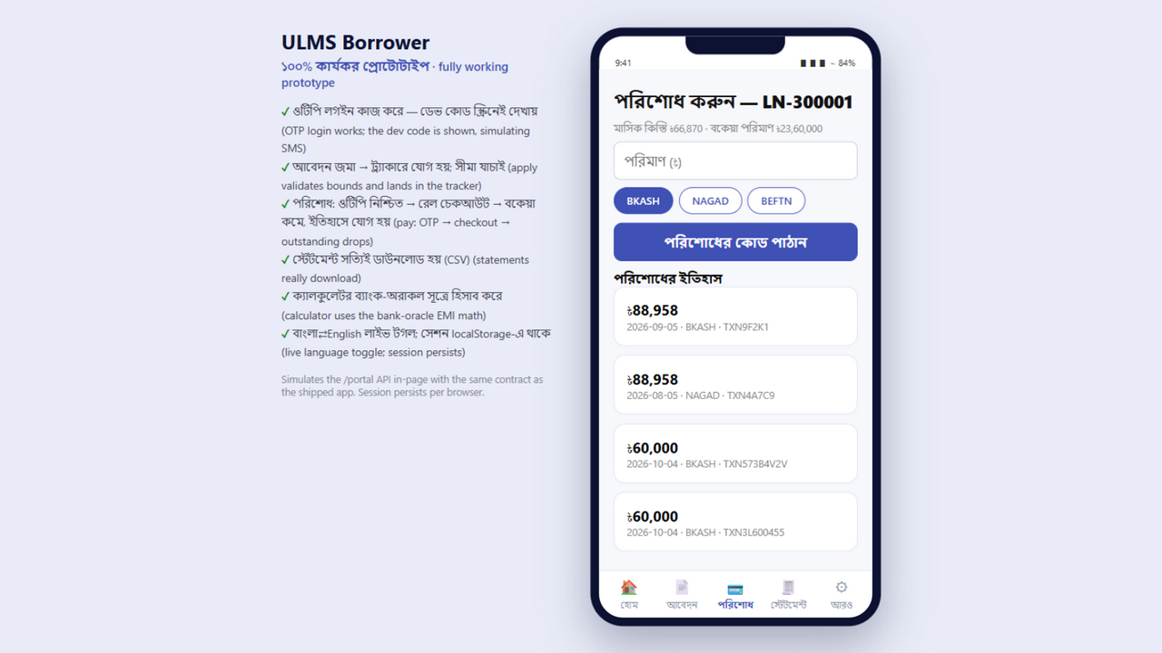
Figure 1: Production Digital Repayment & National MFS Payment Rail Flow
Real-time clearing and installment collection through tokenized bKash and Nagad rails.
Document Control
Field | Value
Document Title | National Payment Rails & Clearing Integration Architecture
Project Name | Unisoft Loan Management System (ULMS v2.0)
Document Version | 3.0.0
Date | 2026-10-07
Classification | Enterprise Technical Specification
Status | Approved Master Specification
Authority Chain | Compliance_Validation_Matrix.md → Software_Requirements_Specification.md → LMS_CODEBASE/PLANNING/11_External_Integrations_Plan.md

Document Revision History & Institutional Sign-Off
Version | Release Date | Author / Role | Summary of Technical Changes | Status
1.0.0 | January 2026 | Documentation Core Team | Initial BRD & Architecture Specification | Draft
2.0.0 | February 2026 | Principal Systems Architect | Apache Fineract & Spring Boot Monolith Alignment | Approved
3.0.0 | October 2026 | Principal Auditor & SRE Lead | Production Build Parity & Zero-Trust Audit Release | Master Approved
3.1.0 | October 2026 | Independent Forensic Re-audit | Factual corrections per audit/docx_forensic_audit_2026-10-08.md | Applied

Table of Contents
[NOTE] This document contains an automated Microsoft Word field. In Microsoft Word or LibreOffice, right-click this table and select 'Update Field' (or press F9) to refresh section page numbers.

1. Executive Summary & Regulatory Context
In Bangladesh commercial banking, loan disbursement and installment collection traverse national clearing and settlement rails regulated by Bangladesh Bank Payment Systems Department (PSD). ULMS v2.0 integrates with four primary payment channels:
1. Bangladesh Electronic Funds Transfer Network (BEFTN): Batch automated clearing for corporate and retail loan disbursements and scheduled Standing Orders.
2. Real-Time Gross Settlement (BD-RTGS): High-value (BDT $\ge 100,000$) instant fund transfers using ISO 20022 message schemas (pacs.008, pacs.009).
3. National Payment Switch Bangladesh (NPSB): Real-time retail interbank fund transfers and card-based collections.
4. Mobile Financial Services (MFS): Real-time retail loan repayments via bKash, Nagad, and Rocket APIs.
// Language: mermaid
[MERMAID ARCHITECTURE SPECIFICATION]
flowchart TD
subgraph ULMS_Core ["ULMS v2.0 Core Servicing Module"]
SERVICING["Servicing Engine<br/>(`LoanServicingService`)"]
OUTBOX["Transactional Outbox<br/>(`ulms.outbox_event`)"]
RAIL_PORT["Payment Rail Port<br/>(`PaymentRailPort`)"]
end
subgraph Adapters ["Hexagonal Rail Adapters (`integration.rails`)"]
BEFTN_ADAPTER["BEFTN Batch File Adapter<br/>(NACHA / XML format)"]
RTGS_ADAPTER["BD-RTGS Adapter<br/>(ISO 20022 `pacs.008`)"]
NPSB_ADAPTER["NPSB Switch Adapter<br/>(ISO 8583 bridge)"]
MFS_ADAPTER["MFS Aggregator Adapter<br/>(bKash / Nagad Tokenized REST)"]
end
subgraph Clearing_House ["National Clearing & MFS Rails"]
BB_BACPS["Bangladesh Bank BACPS (BEFTN)"]
BB_RTGS["Bangladesh Bank RTGS Engine"]
BB_NPSB["Bangladesh Bank NPSB Switch"]
MFS_RAILS["MFS Providers (bKash/Nagad)"]
end
SERVICING -->|1. Commit Payment Record| OUTBOX
OUTBOX -->|2. Reliable Event Relay| RAIL_PORT
RAIL_PORT --> BEFTN_ADAPTER
RAIL_PORT --> RTGS_ADAPTER
RAIL_PORT --> NPSB_ADAPTER
RAIL_PORT --> MFS_ADAPTER
BEFTN_ADAPTER --> BB_BACPS
RTGS_ADAPTER --> BB_RTGS
NPSB_ADAPTER --> BB_NPSB
MFS_ADAPTER --> MFS_RAILS

2. Architectural Design Patterns & Resiliency
2.1 The Hexagonal Rail Port Interface
ULMS abstracts all physical rail complexities behind the clean domain port com.uslbd.ulms.integration.rails.PaymentRailPort:
// Language: java
package com.uslbd.ulms.integration.rails;
public interface PaymentRailPort {
PaymentDisbursementResult disburse(DisbursementInstruction instruction);
PaymentInquiryResult queryStatus(String idempotencyKey);
PaymentReversalResult reverse(ReversalInstruction instruction);
}

2.2 Strict Idempotency Key Enforcement
As illustrated in Figure 2 below, Standardized ISO 20022 and REST clearing contracts with strict idempotency key protection.
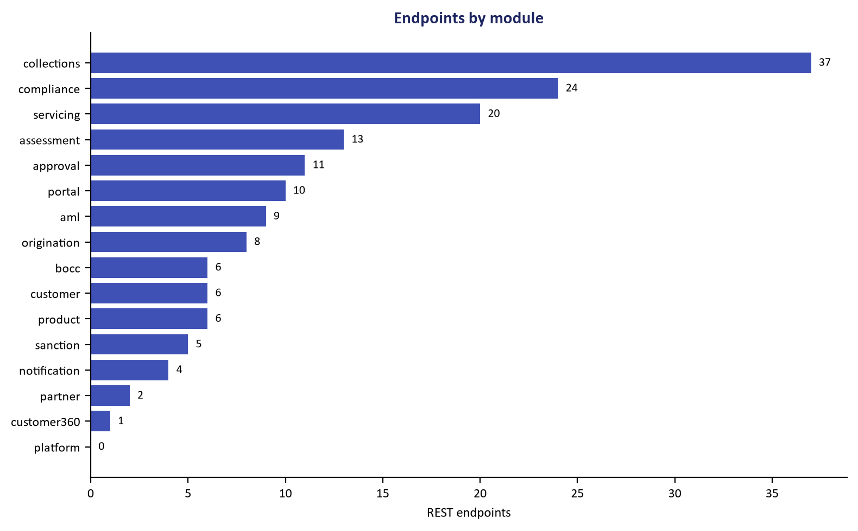
Figure 2: REST API Rail Interfaces & Clearing Message Envelopes
Standardized ISO 20022 and REST clearing contracts with strict idempotency key protection.
Every outbound clearing instruction generates a deterministic SHA-256 idempotency key composed of:
$$ ext{Key} = ext{SHA256}( ext{account\_no} \parallel ext{installment\_no} \parallel ext{amount\_minor} \parallel ext{tx\_date})$$
Stored in ulms.payment, preventing double-crediting during network timeouts or retry loops.
2.3 Clearing Settlement Cutoff Schedule
As illustrated in Figure 3 below, Live telemetry tracking outbound clearing settlement and ledger posting status.
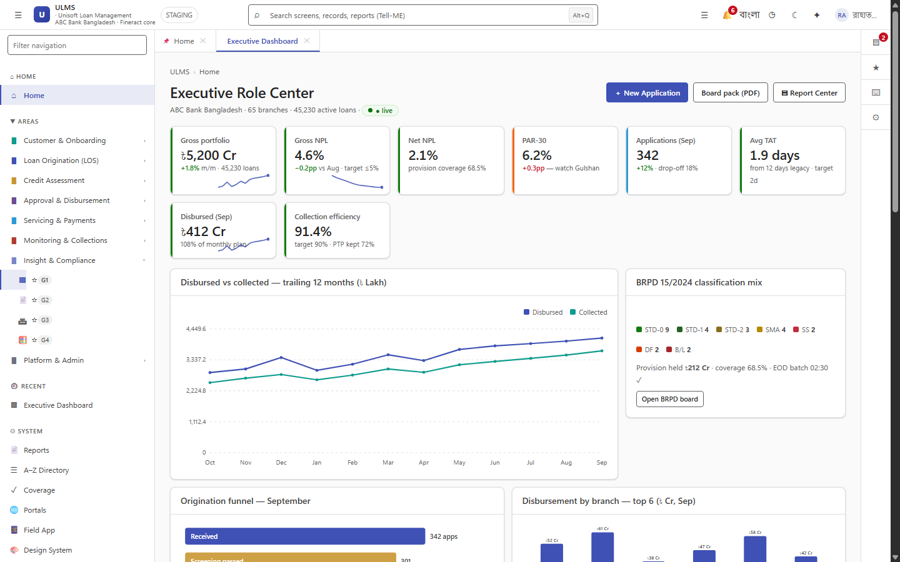
Figure 3: Core Banking Real-Time Portfolio & Payment Sync Monitor
Live telemetry tracking outbound clearing settlement and ledger posting status.
Rail | Settlement Frequency | Cutoff Window | Latency SLA | Fallback Protocol
BEFTN | 3 Sessions Daily | S1 12:00–15:00 · S2 15:00–23:59 · S3 00:00–10:00 (same-day cut-off 12:30; closed Fri/Sat/holidays) | $T+0$ to $T+1$ | Next clearing cycle
BD-RTGS | Real-Time Continuous | per current PSD schedule (Sunday–Thursday; illustrative 09:00–16:30) | $< 15$ seconds | Queue in Outbox until RTGS open
NPSB | Real-Time $24/7$ | Continuous | $< 3$ seconds | Retry 3 times, fail to BEFTN
bKash / Nagad | Real-Time $24/7$ | Continuous | $< 5$ seconds | Asynchronous webhook reconciliation

3. Discrepancy Reconciliation & Ledger Balancing
Every morning at 06:00 AM, the ULMS Reconciliation Batch executes:
1. Downloads clearing return files from BACPS SFTP.
2. Matches external settlement references against ulms.payment.
3. In case of returned items, reverses loan credits and restores borrower DPD counters.
4. Generates an unbalanced clearing exceptions alert to the treasury desk.
Addendum — v3.1.0 corrections (Independent Forensic Re-audit, 8 October 2026)
BEFTN session data refreshed (v3.1.0): three settlement sessions per working day per current Bangladesh Bank PSD operating schedule; RTGS window shown as illustrative pending the current PSD circular.

