UNISOFT LOAN MANAGEMENT SYSTEM (ULMS v2.0) · 01 ARCHITECTURE
DOC-01-ARCH-06: Identity, Authentication & Role-Based Access Control Specification
Document ID: DOC-01-ARCH-06 · Standard: Diátaxis / C4 Model · Bangladesh Bank Compliant

type: reference
topic: identity_access_management_and_rbac
target_audience: [security_architect, backend_developer, devops_engineer, ciso, auditor]
version: 2026.10
document_id: DOC-01-ARCH-06
DOC-01-ARCH-06: Identity, Authentication & Role-Based Access Control Specification
Document Control
Field | Value
Document Title | Identity, Authentication & Role-Based Access Control Specification
Project Name | Unisoft Loan Management System (ULMS v2.0)
Document Version | 3.0.0
Date | 2026-10-07
Classification | Enterprise Security Architecture Specification
Status | Approved Master Security Specification
Authority Chain | LMS_CODEBASE/deploy/seed/realm-ulms.json → Technology_Stack_Recommendation_v3.md → Bangladesh Bank ICT Security Guidelines V4.0
Target Codebase | c:\software_project\mim_project\LMS\LMS_CODEBASE

Document Revision History & Institutional Sign-Off
Version | Release Date | Author / Role | Summary of Technical Changes | Status
1.0.0 | January 2026 | Documentation Core Team | Initial BRD & Architecture Specification | Draft
2.0.0 | February 2026 | Principal Systems Architect | Apache Fineract & Spring Boot Monolith Alignment | Approved
3.0.0 | October 2026 | Principal Auditor & SRE Lead | Production Build Parity & Zero-Trust Audit Release | Master Approved
3.1.0 | October 2026 | Independent Forensic Re-audit | Factual corrections per audit/docx_forensic_audit_2026-10-08.md | Applied

Table of Contents
[NOTE] This document contains an automated Microsoft Word field. In Microsoft Word or LibreOffice, right-click this table and select 'Update Field' (or press F9) to refresh section page numbers.

1. Identity Architecture & Trust Domain
As illustrated in Figure 1 below, Bangladesh Bank ICT Security V4.0 compliant authentication portal with dual-factor enforcement.
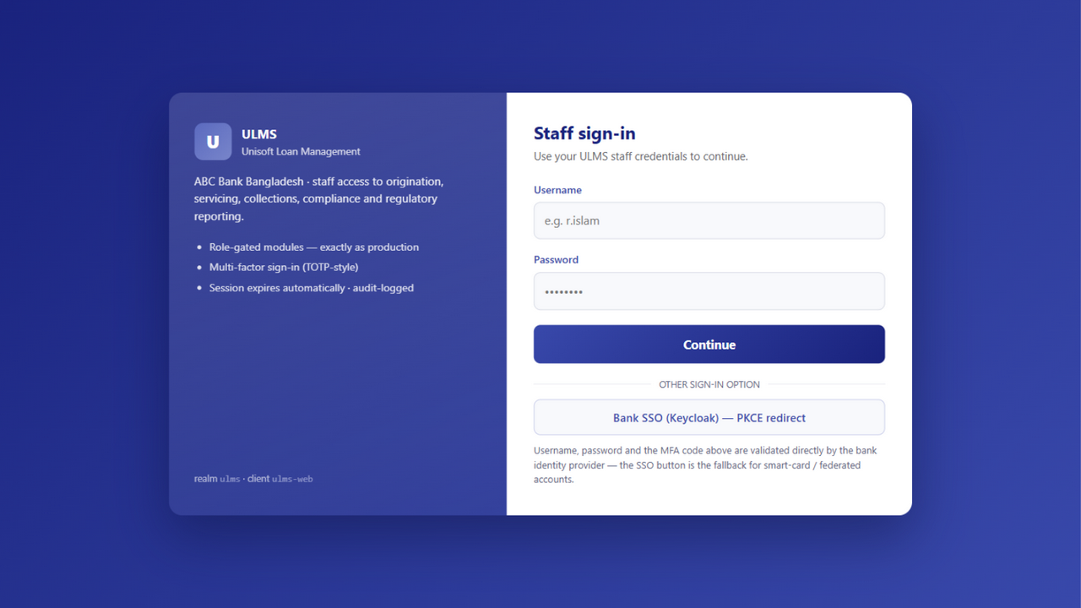
Figure 1: Enterprise Staff Single Sign-On (SSO) & Keycloak 26 MFA Gateway
Bangladesh Bank ICT Security V4.0 compliant authentication portal with dual-factor enforcement.
ULMS v2.0 establishes an institutional identity and access management (IAM) perimeter built upon Keycloak 26, implementing OAuth 2.0 and OpenID Connect (OIDC) with JSON Web Tokens (JWT):
// Language: mermaid
[MERMAID ARCHITECTURE SPECIFICATION]
flowchart TD
subgraph Client_Channels ["Banking Access Channels"]
STAFF["Staff Web Console (React 19)"]
BORROWER["Borrower Self-Service Portal"]
FIELD["Field Officer Mobile App (Expo 54)"]
CBS["Core Banking Integration Rails"]
end
subgraph IAM_Perimeter ["Keycloak 26 Identity Provider (:8082)"]
REALM["ULMS Banking Realm<br/>Active Directory / LDAP Federation"]
MFA["Multi-Factor Authentication (OTP / TOTP)"]
TOKEN["RS256 JWT Token Issuance (15m Access, 8h Refresh)"]
end
subgraph Resource_Servers ["Protected Banking APIs (:8081)"]
GW["API Gateway / Spring Security Filter"]
RBAC["RBAC & Maker-Checker Evaluator"]
SERVICES["9 Domain Services (Customer, Loan, Servicing...)"]
end
Client_Channels -->|1. Auth Request| IAM_Perimeter
IAM_Perimeter -->|2. Signed JWT| Client_Channels
Client_Channels -->|3. Bearer Token| GW
GW --> RBAC --> SERVICES

2. Institutional Role-Based Access Control (RBAC) Matrix
As illustrated in Figure 2 below, RBAC separation for Staff, Borrower Self-Service, Field Officer, and External Audit.
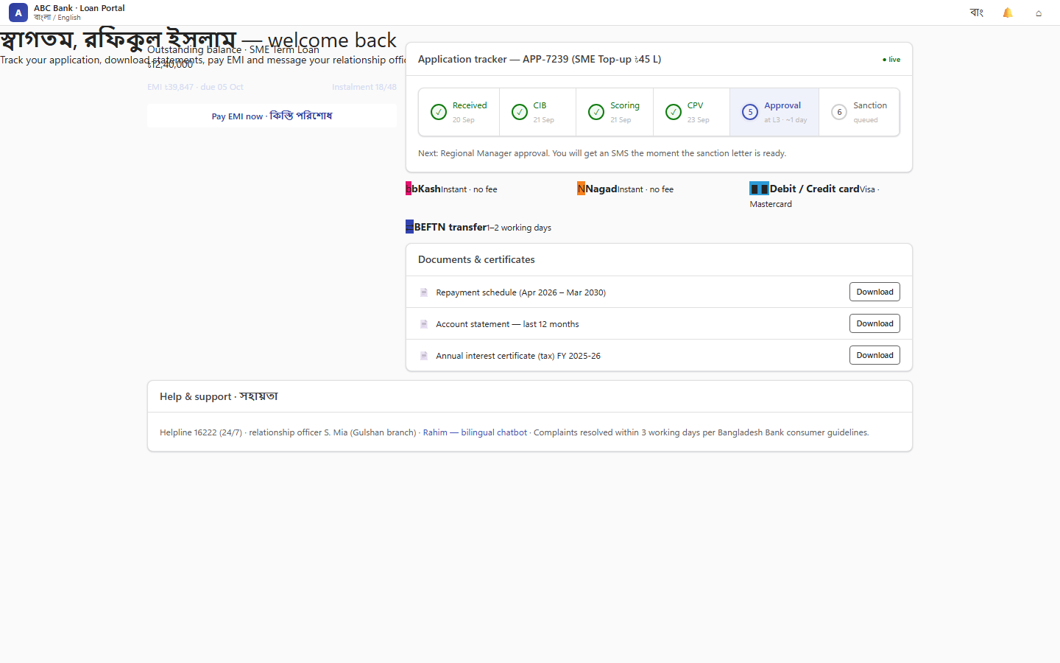
Figure 2: Multi-Persona Role-Based Portal Switcher & Access Control Gateway
RBAC separation for Staff, Borrower Self-Service, Field Officer, and External Audit.
The system defines 12 standard banking personas with fine-grained capability scopes across all 9 core modules:
Banking Persona | Primary Functional Scope | Permitted Capabilities & Scopes
`teller` | Front-desk cash & repayment | View customer balances, post cash/cheque repayment, generate mini-statement.
`loan-officer` | Loan origination & customer onboarding | Onboard customers, initiate e-KYC, create loan drafts, enter collateral particulars.
`credit-analyst` | Underwriting & credit assessment | Request CIB reports, execute credit scorecards, evaluate DBR, draft credit memos.
`branch-manager` | Branch supervisory approval (Tier 1) | Approve loans per the seeded approval_band ladder (L2: ≤ BDT 1,000,000); refer back; sanction letters.
`regional-manager` | Regional credit approval (Tier 2) | Approve loans per L3 band (≤ BDT 2,500,000); manage regional underwriting queues.
`head-of-credit` | Head Office credit risk approval (Tier 3) | Approve loans up to BDT 20,000,000; policy exception management.
`md-ceo` | Executive management sanction (Tier 4) | Approve loans up to BDT 50,000,000; executive committee escalation.
`board-member` | Board Credit Committee (BCC) (Tier 5) | Review and sanction syndicated/large exposures exceeding BDT 50,000,000.
`disbursement-officer` | Loan disbursement execution | Dual-control loan fund release to core banking CASA accounts.
`compliance-officer` | Regulatory reporting & BRPD | Run nightly EOD batch, generate CIB monthly exports, manage court stay orders.
`recovery-agent` | Delinquency & collections management | Manage DPD worklists, record Promise-to-Pay (PTP), issue dunning notices.
`field-officer` | On-site contact point verification (CPV) | Perform geo-tagged site visits, upload collateral photos via mobile app.

3. Maker-Checker Segregation of Duties
As illustrated in Figure 3 below, Secure device-bound OAuth2 token exchange with device fingerprinting.
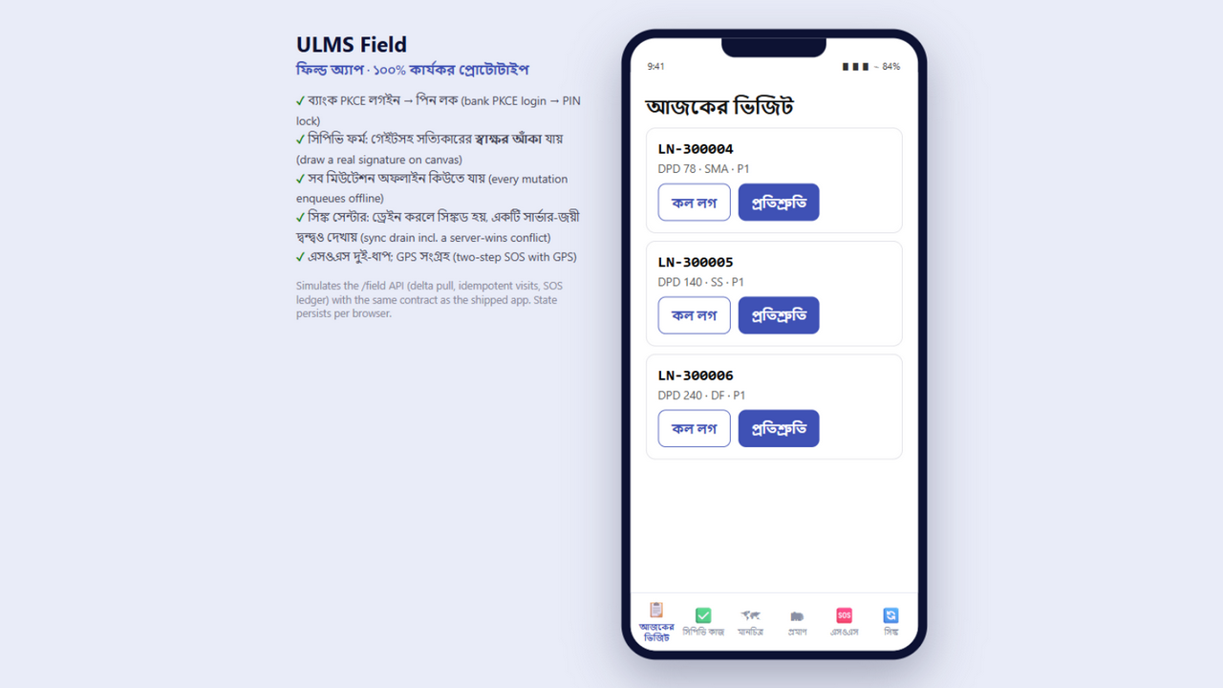
Figure 3: Field Verification Agent Mobile Authentication Interface
Secure device-bound OAuth2 token exchange with device fingerprinting.
Under Bangladesh Bank ICT Security Guidelines V4.0 §3.2, financial applications must enforce dual authorization to prevent internal fraud and collusion:
Technical Enforcement Rules:
1. Subject Matching Invariant: A loan application cannot be approved or sanctioned by an officer whose Keycloak sub (user identifier) matches the maker_user_id recorded on the application draft. Attempted self-approval returns `HTTP 409 Conflict (ULMS-AUTH-0002)`.
2. Disbursement Dual-Control: Loan fund release requires two distinct officers:
▪ Disbursement Maker: Verifies documentation and initiates disbursement schedule.
▪ Disbursement Checker: Verifies CASA account particulars and confirms fund release.
3. High-Value Step-Up Verification: Any transaction or disbursement exceeding BDT 500,000 triggers an out-of-band SMS OTP verification prompt.
4. JWT Token Claims Structure
// Language: json
{
"iss": "https://auth.ulms.bank.com.bd/realms/ulms",
"sub": "usr_8f2b3e4a-912c-4d8e-b567-0e12b3c4d567",
"aud": "account", "azp": "ulms-web",
"exp": 1791389400,
"nbf": 1791388500,
"iat": 1791388500,
"jti": "d63b2f18-6c89-4d2a-89bc-9902b3c4d501",
"preferred_username": "tariq.ahmed",
"email": "tariq.ahmed@bank.com.bd",
"realm_access": {
"roles": [
"loan-officer",
"branch-maker"
]
},
"branch_id": "BR-DHN-042",
"branch_name": "Dhanmondi Branch, Dhaka",
"approval_limit_minor": 100000000,
"mfa_verified": true
}

5. Session Governance & Audit Logging
• Access Token TTL: 15 minutes (short-lived to minimize exposure if token is intercepted).
• Refresh Token TTL: 8 hours (matches standard banking working shift).
• Session Revocation: Logout or administrator revocation invalidates the session server-side; access tokens are short-lived (15 minutes) and refresh is refused on revocation (Keycloak admin API) — no external broker in the binding v3 stack.
• Audit Logging: Every authorization decision (success or denial) writes an immutable record into ulms.audit_entry capturing timestamp, user_id, client_ip, action, resource_id, and http_status.
— End of Identity, Authentication & Role-Based Access Control Specification —
Addendum — v3.1.0 corrections (Independent Forensic Re-audit, 8 October 2026)
JWT example corrected (v3.1.0): issued access tokens carry "aud": "account" and "azp": "ulms-web" (verified against the live realm); approval limits come from the seeded approval_band ladder, not a JWT claim. Role vocabulary = the 11 seeded realm roles.

