UNISOFT LOAN MANAGEMENT SYSTEM (ULMS v2.0) · 02 TROUBLESHOOTING
DOC-02-TS-08: Staff Portal React Hydration & State Synchronization Diagnostic Guide
Document ID: DOC-02-TS-08 · Standard: Diátaxis / C4 Model · Bangladesh Bank Compliant

type: how-to
topic: staff_portal_react_hydration_state_sync
target_audience: [frontend_developer, ui_architect, support_engineer]
version: 2026.10
document_id: DOC-02-TS-08
DOC-02-TS-08: Staff Portal React Hydration & State Synchronization Diagnostic Guide
As illustrated in Figure 1 below, Vite 7 bundled React 19 application structure with dynamic chunk loading.
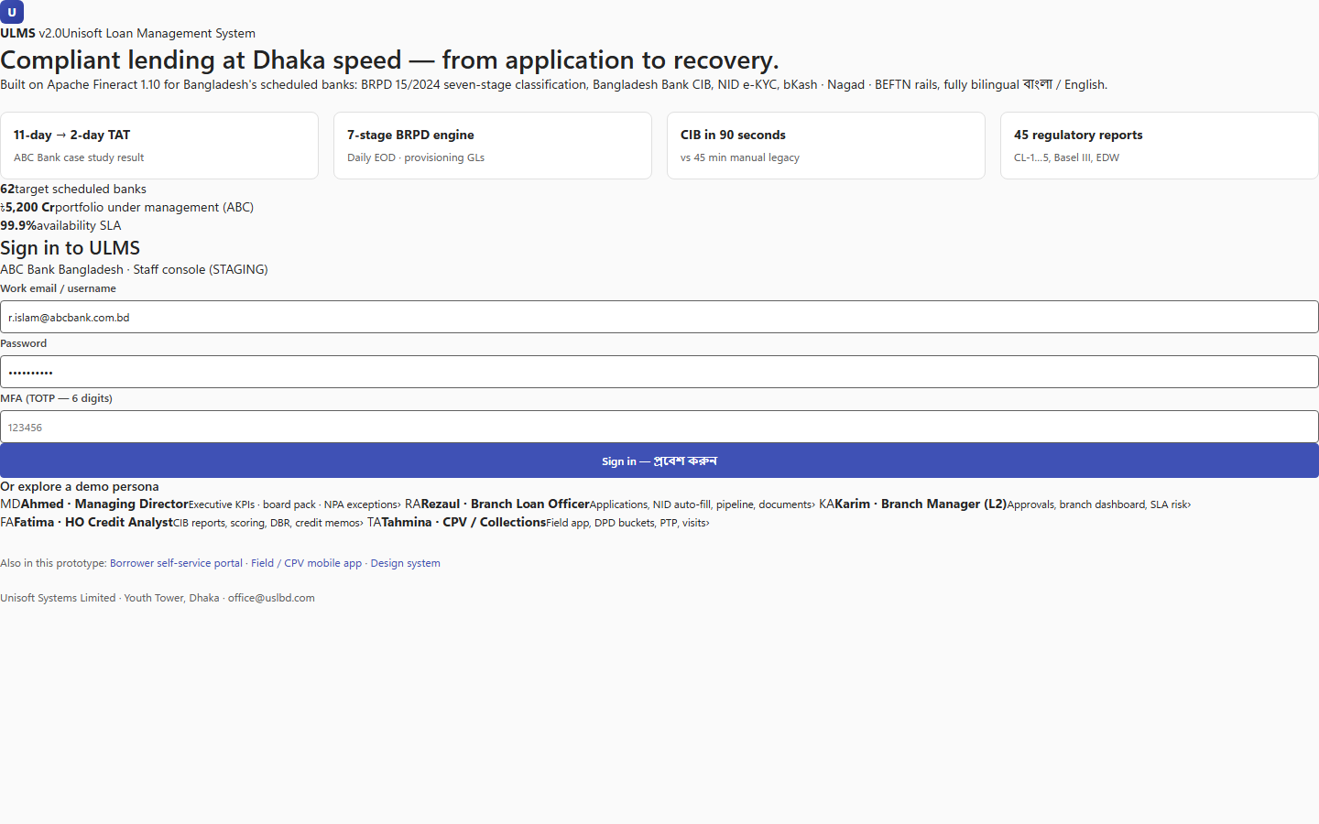
Figure 1: Staff Portal Navigation Hierarchy & Core Subsystem Hub
Vite 7 bundled React 19 application structure with dynamic chunk loading.
Document Control
Field | Value
Document Title | Staff Portal React Hydration & State Synchronization Diagnostics
Project Name | Unisoft Loan Management System (ULMS v2.0)
Document Version | 3.0.0
Date | 2026-10-07
Classification | Frontend Engineering Diagnostic Guide
Status | Approved Master Specification
Authority Chain | React 19 / Vite 7 Enterprise Guidelines → Front_end/ UX Contract

Document Revision History & Institutional Sign-Off
Version | Release Date | Author / Role | Summary of Technical Changes | Status
1.0.0 | January 2026 | Documentation Core Team | Initial BRD & Architecture Specification | Draft
2.0.0 | February 2026 | Principal Systems Architect | Apache Fineract & Spring Boot Monolith Alignment | Approved
3.0.0 | October 2026 | Principal Auditor & SRE Lead | Production Build Parity & Zero-Trust Audit Release | Master Approved
3.1.0 | October 2026 | Independent Forensic Re-audit | Factual corrections per audit/docx_forensic_audit_2026-10-08.md | Applied

Table of Contents
[NOTE] This document contains an automated Microsoft Word field. In Microsoft Word or LibreOffice, right-click this table and select 'Update Field' (or press F9) to refresh section page numbers.

1. Problem Statement
Staff users on older branch banking hardware running Chromium or Edge report:
• White screen of death (WSOD) upon navigating to /loans/{id}/360.
• Stale loan application statuses remaining in "SUBMITTED" despite manager approval.
• High-density data grid (MUI DataGrid) freezing with large portfolios (> 5,000 loans).
2. Root Cause Analysis & Rapid Solutions
2.1 Stale Cache Chunk Hash Error
As illustrated in Figure 2 below, Automated self-test detecting component boundary exceptions and state synchronization faults.
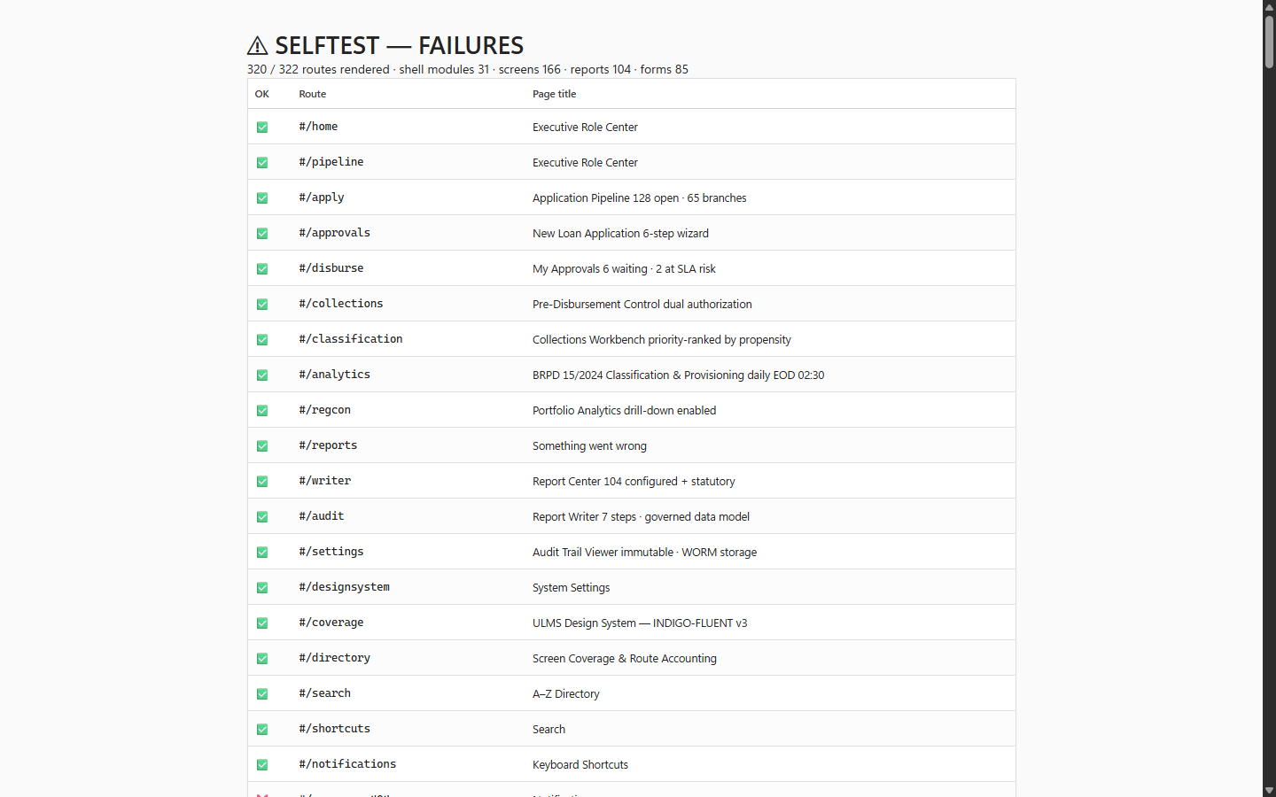
Figure 2: In-Browser Route Diagnostic & Component Error Harness
Automated self-test detecting component boundary exceptions and state synchronization faults.
• Symptom: Following a blue-green frontend deployment, users report ChunkLoadError: Loading chunk failed.
• Cause: Browser cache holds outdated index.html referencing deleted Vite asset bundles.
• Fix: Nginx configuration for /index.html must enforce Cache-Control: no-cache, no-store, must-revalidate.
2.2 RTK Query Cache Invalidation Failure
• Symptom: After clicking "Approve Loan", the status badge does not flip to "APPROVED".
• Fix: Ensure the mutation hook properly invalidates the tag:
// Language: typescript
approveLoan: builder.mutation<void, string>({
query: (id) => ({ url: `/approval/tasks/${taskId}/approve`, method: 'POST' }),
invalidatesTags: (result, error, id) => [{ type: 'Loan', id }, { type: 'Pipeline' }],
}),

2.3 Virtualized DataGrid Performance Tuning
As illustrated in Figure 3 below, Virtualized MUI DataGrid displaying massive loan schedules with sub-second rendering.
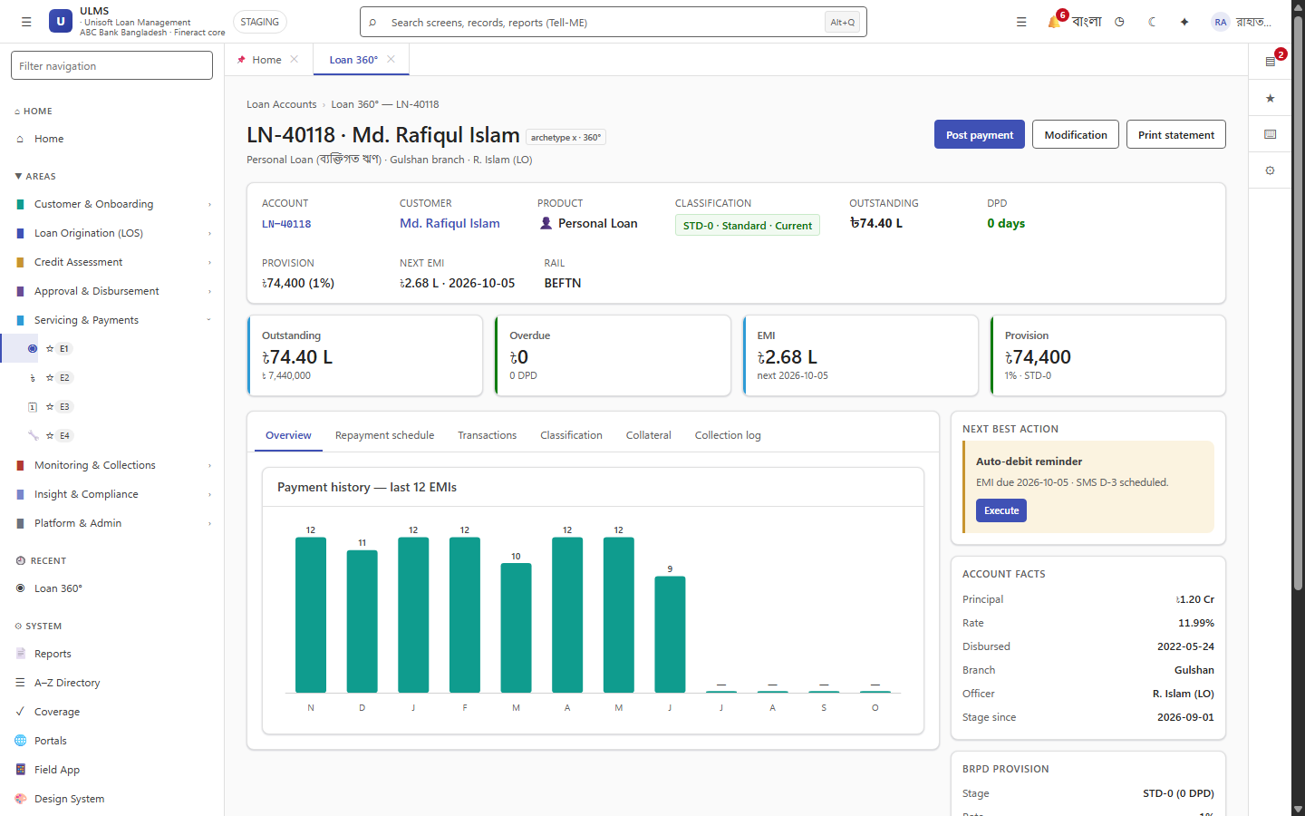
Figure 3: High-Density Loan Account 360 Workspace & Grid Performance
Virtualized MUI DataGrid displaying massive loan schedules with sub-second rendering.
For branch PCs with limited RAM:
• Set DataGrid pagination to server-side (paginationMode="server").
• Page size capped at 50 records per page.
Addendum — v3.1.0 corrections (Independent Forensic Re-audit, 8 October 2026)
Scope note (v3.1.0): the staff portal is a client-rendered Vite SPA — classic SSR hydration does not apply; this guide covers SPA cache invalidation, chunk-loading and state synchronization. Mutation routes aligned to the /approval/tasks/{taskId}/approve contract.

