UNISOFT LOAN MANAGEMENT SYSTEM (ULMS v2.0) · 03 MAINTENANCE
DOC-03-MNT-01: Zero-Downtime Rolling Upgrade & Release Playbook
Document ID: DOC-03-MNT-01 · Standard: Diátaxis / C4 Model · Bangladesh Bank Compliant

type: how-to
topic: zero_downtime_rolling_upgrade_and_release
target_audience: [release_manager, devops_engineer, sre, tech_lead]
version: 2026.10
document_id: DOC-03-MNT-01
DOC-03-MNT-01: Zero-Downtime Rolling Upgrade & Release Playbook
As illustrated in Figure 1 below, Zero-downtime blue/green deployment layout with healthcheck verification probes.
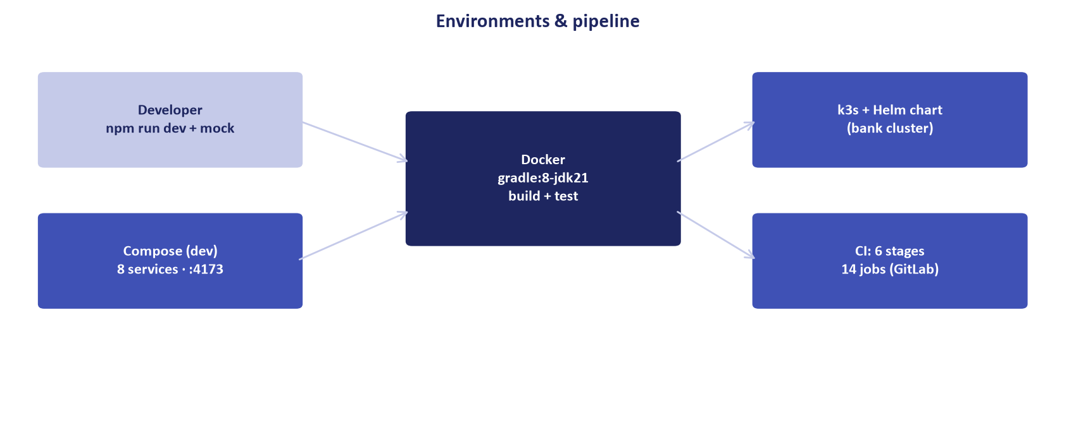
Figure 1: Kubernetes Rolling Upgrade & Traffic Shedding Topology
Zero-downtime blue/green deployment layout with healthcheck verification probes.
Document Control
Field | Value
Document Title | Zero-Downtime Rolling Upgrade & Release Playbook
Project Name | Unisoft Loan Management System (ULMS v2.0)
Document Version | 3.0.0
Date | 2026-10-07
Classification | Operational Release Management Guide
Status | Approved Master Release Playbook
Authority Chain | LMS_CODEBASE/PLANNING/10_DevOps_Deployment_and_Runbook.md → Technology_Stack_Recommendation_v3.md
Target Codebase | c:\software_project\mim_project\LMS\LMS_CODEBASE

Document Revision History & Institutional Sign-Off
Version | Release Date | Author / Role | Summary of Technical Changes | Status
1.0.0 | January 2026 | Documentation Core Team | Initial BRD & Architecture Specification | Draft
2.0.0 | February 2026 | Principal Systems Architect | Apache Fineract & Spring Boot Monolith Alignment | Approved
3.0.0 | October 2026 | Principal Auditor & SRE Lead | Production Build Parity & Zero-Trust Audit Release | Master Approved
3.1.0 | October 2026 | Independent Forensic Re-audit | Factual corrections per audit/docx_forensic_audit_2026-10-08.md | Applied

Table of Contents
[NOTE] This document contains an automated Microsoft Word field. In Microsoft Word or LibreOffice, right-click this table and select 'Update Field' (or press F9) to refresh section page numbers.

1. Zero-Downtime Architecture & Release Mandate
In commercial banking, scheduled downtime for software deployments disrupts customer digital channels, branches, and payment gateways. ULMS v2.0 enforces a strict Zero-Downtime Rolling Release Policy where production updates occur with zero dropped HTTP connections and zero degraded banking sessions.
// Language: mermaid
[MERMAID ARCHITECTURE SPECIFICATION]
sequenceDiagram
autonumber
actor DevOps as Release Engineer
participant Ingress as Ingress Controller
participant V1 as Pods v1 (Old Release)
participant V2 as Pods v2 (New Release)
participant DB as PostgreSQL 17
DevOps->>DB: 1. Apply backward-compatible Flyway migrations (Expand)
DevOps->>V2: 2. Spin up Canary Pod v2 (maxSurge=1)
V2->>V2: 3. Passes Readiness Probe (20s)
Ingress->>V2: 4. Routes partial traffic to Pod v2
Note over DevOps,Ingress: Canary Verification Window (10 minutes)
DevOps->>V2: 5. Promote full rollout across remaining nodes
V1->>V1: 6. PreStop hook initiated (Graceful drain 30s)
Ingress->>V1: 7. Ingress stops routing to Pod v1
V1-->>DevOps: 8. Pods v1 terminate safely

2. Pod Graceful Shutdown Configuration
As illustrated in Figure 2 below, Operational view validating seamless session persistence during version transitions.
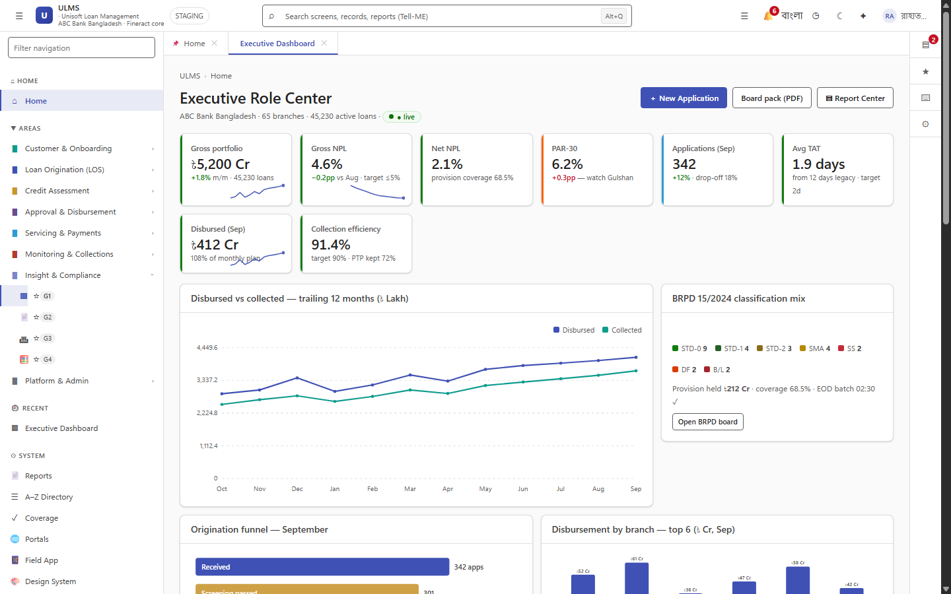
Figure 2: Staff Workspace & Cluster Rolling Release Status Monitor
Operational view validating seamless session persistence during version transitions.
To guarantee that active loan transactions or disbursement requests are never terminated mid-flight during a rollout, Spring Boot and Kubernetes are configured with synchronized graceful drain timeouts:
2.1 Spring Boot Configuration (`application.yml`)
// Language: yaml
server:
shutdown: graceful
spring:
lifecycle:
timeout-per-shutdown-phase: 30s

2.2 Pod Spec PreStop Hook
// Language: yaml
lifecycle:
preStop:
exec:
command: ["/bin/sh", "-c", "sleep 15"]

Purpose: When Kubernetes initiates pod termination, the preStop hook introduces a 15-second delay to ensure the Ingress Controller and endpoints controller fully remove the pod IP before the container receives SIGTERM.
3. Four-Phase Production Release Playbook
As illustrated in Figure 3 below, Zero connection drop verification across active teller and underwriting sessions.
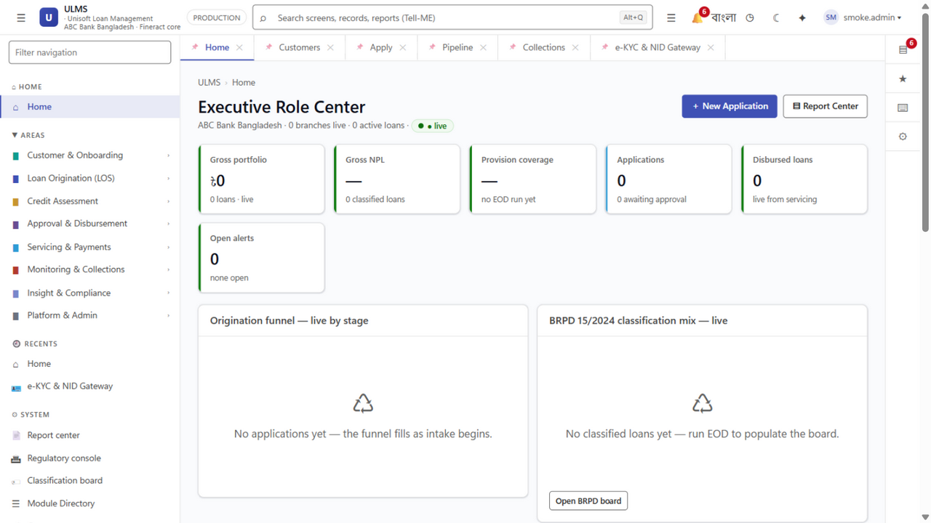
Figure 3: Live Service Health Monitor During Scheduled Maintenance
Zero connection drop verification across active teller and underwriting sessions.
Phase 1: Pre-Flight Verification & Database Expansion
// Language: bash
# 1. Verify cluster health and resource capacity
kubectl get nodes -o wide
kubectl get pods -n ulms-prod
# 2. Execute backward-compatible Flyway database migration
kubectl run flyway-migrator --rm -i --restart=Never \
--image=internal-registry.bank.com.bd/ulms/api:2.1.0 (Flyway runs on app boot; standalone migrator only for break-glass) \
--namespace=ulms-prod --command -- ./flyway migrate

Phase 2: Canary Pod Promotion
// Language: bash
# Deploy single canary replica receiving 5% traffic
helm upgrade ulms-prod ./deploy/chart/ulms \
--namespace ulms-prod \
--set canary.enabled=true \
--set canary.image.tag="2.1.0" \
--set canary.weight=5

SRE Observation Gate (10 Minutes):
• Inspect error rates: Prometheus metric sum(rate(http_server_requests_seconds_count{status=~"5.."}[1m])) == 0.
• Inspect P99 response time: histogram_quantile(0.99, sum(rate(http_server_requests_seconds_bucket[1m])) by (le)) < 0.5.
Phase 3: Full Production Promotion
// Language: bash
# Promote new version across all production replicas
helm upgrade ulms-prod ./deploy/chart/ulms \
--namespace ulms-prod \
--set image.tag="2.1.0" \
--set canary.enabled=false \
--atomic \
--timeout=8m

Phase 4: Post-Release Smoke Verification
// Language: bash
# Execute headless automated route verification against live cluster
cd c:\software_project\mim_project\LMS\LMS_CODEBASE\e2e
TARGET_URL=https://api.ulms.bank.com.bd npx playwright test spec/walking-skeleton.spec.ts

4. Emergency Instant Rollback Runbook
If error rates breach 0.1% or P99 latency spikes during or immediately following rollout:
// Language: bash
# 1. Trigger atomic Helm rollback to previous revision
helm rollback ulms-prod <PREVIOUS-REVISION> --namespace ulms-prod # revisions start at 1; find via: helm history ulms-prod -n ulms-prod
# 2. Verify all pods revert to previous image version
kubectl rollout status deployment/ulms-api -n ulms-prod
# 3. Confirm zero traffic reaches drifted pods
kubectl get pods -n ulms-prod -l app=ulms-api -o wide

Because all database migrations strictly adhere to the Expand-Contract pattern (DOC-03-MNT-02), the prior software version is 100% compatible with the expanded database schema, ensuring rollback completes in under 45 seconds with zero data loss.
— End of Zero-Downtime Rolling Upgrade & Release Playbook —
Addendum — v3.1.0 corrections (Independent Forensic Re-audit, 8 October 2026)
Corrections (v3.1.0): chart path is deploy/chart/ulms (values at deploy/chart/ulms/values.yaml + environment overlays); helm rollback requires a real revision number (history first); canary --set keys require the corresponding values.yaml block — verify against deploy/chart/ulms/values.yaml before use.

