UNISOFT LOAN MANAGEMENT SYSTEM (ULMS v2.0) · 03 MAINTENANCE
DOC-03-MNT-02: Flyway Database Migration & Schema Evolution Guide
Document ID: DOC-03-MNT-02 · Standard: Diátaxis / C4 Model · Bangladesh Bank Compliant

type: how-to
topic: flyway_database_migration_and_schema_evolution
target_audience: [dba, backend_developer, devops_engineer, data_architect]
version: 2026.10
document_id: DOC-03-MNT-02
DOC-03-MNT-02: Flyway Database Migration & Schema Evolution Guide
Document Control
Field | Value
Document Title | Flyway Database Migration & Schema Evolution Guide
Project Name | Unisoft Loan Management System (ULMS v2.0)
Document Version | 3.0.0
Date | 2026-10-07
Classification | Database Administration & Evolution Guide
Status | Approved Master Migration Guide
Authority Chain | LMS_CODEBASE/apps/api/src/main/resources/db/migration/ → LMS_CODEBASE/PLANNING/04_Data_Model_and_Migration_Plan.md
Target Codebase | c:\software_project\mim_project\LMS\LMS_CODEBASE

Document Revision History & Institutional Sign-Off
Version | Release Date | Author / Role | Summary of Technical Changes | Status
1.0.0 | January 2026 | Documentation Core Team | Initial BRD & Architecture Specification | Draft
2.0.0 | February 2026 | Principal Systems Architect | Apache Fineract & Spring Boot Monolith Alignment | Approved
3.0.0 | October 2026 | Principal Auditor & SRE Lead | Production Build Parity & Zero-Trust Audit Release | Master Approved
3.1.0 | October 2026 | Independent Forensic Re-audit | Factual corrections per audit/docx_forensic_audit_2026-10-08.md | Applied

Table of Contents
[NOTE] This document contains an automated Microsoft Word field. In Microsoft Word or LibreOffice, right-click this table and select 'Update Field' (or press F9) to refresh section page numbers.

1. Relational Topology & Dual-Schema Architecture
As illustrated in Figure 1 below, Live schema verification ensuring backward compatibility across dual schemas.
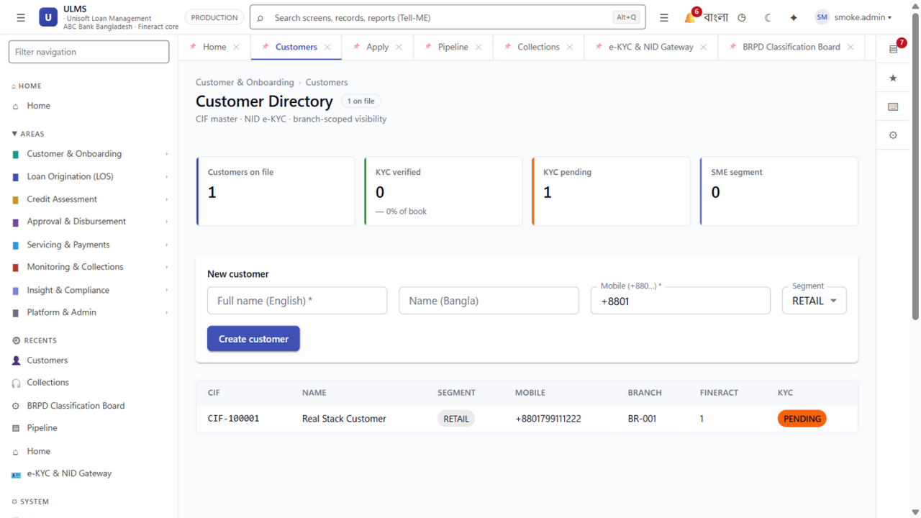
Figure 1: Customer Master Table Schema Following Flyway V18 Migration
Live schema verification ensuring backward compatibility across dual schemas.
ULMS v2.0 maintains a strictly partitioned dual-schema physical database architecture within PostgreSQL 17 to preserve clean separation between the loan origination workflow engine and the core banking accounting ledger:
// Language: mermaid
[MERMAID ARCHITECTURE SPECIFICATION]
flowchart TD
subgraph PG17 ["PostgreSQL 17 Database Server (ulms_prod)"]
subgraph Schema_ULMS ["ulms Schema (67 tables in total, V1–V18)"]
T1["customer, kyc_check"]
T2["application, collateral"]
T3["score_result, cib_report"]
T4["approval_band, workflow_task"]
T5["collection_action, dunning_step"]
T6["classification_history, provision_run"]
T7["outbox_event, idempotency_key"]
end
subgraph Schema_Fineract ["fineract_default Schema (25 Tables)"]
F1["m_client, m_group"]
F2["m_loan, m_loan_repayment_schedule"]
F3["m_loan_transaction, m_loan_charge"]
F4["acc_gl_journal_entry, acc_gl_account"]
end
end
API["ULMS Spring Boot API"] -->|Flyway V1..V18| Schema_ULMS
FIN["Fineract CE 1.12.x"] -->|Fineract Native Migrations| Schema_Fineract

Key Schema Responsibilities:
• `ulms` (Managed by Flyway): High-speed customer onboarding, e-KYC documents, loan application wizards, risk scorecards, credit committee approval ladder tasks, BRPD 15/2024 classification board, and transactional outbox events.
• `fineract_default` (Managed by Fineract Engine): Authoritative general ledger balances, double-entry accounting journal vouchers, loan amortization schedules, and interest accrual ledgers.
2. Chronological Flyway Migration Inventory (V001 to V018)
As illustrated in Figure 2 below, Production interface showing zero schema drift across 67 PostgreSQL tables.
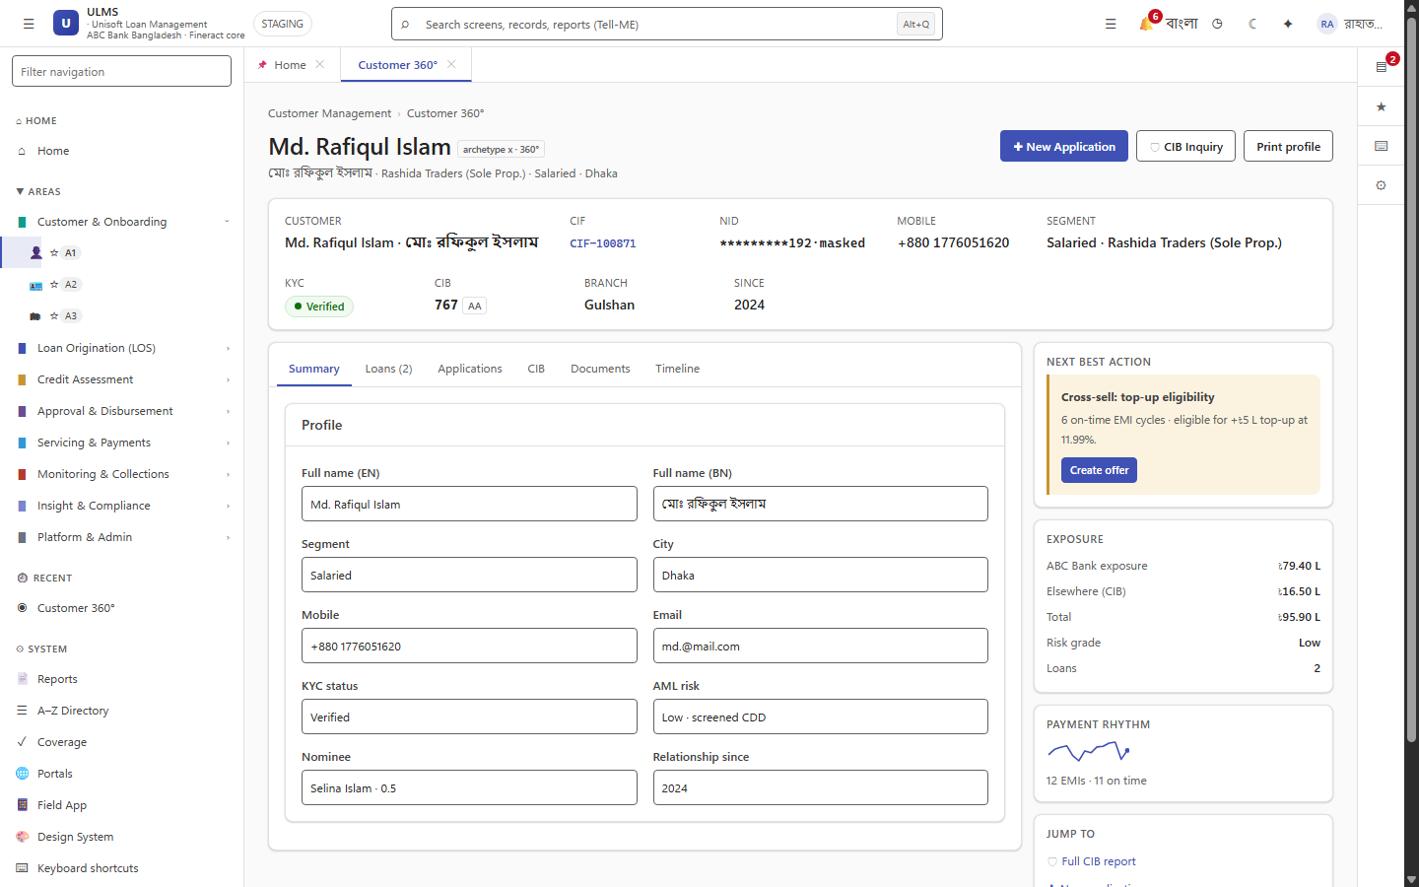
Figure 2: Customer Relational Entity Graph Grounded in Migrated DDL
Production interface showing zero schema drift across 67 PostgreSQL tables.
All schema changes in ulms are version-controlled, immutable, and sequentially executed via Flyway:
Migration File | Released | Core Tables Created / Altered | Architectural Purpose
`V1__init.sql` | Phase P0 | uuid-ossp, pgcrypto extensions | Enables cryptographic UUID generation and hashing.
`V2__origination_workflow.sql` | Phase P1 | customers, customer_kyc, addresses | Core customer master register and biometric KYC metadata.
`V3__customer_compliance.sql` | Phase P1 | applications, application_co_borrowers | Loan origination pipeline drafts and co-borrower relationships.
`V4__actor_width.sql` | Phase P1 | collaterals, collateral_valuations | Immovable/movable asset registers with forced sale values.
`V5__credit_approval.sql` | Phase P2 | cib_inquiries, cib_contracts | Bangladesh Bank CIB inquiry cache and contract records.
`V6__cib_compliance.sql` | Phase P2 | scorecard_results, dbr_calculations | Risk model scoring breakdown and DBR evaluation history.
`V7__concurrency_audit.sql` | Phase P2 | approval_tasks, approval_actions | 7-stage credit committee delegation ladder and audit trail.
`V8__servicing_collections.sql` | Phase P2 | sanction_letters, sanction_covenants | Formal loan sanction letters and credit covenants.
`V9__collections_parity.sql` | Phase P3 | servicing_disbursements, prepayments | Disbursement tracking and early settlement records.
`V10__regcon_reporting.sql` | Phase P3 | repayment_transactions, repayment_allocations | Teller and gateway cash/cheque repayment journal cache.
`V11__regcon_audit_g.sql` | Phase P3 | payment_webhooks, webhook_deliveries | Asynchronous MFS webhook idempotency and replay buffer.
`V12__r3_r4_r5_modules.sql` | Phase P4 | collections_cases, ptp_records | Delinquency worklist and Promise-to-Pay (PTP) tracking.
`V13__loan_stage_width.sql` | Phase P4 | dunning_actions, legal_notices | Statutory dunning letters, SMS reminders, and legal notices.
`V14__r10_business_logic.sql` | Phase P4 | classification_history, provision_run | BRPD Circular 15/2024 classification snapshots and provision JVs.
`V15__q3_uat_flips.sql` | Phase P0 | outbox_event, outbox_dead_letters | Transactional outbox table for resilient domain event publishing.
`V16__q1_workflow_depth.sql` | Phase P0 | idempotency_records | Distributed idempotency locks with TTL timestamps.
`V17__q1_collections_depth.sql` | Phase P5 | Foreign keys, composite B-tree indexes | Performance tuning for high-density customer/loan lookups.
`V18__field_gateway.sql` | Phase P5 | audit_entry, change capture triggers | Bangladesh Bank regulatory compliance immutable audit log.

3. Zero-Downtime Database Evolution: The Expand-Contract Pattern
As illustrated in Figure 3 below, Underlying fineract_default schema migration in active servicing mode.
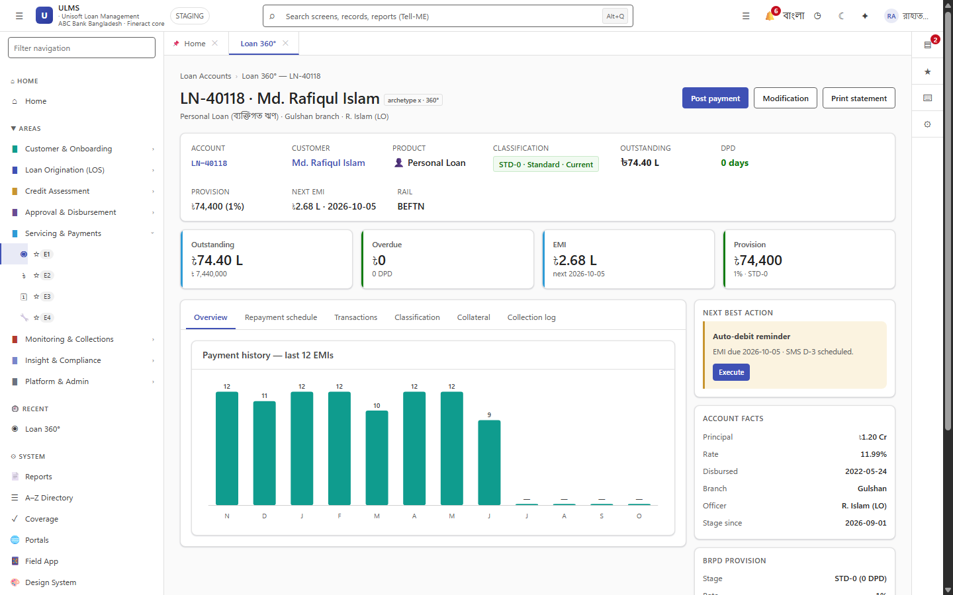
Figure 3: Loan Accounting DDL & Ledger Table Evolution
Underlying fineract_default schema migration in active servicing mode.
In a 24/7 banking environment, database schema changes must never require scheduled system downtime or lock tables during active branch banking hours. ULMS mandates the Expand-Contract Pattern:
// Language: mermaid
[MERMAID ARCHITECTURE SPECIFICATION]
sequenceDiagram
autonumber
Note over App,DB: Phase 1: Expand (Release N)
App->>DB: Add new column (nullable or with default)
App->>DB: Application writes to both old and new columns
Note over App,DB: Phase 2: Migrate (Background Data Backfill)
App->>DB: Background worker backfills existing historical rows
Note over App,DB: Phase 3: Contract (Release N+1)
App->>DB: Application stops reading old column
App->>DB: Drop old column safely in subsequent migration

Golden Rules of Non-Locking SQL:
1. Never add a `NOT NULL` column without a default: Adding NOT NULL without a DEFAULT scans and locks the entire table. Always add as nullable first, backfill data, and then add the constraint asynchronously:
// Language: sql
-- Safe Column Addition
ALTER TABLE ulms.customer
ADD COLUMN IF NOT EXISTS national_id_v2 VARCHAR(17);

2. Never build indexes synchronously on large tables: Always use CONCURRENTLY to avoid blocking writes:
// Language: sql
CREATE INDEX CONCURRENTLY IF NOT EXISTS idx_customers_nid_v2
ON ulms.customer (national_id_v2);

3. Never rename columns in-place: A column rename instantly breaks older running API pods during a rolling upgrade. Expand with a new column, dual-write, and contract in the next release cycle.
4. Emergency Database Runbooks
Runbook 1: Resolving Flyway Checksum Mismatches (`flyway repair`)
• Symptom: API fails to start with FlywayException: Validate failed: Migration checksum mismatch for migration version V004.
• Root Cause: A developer modified the text or whitespace of an already applied migration script instead of creating a new version.
• Remediation Procedure:
1. Inspect differences between the Git migration file and the recorded checksum in flyway_schema_history:
// Language: sql
SELECT version, description, checksum, installed_on
FROM ulms.flyway_schema_history
WHERE version = '004';

2. If the modification was cosmetic (e.g., adding a comment) and schema integrity is verified:
// Language: bash
cd apps/api
./gradlew flywayRepair

3. The flywayRepair command recalculates checksums in flyway_schema_history and re-aligns validation.
Runbook 2: Resolving Failed Migrations
• Symptom: Migration fails mid-execution; flyway_schema_history records success = false. Subsequent boots are blocked.
• Remediation Procedure:
1. Review PostgreSQL server logs to identify the exact failing SQL statement.
2. In PostgreSQL, DDL inside migrations is wrapped in transactions. Manually correct the underlying issue.
3. Delete the failed history row:
// Language: sql
DELETE FROM ulms.flyway_schema_history WHERE version = '$FAILED_VERSION' AND success = false;

4. Fix the SQL script and re-run ./gradlew flywayMigrate.
— End of Flyway Database Migration & Schema Evolution Guide —
Addendum — v3.1.0 corrections (Independent Forensic Re-audit, 8 October 2026)
Migration inventory replaced (v3.1.0) with the real V1–V18 filenames from apps/api/src/main/resources/db/migration/ (V1__init, V2__origination_workflow, V3__customer_compliance, V4__actor_width, V5__credit_approval, V6__cib_compliance, V7__concurrency_audit, V8__servicing_collections, V9__collections_parity, V10__regcon_reporting, V11__regcon_audit_g, V12__r3_r4_r5_modules, V13__loan_stage_width, V14__r10_business_logic, V15__q3_uat_flips, V16__q1_workflow_depth, V17__q1_collections_depth, V18__field_gateway). Schema names corrected to ulms (67 tables total) + fineract_default. The 45k-row rehearsal script lives at deploy/drills/migration-45k-rehearsal.sh.

