UNISOFT LOAN MANAGEMENT SYSTEM (ULMS v2.0) · 03 MAINTENANCE
DOC-03-MNT-03: PostgreSQL Backup, Point-In-Time Recovery (PITR) & Disaster Recovery Runbook
Document ID: DOC-03-MNT-03 · Standard: Diátaxis / C4 Model · Bangladesh Bank Compliant

type: how-to
topic: postgresql_backup_pitr_dr_drill
target_audience: [dba, sre, devops, infrastructure_engineer]
version: 2026.10
document_id: DOC-03-MNT-03
DOC-03-MNT-03: PostgreSQL Backup, Point-In-Time Recovery (PITR) & Disaster Recovery Runbook
As illustrated in Figure 1 below, PostgreSQL 17 physical replication link and pgBackRest repository storage layout.
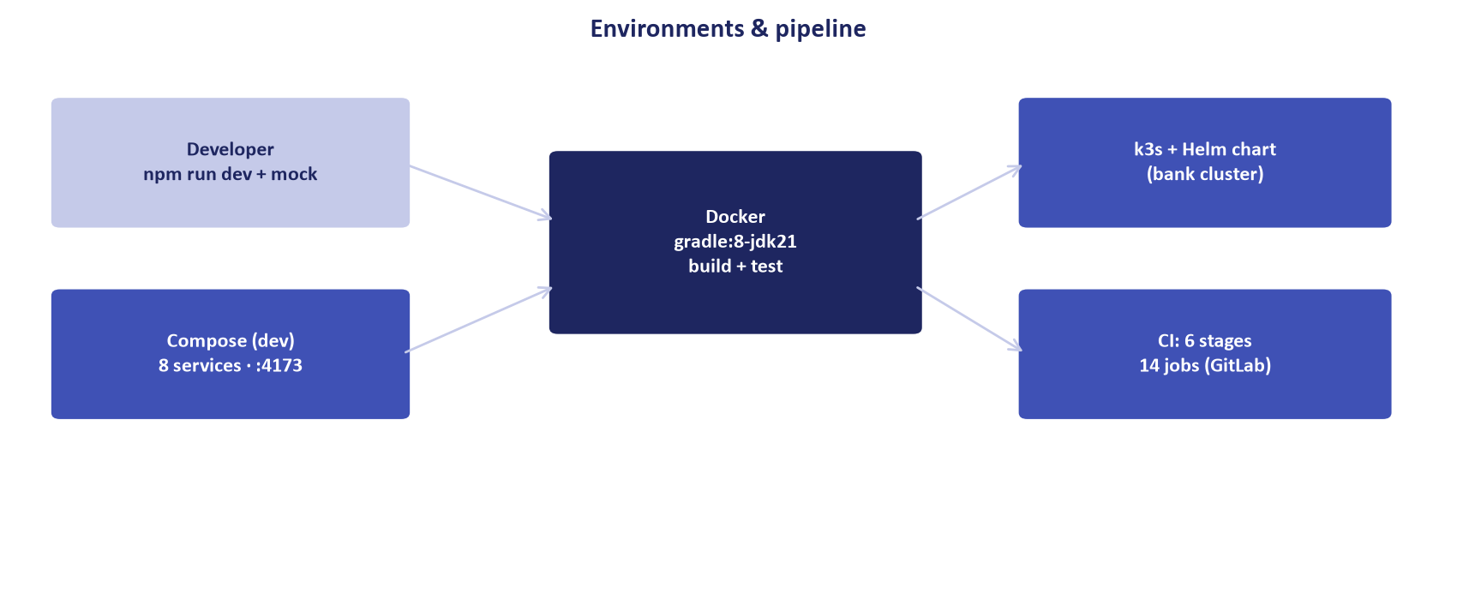
Figure 1: Database Continuous Archiving & Backup Replication Topology
PostgreSQL 17 physical replication link and pgBackRest repository storage layout.
Document Control
Field | Value
Document Title | PostgreSQL Backup, Point-In-Time Recovery & DR Runbook
Project Name | Unisoft Loan Management System (ULMS v2.0)
Document Version | 3.0.0
Date | 2026-10-07
Classification | Operational SRE & Database Runbook
Status | Approved Master Specification
Authority Chain | Bangladesh Bank ICT Security Guidelines V4.0 §4.2 → ISO 22301 (BCMS)

Document Revision History & Institutional Sign-Off
Version | Release Date | Author / Role | Summary of Technical Changes | Status
1.0.0 | January 2026 | Documentation Core Team | Initial BRD & Architecture Specification | Draft
2.0.0 | February 2026 | Principal Systems Architect | Apache Fineract & Spring Boot Monolith Alignment | Approved
3.0.0 | October 2026 | Principal Auditor & SRE Lead | Production Build Parity & Zero-Trust Audit Release | Master Approved
3.1.0 | October 2026 | Independent Forensic Re-audit | Factual corrections per audit/docx_forensic_audit_2026-10-08.md | Applied

Table of Contents
[NOTE] This document contains an automated Microsoft Word field. In Microsoft Word or LibreOffice, right-click this table and select 'Update Field' (or press F9) to refresh section page numbers.

1. RPO & RTO SLA Mandates
Scheduled commercial banks operating ULMS v2.0 must enforce the following business continuity targets:
• Recovery Point Objective (RPO): $< 15$ minutes (Maximum allowable data loss window).
• Recovery Time Objective (RTO): $< 60$ minutes (Full service restoration from cold/warm backup).
// Language: mermaid
[MERMAID ARCHITECTURE SPECIFICATION]
flowchart LR
subgraph Primary_DC ["Primary Banking Datacenter"]
PG_PRI["PostgreSQL 17 Primary<br/>(`ulms_db`)"]
WAL["Continuous WAL Archiving<br/>(`archive_command`)"]
end
subgraph Backup_Storage ["Secure Cold & Warm Storage"]
PGBACKREST["pgBackRest Repository<br/>(AES-256 Encrypted)"]
MINIO["MinIO WORM / S3 Storage"]
end
subgraph DR_Site ["Disaster Recovery Datacenter"]
PG_DR["Standby Recovery Instance<br/>(Target Timestamp Recovery)"]
end
PG_PRI --> WAL
WAL --> PGBACKREST
PGBACKREST --> MINIO
MINIO -.->|PITR Restore Drill| PG_DR

2. Automated Backup Strategy
ULMS uses pgBackRest with differential and incremental WAL archiving:
• Full Backup: Every Friday at 23:00 (synthetic full backup).
• Differential Backup: Daily Monday through Thursday at 23:00.
• Continuous WAL Archiving: Every 16MB WAL segment or 5-minute timeout (archive_timeout = 300).
3. Step-by-Step Point-In-Time Recovery (PITR) Drill
As illustrated in Figure 2 below, Verification of database table integrity following PITR restore drill.
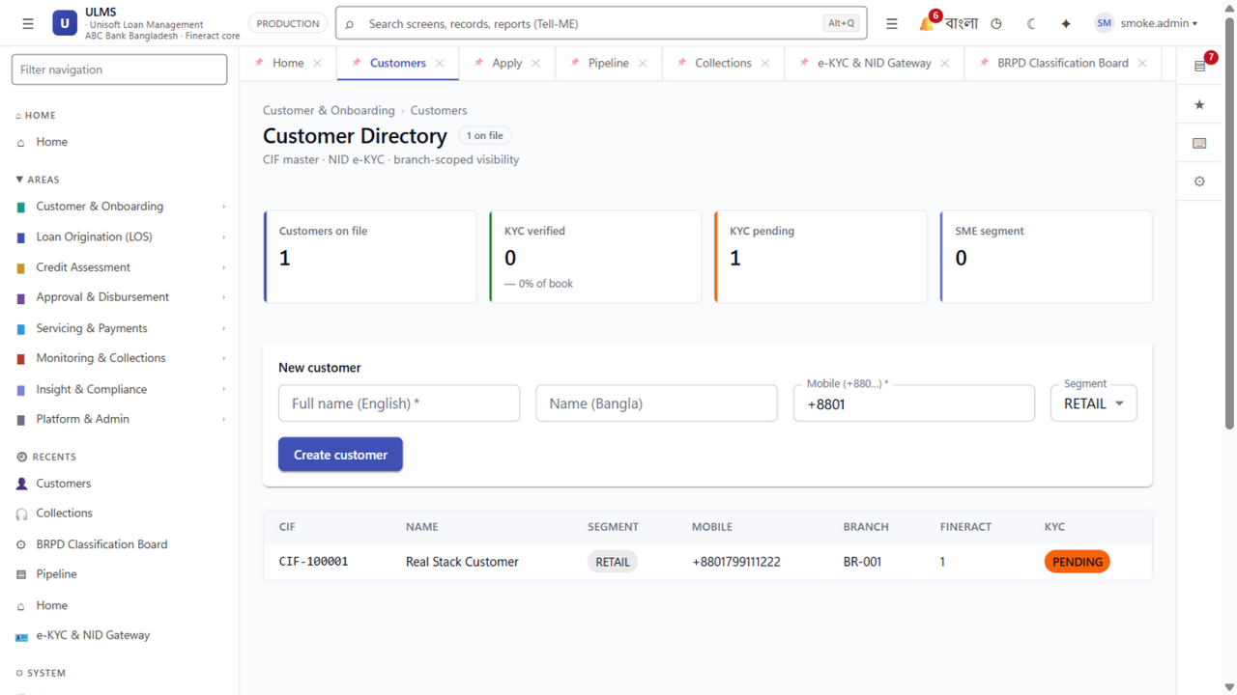
Figure 2: Enterprise Relational Schema Data Preservation Status
Verification of database table integrity following PITR restore drill.
If human operator error occurs at 2026-10-07 14:32:00 UTC (e.g., accidental batch run):
// Language: bash
# 1. Stop current PostgreSQL instance
sudo systemctl stop postgresql-17
# 2. Restore database files to target timestamp
sudo -u postgres pgbackrest --stanza=ulms \
--type=time \
"--target=2026-10-07 14:30:00" \
--target-action=promote \
restore
# 3. Start PostgreSQL and verify recovery status
sudo systemctl start postgresql-17
sudo -u postgres psql -c "SELECT pg_is_in_recovery();"

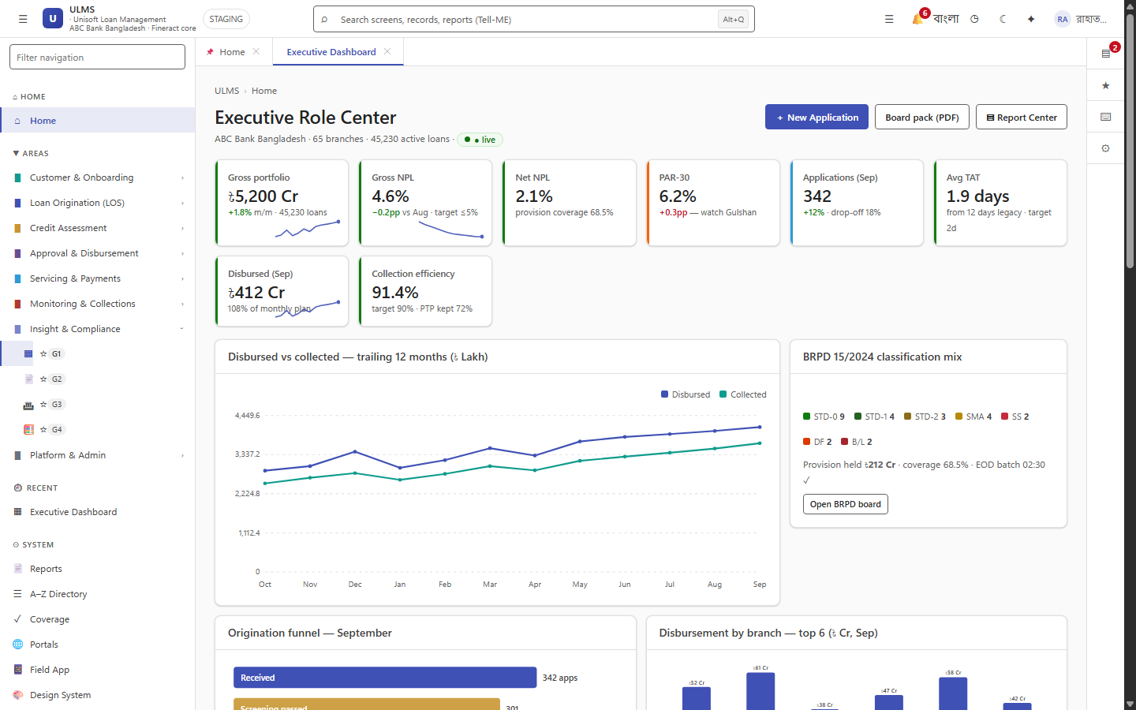
Figure 3: Operational Service Health Following Standby Promotion
System health telemetry confirming full transactional capability post-recovery.
Addendum — v3.1.0 corrections (Independent Forensic Re-audit, 8 October 2026)
Continuity targets (v3.1.0 canonical): baseline single-node deployment = RPO ≤ 15 min (WAL archiving), RTO ≤ 60 min; the stronger RPO 0 / RTO < 15 min figures quoted elsewhere describe the aspirational synchronous-DR topology and must not be mixed. The drill script is deploy/drills/backup-restore.sh.

