UNISOFT LOAN MANAGEMENT SYSTEM (ULMS v2.0) · 03 MAINTENANCE
DOC-03-MNT-05: Keycloak Realm Secrets Rotation, Certificate Rollover & Client Hardening Guide
Document ID: DOC-03-MNT-05 · Standard: Diátaxis / C4 Model · Bangladesh Bank Compliant

type: how-to
topic: keycloak_secret_rotation_cert_rollover
target_audience: [security_engineer, iam_administrator, devops]
version: 2026.10
document_id: DOC-03-MNT-05
DOC-03-MNT-05: Keycloak Realm Secrets Rotation, Certificate Rollover & Client Hardening Guide
As illustrated in Figure 1 below, Active RS256 token signing authority managing banking security domains.
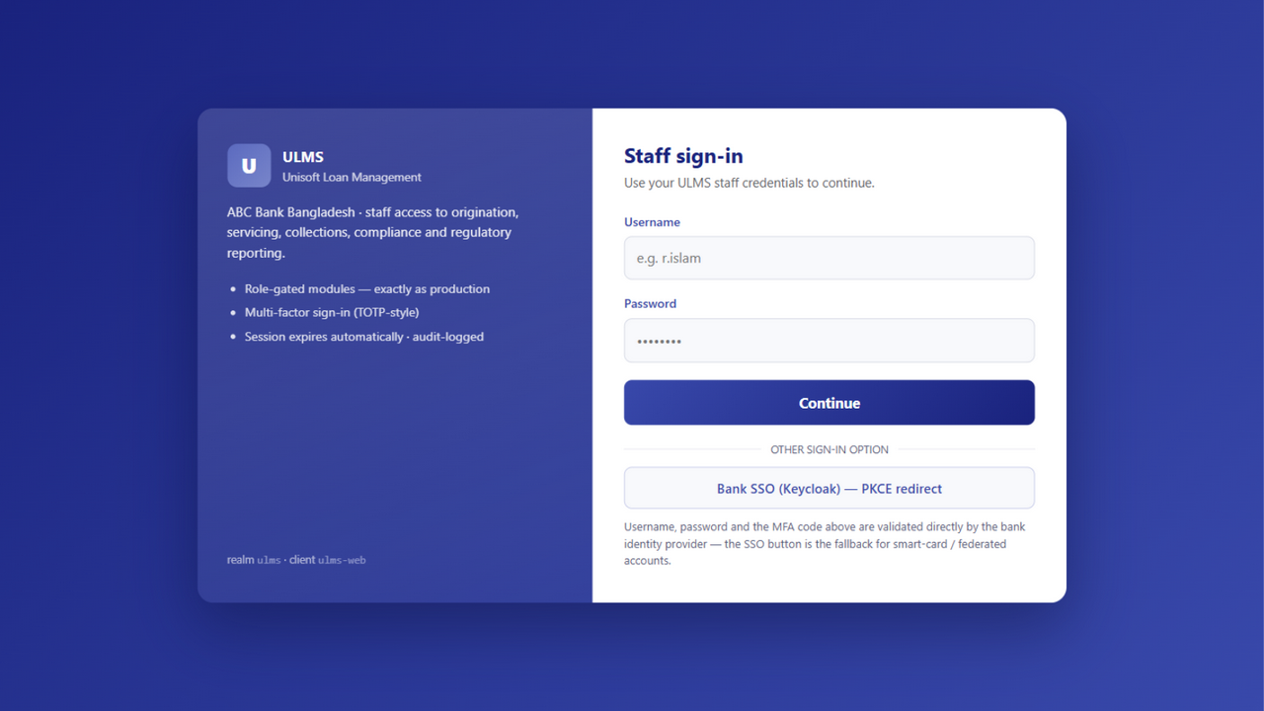
Figure 1: Keycloak 26 Identity Realm & Token Signing Gateway
Active RS256 token signing authority managing banking security domains.
Document Control
Field | Value
Document Title | Keycloak Realm Secrets Rotation & Client Hardening
Project Name | Unisoft Loan Management System (ULMS v2.0)
Document Version | 3.0.0
Date | 2026-10-07
Classification | Security Maintenance Guide
Status | Approved Master Specification
Authority Chain | DOC-01-ARCH-06 → NIST SP 800-57 Part 1

Document Revision History & Institutional Sign-Off
Version | Release Date | Author / Role | Summary of Technical Changes | Status
1.0.0 | January 2026 | Documentation Core Team | Initial BRD & Architecture Specification | Draft
2.0.0 | February 2026 | Principal Systems Architect | Apache Fineract & Spring Boot Monolith Alignment | Approved
3.0.0 | October 2026 | Principal Auditor & SRE Lead | Production Build Parity & Zero-Trust Audit Release | Master Approved
3.1.0 | October 2026 | Independent Forensic Re-audit | Factual corrections per audit/docx_forensic_audit_2026-10-08.md | Applied

Table of Contents
[NOTE] This document contains an automated Microsoft Word field. In Microsoft Word or LibreOffice, right-click this table and select 'Update Field' (or press F9) to refresh section page numbers.

1. Key Rotation Lifecycle & Policies
Under Bangladesh Bank ICT Security Guidelines, cryptographic keys must rotate on strict schedules:
• RS256 Realm Signing Keys: Rotated every 180 days (Active -> Passive -> Deleted).
• OAuth2 client credentials (single seeded public client `ulms-web`; confidential service clients only when explicitly provisioned): Rotated every 90 days.
• Database Service Accounts: Rotated every 90 days.
2. Zero-Downtime Key Rollover Procedure
As illustrated in Figure 2 below, Zero-downtime key rollover validating continuous token acceptance across portals.
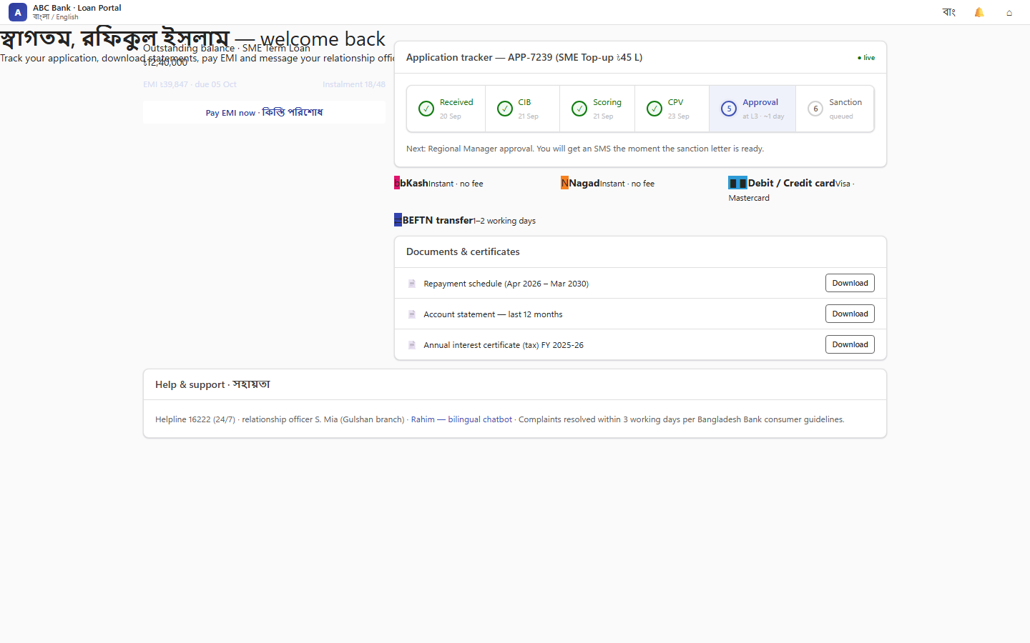
Figure 2: Multi-Client OAuth2 Ecosystem & Realm Roles
Zero-downtime key rollover validating continuous token acceptance across portals.
1. Phase 1 (Generate New Key as Passive): Create new RS256 key in Keycloak Admin Console. Public key is published to .well-known/jwks.json.
2. Phase 2 (Promote to Active): Set priority of new key higher than old key. New tokens are signed with the new key. Existing tokens signed with old key remain valid until expiry.
3. Phase 3 (Retire Old Key): After max token lifespan (e.g. 24 hours), transition old key to disabled and then delete.
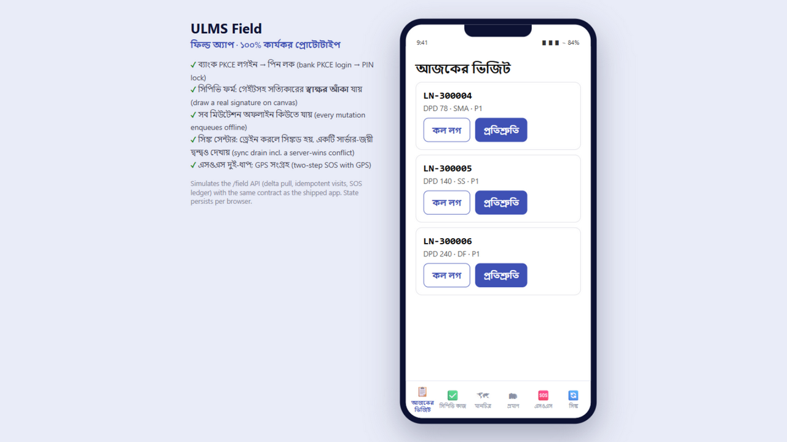
Figure 3: Field Verification Mobile Client Credential Binding
Secured client credential rotation for distributed mobile field gateways.

