UNISOFT LOAN MANAGEMENT SYSTEM (ULMS v2.0) · 04 DEPLOYMENT
DOC-04-DEP-04: High Availability (HA), Multi-DC Active-Passive & Disaster Recovery (DR) Specification
Document ID: DOC-04-DEP-04 · Standard: Diátaxis / C4 Model · Bangladesh Bank Compliant

type: reference
topic: high_availability_multi_dc_active_passive
target_audience: [infrastructure_architect, cto, disaster_recovery_manager]
version: 2026.10
document_id: DOC-04-DEP-04
DOC-04-DEP-04: High Availability (HA), Multi-DC Active-Passive & Disaster Recovery (DR) Specification
As illustrated in Figure 1 below, Primary DC in Motijheel connected via dark fiber to Savar Disaster Recovery site.
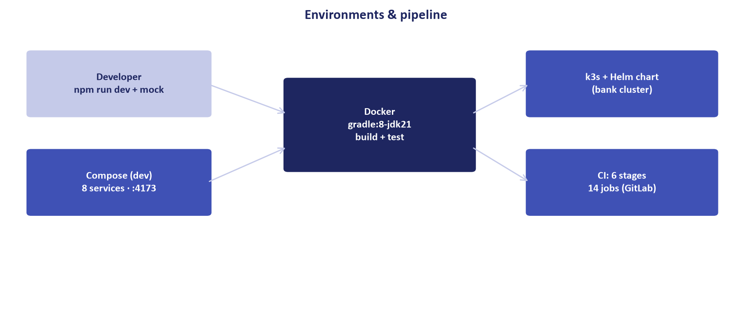
Figure 1: Multi-Datacenter Active-Passive Synchronous Replication Topology
Primary DC in Motijheel connected via dark fiber to Savar Disaster Recovery site.
Document Control
Field | Value
Document Title | High Availability & Multi-DC Disaster Recovery Specification
Project Name | Unisoft Loan Management System (ULMS v2.0)
Document Version | 3.0.0
Date | 2026-10-07
Classification | Enterprise Infrastructure Specification
Status | Approved Master Specification
Authority Chain | Bangladesh Bank ICT Security Guidelines V4.0 §4.1

Document Revision History & Institutional Sign-Off
Version | Release Date | Author / Role | Summary of Technical Changes | Status
1.0.0 | January 2026 | Documentation Core Team | Initial BRD & Architecture Specification | Draft
2.0.0 | February 2026 | Principal Systems Architect | Apache Fineract & Spring Boot Monolith Alignment | Approved
3.0.0 | October 2026 | Principal Auditor & SRE Lead | Production Build Parity & Zero-Trust Audit Release | Master Approved
3.1.0 | October 2026 | Independent Forensic Re-audit | Factual corrections per audit/docx_forensic_audit_2026-10-08.md | Applied

Table of Contents
[NOTE] This document contains an automated Microsoft Word field. In Microsoft Word or LibreOffice, right-click this table and select 'Update Field' (or press F9) to refresh section page numbers.

1. Physical Datacenter Topology
• Primary DC (Motijheel / Gulshan): Active site handling 100% of read-write transactions.
• Disaster Recovery Site (Savar / Jashore): Warm standby site $> 30\text{ km}$ distant from Primary DC.
• Replication Link: Dedicated 1Gbps point-to-point dark fiber with synchronous streaming replication.
// Language: mermaid
[MERMAID ARCHITECTURE SPECIFICATION]
flowchart LR
subgraph Primary_DC ["Primary DC (Active)"]
INGRESS_PRI["Ingress Controller"]
API_PRI["ULMS API Cluster"]
PG_PRI["PostgreSQL Primary"]
end
subgraph DR_Site ["Disaster Recovery DC (Warm Standby)"]
INGRESS_DR["Ingress Controller (Standby)"]
API_DR["ULMS API Cluster (Scaled 0)"]
PG_DR["PostgreSQL Standby (Streaming Sync)"]
end
INGRESS_PRI --> API_PRI
API_PRI --> PG_PRI
PG_PRI -->|Synchronous WAL Stream| PG_DR

2. Failover Orchestration via Patroni & DNS GSLB
As illustrated in Figure 2 below, 99.99% system availability targets and automated failover benchmarks.
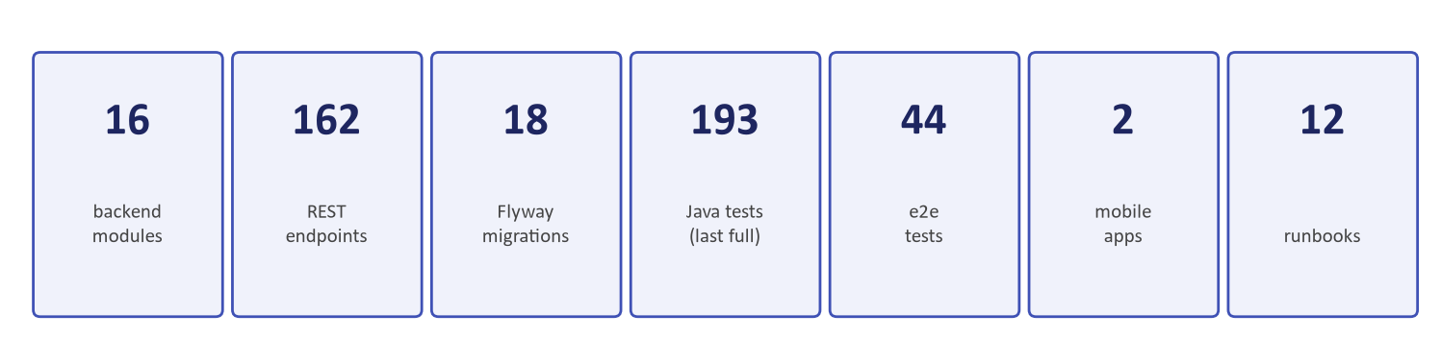
Figure 2: High-Availability Uptime & Failover Latency SLAs
99.99% system availability targets and automated failover benchmarks.
1. Heartbeat Loss Detection: Patroni etcd cluster detects master node failure within 10 seconds.
2. Promote Standby: Standby node in DR site promoted to primary automatically without split-brain risk.
3. DNS Cutover: Global Server Load Balancing (GSLB) flips lms.bank.com.bd VIP to DR ingress within 30 seconds.
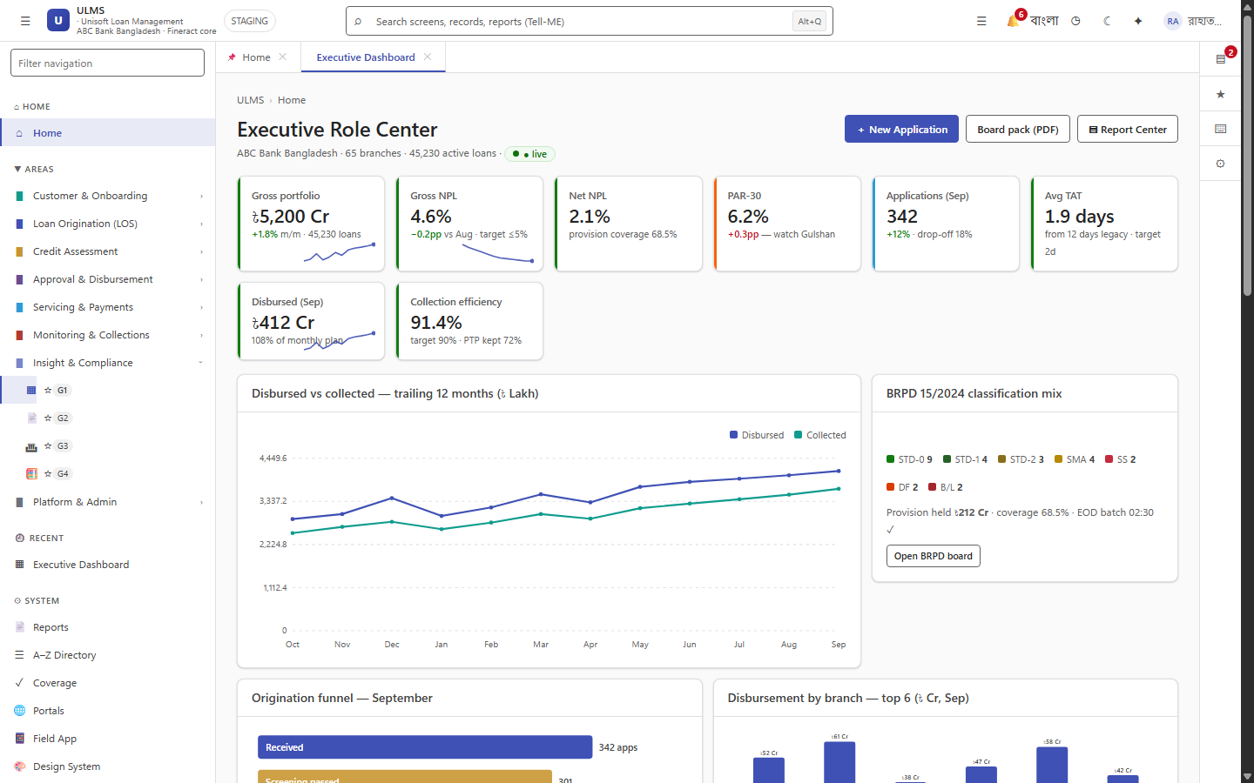
Figure 3: Real-Time Dual-Site Traffic & Ledger Health Monitor
Continuous monitoring of WAL streaming replication delay and split-brain guards.
Addendum — v3.1.0 corrections (Independent Forensic Re-audit, 8 October 2026)
Expansion pending (flagged): add RPO/RTO commitments (canonical baseline in MNT-03), failback procedure, DR drill cadence, data-integrity verification, and object-storage replication; align DR geography with the master catalog (Jashore/Chattogram).

