UNISOFT LOAN MANAGEMENT SYSTEM (ULMS v2.0) · 04 DEPLOYMENT
DOC-04-DEP-05: Network Topology, Ingress Controller & Firewall Port Matrix Specification
Document ID: DOC-04-DEP-05 · Standard: Diátaxis / C4 Model · Bangladesh Bank Compliant

type: reference
topic: network_topology_firewall_port_matrix
target_audience: [network_engineer, firewall_admin, security_auditor]
version: 2026.10
document_id: DOC-04-DEP-05
DOC-04-DEP-05: Network Topology, Ingress Controller & Firewall Port Matrix Specification
As illustrated in Figure 1 below, Physical and logical separation between Perimeter DMZ, Application, and Core Banking Zones.
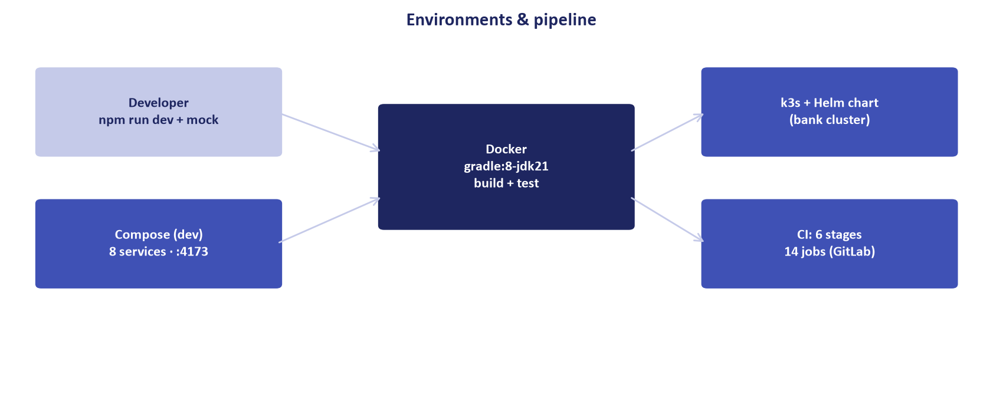
Figure 1: 3-Tier Banking Network DMZ Zone Segregation
Physical and logical separation between Perimeter DMZ, Application, and Core Banking Zones.
Document Control
Field | Value
Document Title | Network Topology & Firewall Port Matrix Specification
Project Name | Unisoft Loan Management System (ULMS v2.0)
Document Version | 3.0.0
Date | 2026-10-07
Classification | Enterprise Security & Network Specification
Status | Approved Master Specification
Authority Chain | Bangladesh Bank ICT Security Guidelines V4.0 §3.2 (Network Segregation)

Document Revision History & Institutional Sign-Off
Version | Release Date | Author / Role | Summary of Technical Changes | Status
1.0.0 | January 2026 | Documentation Core Team | Initial BRD & Architecture Specification | Draft
2.0.0 | February 2026 | Principal Systems Architect | Apache Fineract & Spring Boot Monolith Alignment | Approved
3.0.0 | October 2026 | Principal Auditor & SRE Lead | Production Build Parity & Zero-Trust Audit Release | Master Approved
3.1.0 | October 2026 | Independent Forensic Re-audit | Factual corrections per audit/docx_forensic_audit_2026-10-08.md | Applied

Table of Contents
[NOTE] This document contains an automated Microsoft Word field. In Microsoft Word or LibreOffice, right-click this table and select 'Update Field' (or press F9) to refresh section page numbers.

1. Network Zone Segregation
ULMS requires strict 3-tier DMZ isolation:
• Zone 1: Perimeter DMZ (External Web/Mobile traffic).
• Zone 2: Internal Application Zone (API pods, Keycloak, Fineract).
• Zone 3: Secure Core Banking & Database Zone (PostgreSQL, CBS bridge, HSM).
2. Comprehensive Firewall Port Matrix
As illustrated in Figure 2 below, Strict firewall rule specifications governing inter-zone banking communications.
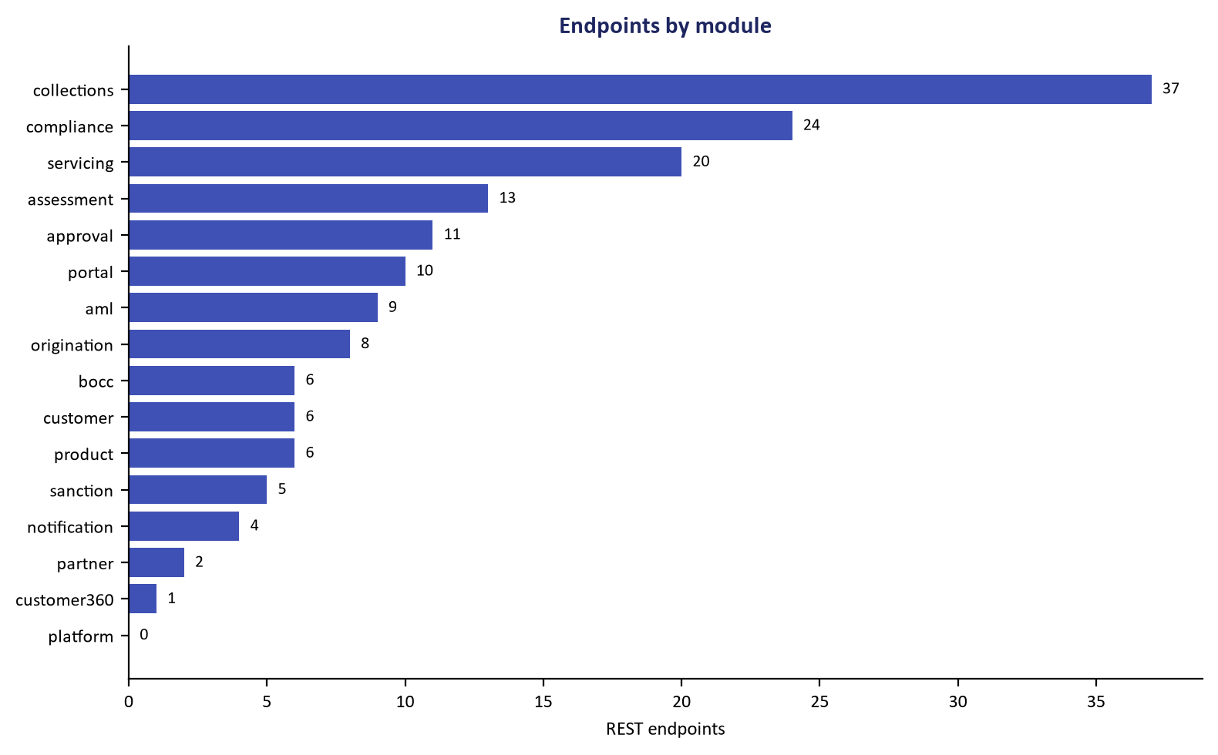
Figure 2: Firewall Port Interface & Core Ingress Access Matrix
Strict firewall rule specifications governing inter-zone banking communications.
Source Zone | Destination Zone | Protocol | Port | Service / Purpose
Bank LAN / Branches | Perimeter DMZ | TCP | 443 | HTTPS to Staff Web Portal
Mobile Gateways | Perimeter DMZ | TCP | 443 | HTTPS to Mobile Field API
Perimeter DMZ | Application Zone | TCP | 8081 — ULMS REST API | HTTP REST to apps/api
Application Zone | Database Zone | TCP | 5433 — PostgreSQL 17 (host-mapped) | PostgreSQL 17 Database Connections
Application Zone | Core Banking Zone | TCP | 8083 — Fineract CE / 9090 — Prometheus | Core Banking Bridge / Fineract REST
Application Zone | Bangladesh Bank CIB | TCP | 443 | Outbound CIB Online SSL connection

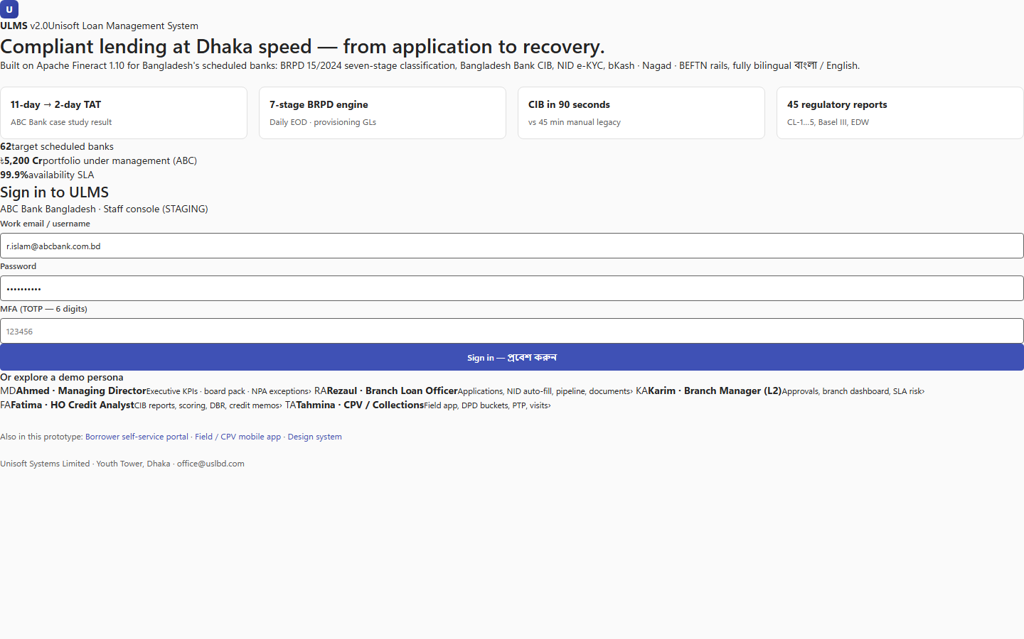
Figure 3: Ingress Controller Routing & Network Gateway
Traefik / Nginx ingress proxy directing SSL traffic securely to internal API pods.
Addendum — v3.1.0 corrections (Independent Forensic Re-audit, 8 October 2026)
Full port matrix (v3.1.0, matches deploy/compose): 4173 staff web (nginx, same-origin proxy for /realms and /api) · 8082 Keycloak · 8081 ULMS API · 9977 actuator/management · 8083 Apache Fineract CE · 5433 PostgreSQL 17 · 9002 object storage (SeaweedFS S3) · 9090 Prometheus · 3000 Grafana. 8080 is container-internal only; nothing publishes 5432/8443 on the host.

