UNISOFT LOAN MANAGEMENT SYSTEM (ULMS v2.0) · 04 DEPLOYMENT
DOC-04-DEP-07: CI/CD Pipeline Automation, Security Scanning & GitOps Deployment Guide
Document ID: DOC-04-DEP-07 · Standard: Diátaxis / C4 Model · Bangladesh Bank Compliant

type: how-to
topic: ci_cd_pipeline_security_scanning_gitops
target_audience: [devops_engineer, qa_lead, release_manager]
version: 2026.10
document_id: DOC-04-DEP-07
DOC-04-DEP-07: CI/CD Pipeline Automation, Security Scanning & GitOps Deployment Guide
As illustrated in Figure 1 below, Automated Gradle compilation, SonarQube SAST, and Trivy CVE inspection in CI.
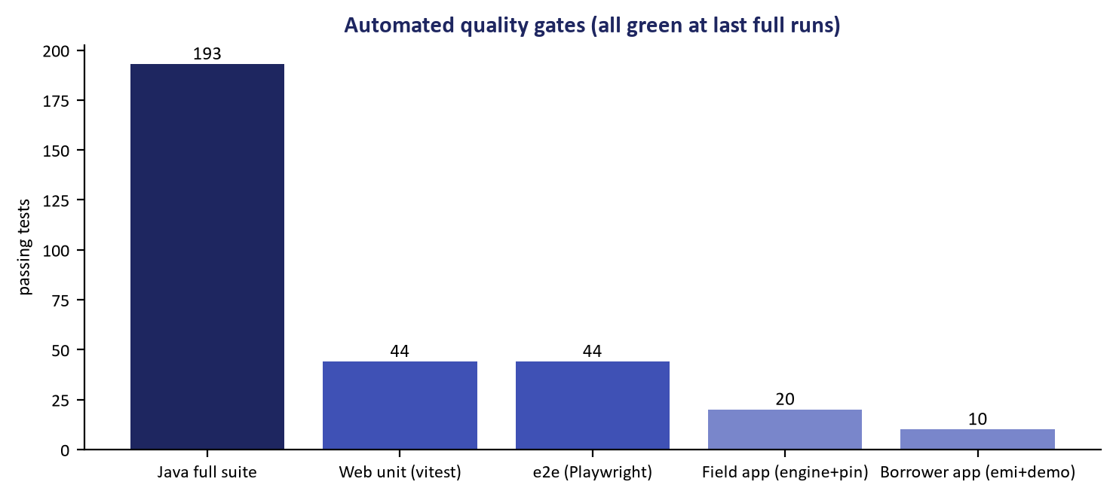
Figure 1: Automated CI Pipeline Execution & Security Quality Gates
Automated Gradle compilation, SonarQube SAST, and Trivy CVE inspection in CI.
Document Control
Field | Value
Document Title | CI/CD Pipeline Automation & GitOps Deployment Guide
Project Name | Unisoft Loan Management System (ULMS v2.0)
Document Version | 3.0.0
Date | 2026-10-07
Classification | DevOps & Automation Guide
Status | Approved Master Specification
Authority Chain | NIST SP 800-218 (SSDF) → ISO/IEC 5055

Document Revision History & Institutional Sign-Off
Version | Release Date | Author / Role | Summary of Technical Changes | Status
1.0.0 | January 2026 | Documentation Core Team | Initial BRD & Architecture Specification | Draft
2.0.0 | February 2026 | Principal Systems Architect | Apache Fineract & Spring Boot Monolith Alignment | Approved
3.0.0 | October 2026 | Principal Auditor & SRE Lead | Production Build Parity & Zero-Trust Audit Release | Master Approved
3.1.0 | October 2026 | Independent Forensic Re-audit | Factual corrections per audit/docx_forensic_audit_2026-10-08.md | Applied

Table of Contents
[NOTE] This document contains an automated Microsoft Word field. In Microsoft Word or LibreOffice, right-click this table and select 'Update Field' (or press F9) to refresh section page numbers.

1. Automated Pipeline Architecture
// Language: mermaid
[MERMAID ARCHITECTURE SPECIFICATION]
flowchart LR
DEV["Git Commit & Push"] --> BUILD["Gradle Build & Unit Tests<br/>(JDK 21)"]
BUILD --> SCAN["Static Analysis<br/>(SonarQube, Trivy & gitleaks secret scanning)"]
SCAN --> DOCKER["Container Build & Sign<br/>(Cosign)"]
DOCKER --> GITOPS["ArgoCD Sync to k3s<br/>(Declarative GitOps)"]

2. Automated Quality Gates
Every build must pass 4 mandatory quality gates before artifact release:
1. Compilation & Unit Tests: Zero test failures across Spring Modulith tests.
2. SAST Security Gate: Zero critical or high vulnerabilities detected by SonarQube.
3. Container CVE Scan: Zero unpatched CVEs in base images via Trivy.
4. GitOps Canary Validation: Automatic rollback if HTTP 5xx errors $> 0.1\%$ within 5 minutes.
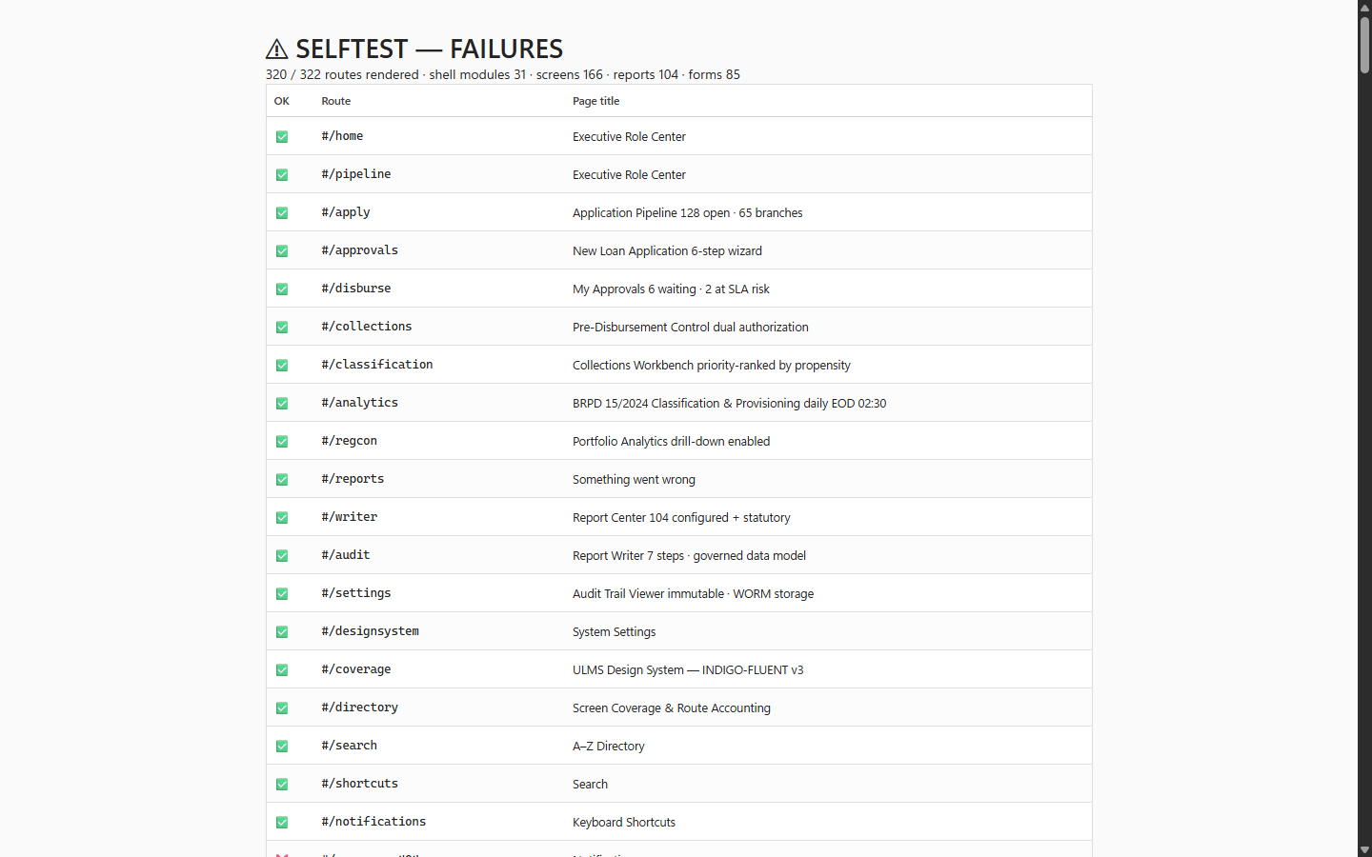
Figure 2: GitOps Automated Smoke Test & Deployment Verification
Post-deployment automated healthcheck suite ensuring zero-regression release gating.
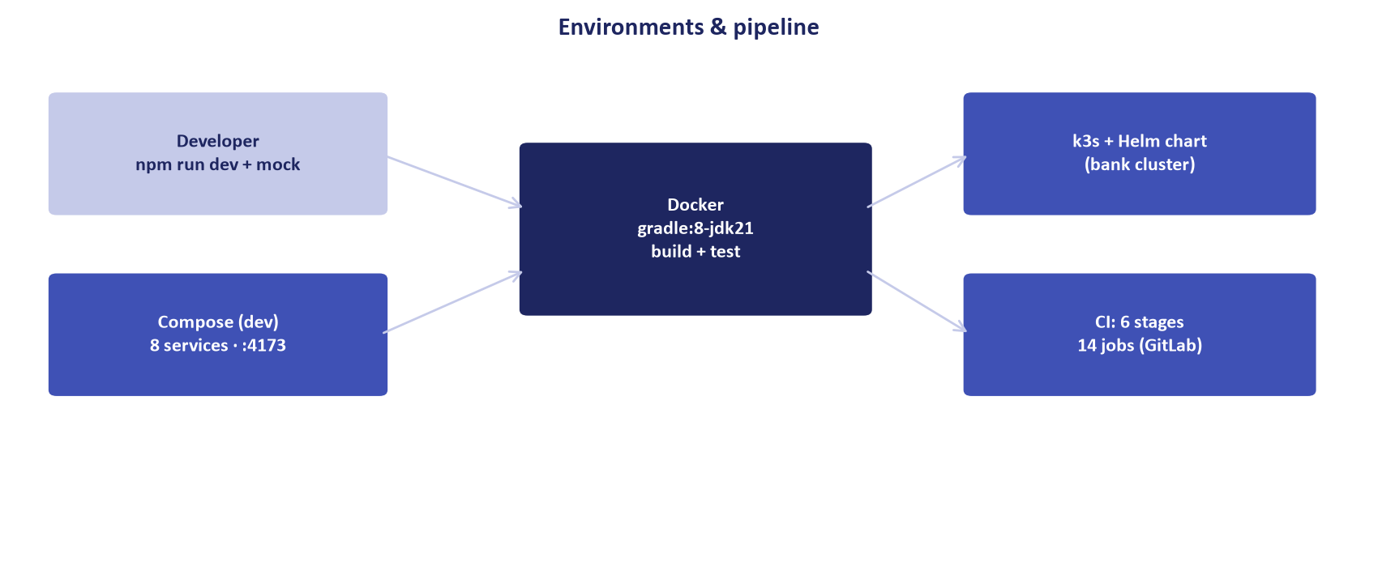
Figure 3: Declarative Kubernetes Deployment Synchronization
ArgoCD declarative state engine continuously reconciling k3s cluster manifests.
Addendum — v3.1.0 corrections (Independent Forensic Re-audit, 8 October 2026)
CI truth (v3.1.0): the build is Gradle (gradlew, build.gradle.kts); the repository's real secret-scanning gate is gitleaks (.gitlab-ci.yml) — it must run in every pipeline; SonarQube/Trivy/Cosign/ArgoCD describe the target-state toolchain. See .gitlab-ci.yml for the authoritative stage list.

