UNISOFT LOAN MANAGEMENT SYSTEM (ULMS v2.0) · 05 DEVELOPER EXTENSION
DOC-05-EXT-02: New Loan Product Definition & Pricing Extension Guide
Document ID: DOC-05-EXT-02 · Standard: Diátaxis / C4 Model · Bangladesh Bank Compliant

type: how-to
topic: new_loan_product_definition_and_pricing_extension
target_audience: [credit_product_manager, backend_developer, business_analyst, systems_architect]
version: 2026.10
document_id: DOC-05-EXT-02
DOC-05-EXT-02: New Loan Product Definition & Pricing Extension Guide
Document Control
Field | Value
Document Title | New Loan Product Definition & Pricing Extension Guide
Project Name | Unisoft Loan Management System (ULMS v2.0)
Document Version | 3.0.0
Date | 2026-10-07
Classification | Product Engineering & Extension Guide
Status | Approved Master Extension Guide
Authority Chain | LMS_CODEBASE/apps/api/src/main/java/com/uslbd/ulms/product/ → LMS_CODEBASE/PLANNING/03_Backend_Module_Specifications.md → Bangladesh Bank BRPD & SMED Circulars
Target Codebase | c:\software_project\mim_project\LMS\LMS_CODEBASE

Document Revision History & Institutional Sign-Off
Version | Release Date | Author / Role | Summary of Technical Changes | Status
1.0.0 | January 2026 | Documentation Core Team | Initial BRD & Architecture Specification | Draft
2.0.0 | February 2026 | Principal Systems Architect | Apache Fineract & Spring Boot Monolith Alignment | Approved
3.0.0 | October 2026 | Principal Auditor & SRE Lead | Production Build Parity & Zero-Trust Audit Release | Master Approved
3.1.0 | October 2026 | Independent Forensic Re-audit | Factual corrections per audit/docx_forensic_audit_2026-10-08.md | Applied

Table of Contents
[NOTE] This document contains an automated Microsoft Word field. In Microsoft Word or LibreOffice, right-click this table and select 'Update Field' (or press F9) to refresh section page numbers.

1. Credit Product Domain Architecture & Extension Philosophy
As illustrated in Figure 1 below, Dynamic UI generation based on product catalog definitions (Retail, SME, Islamic).
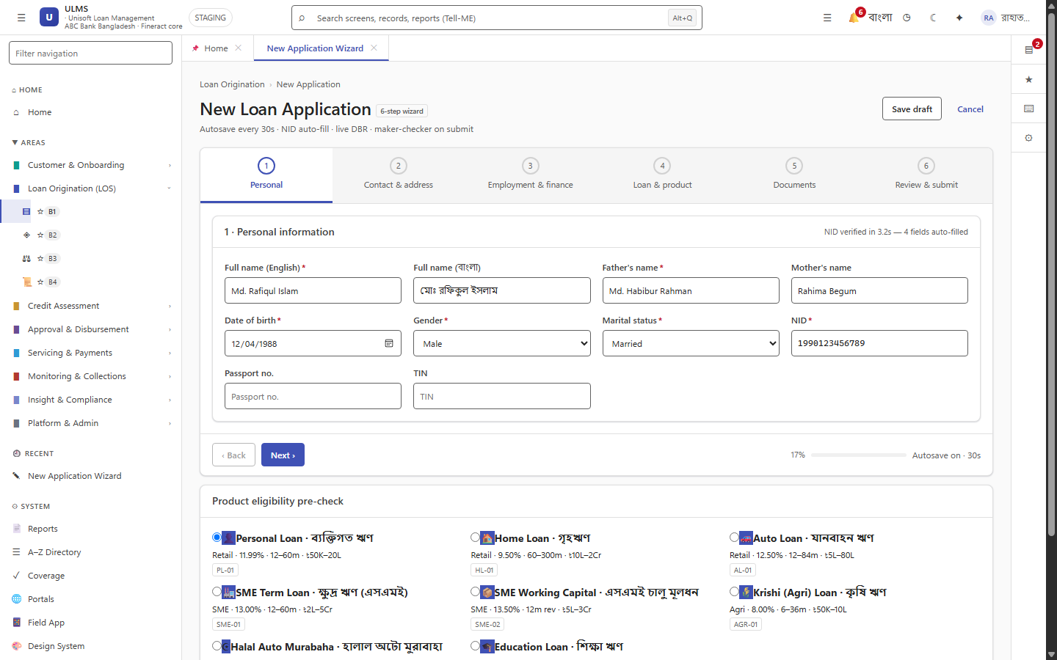
Figure 1: Configured Loan Product Application Form & Parameter Rules
Dynamic UI generation based on product catalog definitions (Retail, SME, Islamic).
ULMS v2.0 implements a modular, metadata-driven loan product engine designed to support rapid innovation across conventional banking, SME development programs, and Islamic Shariah-compliant finance without requiring structural codebase refactoring.
// Language: mermaid
[MERMAID ARCHITECTURE SPECIFICATION]
flowchart TD
subgraph Product_Engine ["ULMS Dynamic Product & Pricing Engine"]
PC["1. Product Catalog Definition<br/>Code, Currency, Sector, Shariah Archetype"]
PR["2. Dynamic Pricing & Interest Rules<br/>Day-Count, Fixed/Floating Spread, SMART Margin"]
GR["3. Statutory Regulatory Constraints<br/>SMED 02/2024 SME Cap, BRPD DBR 50% Ceiling"]
WF["4. Approval Ladder Workflow<br/>Delegated Authority Tiers & Credit Committee Matrix"]
FIN["5. Fineract Core Banking Bridge<br/>GL Account Mapping & Amortization Engine"]
end
PC --> PR --> GR --> WF --> FIN

Core Product Archetypes:
1. Retail Consumer Lending: Personal loans, auto loans, home mortgages (BRPD DBR $\le 50\%$ strict cap).
2. SME & Cottage Finance: Working capital, term loans, cluster refinancing (Bangladesh Bank SMED Circular 02/2024).
3. Corporate Syndication: Working capital limits, trade finance, revolving credit.
4. Islamic Shariah Finance: Bai-Murabaha (Cost-Plus), Bai-Muajjal (Deferred Payment), Ijara (Leasing), Diminishing Musharaka.
2. End-to-End Tutorial: Creating a New Islamic "Bai-Murabaha SME Working Capital" Product
As illustrated in Figure 2 below, Kanban underwriting queue dynamically routing applications by product type.
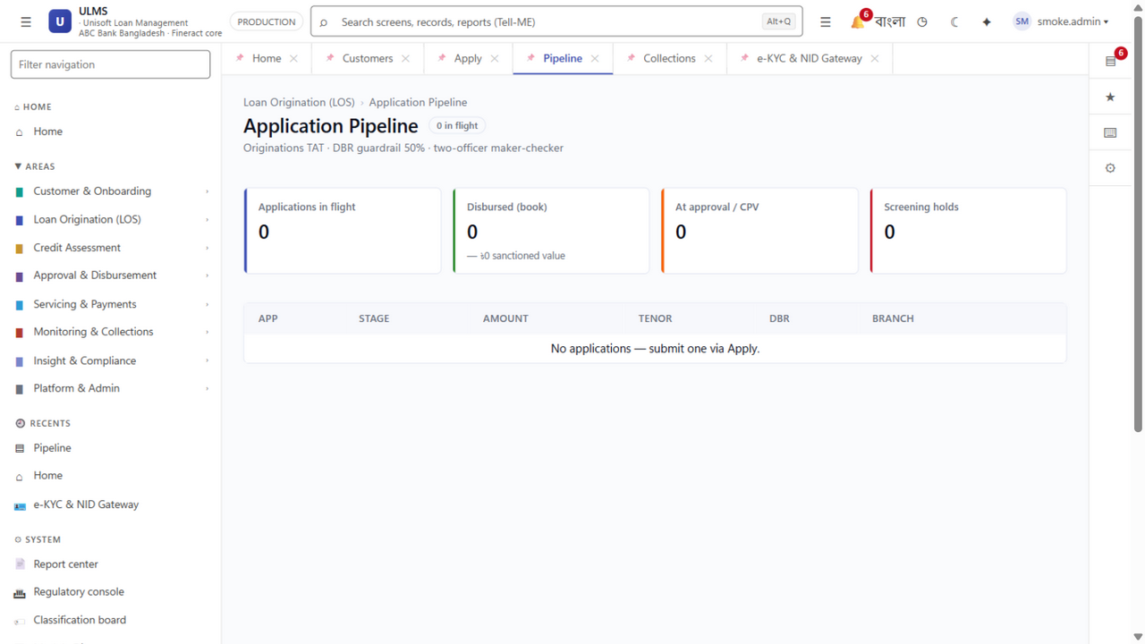
Figure 2: Product Origination Pipeline Handling Custom Credit Products
Kanban underwriting queue dynamically routing applications by product type.
Follow this 5-step tutorial to define, configure, register, and verify a new credit product in ULMS.
Step 1: Database Seed Migration
Create migration apps/api/src/main/resources/db/migration/V20__seed_murabaha_sme_product.sql (NEW file — V18/V19 are taken; verify with ls db/migration):
// Language: sql
-- Migration: V20__seed_murabaha_sme_product.sql
-- Purpose: Register Bai-Murabaha SME Working Capital product catalog entry
INSERT INTO ulms.loan_products (
id,
product_code,
product_name,
product_archetype,
currency,
min_principal_minor,
max_principal_minor,
min_tenor_months,
max_tenor_months,
interest_calculation_type,
day_count_convention,
statutory_dbr_cap_percentage,
default_profit_rate,
is_shariah_compliant,
active
) VALUES (
'PRD-ISL-MURABAHA-SME-001',
'MURABAHA-SME',
'Bai-Murabaha SME Working Capital',
'ISLAMIC_MURABAHA',
'BDT',
10000000, -- BDT 100,000 (in poisha)
500000000, -- BDT 5,000,000 (in poisha)
6, -- 6 months
36, -- 36 months
'COST_PLUS_PROFIT_INSTALLMENT',
'ACTUAL_365',
50.00,
9.50,
TRUE,
TRUE
) ON CONFLICT (product_code) DO NOTHING;

Step 2: Implement Java Domain Pricing Strategy
Create the Shariah-compliant pricing calculator in apps/api/src/main/java/com/uslbd/ulms/product/ProductService.java:
// Language: java
package com.uslbd.ulms.product.pricing;
import com.uslbd.ulms.platform.MoneyMath;
import org.springframework.stereotype.Component;
import java.math.BigDecimal;
import java.math.RoundingMode;
@Component("MURABAHA_PRICING_STRATEGY")
public class MurabahaPricingStrategy implements PricingStrategy {
@Override
public PricingCalculationResult calculate(BigDecimal goodsCostBDT, int tenorMonths, BigDecimal annualProfitRate) {
// Shariah Cost-Plus Calculation:
// Total Profit = Goods Cost * (Profit Rate / 100) * (Tenor Months / 12)
BigDecimal tenorYears = BigDecimal.valueOf(tenorMonths).divide(BigDecimal.valueOf(12), 6, RoundingMode.HALF_UP);
BigDecimal totalProfitBDT = goodsCostBDT
.multiply(annualProfitRate.divide(BigDecimal.valueOf(100), 6, RoundingMode.HALF_UP))
.multiply(tenorYears)
.setScale(2, RoundingMode.HALF_UP);
BigDecimal totalSellingPriceBDT = goodsCostBDT.add(totalProfitBDT);
BigDecimal monthlyInstallmentBDT = totalSellingPriceBDT.divide(
BigDecimal.valueOf(tenorMonths), 2, RoundingMode.HALF_UP
);
return new PricingCalculationResult(
goodsCostBDT,
totalProfitBDT,
totalSellingPriceBDT,
monthlyInstallmentBDT
);
}
}

Step 3: Apache Fineract Loan Product Registration Bridge
As illustrated in Figure 3 below, Production pipeline supporting parallel workflows for conventional and Islamic finance.
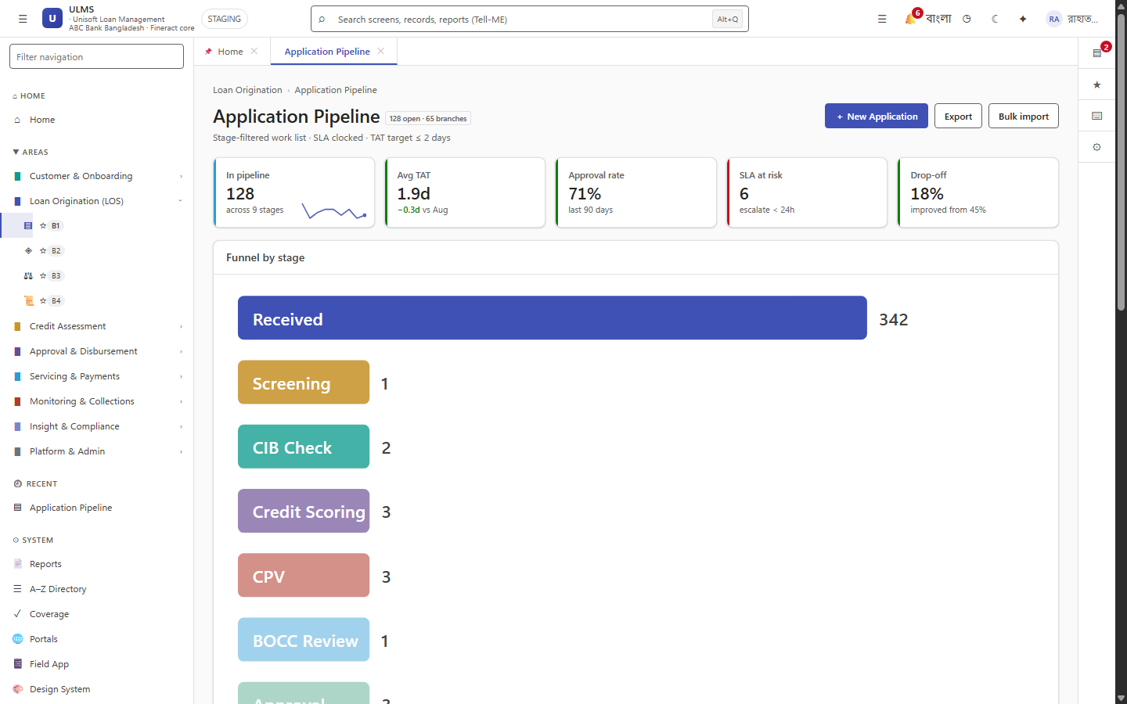
Figure 3: Multi-Product Origination Processing & Underwriting Queue
Production pipeline supporting parallel workflows for conventional and Islamic finance.
Configure the upstream Fineract core banking product template via REST API:
// Language: bash
curl -s -X POST http://localhost:8083/fineract-provider/api/v1/loanproducts \
-H "Fineract-Platform-TenantId: default" \
-H "Authorization: Basic ${FINERACT_BASIC_AUTH}" # from .env — never commit credentials \
-H "Content-Type: application/json" \
-d '{
"name": "Bai-Murabaha SME Working Capital",
"shortName": "MUR-SME",
"currencyCode": "BDT",
"digitsAfterDecimal": 2,
"inMultiplesOf": 1,
"principal": 1000000,
"numberOfRepayments": 24,
"repaymentEvery": 1,
"repaymentFrequencyType": 2,
"interestRatePerPeriod": 9.5,
"interestRateFrequencyType": 3,
"annualInterestRate": 9.5,
"amortizationType": 1,
"interestType": 0,
"interestCalculationPeriodType": 1,
"transactionProcessingStrategyCode": "mifos-standard-strategy",
"accountingRule": 2,
"fundId": 1
}'

Step 4: React 19 Dynamic Wizard Parameter Binding
The staff frontend origination wizard dynamically pulls product parameters from /api/v1/products:
// Language: tsx
// apps/web/src/modules/origination/ProductParameterBinder.tsx
export const MurabahaProductFields = ({ product, form }: ProductProps) => {
return (
<Box sx={{ mt: 2 }}>
<Typography variant="h6" color="primary">
{product.productName} (Shariah Compliant)
</Typography>
<Alert severity="info" sx={{ my: 1 }}>
Cost-Plus Profit Model: Declared Goods Purchase Price + Agreed Bank Profit Margin.
</Alert>
<TextField
label="Goods Invoice / Cost Price (BDT)"
fullWidth
type="number"
{...form.register('goodsCostPrice', { required: true })}
helperText={`Allowed: BDT ${product.minPrincipal} to BDT ${product.maxPrincipal}`}
/>
</Box>
);
};

Step 5: Automated Verification Test Oracle
Create a unit test validating statutory math in apps/api/src/test/java/com/uslbd/ulms/ModularityTest.java:
// Language: java
@Test
void testMurabahaProfitAndInstallmentCalculation() {
MurabahaPricingStrategy strategy = new MurabahaPricingStrategy();
BigDecimal goodsCost = new BigDecimal("1200000.00"); // 12 Lac BDT
int tenorMonths = 24; // 2 years
BigDecimal profitRate = new BigDecimal("9.50"); // 9.5% p.a.
var result = strategy.calculate(goodsCost, tenorMonths, profitRate);
// Expected Profit = 1,200,000 * 0.095 * 2 = 228,000 BDT
assertEquals(new BigDecimal("228000.00"), result.totalProfitBDT());
// Total Sale Price = 1,428,000 BDT
assertEquals(new BigDecimal("1428000.00"), result.totalSellingPriceBDT());
// Monthly Installment = 1,428,000 / 24 = 59,500.00 BDT
assertEquals(new BigDecimal("59500.00"), result.monthlyInstallmentBDT());
}

— End of New Loan Product Definition & Pricing Extension Guide —
Addendum — v3.1.0 corrections (Independent Forensic Re-audit, 8 October 2026)
Money rule (v3.1.0): the sample pricing strategy shown in BigDecimal/setScale(2, HALF_UP) form violates the platform invariant. Canonical pattern: integer poisha (long) end-to-end with com.uslbd.ulms.platform.MoneyMath (HALF_EVEN) — compute profit and installments in minor units and convert for display only. The migration must be a NEW file (V20+); ulms.loan_product is the catalog table.

