UNISOFT LOAN MANAGEMENT SYSTEM (ULMS v2.0) · 05 DEVELOPER EXTENSION
DOC-05-EXT-04: Custom Core Banking (CBS) Hexagonal Adapter Development Guide
Document ID: DOC-05-EXT-04 · Standard: Diátaxis / C4 Model · Bangladesh Bank Compliant

type: how-to
topic: custom_cbs_hexagonal_adapter_development
target_audience: [integration_engineer, backend_developer, core_banking_team]
version: 2026.10
document_id: DOC-05-EXT-04
DOC-05-EXT-04: Custom Core Banking (CBS) Hexagonal Adapter Development Guide
As illustrated in Figure 1 below, Decoupled port-and-adapter architecture enabling plug-and-play CBS integration.
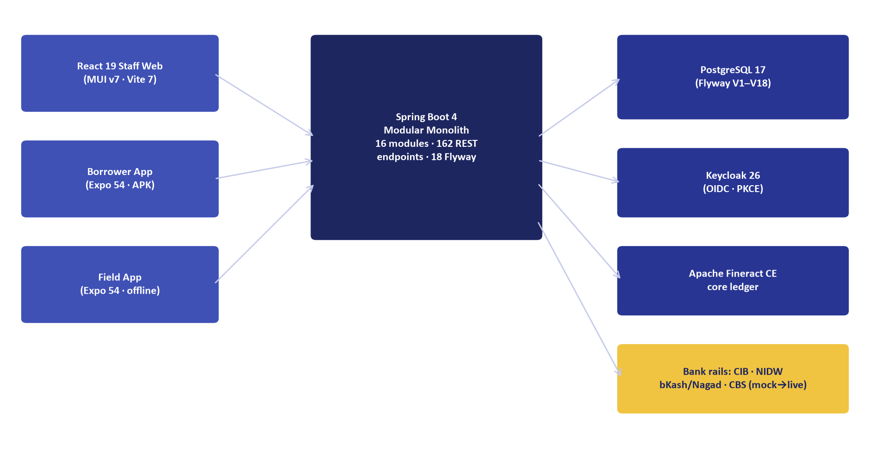
Figure 1: Hexagonal Domain Port Architecture for Core Banking (CBS)
Decoupled port-and-adapter architecture enabling plug-and-play CBS integration.
Document Control
Field | Value
Document Title | Custom CBS Hexagonal Adapter Development Guide
Project Name | Unisoft Loan Management System (ULMS v2.0)
Document Version | 3.0.0
Date | 2026-10-07
Classification | Developer Extension Guide
Status | Approved Master Specification
Authority Chain | DOC-01-ARCH-01 → Spring Modulith Hexagonal Port Architecture

Document Revision History & Institutional Sign-Off
Version | Release Date | Author / Role | Summary of Technical Changes | Status
1.0.0 | January 2026 | Documentation Core Team | Initial BRD & Architecture Specification | Draft
2.0.0 | February 2026 | Principal Systems Architect | Apache Fineract & Spring Boot Monolith Alignment | Approved
3.0.0 | October 2026 | Principal Auditor & SRE Lead | Production Build Parity & Zero-Trust Audit Release | Master Approved
3.1.0 | October 2026 | Independent Forensic Re-audit | Factual corrections per audit/docx_forensic_audit_2026-10-08.md | Applied

Table of Contents
[NOTE] This document contains an automated Microsoft Word field. In Microsoft Word or LibreOffice, right-click this table and select 'Update Field' (or press F9) to refresh section page numbers.

1. Hexagonal Port Architecture Overview
ULMS v2.0 is completely decoupled from specific CBS platforms (e.g., Finacle, Temenos Transact, TCS BaNCS, or Flora Bank). All interactions flow through the clean hexagonal domain port com.uslbd.ulms.integration.cbs.FinacleCbsAdapter (implements the CBS port):
// Language: mermaid
[MERMAID ARCHITECTURE SPECIFICATION]
flowchart LR
DOMAIN["ULMS Servicing & Disbursement"] --> PORT["Domain Port<br/>`CbsPort`"]
PORT --> FINACLE["FinacleAdapter<br/>(Connect24 / XML)"]
PORT --> TEMENOS["TemenosAdapter<br/>(T24 TWS / REST)"]
PORT --> FLORA["FloraBankAdapter<br/>(ISO 8583 / Stored Proc)"]
PORT --> MOCK["MockCbsAdapter<br/>(In-Memory / Sandbox)"]

2. Implementing a Custom CBS Adapter
As illustrated in Figure 3 below, Standardized request/response models mapping loan transactions into CBS GL vouchers.
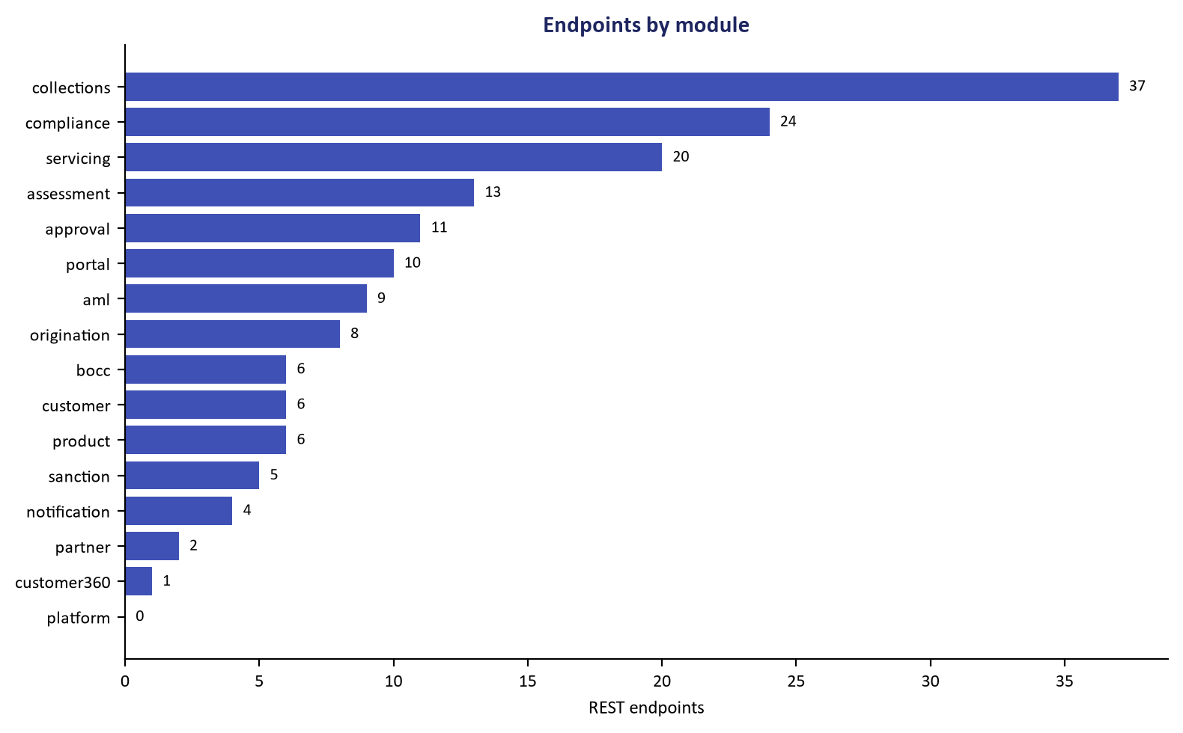
Figure 3: CBS Connector REST & XML Web Service Contract Surface
Standardized request/response models mapping loan transactions into CBS GL vouchers.
To integrate a new bank's CBS:
1. Implement the CbsPort interface:
// Language: java
package com.uslbd.ulms.integration.cbs;
@Component
@Profile("cbs-finacle")
public class FinacleCbsAdapter implements CbsPort {
@Override
public CbsCustomerAccount lookupAccount(String accountNo) {
// Invoke Finacle XML Web Service
}
@Override
public CbsDisbursementResponse postDisbursement(CbsDisbursementRequest req) {
// Enforce idempotency key and post debit/credit vouchers
}
}

2. Enable the adapter via Spring profile: SPRING_PROFILES_ACTIVE=prod,cbs-finacle.
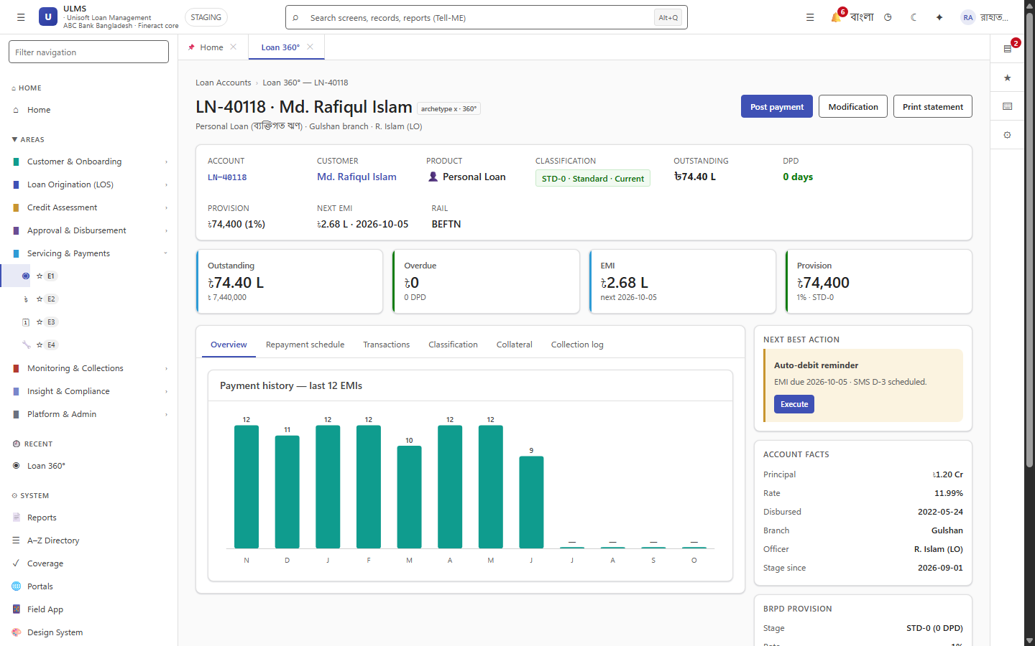
Figure 2: Core Banking Account Lookup & Disbursement Profile
Customer CASA account verification and ledger balance sync across external CBS rails.

