UNISOFT LOAN MANAGEMENT SYSTEM (ULMS v2.0) · 05 DEVELOPER EXTENSION
DOC-05-EXT-05: React Staff Portal Screen & High-Density Data Grid Extension Guide
Document ID: DOC-05-EXT-05 · Standard: Diátaxis / C4 Model · Bangladesh Bank Compliant

type: tutorial
topic: react_staff_portal_screen_extension
target_audience: [frontend_developer, ui_ux_designer]
version: 2026.10
document_id: DOC-05-EXT-05
DOC-05-EXT-05: React Staff Portal Screen & High-Density Data Grid Extension Guide
As illustrated in Figure 1 below, Unified navigation layout with high-density navigation tiles and responsive layout.
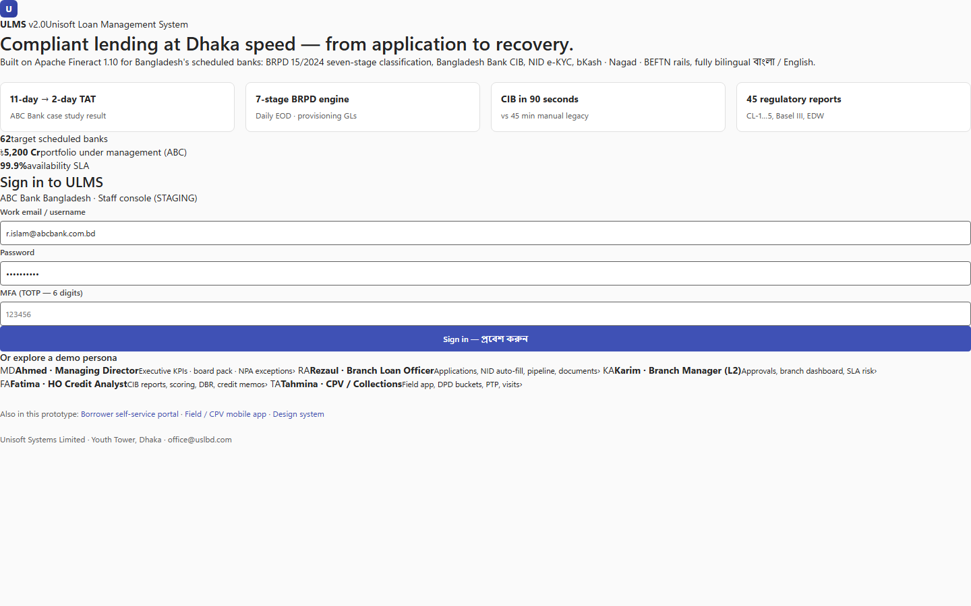
Figure 1: Dynamics 365 Enterprise Navigation & Screen Hub
Unified navigation layout with high-density navigation tiles and responsive layout.
Document Control
Field | Value
Document Title | React Staff Portal Screen Extension Guide
Project Name | Unisoft Loan Management System (ULMS v2.0)
Document Version | 3.0.0
Date | 2026-10-07
Classification | Developer Tutorial
Status | Approved Master Specification
Authority Chain | React 19 / MUI v7 Guidelines → Front_end/ Validated UX Prototype

Document Revision History & Institutional Sign-Off
Version | Release Date | Author / Role | Summary of Technical Changes | Status
1.0.0 | January 2026 | Documentation Core Team | Initial BRD & Architecture Specification | Draft
2.0.0 | February 2026 | Principal Systems Architect | Apache Fineract & Spring Boot Monolith Alignment | Approved
3.0.0 | October 2026 | Principal Auditor & SRE Lead | Production Build Parity & Zero-Trust Audit Release | Master Approved
3.1.0 | October 2026 | Independent Forensic Re-audit | Factual corrections per audit/docx_forensic_audit_2026-10-08.md | Applied

Table of Contents
[NOTE] This document contains an automated Microsoft Word field. In Microsoft Word or LibreOffice, right-click this table and select 'Update Field' (or press F9) to refresh section page numbers.

1. Architectural Principles
All Staff Portal screens follow the Dynamics 365 Enterprise Design Pattern:
• High data density ($32\text{px}$ compact row heights).
• Monospace font for monetary and account numbers (font-mono).
• Dual language support (Bengali / English via react-i18next).
• Keyboard shortcuts for rapid banking data entry (e.g. Alt+A to Approve, Alt+S to Save).
2. Creating a New Banking Screen in 4 Steps
1. Define RTK Query Endpoint:
In src/api/<domain>.ts (typed fetch hooks — the codebase uses no RTK Query/Zustand), add query hook useGetCreditAssessmentQuery.
2. Create Page Component:
In src/features/<domain>/<Domain>Page.tsx (feature-folder convention), construct layout with DynamicsHeader, KpiBanner, and MuiDataGrid.
3. Register Route:
In src/app/routes.tsx, mount route /credit/scorecards/:id protected by RequireRole(['credit-analyst']).
4. Add Navigation Tile:
Add entry to src/shell/navData.ts under Origination Subsystem.
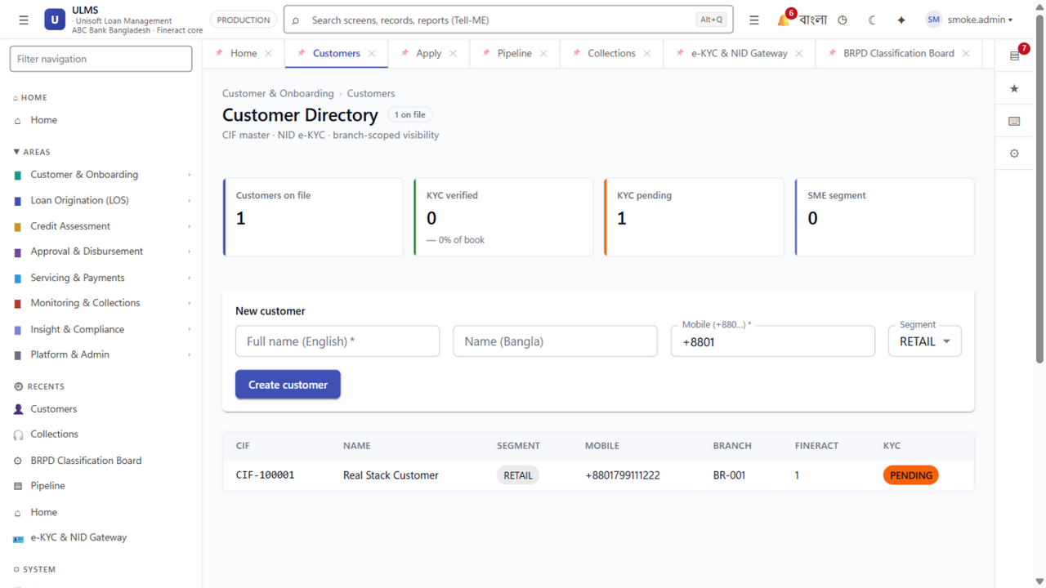
Figure 2: High-Density MUI DataGrid Custom Entity Grid
Compact banking data grid with monospace currency formatting and instant filtering.
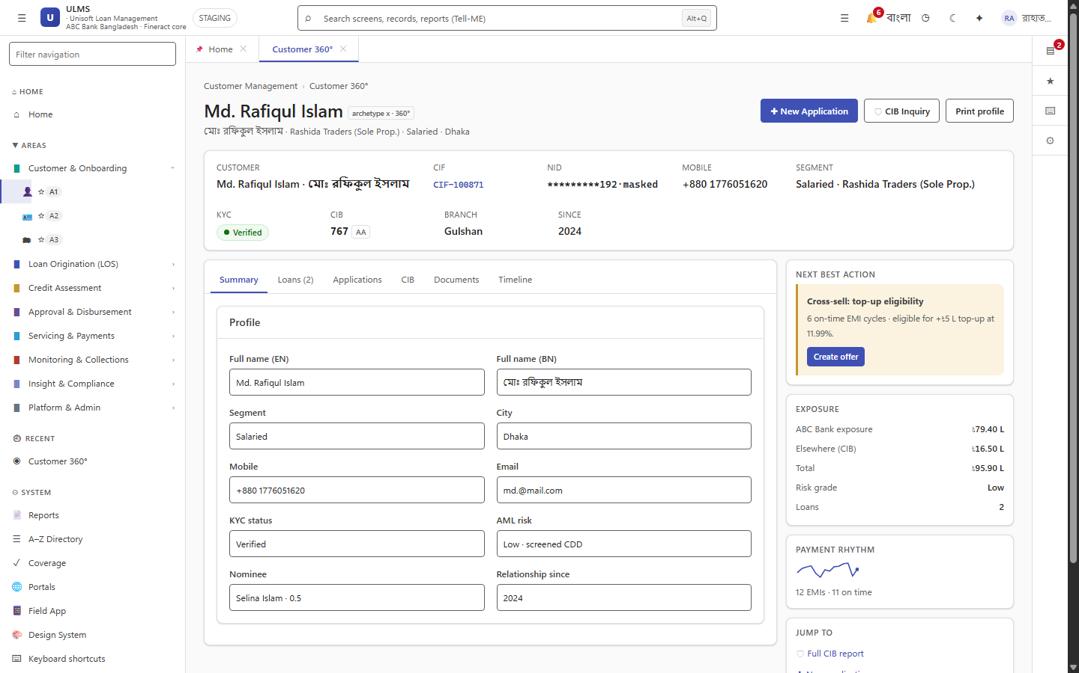
Figure 3: Custom Banking Form Layout with Live Scorecard Banner
Standardized enterprise card widgets displaying customer credit scoring metrics.
Addendum — v3.1.0 corrections (Independent Forensic Re-audit, 8 October 2026)
Frontend truth (v3.1.0): the web app is plain typed-fetch React 19 (no Redux/RTK Query/TanStack/Zustand); feature code lives under src/features/<domain>/ with navigation declared in src/shell/navData.ts and routes in src/app. Role keys are the seeded realm roles (e.g. credit-analyst).

