UNISOFT LOAN MANAGEMENT SYSTEM (ULMS v2.0) · 05 DEVELOPER EXTENSION
DOC-05-EXT-08: Enterprise Test Harness Development, Testcontainers & Mocks Guide
Document ID: DOC-05-EXT-08 · Standard: Diátaxis / C4 Model · Bangladesh Bank Compliant

type: tutorial
topic: enterprise_test_harness_testcontainers
target_audience: [qa_engineer, backend_developer, ci_cd_engineer]
version: 2026.10
document_id: DOC-05-EXT-08
DOC-05-EXT-08: Enterprise Test Harness Development, Testcontainers & Mocks Guide
As illustrated in Figure 1 below, Testcontainers launching real database instances ensuring zero SQL compatibility gaps.
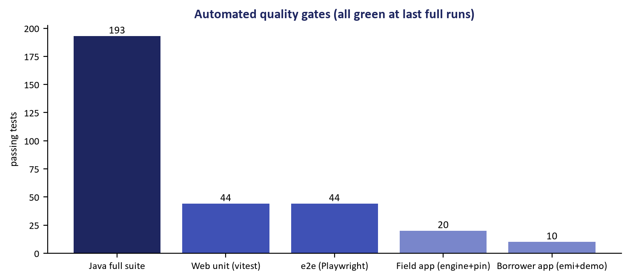
Figure 1: Automated Integration Test Execution with Real PostgreSQL 17
Testcontainers launching real database instances ensuring zero SQL compatibility gaps.
Document Control
Field | Value
Document Title | Test Harness Development & Testcontainers Guide
Project Name | Unisoft Loan Management System (ULMS v2.0)
Document Version | 3.0.0
Date | 2026-10-07
Classification | Quality Engineering Guide
Status | Approved Master Specification
Authority Chain | DOC-06-QA-01 → Spring Boot 4 Testing Best Practices

Document Revision History & Institutional Sign-Off
Version | Release Date | Author / Role | Summary of Technical Changes | Status
1.0.0 | January 2026 | Documentation Core Team | Initial BRD & Architecture Specification | Draft
2.0.0 | February 2026 | Principal Systems Architect | Apache Fineract & Spring Boot Monolith Alignment | Approved
3.0.0 | October 2026 | Principal Auditor & SRE Lead | Production Build Parity & Zero-Trust Audit Release | Master Approved
3.1.0 | October 2026 | Independent Forensic Re-audit | Factual corrections per audit/docx_forensic_audit_2026-10-08.md | Applied

Table of Contents
[NOTE] This document contains an automated Microsoft Word field. In Microsoft Word or LibreOffice, right-click this table and select 'Update Field' (or press F9) to refresh section page numbers.

1. Zero-Mock Database Testing with Testcontainers
As illustrated in Figure 2 below, Deterministic verification of external CIB and NIDW API mocks with WireMock.
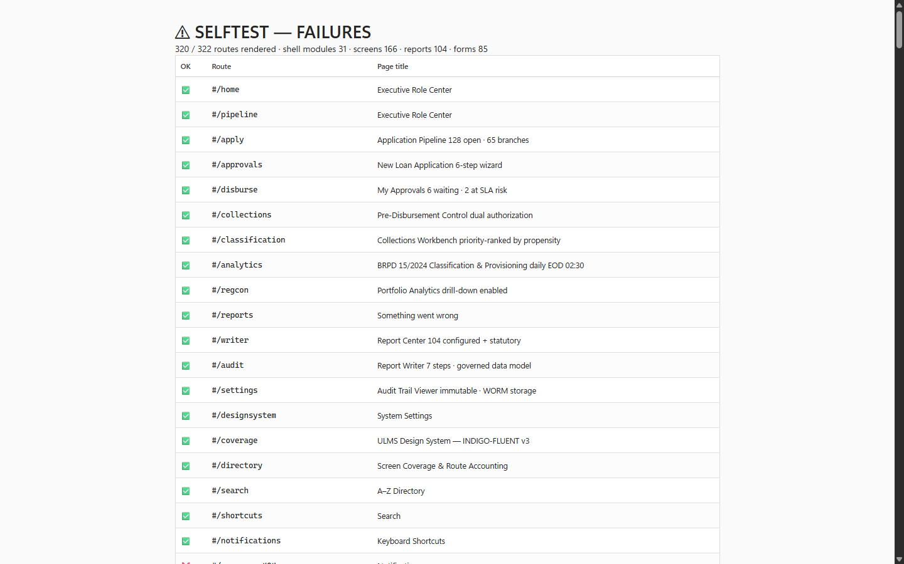
Figure 2: Diagnostic Self-Testbed & Mock Service Scenarios
Deterministic verification of external CIB and NIDW API mocks with WireMock.
ULMS rejects in-memory H2 databases for testing because H2 fails to emulate PostgreSQL 17 features (JSONB operators, CTEs, window functions, and Flyway V1-V18 scripts). All integration tests run against real PostgreSQL 17 inside Docker:
// Language: java
@SpringBootTest
@Testcontainers
public abstract class AbstractIntegrationTest {
@Container
static PostgreSQLContainer<?> postgres = new PostgreSQLContainer<>("postgres:17-alpine")
.withDatabaseName("ulms_test")
.withUsername("test")
.withPassword("test");
@DynamicPropertySource
static void configureProperties(DynamicPropertyRegistry registry) {
registry.add("spring.datasource.url", postgres::getJdbcUrl);
}
}

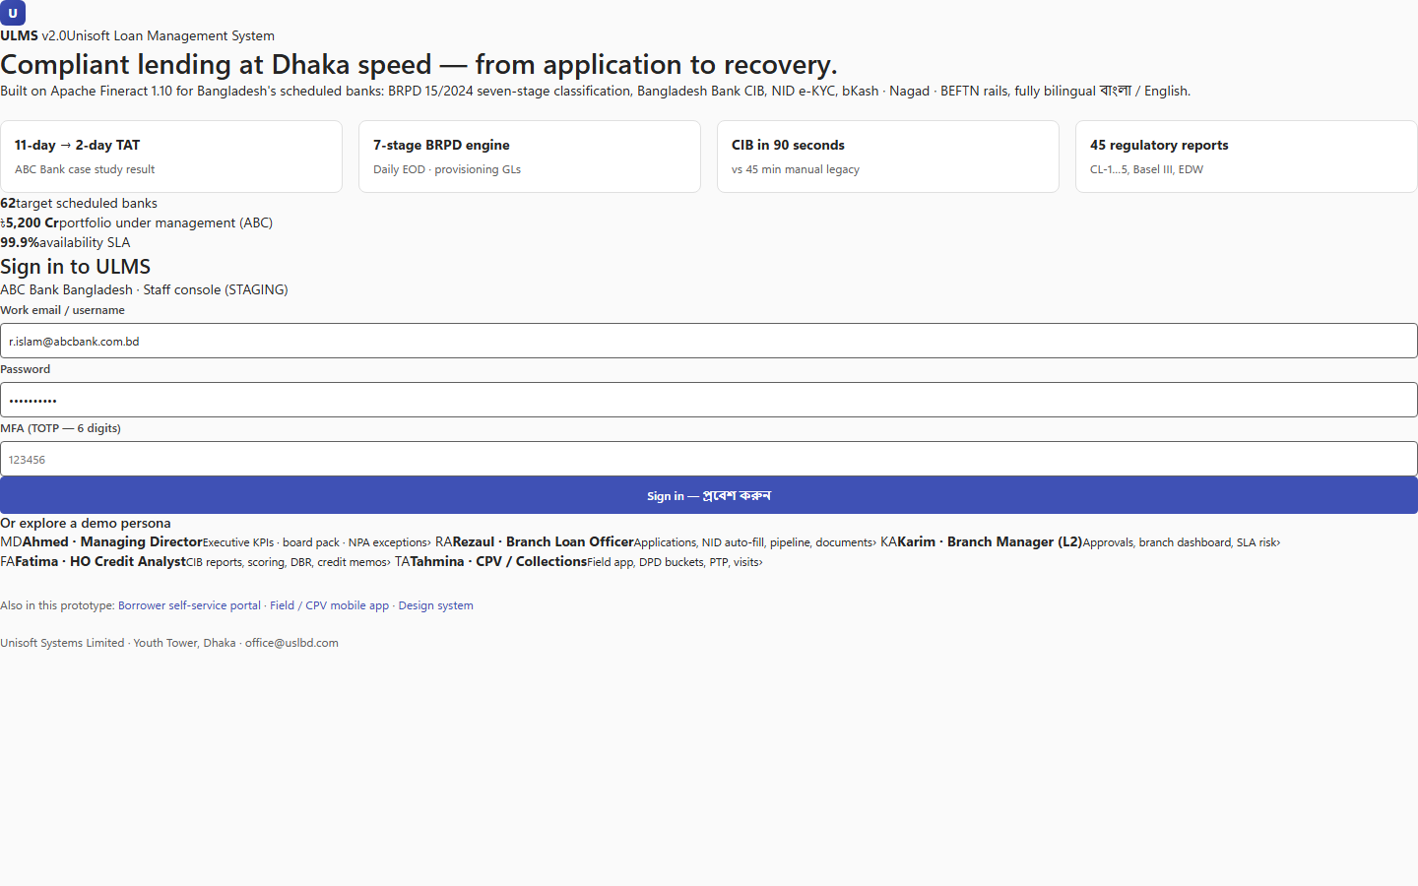
Figure 3: Quality Engineering & Testing Hub Directory
Unified interface for executing component tests, modularity tests, and E2E journeys.
Addendum — v3.1.0 corrections (Independent Forensic Re-audit, 8 October 2026)
Expansion pending (flagged): WireMock configuration and mock-adapter guidance (promised in the catalog) not yet authored; the Testcontainers-PostgreSQL principle stated here is correct (no H2).

