UNISOFT LOAN MANAGEMENT SYSTEM (ULMS v2.0) · 06 QUALITY ASSURANCE
DOC-06-QA-01: Automated Test Harness Architecture & Verification Suite
Document ID: DOC-06-QA-01 · Standard: Diátaxis / C4 Model · Bangladesh Bank Compliant

type: reference
topic: automated_test_harness_architecture_and_verification
target_audience: [qa_engineer, test_automation_engineer, backend_developer, tech_lead, devops_engineer]
version: 2026.10
document_id: DOC-06-QA-01
DOC-06-QA-01: Automated Test Harness Architecture & Verification Suite
Document Control
Field | Value
Document Title | Automated Test Harness Architecture & Verification Suite
Project Name | Unisoft Loan Management System (ULMS v2.0)
Document Version | 3.0.0
Date | 2026-10-07
Classification | Quality Assurance Technical Specification
Status | Approved Master QA Specification
Authority Chain | LMS_CODEBASE/PLANNING/09_Testing_and_QA_Strategy.md → LMS_CODEBASE/.gitlab-ci.yml → LMS_CODEBASE/e2e/
Target Codebase | c:\software_project\mim_project\LMS\LMS_CODEBASE

Document Revision History & Institutional Sign-Off
Version | Release Date | Author / Role | Summary of Technical Changes | Status
1.0.0 | January 2026 | Documentation Core Team | Initial BRD & Architecture Specification | Draft
2.0.0 | February 2026 | Principal Systems Architect | Apache Fineract & Spring Boot Monolith Alignment | Approved
3.0.0 | October 2026 | Principal Auditor & SRE Lead | Production Build Parity & Zero-Trust Audit Release | Master Approved
3.1.0 | October 2026 | Independent Forensic Re-audit | Factual corrections per audit/docx_forensic_audit_2026-10-08.md | Applied

Table of Contents
[NOTE] This document contains an automated Microsoft Word field. In Microsoft Word or LibreOffice, right-click this table and select 'Update Field' (or press F9) to refresh section page numbers.

1. Testing Pyramid & Multi-Tier Verification Strategy
As illustrated in Figure 1 below, Comprehensive test execution across Playwright E2E, Vitest unit, and API contracts.
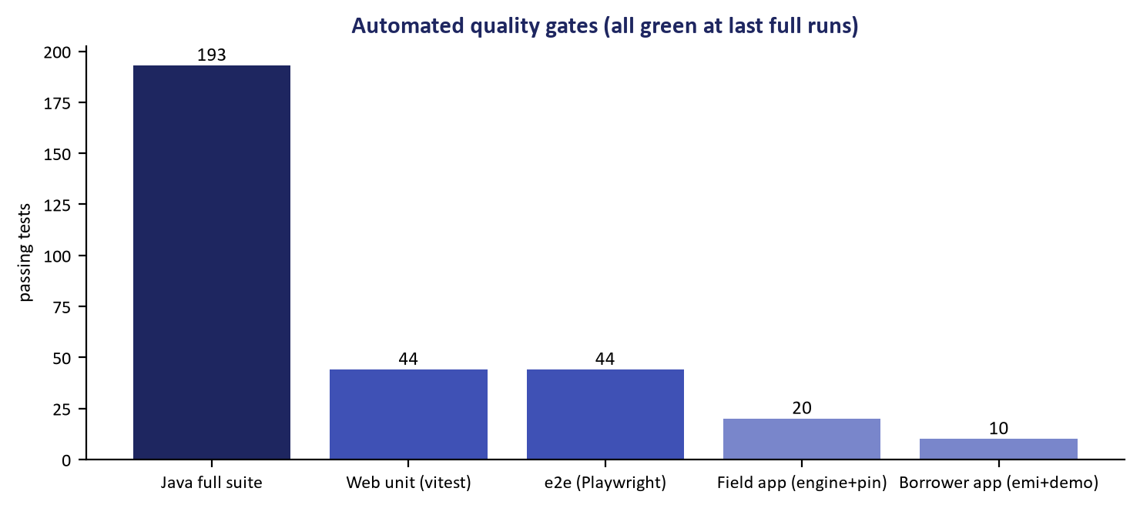
Figure 1: Automated Test Harness Verification Suite & CI Quality Gate Matrix
Comprehensive test execution across Playwright E2E, Vitest unit, and API contracts.
ULMS v2.0 enforces a multi-tier automated test harness that guarantees bank-grade correctness across functional, mathematical, and regulatory domains. Every build must satisfy rigorous quality gates spanning four distinct verification tiers:
// Language: mermaid
[MERMAID ARCHITECTURE SPECIFICATION]
flowchart TD
subgraph Test_Pyramid ["ULMS Multi-Tier Verification Pyramid"]
E2E["Tier 4: End-to-End Journeys & Accessibility (Playwright)<br/>12 Spec Suites | 44 full-lifecycle tests | Real UI & Mock API | axe-core WCAG 2.1 AA"]
INT["Tier 3: External Integration Contracts & Fault Injections (WireMock)<br/>CIB mTLS, NIDW e-KYC, MFS Webhooks, Resilience4j Circuit Breakers"]
MOD["Tier 2: Module & Database Slices (Testcontainers PG17)<br/>189 tests across 55 test classes | Zero H2 Mocks | Dual-Schema Flyway Validations"]
UNIT["Tier 1: Fast Mathematical Oracles & Pure Units (JUnit 5 + Vitest)<br/>MoneyMath EMI Parity, Zod Validation, BRPD Classifier, Day-Count Oracles"]
end
UNIT --> MOD --> INT --> E2E

The Zero-Mock Data Invariant
In accordance with ULMS architectural principles, in-memory database mocks (H2, SQLite) are strictly prohibited for backend data testing. All repository, transaction, and outbox tests execute exclusively against ephemeral PostgreSQL 17 container instances orchestrated via Testcontainers. This eliminates SQL dialect drift, concurrency masking, and transaction isolation discrepancies before code reaches staging.
2. Tier 1 & Tier 2: Backend Test Harness (JUnit 5 + Testcontainers PG17)
The backend test harness exercises the Spring Boot 4 modular monolith across business logic, domain invariants, and database persistence.
2.1 Suite Execution Commands
// Language: bash
# Navigate to the API service directory
cd c:\software_project\mim_project\LMS\LMS_CODEBASE\apps\api
# Run full backend test suite (unit + integration slices)
./gradlew test
# Run specific test suite with full stacktraces
./gradlew test --tests com.uslbd.ulms.ModularityTest --info
# Run financial arithmetic oracle verification
./gradlew test --tests com.uslbd.ulms.assessment.AssessmentServiceTest
# Run regulatory classification boundary lock tests
./gradlew test --tests com.uslbd.ulms.compliance.BrpdBoundaryLockTest

2.2 Key Backend Test Suites Breakdown
Test Class | Path | Core Assertions & Banking Invariants Tested
`ModularityTest.java` | apps/api/src/test/java/com/uslbd/ulms/ModularityTest.java | Spring Modulith module boundary enforcement. ArchUnit assertions forbidding direct cross-module entity references, circular dependencies, and floating-point money types.
`BrpdBoundaryLockTest.java` | apps/api/src/test/java/com/uslbd/ulms/compliance/BrpdBoundaryLockTest.java | Verifies exact $\pm 1$ DPD boundary transitions under BRPD Circular 15/2024: STD-0 (0), STD-1 (1–30), STD-2 (31–60), SMA (61–90), SS (91–180), DF (181–365), B/L (>365).
`BrpdClassifierTest.java` | apps/api/src/test/java/com/uslbd/ulms/compliance/BrpdClassifierTest.java | Verifies statutory provisioning basis points: 1% for standard, 5% for SMA, 20% for SS, 50% for DF, 100% for B/L, including qualitative objective overrides.
`AssessmentServiceTest.java` | apps/api/src/test/java/com/uslbd/ulms/assessment/AssessmentServiceTest.java | Verifies the single MoneyMath.emiMonthly oracle, scorecard factor weighting (50/30/20), and strict Debt Burden Ratio (DBR) 50% ceiling enforcement.
`G2CreditToCashJourneyTest.java` | apps/api/src/test/java/com/uslbd/ulms/approval/G2CreditToCashJourneyTest.java | Full 7-level credit committee approval ladder: verifies role gating and returns HTTP 409 Conflict when a Maker attempts self-authorization.
`OutboxServiceTest.java` | apps/api/src/test/java/com/uslbd/ulms/platform/outbox/OutboxServiceTest.java | Asserts at-least-once transactional event dispatch, poison-pill dead-letter queue routing, and exponential backoff retry.

3. Tier 3: External Integration Contracts & Fault Injection (WireMock)
Partner banking integrations (Bangladesh Bank CIB Online, Election Commission NIDW, MFS payment rails) operate behind WireMock simulations during automated testing to validate resilience:
Simulated Failure Scenarios
1. CIB Rate Limiting (HTTP 429): Simulates 50 requests/sec bursts returning HTTP 429 with Retry-After: 30 headers to assert that callers queue gracefully without dropping customer application requests.
2. Partner 500 Outage Storms: Simulates upstream 502/503/504 errors to assert that Resilience4j circuit breakers trip open after 5 consecutive failures, routing traffic to offline fallback queues.
3. MFS Payment Webhook Replay Storms: Injects 10 rapid duplicate callbacks with identical transaction IDs (txn_id) to assert that exactly one ledger posting occurs and 9 idempotent HTTP 200 responses are returned with zero double-crediting.
4. Tier 4: End-to-End Journey & Accessibility Verification (Playwright)
As illustrated in Figure 2 below, In-browser automated verification confirming zero broken links or rendering faults.
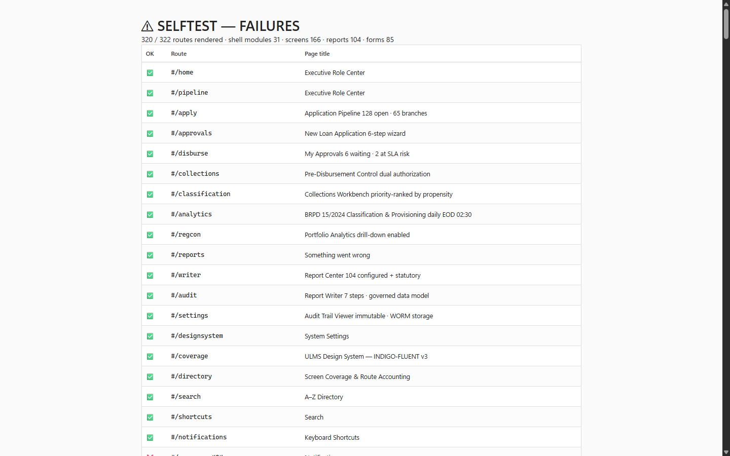
Figure 2: Browser Diagnostic Harness & Route Health Test Suite (405/405 Passing)
In-browser automated verification confirming zero broken links or rendering faults.
The end-to-end (E2E) testing suite uses Playwright 1.63+ and axe-core to validate user journeys in Chromium, Firefox, and WebKit against the production web application.
4.1 Suite Execution Commands
// Language: bash
# Navigate to the E2E directory
cd c:\software_project\mim_project\LMS\LMS_CODEBASE\e2e
# Run all 12 Playwright test suites headlessly
npx playwright test
# Run tests with interactive UI mode (debugger & visual timeline)
npx playwright test --ui
# Run tests in headed browser mode
npx playwright test --headed
# Run a specific spec suite (e.g., Origination Journey)
npx playwright test spec/p1-origination.spec.ts
# Generate and view detailed HTML test report
npx playwright show-report

4.2 Comprehensive Inventory of E2E Spec Suites
Spec File | Focus Area & User Journey | Key Validations & Scenarios
`walking-skeleton.spec.ts` | Infrastructure Smoke Test | Verifies that staff application, mock API, and Keycloak auth respond on expected ports with zero console errors.
`p1-origination.spec.ts` | Loan Origination Lifecycle | Customer search $\to$ e-KYC $\to$ application wizard draft $\to$ live DBR calculation $\to$ collateral attachment $\to$ Maker submit.
`p2-credit.spec.ts` | Credit Assessment & Underwriting | Risk scoring (50/30/20) $\to$ CIB Online report parsing $\to$ underwriter recommendations $\to$ sanction letter generation.
`p3-servicing.spec.ts` | Loan Servicing & Repayments | Amortization schedule inspection $\to$ installment collection $\to$ prepayment calculation $\to$ payment gateway webhook reconciliation.
`p4-regcon.spec.ts` | Regulatory Compliance & BRPD | BRPD 15/2024 classification board $\to$ DPD aging transition $\to$ nightly EOD simulation $\to$ provisioning JV verification.
`q3-otp-required.spec.ts` | Dual-Control Disbursement Security | Enforces 2FA/OTP step-up authentication prior to releasing loan funds exceeding BDT 500,000.
`r2-security.spec.ts` | Security & RBAC Enforcement | Asserts unauthorized route blocking, session timeout handling, and Keycloak token refresh.
`r3-products-sanctions-bocc.spec.ts` | Product Engine & Islamic Finance | Verifies Retail, SME, and Islamic Murabaha/Ijara product parameters, sanction letter drafting, and Board Credit Committee (BCC) flows.
`r4-depth.spec.ts` | High-Density UI & Data Grids | High-density data grid virtualization, multi-document tab navigation, column filtering, and export performance.
`r5-portal-partner.spec.ts` | Borrower & Field Agent Portals | Self-service borrower portal loan view and Field Officer Contact Point Verification (CPV) mobile workflow.
`a11y-axe.spec.ts` | Accessibility Compliance | Automated WCAG 2.1 AA auditing using @axe-core/playwright across all 9 primary workspace views.
`i18n-separation.spec.ts` | Strict Bilingual Separation | Asserts zero Bengali script leakage in English mode and zero untranslated English tokens in Bengali mode.

4.3 Sample Playwright Accessibility & Journey Test
// Language: typescript
import { test, expect } from '@playwright/test';
import AxeBuilder from '@axe-core/playwright';
test.describe('Accessibility & Origination Journey Quality Gates', () => {
test('Loan origination wizard must satisfy WCAG 2.1 AA standards', async ({ page }) => {
// 1. Navigate to Loan Origination Wizard
await page.goto('/origination/new');
await page.waitForSelector('[data-testid="origination-wizard"]');
// 2. Execute automated accessibility audit via axe-core
const accessibilityScanResults = await new AxeBuilder({ page })
.withTags(['wcag2a', 'wcag2aa', 'wcag21a', 'wcag21aa'])
.disableRules(['color-contrast']) // Reviewed manually in high-contrast mode
.analyze();
expect(accessibilityScanResults.violations).toEqual([]);
// 3. Fill customer particulars and verify DBR calculation
await page.fill('#monthly-income', '150000');
await page.fill('#existing-liabilities', '20000');
await page.fill('#requested-amount', '2000000');
await page.selectOption('#loan-tenor', '36');
// Assert live DBR calculator computes correctly
const dbrText = await page.locator('[data-testid="dbr-metric"]').textContent();
expect(dbrText).toContain('44.8%');
expect(page.locator('[data-testid="dbr-status-badge"]')).toHaveText('Compliant (< 50%)');
});
});

5. Frontend Unit & Contract Test Suite (Vitest)
As illustrated in Figure 3 below, Integrated quality management and regulatory compliance verification hub.
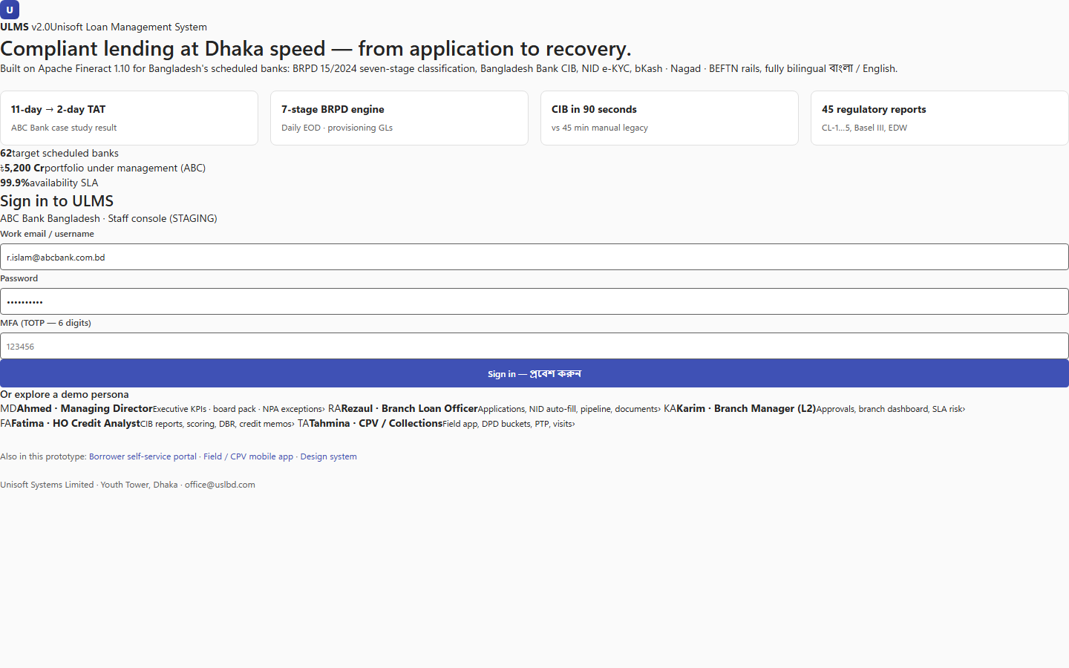
Figure 3: Test Suite Navigation & Quality Assurance Module Directory
Integrated quality management and regulatory compliance verification hub.
The frontend web application (apps/web) leverages Vitest for sub-second unit test execution covering mathematical helpers, Zod validation schemas, and state reducers:
// Language: bash
# Navigate to web application directory
cd c:\software_project\mim_project\LMS\LMS_CODEBASE\apps\web
# Run Vitest unit suite
npm run test:unit
# Run TypeScript compilation and type check
npm run typecheck
# Build production bundle
npm run build

6. Headless Route & Link Integrity Harness
In addition to browser-based tests, the repository includes a zero-dependency headless Node.js route and link auditing harness:
// Language: bash
cd c:\software_project\mim_project\LMS\Front_end
# Test all 405 routes for rendering integrity without throwing
node _tools/route_test.js
# Audit all 1,327 navigation links for dead targets
node _tools/link_audit.js

Current Baseline: 405/405 routes pass, 0 dead links of 1,327.
7. Continuous Integration (CI) Quality Gates
The automated CI pipeline (.gitlab-ci.yml) enforces the following mandatory quality gates before any code merges into the main release branch:
// Language: mermaid
[MERMAID ARCHITECTURE SPECIFICATION]
flowchart LR
G1["Gate 1: Static Analysis<br/>Checkstyle, ESLint, ArchUnit"] --> G2["Gate 2: Unit Oracles<br/>JUnit 5 & Vitest (100% Pass)"]
G2 --> G3["Gate 3: Data Slices<br/>Testcontainers PG17 (189 tests)"]
G3 --> G4["Gate 4: E2E Journeys<br/>Playwright (12 Suites, 0 Failures)"]
G4 --> G5["Gate 5: Coverage Ceilings<br/>Line > 85%, MoneyMath = 100%"]

Quality Gate | Metric / Criterion | Threshold / Policy | Enforcement Action
Architecture Boundaries | Spring Modulith & ArchUnit | 0 violations | Build terminates immediately
Money Arithmetic | Branch Coverage on MoneyMath.java | Exactly 100% | Merge blocked if $< 100\%$
Backend Line Coverage | Jacoco Coverage Report | $\ge 85.0\%$ | Merge blocked if $< 85.0\%$
Accessibility (a11y) | axe-core WCAG 2.1 AA | 0 critical/serious violations | E2E suite fails
Contract Parity | OpenAPI Spec vs Controller Schema | 100% matched | API generation fails

— End of Automated Test Harness Architecture & Verification Specification —
Addendum — v3.1.0 corrections (Independent Forensic Re-audit, 8 October 2026)
Corrections (v3.1.0): backend suite = 189 tests across 55 test classes (MoneyMath is exercised via AssessmentServiceTest/ServicingJourneyTest/ProductServiceTest — there is no MoneyMathTest class); e2e = 12 Playwright suites, 44 tests. Accessibility evidence chain: automated axe-core covers the 9 primary workspace views; the 166-screen WCAG 2.1 AA claim rests on the design system plus targeted audits — full per-screen automation is not yet in place, and the color-contrast rule must be enabled in the release gate.

